# MCM529 Dominic McNeill

102061800

# AI Design:

## Flow chart:

[Link to diagram](https://viewer.diagrams.net/?tags=%7B%7D&lightbox=1&highlight=0000ff&edit=_blank&layers=1&nav=1&title=StateMachineAIModule.drawio&dark=auto#Uhttps%3A%2F%2Fdrive.google.com%2Fuc%3Fid%3D1t53fZWIuec5HHsRFXfMy_FqkZ0WhrsyU%26export%3Ddownload)

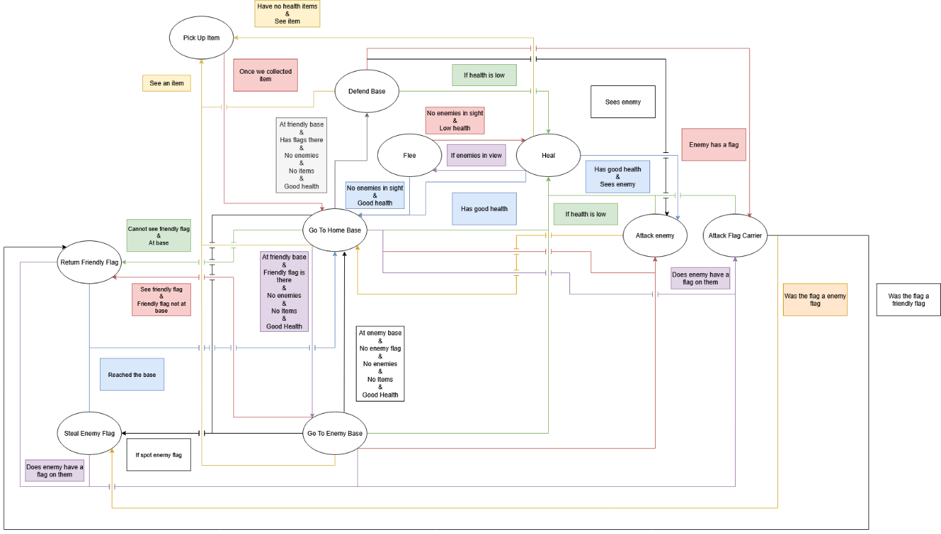

## State table:

All states:

* Go to friendly base.
* Go to enemy base.
* Return friendly flag.
* Steal enemy flag.
* Attack enemy.
* Attack flag carrier.
* Heal.
* Flee.
* Pickup item
* Defend base.

|  |  |  |  |
| --- | --- | --- | --- |
| Current State | Input | Next State | Output |
| Go to friendly base | Spots friendly flag not in base | Return friendly flag | Go and return friendly flag to base |
| Go to friendly base | See enemy flag | Steal enemy flag | Get the enemy flag and take it to base |
| Go to friendly base | Low health | Heal | Try and heal self |
| Go to friendly base | See enemy | Attack enemy | Go to enemy and attack them |
| Go to friendly base | See enemy with flag | Attack flag carrier | Go to flag carrier and attack them |
| Go to friendly base | See both flags at base | Defend base | Sit at base and defends |
| Go to friendly base | See item | Pick up item | Go and collect the item |
| Go to friendly base | At base | Go to enemy base | Start heading to the enemy base |
| Go to enemy base | Spots friendly flag not in base | Return friendly flag | Go and return friendly flag to base |
| Go to enemy base | See enemy flag | Steal enemy flag | Get the enemy flag and take it to base |
| Go to enemy base | Low health | Heal | Try and heal self |
| Go to enemy base | See enemy | Attack enemy | Go to enemy and attack them |
| Go to enemy base | See enemy with flag | Attack flag carrier | Go to flag carrier and attack them |
| Go to enemy base | See item | Pick up item | Go and collect the item |
| Go to enemy base | At enemy base | Go to friendly base | Start heading to the friendly base |
| Attack enemy | Target enemy is dead | Go to friendly base | Go back to base |
| Attack enemy | We have low heal | Heal | Try and heal self |
| Attack flag carrier | Was the dropped flag the friendly flag | Return friendly flag | Return the flag to base |
| Attack flag carrier | Was the dropped flag the enemy flag | Steal enemy flag | Return the flag to base |
| Return friendly flag | At friendly base | Go to friendly base | Returned the flag |
| Return friendly flag | Enemy has flag | Attack flag carrier | Attacking enemy with flag |
| Steal enemy flag | At friendly base | Go to friendly base | Stole the flag |
| Steal enemy flag | Enemy has flag | Attack flag carrier | Attacking enemy with flag |
| Heal | Sees enemy and has no health item | Flee | Run away |
| Heal | Sees enemy and has health item | Attack enemy | Attack the enemy |
| Heal | Healed | Go to friendly base | Go back to what we are doing |
| Heal | Has no health item | Pickup item | Go look for items |
| Flee | See no enemies and has low health | Heal | Go back to healing self |
| Flee | See no enemies and has good health | Go to friendly base | Go back to what we were doing |
| Pickup item | Collected item | Go to friendly base | Go back to what we were doing |
| Defend base | Low health | Heal | Try and heal self |
| Defend base | See enemy | Attack enemy | Go to enemy and attack them |
| Defend base | See enemy with flag | Attack flag carrier | Go to flag carrier and attack them |
| Defend base | See item | Pick up item | Go and collect the item |

# Testing:

|  |  |
| --- | --- |
| Action | Result |
| Go to friendly base | AI will go to their base, if they are hurt they will switch to heal, if they see any flags, they will switch to collect them, switch to attack the closes enemy in sight, switch to attack flag carrier if the any of the spotted enemies has a flag, switches to pick up item if the AI sees an item, the AI will switch to defending base when both flags are there. |
| Go to enemy base | AI will go to the enemy base, if they are hurt they will switch to heal, if they see any flags, they will switch to collect them, switch to attack the closes enemy in sight, switch to attack flag carrier if the any of the spotted enemies has a flag, switches to pick up item if the AI sees an item. |
| Attack enemy | AI will attack enemy ai and use power up, they will switch back to go to friendly / enemy base if health is good or break combat to heal. |
| Attack flag carrier | AI attacks the enemy with the flag and switches to respected steal / return flag state. |
| Heal | If the AI has a health item, they will use the item, if they do not then they will run away if there are enemies or look for health items if not. |
| Flee | The AI will attempt to get away from the enemy, but because it picks a random location, the AI could walk towards the enemy. (Using the flee function will make the AI walk into a corner) |
| Pickup item | AI will go and collect the item and go to their base or enemy base depends on what is closest. (AI can get stuck switching into this state and out to go to base if other agents are closer to items) |
| Steal enemy flag | The AI will go and pickup the flag and take it to its base, once at the base it will switch to go to friendly base or defend base depending on if both flags are there. |
| Return friendly flag | *The ai will go to the flag and try to collect it, the AI can get stuck if someone else picks it up.* The AI switch to attack flag carrier if any enemy has a flag. The AI will check its base for the flag, then it will head to the enemy’s base. *(edge case if the enemy or teammate dies with flag in an area the AI does not path to, resulting in the AI just breaking)* |
| Defend base | The AI sit at the base if the spot an enemy they will attack the closet enemy, if they see an item they will switch to pickup item, if an enemy has either flag, the AI will switch to attack flag carrier. |

## Any notes or unexpected outcomes:

AI spotting flags and items through walls, the fix was the walls were triggers and one of the checks only work on colliders, set the walls to colliders and that fixed the issue.

AI are getting stuck trying to pickup an item they already pickup, fixed by calling collect item once within range and exiting the state rather than waiting for the item to be destroyed since the game object gets parented to the AI.

(this now creates the issue of when other AI’s pick up the item, the current AI will still try and pick it up and start looping between this state and go to base state).

AI fleeing runs into the corner of the map. Fixed by using random location.

(AI now can run into the enemy and create a new issue where if the AI already has a target point, it will go to that first before fleeing).

When the AI tries to heal with no heal items, the AI would exit out of the state and loop going in and out of this state with go to base. Fixed by having the heal state make the enemy randomly roam to look for more items, and if they spot one, get it.

AI teammates would get stuck on each other trying to go to a target point. Fixed by checking if the AI is within a distance from the point. Still have the possibility of the AI running into each other and getting stuck elsewhere.

AI would try and steal the enemy flag when defending and the flag is at their base. Fixed by checking if the flag is withing a range of the base, the same range that allows the AI to mark they reached the target point.



AI attack flag carrier does not activate. The cause was the way I checked the flag using line of sight so when the enemy picks it up the friendly does not have line of sight. The fix is to check the enemy AI data to check if the enemy has any flags on them.

# Reflection:

My implementation, mainly with actions, created a more complex states where some could be simplified or merged, such as making return and steal flag into one state called collect flag (this would collect and return the flag to base), another would be attack enemy and attack flag carrier, this can just be attack enemy.

Another thing I could improve is the combat, making the AI stop when next to each other to improve hits. Only use powerup when within range and not chasing. Stop attacking / chasing when out of range and sight after some time. The ai does priorities the closest enemy only when looking for a target, this can be changed to be constantly checking and go for weaker enemies.

The state machine implementation does work but I would also include a way to store / get the previous state so I can transition back in the future and add another method in state base call can transition which would return if I can transition onto the state so the AI does not stuck switching between two states.

Having a middle state or idle state to transition to multiple states rather than use go to friendly base would be wise as better checks can be put in place to stop the ai from needing to go to their base to then start going to the enemy base. (I tried to get around this be checking if the AI is closer to the enemy base, then go to enemy base).

Overall fun to implement and use. If I were to do it again, I would break down the actions to be simpler and add some additional logic / structure to the state machine to better handle transitions.