**Game Design Document for:**

# Solitary Edge

**The Zombie Space FPS**

All work Copyright ©2021 by Woolford Studios Ltd

Version # 1.00

Sunday, November 21, 2021**Table of Contents**

**Name of Game 1**

**Foreword 4**

**Project Management 5**

Version 1.10 5

Version 2.00 5

Version 2.10 5

**Health and Safety in the workplace 6**

**Copyright Laws 6**

**Game Overview 7**

Philosophy/ theme/ morals 7

*Philosophical point #1 7*

*Philosophical point #2 7*

Common Questions 7

*What is the game? 7*

*Who is the target audience? 7*

*What themes are present in the game? 7*

*Where does the game take place? 7*

*What/who do I control? 7*

*How many characters do I control? 8*

*What is the main focus? 8*

*What is different? 8*

**Feature Set 9**

General Features 9

Gameplay 9

**The Game World 10**

Overview 10

World Feature #1 10

World Feature #2 10

The Physical World 10

*Overview 10*

*Key Locations 10*

*Objects 10*

**The World Layout 11**

Overview 11

World Layout Detail #1 11

World Layout Detail #2 11

**Game Characters 12**

Overview 12

Characters 12

Character type 12

Character backstory 12

Character Profiles 12

**Single-Player Narrative Design 13**

Overview 13

Narrative design Detail #1 13

Narrative design Detail #2 13

Story/ ‘essential lore’ 13

Timeline of events 13

**Script development 14**

Overview 14

Game dialogue sources 14

Film scripts 14

Script development stages 14

Finalised script for VA 14

**Art Style 15**

Overview 15

Character Designs 15

Storyboard of dialogue scene 15

**Critical Reflection 16**

**Extra Miscellaneous Stuff 17**

Overview 17

Junk I am working on… 17

**“XYZ Appendix” 18**

**“Objects Appendix” 18**

**“References/bibliography” 18**

**“Diary/journal submissions” 18**

**“Images (flowcharts, mind-maps, diagrams etc)” 18**

**“Story Appendix” 18**

**“World map” 18**

**“Dialogue branches outside of demo” 18**

**“Endings/outcomes” 18**

**“Classroom notes” 18**

**“Playable demo” 18**

time table and road map, maybe idea generation.

sorry if you can’t read, this is to organize ideas and help implement the main mechanics.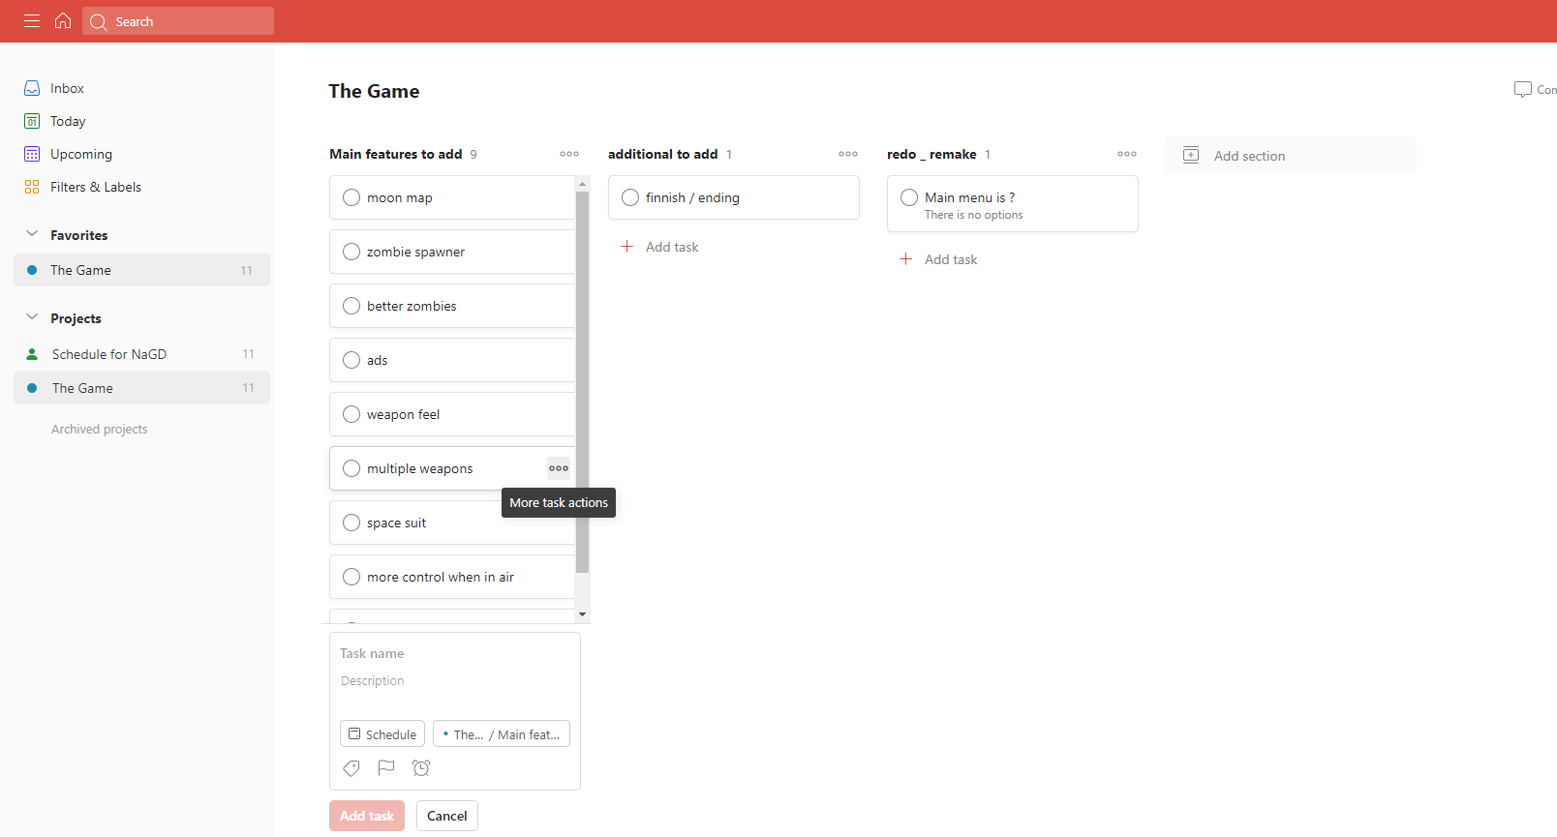

# Project Management

## Version 1.10

Version 1.10 includes some tuning and tweaking that I did after making my initial pass at the design. Here is what I changed.

I just working on the idea as i go, now i want to add a way to leave (like a quick win)

# Solitary Edge is the name I have decided on fitting the theme of the zombie fps.

## Version 2.00

Version 2.00 is the first version of the design where a major revision has been made now that much more is known about the game. After many hours of design, many decisions have been made. Most of these large design decisions are now reflected in this document.

Included in the changes are:

1. Paring down of the design scope.
2. More detailed descriptions in many areas, specifically A, B and C.
3. Story details.
4. World layout and design.

## Version 2.10

Version 2.10 has several small changes over that of version 2.00. The key areas are in many of the appendixes.

Included in the changes are:

1. Minor revisions throughout the entire document.
2. Added “User Interface Appendix”.
3. Added “Game Object Properties Appendix”.
4. Added concept sketches for the world.

<https://1drv.ms/x/s!ApbtjD5wgAruiAykKVkLVRf85SQq?e=e6RDr5>

time table ^

# Game Overview

## Philosophy/ theme/ morals

*You can mention other game designers that have influenced your decision making. For example, ‘I like the storytelling structure from game X, and will incorporate it into my narrative by...’*

I was thinking about a zombie survival game similar to moon on call of duty: black ops 1 and 3. I like games like these and they are straight forward too.

### Philosophical point #1

*Describe and explain what the game is trying to do. How will the game follow the brief? How will it subvert expectations? Refer to the client, and the client's values/expectations.*

The game is a zombie shooter where you must survive as long as you can.

### Philosophical point #2

*What will this game achieve? What impact will it have? What ideals and morals have you included? Be as wild and creative as you can be.*

hopefully more guns and weapons, a max ammo event and different map locations. maybe a twist on the perks and pack-a-punch machine.

## Common Questions

### What is the game?

*Describe the game in a paragraph. This is the answer to the most common question that you will be asked. Put the concept and premise here.*

The game is a fps zombie survival game where you must survive as long as possible without dying.

### Who is the target audience?

*Consider the brief, genre, and use of IP- discuss your created target demographic and why/ how you will target them.*

PEGI 16

### What themes are present in the game?

Summarize the theme/s of the game. You can elaborate on the premise of the story to help you establish the theme.

The game is a horror-esk game where you fight waves of zombies for as long as possible, this would take place on the moon as well (story based).

### Where does the game take place?

Describe the world/ setting that your game takes place in. Is it fiction or non-fiction? Help frame it in the reader’s mind by spending a few sentences on it here. You can go into lengthy detail later in a section solely dedicated to describing the world. Remember that we want to keep this part of the design light and readable.

The world is fiction as the player is on the moon base where everything possible went wrong, there are different locations but the main one is the drilling area where the scientists got the strange rock sample. Another is the port where people tried to flee the site. and the main science block where the sample broke out infecting everyone.

### What/who do I control?

Describe what the player will control- it's mainly a narrative game so focus on that area

The player will be incontrol of a stranded character (Depending on the location) as they try to leave but are faced with waves upon waves or zombies.

### How many characters do I control?

If this applies, talk a little more about the control choices. Does the game show the story from multiple characters' perspectives? Remember to add answers to questions that you think the reader will ask. This is totally dependent on your design.

You will control one per game but the character will be changed with the map (this excludes test maps).

### What is the main focus?

Now that we know where the game takes place and what the player controls. What are they supposed to achieve in this world?

They (depending on what they want to do) can attempt to escape (easter egg, if i can add it) or survive as long as possible (main objective)

### What is different?

Tell them what is different from the games that are attempting this in the market right now (look at other narrative games- visual novels, walking simulators, even AAA narrative games such as Guardians of the Galaxy.)

This has only solo play in it, no in-game purchases and the game is solely based on the moon because it’s has a unique mechanic. Only games that are similar is Call Of Duty: Black Ops 1 to X that introduce the map moon. they don’t have a way to escape but have two areas connected via teleporter which is too sci-fi for me.

# Feature Set

## General Features

You can add or take away features in this section

Brief overview:

Moon physics/gravity.

infinity gameplay.

increases difficulty as rounds progress.

*if i can include:*

a way to escape.

## Gameplay

List items here that are key to the gameplay experience

* different weapons the player can acquire for eliminating threats.
* infinite waves.
* different locations (maps)

# The Game World

## Overview

Provide an overview of the game world. Here you should outline the concept and premise of the narrative. The way you shape this document can vary, you can use flowcharts, diagrams, tables or other means.

This is mainly a section that you can briefly use to cover mechanics. Add or remove sections that are applicable.

mainly just surviving waves of zombies that get harder to eliminate at rounds progress. There will be different weapons the player can use and locations.

## World Feature #1

This section is not supposed to be called world feature #1 but is supposed to be titled with some major things about the world or game narrative. This is where you break down what is so great about the game world into component pieces and describe each one.

Basically there is a survier per map that has to battle waves of zombies, but there is a way to escape but you must complete the side objective to progress. other than that the game is just a simple zombie survival game.

## ~~World Feature #2~~

~~Same thing here. Don’t sell too hard. These features should be awesome and be selling the game on its own.~~

## The Physical World

### Overview

Describe an overview of the physical world. Then start talking about the components of the physical world below in each paragraph.

The following describes the key components of the physical world.

### Key Locations

Describe the key locations in the world here.

Testing Friday's have text to speech translation and it's like in same I didn't say Friday has text to speech translation and it's like the same I didn't say Friday has text to speed translation and it's the same I didn't dogshit on toast taste delicious with Scarlet Dogshit on toast taste delicious with Sam and Scarlett in the same room smelling their assholes with a romantic or around them smelling like perfume and Scarlett sent this quite wet doggy which brings out the unique question of why the f*** does it stink of niceness in this room also it says the f word it senses the f word.,?

### Objects

Describe the different objects that can be found in the world.

See the “Objects Appendix” for a list of all the objects found in the world.

# The World Layout

## Overview

Provide an overview here. Include a map, locations, storyboards- showcase the world.

## World Layout Detail #1

## World Layout Detail #2

# Game Characters

## Overview

Overview of your characters.

## Characters

How you created the characters or whether the player can personalize their own character. Include PC (playable character) and any NPC’s here and their function (blank slate, established character.)

## Character type

Outline each major character in terms of type: flat, round, protagonist, antagonist- conventional (Propp), unconventional. Explain why these are used.

## Character backstory

Write a backstory for the main characters. Include details such as their goals, actions, physiological, sociological, psychological aspects, representation, character growth, character arcs, character capabilities, etc. Are there any emotional themes in their backstory? In a narrative game, the player needs to invest their time and immerse themselves- how can you make sure that happens?

## Character Profiles

Template provided

# ~~Single-Player Narrative Design~~

## ~~Overview~~

~~Describe the single-player game experience in a few sentences.~~

~~Here is a breakdown of the key components of the single player game.~~

## ~~Narrative design Detail #1~~

~~In this section you will need to include the games plot devices:~~

~~What plot devices will you utilise and why?~~

~~Exposition, conflict, climax, inciting incident, resolution, plot twists, suspense, goals, MacGuffin, foreshadowing, etc.~~

~~Are there any emotional themes that will resonate throughout the story?~~

## ~~Narrative design Detail #2~~

## ~~Story/ ‘essential lore’~~

~~Describe your story idea here. Reference what type of narrative structure your story will have, conventional (Todorov, Propp, Campbell) or unconventional. Construct a visual narrative diagram of the story which pin-points important events, an overall timeline, and includes linear and non-linear branches.~~

~~You can do this with a flow chart (lucidcharts etc)~~

## ~~Timeline of events~~

~~A timeline of story events overall and in the demo, can be made in a flowchart or by other means~~

# Script development

will do this if I add the escape path.

## Overview

Provide an overview of this section

## Game dialogue sources

Research into the purpose of game dialogue sources, include examples of other GDD’s- how do video games document their dialogue? Use examples- include videos if needed. What impact do these types of dialogue have on the player?

## Film scripts

Research and include film scripts and how they impact video games- how and when are they used? VA

## Script development stages

Include initial ideas and iterations; including non-linear narrative branches, implementation of research and how it affects your script development

## Finalized script for VA

Finalized script for VA following industry standard:

Title Page, Scene Heading/ Subheader, Action, Character, Dialogue, Parenthetical, Extension, Storyboards and Flowchart (linear and non-linear dialogue moments)

# Art Style

## Overview

Include character designs. These can be sketches- and can be shown via a storyboard

## Character Designs (optional)

Add designs for major PC and NPC’s here

## Storyboard of dialogue scene

Include a storyboard of the events of your dialogue scene from your demo

# Critical Reflection

# Extra Miscellaneous Stuff

## Overview

Anything else that is relevant that you may have missed or isn’t essential… maybe the game world has a monetary system and economy that you are dying to add but it doesn’t fit anywhere else.

## Junk I am working on…

Crazy idea #1

I was thinking about different types of zombies, like a tank.

Crazy idea #2

# “XYZ Appendix”

Provide a brief description of what this appendix is for and then get down to business and provide data to the reader.

Here are a few examples of some of the appendices in my latest design…

# “Objects Appendix”

# “References/bibliography”

# “Diary/journal submissions”

# “Images (flowcharts, mind-maps, diagrams etc)”

# “Story Appendix”

# “World map”

# “Dialogue branches outside of demo”

# “Endings/outcomes”

# “Classroom notes”

# “Playable demo”