COVID-19 SIR-Model Simulation On Social Distancing

Dominik Tajak

Mid-America Christian University

Author Note

This paper is turned in as a partial requirement for the Mathematical Modeling course to the instructor Dr. Carol Fowlkes.

**Abstract**

This paper along with the provided Jupyter Notebook Python files is going to simulate scenarios in which several European countries are initially exposed to the novel COVID-19 virus. The two specific simulations aim to use the SIR-model with and without the practice of social distancing. The concluding results will be analyzed in the scope of underlying legitimate COVID-19 data to retrieve insight on the effectiveness of social distancing.

*Keywords*: COVID-19, Corona, Social Distancing, Python, Jupyter, SIR, modeling, data

**COVID-19 SIR-Model Simulation On Social Distancing**

With an increasing number of rumors about a new pandemic virus going around the world at the beginning of January 2020, several scientific articles introduced the discovery of a new immune-system-attacking disease based in Wuhan, China. The newly discovered virus was deemed similar to viruses such as the Severe Acute Respiratory Syndrome coronavirus (SARS-CoV) and the Middle East Respiratory Syndrome coronavirus (MERS-CoV). As initially, nations were not aware of the significance of this virus, numbers of the so-called COVID-19 appeared to be flattening in China whereas new COVID-19 infections are striking globally due to air travel. The virus’s reproductive number is high, indicating a high potential to infect large numbers of populations concluding in affected individuals experiencing symptoms severe enough to overwhelm any country’s healthcare systems. The world has experienced an alarming increase in confirmed infection cases and deaths resulting in political actions locking down cities, countries, and even continents. Additionally, a very significant approach in fighting this pandemic was to introduce social distancing which requires each person to keep a 6-feet distance from another to decrease the transmission rate of the virus. Since this regulation has been enforced by most countries on Earth, the rate of new cases decreased (Kondziolka & Couldwell, 2020).

**Literature Review**

The COVID-19 pandemic has resulted in an uncountable number of studies and research in the medical field. Besides worrying about the immediate impact of the virus itself, scientist, doctors, mathematicians, etc. are trying to gain new insights on how the disease is spreading, how infectious it is, what symptoms there are, and how we as humans can prevent to be infected while keeping a relatively normal daily life. The most reliable and accurate COVID-19 data currently available for people is based on data gathering and science by John Hopkins University and is regularly updated to provide insight on new cases, deaths, and recoveries from all around the globe (Corona Virus Resource Center, 2020). A very recent finding from April 16th shows that COVID-19 co-infections with other respiratory pathogens are approximately 21%. In addition to the current complications of testing thoroughly for the virus, scientists from Stanford University have discovered that the identification of another pathogen may not rule out the presence of the novel coronavirus. Due to many unaware doctors, physicians, and practitioners, the inference that other respiratory pathogens excluded the possibility of a positive test for COVID-19 cost the lives of valuable lifesavers from health sectors globally (Van Beusekom, 2020).

**Methods**

Intending to visually explain the significance of social distancing in this epidemic, I used an SIR-model to illustrate scenarios in a simple yet relevant context focusing my experimental data on the European countries France, Germany, Italy, and Spain due to their size of the population, living standard, and consistent COVID-19 reporting. ”An SIR model is an epidemiological model that computes the theoretical number of people infected with a contagious illness in a closed population over time.” (Weisstein, 2020) This model involves coupled differential equations relating the number of susceptible individuals S(t), the number of infected individuals I(t), and the number of individuals who have recovered R(t), all over a span of time. Since the COVID-19 crisis is too complex to fathom and be described by mathematical models no matter the complexity, I chose to use one of the simplest SIR models, which is called the “Kermack-McKendrick model.” This rather simple approach helped me to reach my goal of using an SIR model to retrieve insight into the effectiveness of social distancing by deliberately changing the ‘contact-per-day’ variable and analyzing the resulting number of ‘Infected’ in simulations of multiple weeks or months. This model disregards death rates and solely focuses on the analysis of social distancing. To start of my project, I gathered dataset from GitHub that were retrieved from John Hopson University COVID-19 data and relatively well-prepared (Imdevskp, 2020). Nonetheless, to visualize the current reality in those four thematized countries, I had to run several clean-up code snippets. To make the model reusable and visually appealing, I used Python’s Pandas and MatPlotLib libraries throughout my programming approaches. The methodology, assumption, and requirements for the underlying model are described as followed.

Assumptions:

* No one is added to the susceptible group, ignoring births and immigration
* Recovery gives total immunity
* Fixed infection and recovery rates
* Timesteps are fixed to one day
* The only way an individual leaves the susceptible group is by becoming infected
* We assume that the time-rate of change of S(t) depends on the number of already susceptibles, the number of already infected, and the amount of contact between susceptibles and infected
* Not all contacts are with susceptible individuals

The fixed number of contacts per day that are sufficient to spread the disease, as know as the transmission rate, is described as the variable ‘b’, while the fixed fraction of the infected group recovering during any given day is described as the variable ‘k’. I am assuming that, based on research, the symptoms of infected individuals cease after approximately 14 days. It depends on the individual and the drastic instance of the infection, but I decided to go with the const k of 1/14. These two variables are significant in my model approach and overall argument and objective. The const ‘k’ cannot be changed as far as scientists have discovered until this day. Nonetheless, what can be altered is the variable ‘b’ which is the interaction rate between susceptibles and infected. The model is going to show two simulations based on an alternation of the underlying constant ‘b’ who’s alternation towards a smaller value represents the population’s compliance with the principle of social distancing.

On a mathematical level, the concluding constant ‘r_0’ represents the contacts per infection, which is considered the scientifically most relevant coefficient in any SIR model. If this number is greater than 1, the virus exponentially spreads through the population. Vice versa, a smaller ‘r_0’ means a less dangerous virus. In mathematical terms, I am assuming:

* n = S + I + R
* 1 = S/n + I/n + R/n
* 0 = dS/dt + dI/dt + dR/dt
* dS/dt = -b*S*I -> Si+1 - Si = -(b*S*I)dt
  + -> **Si+1 = Si - (b*S*I)dt**
* dI/dt = b*S*I - k*I -> Ii+1 - Ii = (b*S*I -k*I)dt
  + -> **Ii+1 = Ii + (b*S*I -k*I)dt**
* dR/dt = k*I -> Ri+1 - Ri = k*Idt
  + -> **Ri+1 = Ri + k*Idt**

Finally, I complete my SIR model by giving each differential equation an initial condition in terms of the total population, the number of susceptibles, infected and recovered, and initial constants of contacts per day and time to recover. For this particular virus, it is unknown that anyone was immune straight from the beginning of the epidemic. Therefore, I am assuming that everyone is susceptible. I will also biasedly assume that there was a trace level of infection of 50 individual potentially coming back from a trip to China.

**Results**

From the data preprocessing for the current legitimate data for France, Germany, Italy, and Spain, I came up with visual evidence for urgently required reactions due to the alerting significance of the COVID-19 pandemic infection rate. The following four graphs show the current cases of the novel virus starting from its impactful spread on around March 9th, 2020 until April 27th. The graphs illustrate linear-like growth in the newly confirmed infection cases and recoveries while having different slopes. The death equations seem to be linear as well, having very small slopes.

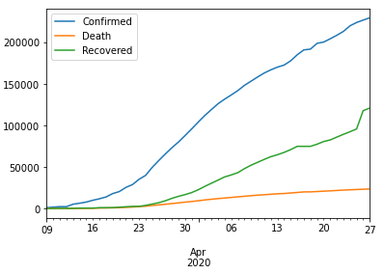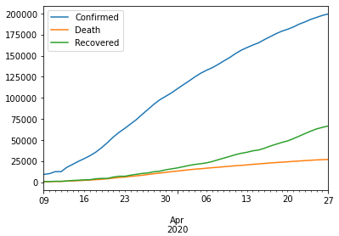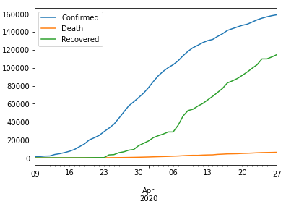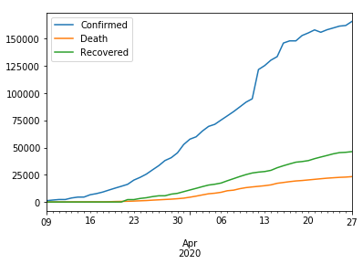

Germany

France

Spain

Italy

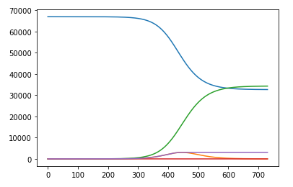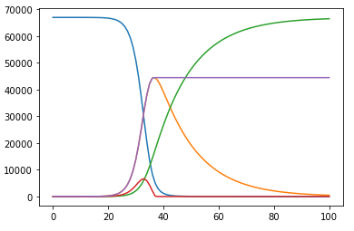The following graphs show the results of the simulations of my SIR model for France not complying with social distancing vs. complying with social distancing.

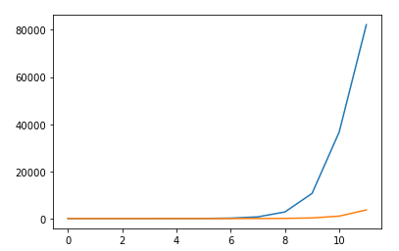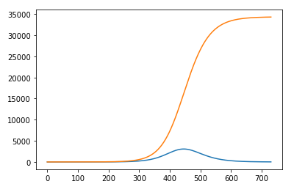The blue line represents the total of susceptibles, the green line the total of recoveries, the orange line the total infected, the purple line the total number of cases, and the red line the number of new cases. The red circle on the left represents the day on which the virus’ infection rate decreases which implies the gradual end of possible infections and a population that became entirely infected. The circle on the right represents the inflection point of the susceptibles equation which represents the gradual end of infections. In addition to the SIR-model, I included a visualization of new cases and total cases. The Jupyter Notebook file includes the rest of the graphs and more insight into the coding process as shown in the last two visualizations that respectively illustrate France’s best and worst scenario simulation for the COVID-19 pandemic. The left graph suggests strict compliance with social distancing over a period of approximately 450 days. This point illustrates the end of newly reported cases and, therefore, the end of the COVID-19 virus. The right graph shows an extreme simulation of the complete infection of the entire population after only ten days due to not complying with social distancing.

Infected

Recovered

Recovered

Infected

**Discussion**

The graphs showing the four country’s confirmed, recovered, and death cases very early on already implicated a need for drastic measures, such as the introduced social distancing. By most countries enforcing social distancing in mid to late March, the drastically increasing curve of confirmed cases was slowed down. Nevertheless, a proper execution of social distancing would have meant a change from a high-slope linear equation towards a logarithmic-like flattening curve. In fact, the curve remained the same until April 27th or today, per se, which implies that the population is not conforming to the standards of social distancing.

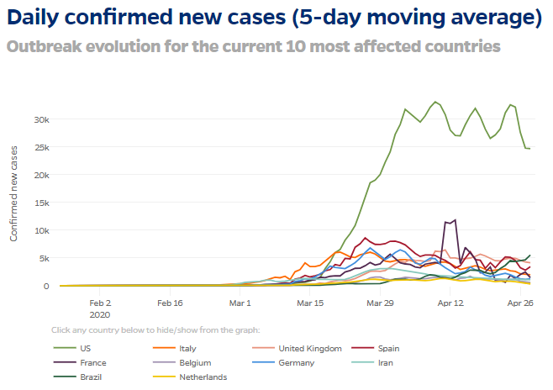Based on the graphs concluding from my SIR-model simulation, tweaking the variable ‘b’ towards representing a realistic scenario of social distancing resulted in a significant decrease in new cases of infections. The most significant result I can retrieve from my methodology using my SIR-model is that 100% compliance with social distancing for a period of approximately 1.5 years could completely eliminate the COVID-19 virus. Since all populations around the world are conforming to those standards in a fluctuating manner, the concluding results and data fluctuate as well. The following chart from John Hopkins University shows population’s behavior and the lack of compliance with social distancing. These fluctuations are confirmed on the real case data from above who’s curves are linear which suggests an inconstent but steadily growing line that represents the total number of cases (Corona Virus Resource Center, 2020).

**Conclusion**

Based on my SIR-model following the real-time data from John Hopkins University, nations all around the world have managed to slow down COVID-19, but are still struggling to make the curves decrease significantly. The underlying data implies that the speed of infections has been maneuvered towards being less catastrophic but far from resolved. Even though my model shows a very simplified approach in predicting how social distancing can defeat the novel virus, there must be some truth in it that suggests a relevant and world-saving measure of strict social distancing.

**References**

Corona Virus Resource Center. (2020). Retrieved from https://coronavirus.jhu.edu/

Imdevskp. (2020). *covid_19_jhu_data_web_scrap_and_cleaning.* GitHub. Retrieved from https://github.com/imdevskp/covid_19_jhu_data_web_scrap_and_cleaning

Kondziolka, D., Couldwell, W. (March, 2020). *Introduction. On pandemics: the impact of COVID-19 on the practice of neurosurgery.* Retrieved from https://thejns.org/view/journals/j-neurosurg/aop/article-10.3171-2020.3.JNS201007/article-10.3171-2020.3.JNS201007.xml

Van Beusekom, M. (April, 2020). *Researchers report 21% COVID-19 co-infection rate*. Retrieved from https://www.cidrap.umn.edu/news-perspective/2020/04/researchers-report-21-covid-19-co-infection-rate

Weisstein, E. (2020) *SIR Model*. MathWorld--A Wolfram Web Resource. Retrieved from https://mathworld.wolfram.com/SIRModel.html