CLARIZZA MAE SABIÑANO
BSIT-3A

CODE:
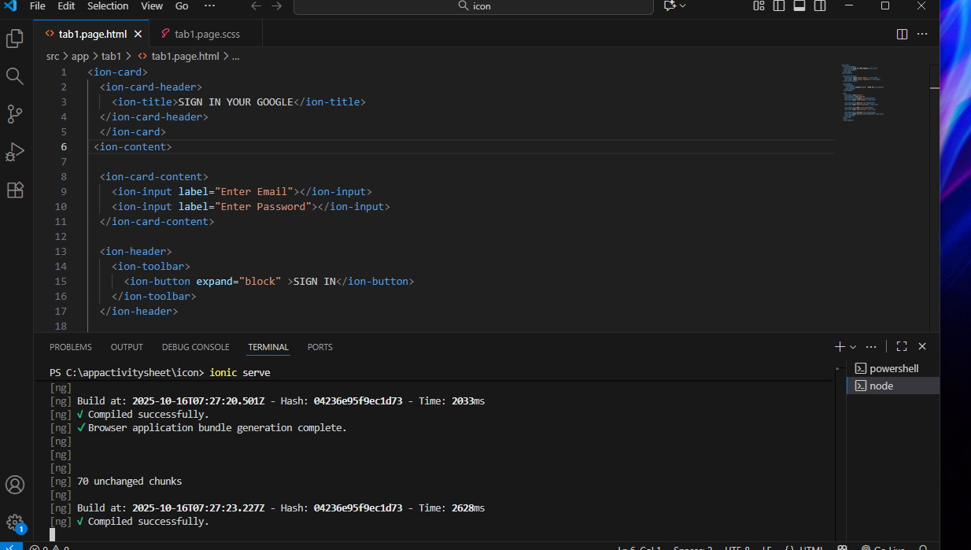

OUTPUT:

