
CC105 - Application Development and Emerging Technologies
2 nd Semester, AY 2024 – 2025
Final Project

Crave and Click Online

Submitted by:
Joshua Villanueva
Dominador III A. Orpilla
Clarizza Mae Mendoza
Jesielyn P. Ursua
Hanna Jhen Lastima
Rainier Jay Sante
Rodolfo Gabatino III
Nathaniel Mirano
Alyson Rivera
John Cyrus De Leon

Submitted To:
Sir. Rommel D. Lacasandili
Instructor


I. INTRODUCTION:

Most people do not like going out to order food from restaurants or fast food establishments. That need is met by this app, which lets users order food online. It allows users to view menus, order, make modifications on their choices, They can also save favorite orders for easy reordering and get recommendations based on taste. Generally, this application is a simple and effective means by which individuals can access their preferred meals from the comfort of their homes.

II. TARGET AUDIENCE

Target groups for this restaurant ordering app consist of working individuals with no time to cook, students seeking simple and cheap food, and family consumers seeking easy-to-prepare dinners during working nights. It also targets health-aware individuals who like to have special meal options, technologically savvy consumers who like to use apps, seniors who can't get out, foodies who desire to experiment with various foods, and urban dwellers who have difficulty eating outside due to traffic and parking. By targeting these segments, the app will be in a better position to address the needs and likings of its users.

III. TECHNOLOGY STACKS AND PLATFORMS
The web system for ordering food has been created with the intention to deliver the best experience for Windows users as well as mobile platforms, utilizing a solid and platform-agnostic technology stack. Designed as a web application, it uses HTML5 for semantic marking and CSS3 for responsive styling, delivering an uninterrupted interface irrespective of screen size. JavaScript has been used for adding interactivity and increasing user engagement, facilitating dynamic content update and a frictionless user experience.

The application centers on rendering a rich frontend experience, applying responsive user interface with JavaScript. Modern design principles are applied through the use of CSS3, making the application intuitive and beautiful to look at on both desktop and mobile platforms.



IV. FEATURES

Here are the features of of the proposed entitle Crave and Click food ordering system where the app displays the following:

Sign -up form - In this form the customer must fill the form containing the customers name, address email and password and will go to the login form

Home website - In this website section the customer will see the main page of the website, here the customers will see the food options.

Food choices - After clicking one of the the 3 shown foods at the main page the customers will see the food choices .

Food quantity and total - The customers can select quantity of their orders and after they selected the food that they want, total of the orderds will be shown at the bottom of the page.

Automatically go to the next page - Go to the next page of food after placing order.

Checkout page - After placing all orders the totals of all orders will be computed.


V. DESIGNS/WIREFRAMES
The interface of the food ordering system design makes it easier to choose and buy meals. Its user-friendly design makes it simple for customers to easily browse a variety menu that includes excellent photos and thorough descriptions of every dish.

Sign up form

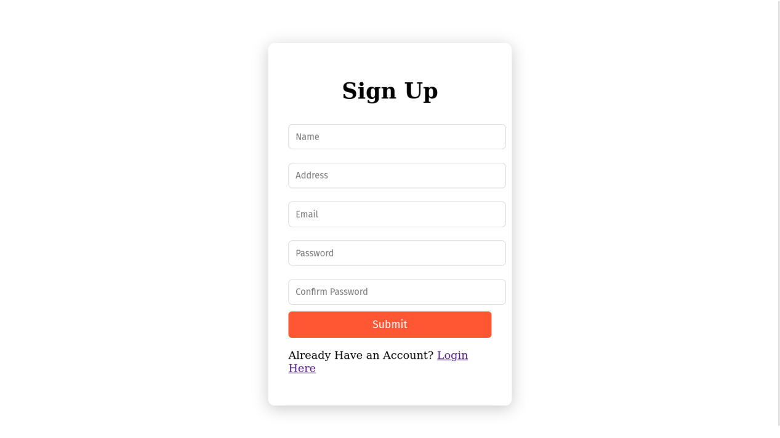

In this form is designed to register new users quicly and securely. It inlcudes four essential fields: The Name, Email address, Password and the another Password confirmation.




Log-in Form
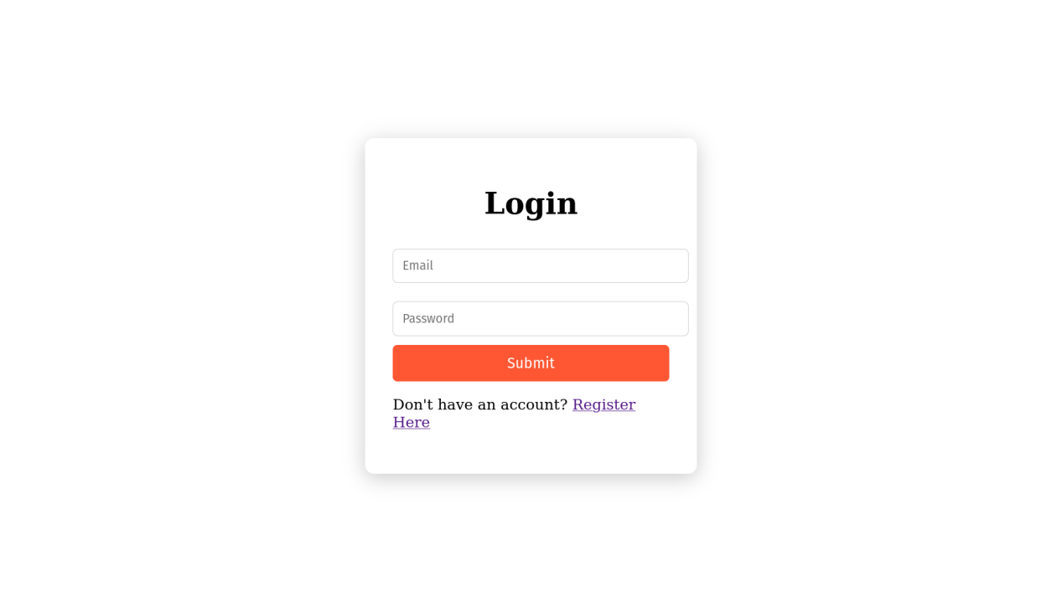
After the user finished signing up the user then will go to the Log-in form.

The main page
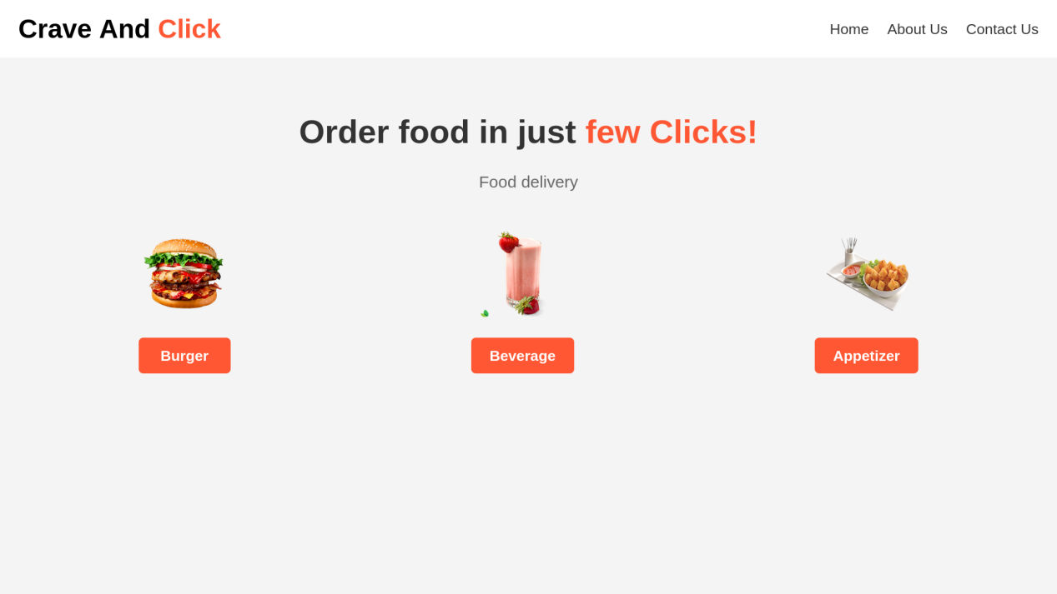

This main page is where you can see the types of foods you want to order.


Placing order

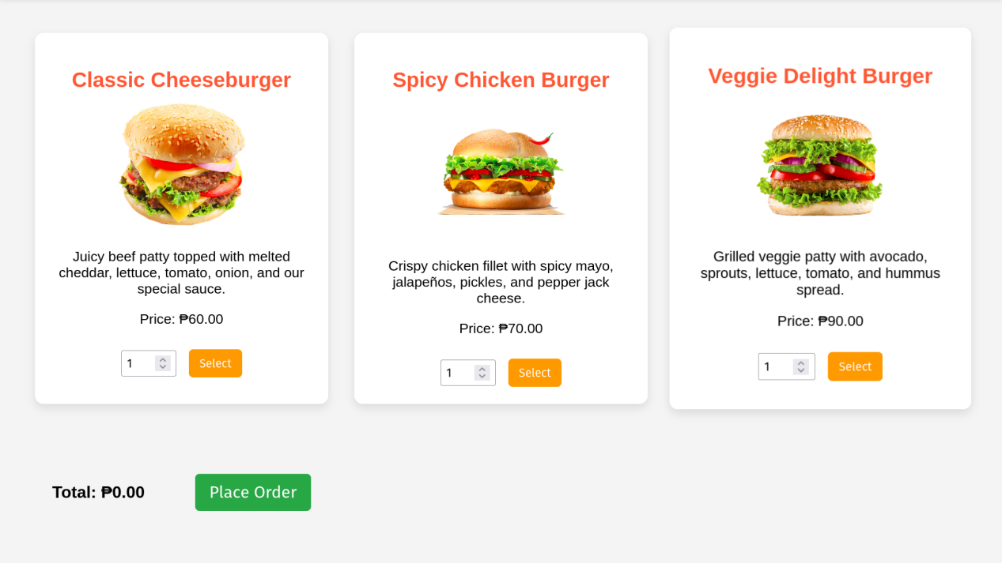

In this page you can select the quantity of the food you want to order.

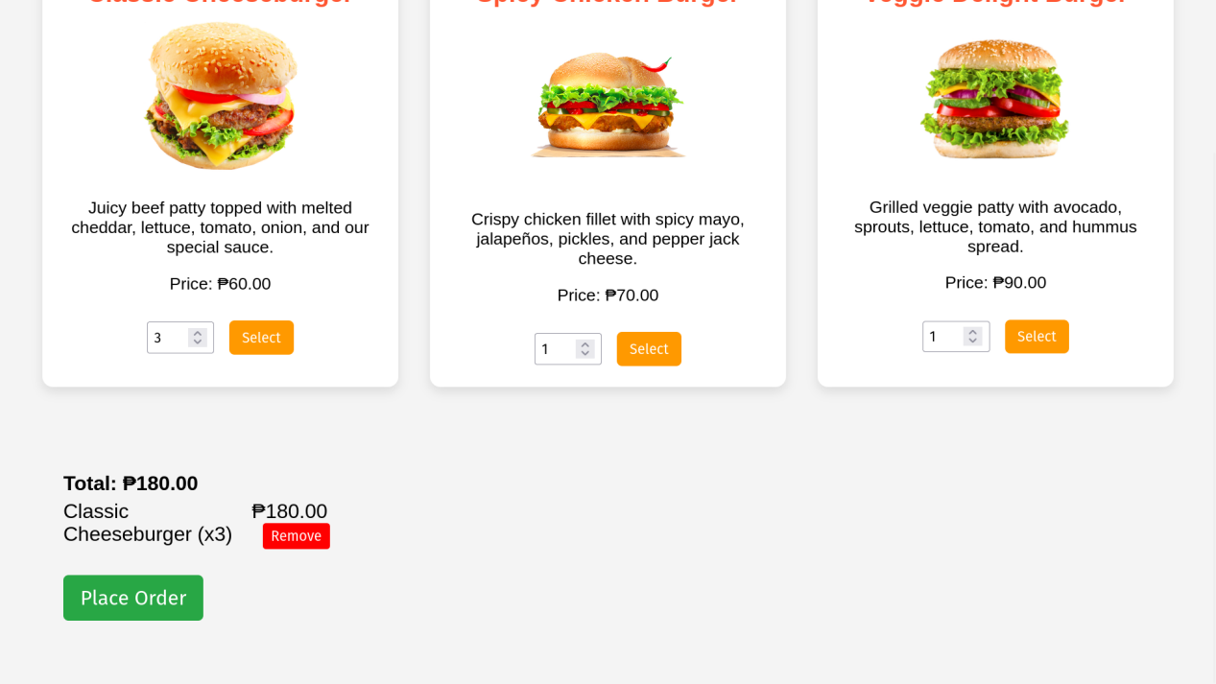


After selecting the food the total of your order will popup and also theres a remove button so you can remove the order you accidentally selcted.

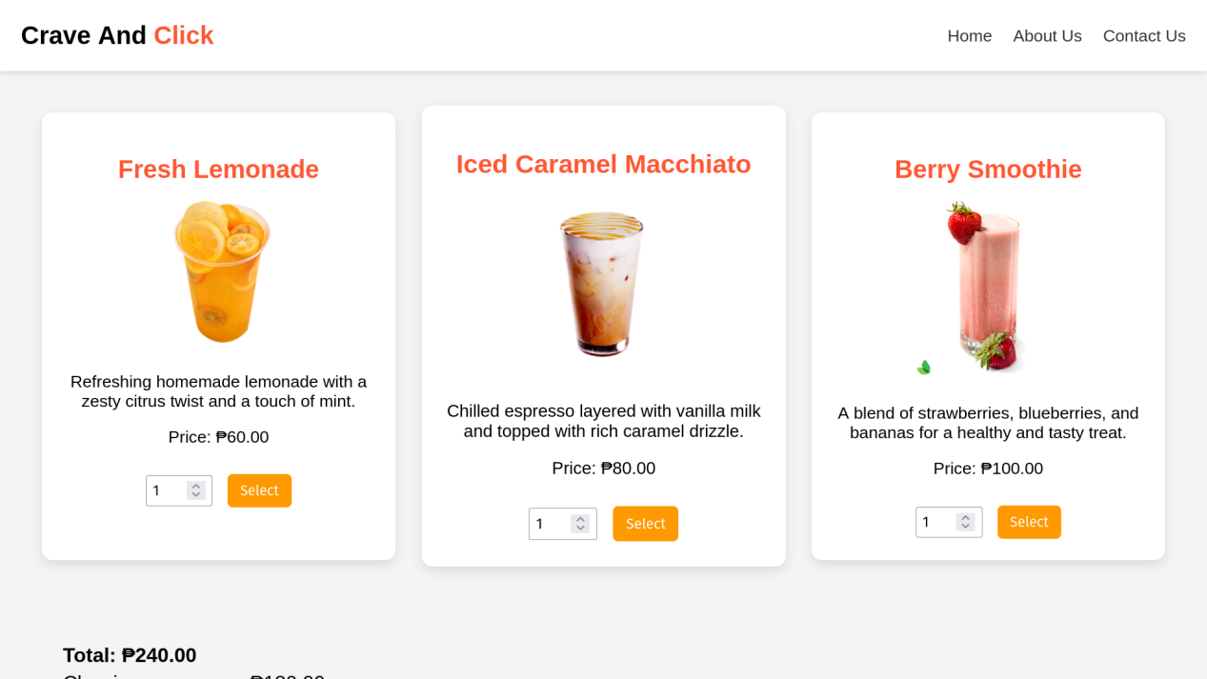

The page will automatically go to the other page, also same as the above pagee.


`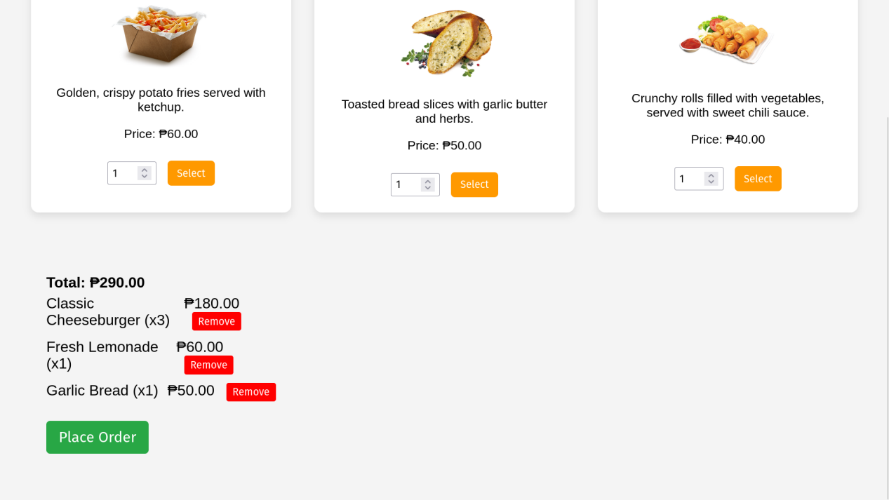

This is also same as the above page, after clicking the place order button the checkout page will pop out.

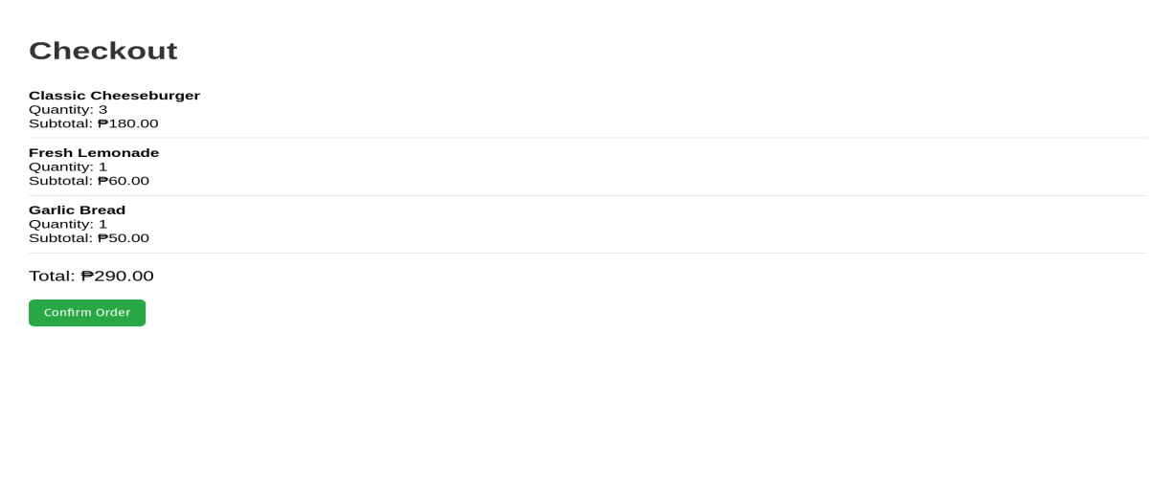

Checkout page where you can confirm your orders.


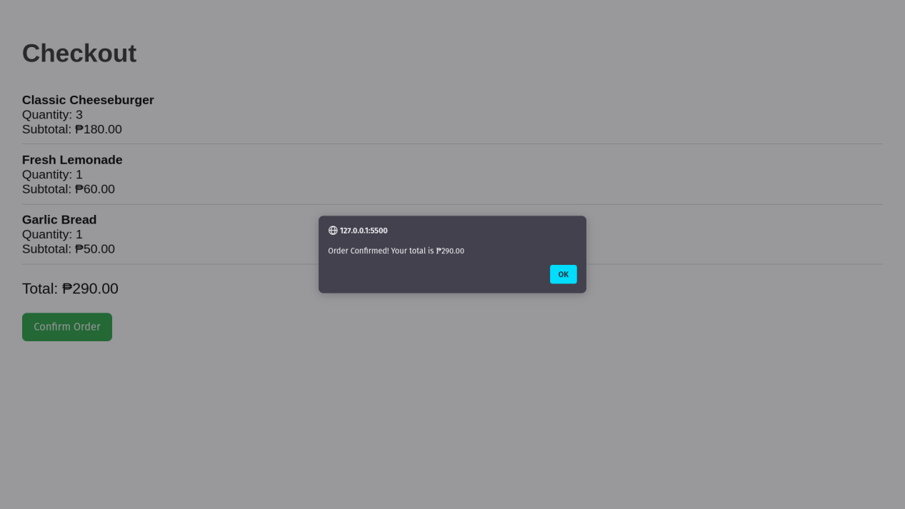

Confirmation popout message.

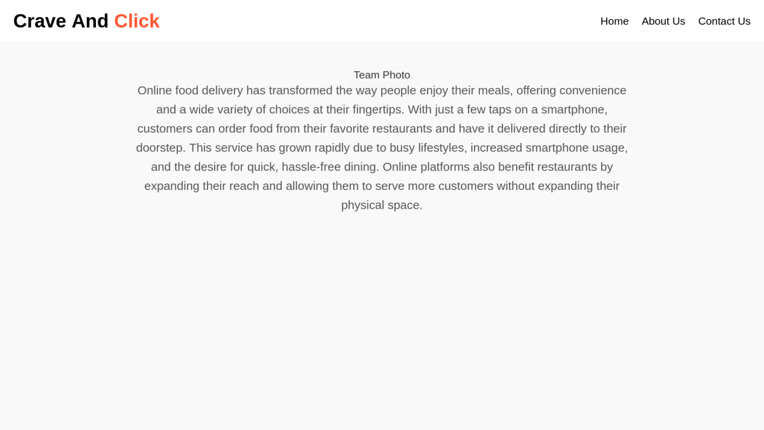

About us section the team of developers of this website.


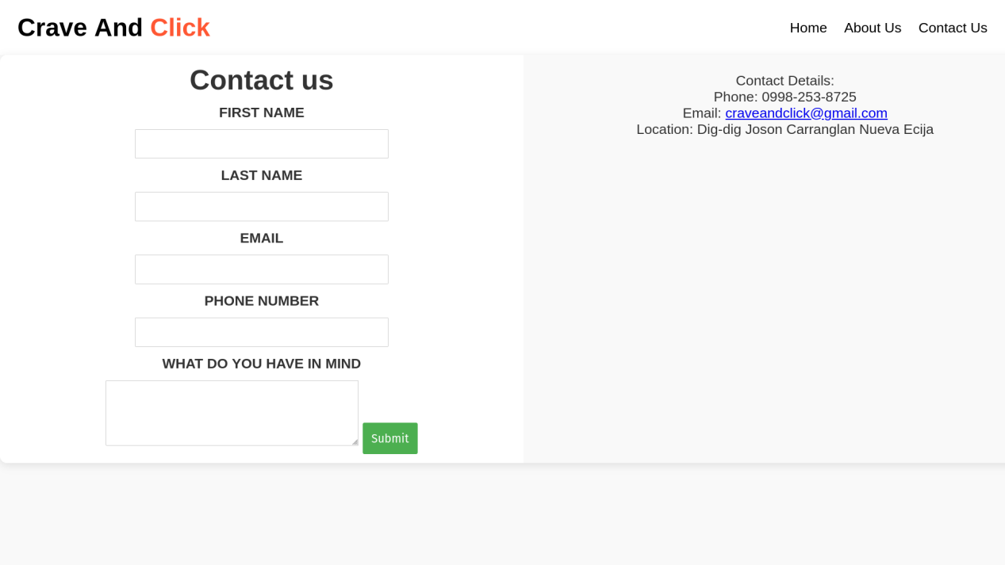

Contact us page where you can contact us.

VI. Acceptance Criteria

The online food ordring system needs to ensure a smooth user experience that start with a simple registration and login process for users to create their accounts easily. Users should have an access to organized menu, with descriptions of the specific dish, making it easy for users to add items, customizing their orders, ans see a full summary before checking out.


Acceptance Criteria:

Acceptance Criteria below shows how the system accepts orders from the Customers, The website must be accessible via web browsers eq.Chrome, firefox.
Users should be able to register with valid email address and password receive email verification and login, The system must allow customers tp browse the menu, add items and modify quantities before the checkout process.

INTERNET CONNECTION
CHECKING OUT

CUSTOMERS ORDER

REGISTRATION AND LOGIN

USER ACCESS TO THE WEBSITE


