Faculty of Mathematics and Information Science Warsaw University of Technology



NotifyMe  
Location based notification system

Final specification

Aleksandra Dominas

Version 1.3

014.01.2019

Table of contents

1. Specification 2

2. User interface 2

# 1. Specification

The application will be created for Android system using Java language with Google API used for location services. To ensure the proper functionality, the system will also use Geofencing API in order to trigger notifications when user enters specified area.

It is possible to setup multiple geofences. Additionally, user can disable a specific geofence by simply clicking on a marker on a map.

Geofencing itself is an IntentService, which runs in a background of the application. This application handles two main messages from this service, which are “GEOFENCE_TRANSITION_ENTER” and “GEOFENCE_TRANSITION_EXIT”, so the user will be notified each time he enters or leaves the area of the geofence.

# 2. User interface

The application consist of one main screen, which contains search bar for easier map navigation, search button and button enabling geofencing service.

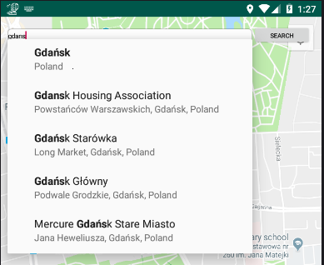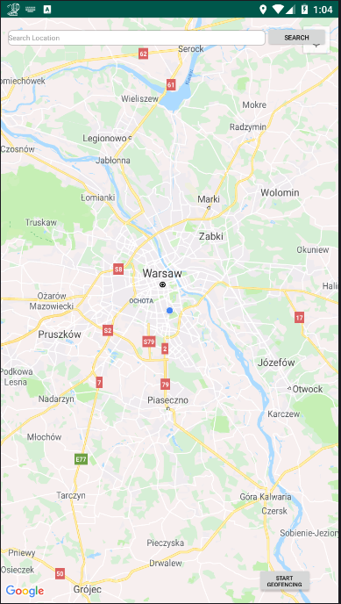

The geofences are setup by selecting location on a map by clicking in a desired place on a map and clicking “Start geofencing” button. After that, user can setup a GeofenceId and its radius, example below.

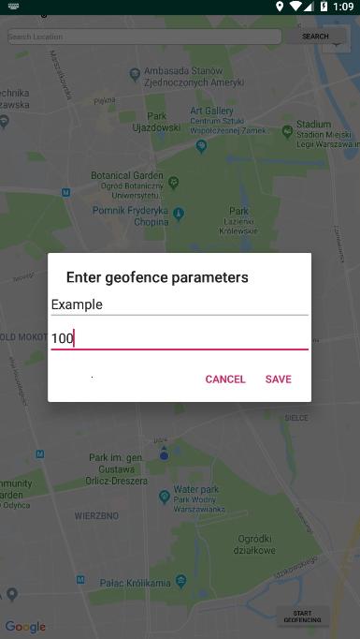

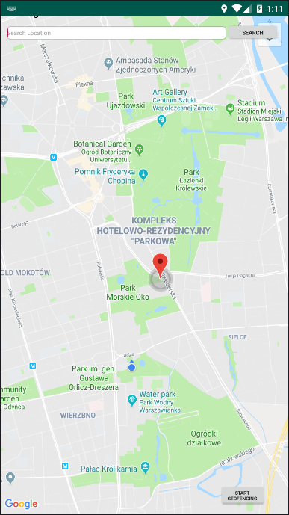After specifying the parameters, the area of the geofence is drawn on the map.

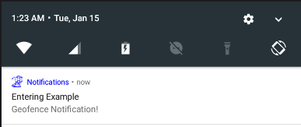When the user enters or leaves the area, a notification is triggered.