Faculty of Mathematics and Information Science Warsaw University of Technology



NotifyMe  
Location based notification system

Initial specification

Aleksandra Dominas

Version 1.2

07.01.2019

Table of contents

1. Specification 2

2. Requirements 2

2.1 Functional requirements 2

2.2 Non-functional requirements 2

# 1. Specification

The application will be created for Android system using Java language with Google API used for location services. To ensure the proper functionality, the system will also use Geofencing API in order to trigger notifications when user enters specified area.

# 2. Requirements

## 2.1 Functional requirements

The functional requirements are presented below.

1. The application’s “NotifyMe” the main purpose will be to send user a notification when he gets to a specified place.
2. The user has to be able to see all his set notifications
3. The user can select a notification from history and set it anew
4. The notification can be turned off or snoozed for specific period of time

## 2.2 Non-functional requirements

The non-functional requirements are presented below:

1. Notifications should be sent when the user enters the area determined by the previously provided distance (radius) from the required place
2. The application has to store all planned notifications
3. The application has to keep a history of all notifications not older than time specified by the user

# 3. User interface

The application consist of one main screen, which contains search bar for easier map navigation.

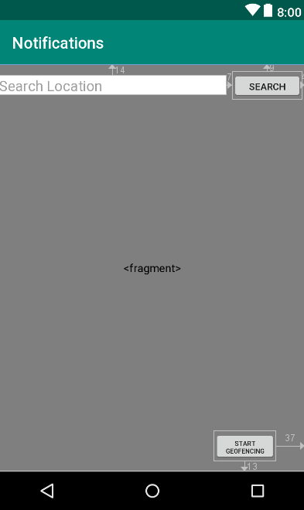

The “fragment” element represent the map view. By clicking on the map, user can select a centre of a radial area with specified radius, which will be used as geofencing area.

The “Start geofencing” button starts the geofencing service, which monitors user’s position and notifies when user leaves or enters the area specified earlier.