Raising OEE on a Packaging-Machine Fleet
A Lean Six Sigma DMAIC project on the PIADE dataset - project guide and report
Stack: PostgreSQL (data engine) - Excel (DMAIC analysis, 16,600+ live formulas) - Power BI (control cockpit) - Python (optional: charts and inventory simulation)
Data: 5 industrial packaging machines, 429,394 state intervals, 132 alarm codes, Jan 2020 - Dec 2021.
Honesty note. This is a retrospective study of a public dataset. Define, Measure, Analyze and the Control design are real analysis. Improve-phase gains are projections from assumed reduction rates, not measured results. Say this plainly in any interview.

0. What is in the package and how to run it
Folder / file | What it is | When you use it
sql/01_schema_and_load.sql | Loads raw_data.csv, builds f_interval (counter deltas, shifts, production day), f_downtime_event, dimensions, data-quality view | Measure - first thing you run
sql/02_dmaic_views.sql | 25 views: OEE, loss tree, Pareto, MTBF/MTTR, shift tests, FMEA inputs, SMED, inventory, Kanban, X-bar/R, capability | Measure to Control
sql/03_export.sql | Exports every view to CSV for Excel / Power BI | After 02
excel/PIADE_LSS_DMAIC_Workbook.xlsx | 28 tabs in DMAIC order; all analysis as formulas; yellow cells = assumptions | Your main working file
powerbi/PIADE_PowerBI_measures.dax | Power Query connection, relationships, DAX measures, page plan | Control - build the cockpit
python/ (optional) | Charts in this report + Monte-Carlo inventory backtest | Only if you want to regenerate figures

Run order. Install PostgreSQL 14+, create a database called piade, put raw_data.csv in the sql folder, then run:
psql -d piade -f 01_schema_and_load.sql then psql -d piade -f 02_dmaic_views.sql then psql -d piade -f 03_export.sql
Open the workbook: the Data_Daily and Data_Shift tabs already hold the SQL extracts, so every tab works immediately. To refresh with new data, paste the new CSVs into those two tabs.

Project snapshot
Metric | Baseline | Where it comes from
Fleet OEE (A x P x Q) | 51.7% (64.3% x 80.8% x 99.6%) | v_oee_summary / M2_OEE
OEE by machine | s_1 65.2% | s_2 32.2% | s_3 44.2% | s_4 44.8% | s_5 55.3% | M2_OEE
Biggest loss | Idle with no reason code: 10,266 h = 27.3% of planned time | v_loss_tree / M3
Alarm downtime | 3,147 h (8.4%) from 92,005 stops; 7 of 132 codes = 81.6% | v_pareto_alarm / M4
Stop profile | MTBF 15.8 run-min, MTTR 2.1 min -> minor stops | v_reliability / M5
Package quality | 4,088 DPMO = 4.1 sigma (not the problem) | M6_Sigma
Pilot s_1 X-bar/R | CL 67.3%; 2021 mean 62.7% (-4.6 pts), 18 run-rule signals | v_xbar_r_chart / C1
Projected OEE | 61.9% (+10.1 pts) if assumed lever rates hold | I2_OEE_Scenario

1. DEFINE - what problem, how big, what goal

What you do
- Write the charter in D1_Charter. Its problem statement, business case and goal are formulas, so they update from the Measure tabs.
- Fill the team row with real roles if you present this as a simulated plant project.
- Build the SIPOC (D2) and turn each voice-of-customer complaint into a measurable CTQ with a spec (D3).

Result
Problem statement. Between Jan-2020 and Dec-2021 the 5 packaging machines ran at 51.7% OEE against a 65% target. 27% of planned time was idle with no reason code and 8.4% was lost to 92,005 alarm stops. s_1, the highest-volume machine, is the only one whose OEE fell in 2021.
Goal (SMART). Raise fleet OEE from 51.7% to at least 60% (stretch 65%) within 6 months of go-live. Hold quality at or above 99.5% and packaging-material service level at or above 98%.
Business case. Each OEE point is worth about 0.92 million good packs a year. At an assumed INR 0.60 contribution per pack, that is roughly INR 5.5 lakh a year per point.
Why s_1 is the pilot. It carries 33% of fleet volume. It owns the single largest alarm loss (A_065, 858 h). It is the only machine whose OEE dropped in 2021.

2. MEASURE - how good is the process, and can we trust the data?

What you do
- Run sql/01. Then query v_data_quality. This is your measurement-system analysis: machine logs cannot be re-measured, so a Gage R&R is replaced by integrity checks.
- Understand the three data traps the SQL handles. elapsed is in milliseconds. pi and po are cumulative counters read at the END of each interval (verified: the delta tracks speed x time with r = 0.95). Counter resets must be excluded (85 negative deltas, 2,397 glitches in total).
- Define OEE the TPM way. Scheduled downtime is excluded from planned time. Idle and alarm downtime are availability losses. Performance = units in / (rated speed x run time). Quality = units out / units in.
- Build the loss tree (M3). Both check cells must read 0; that proves the tree adds up to OEE.
- Run the Pareto (M4), MTBF/MTTR (M5) and sigma level (M6).
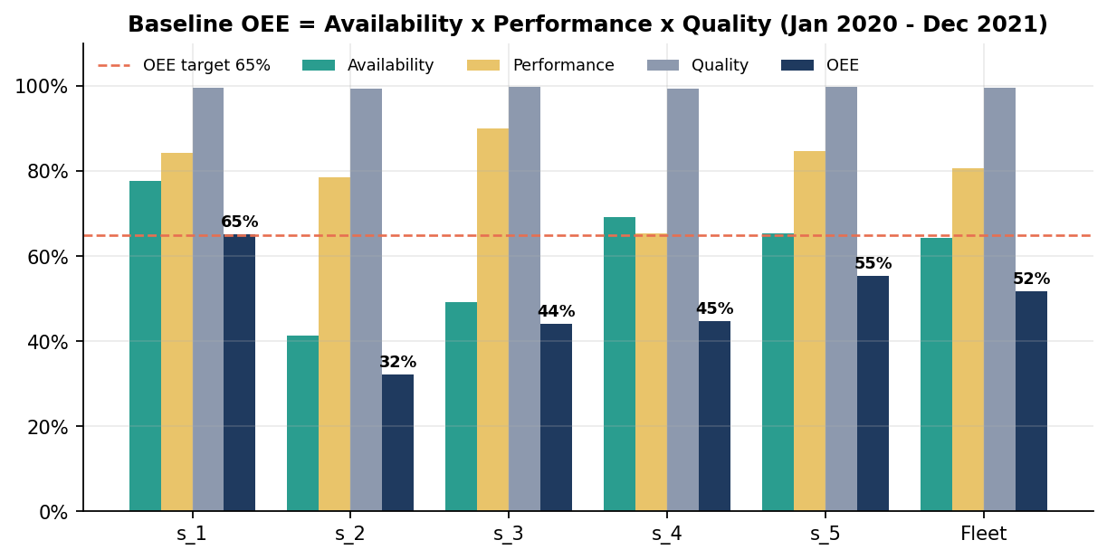
Figure 1 - Baseline OEE by machine. Only s_1 is near the 65% target.
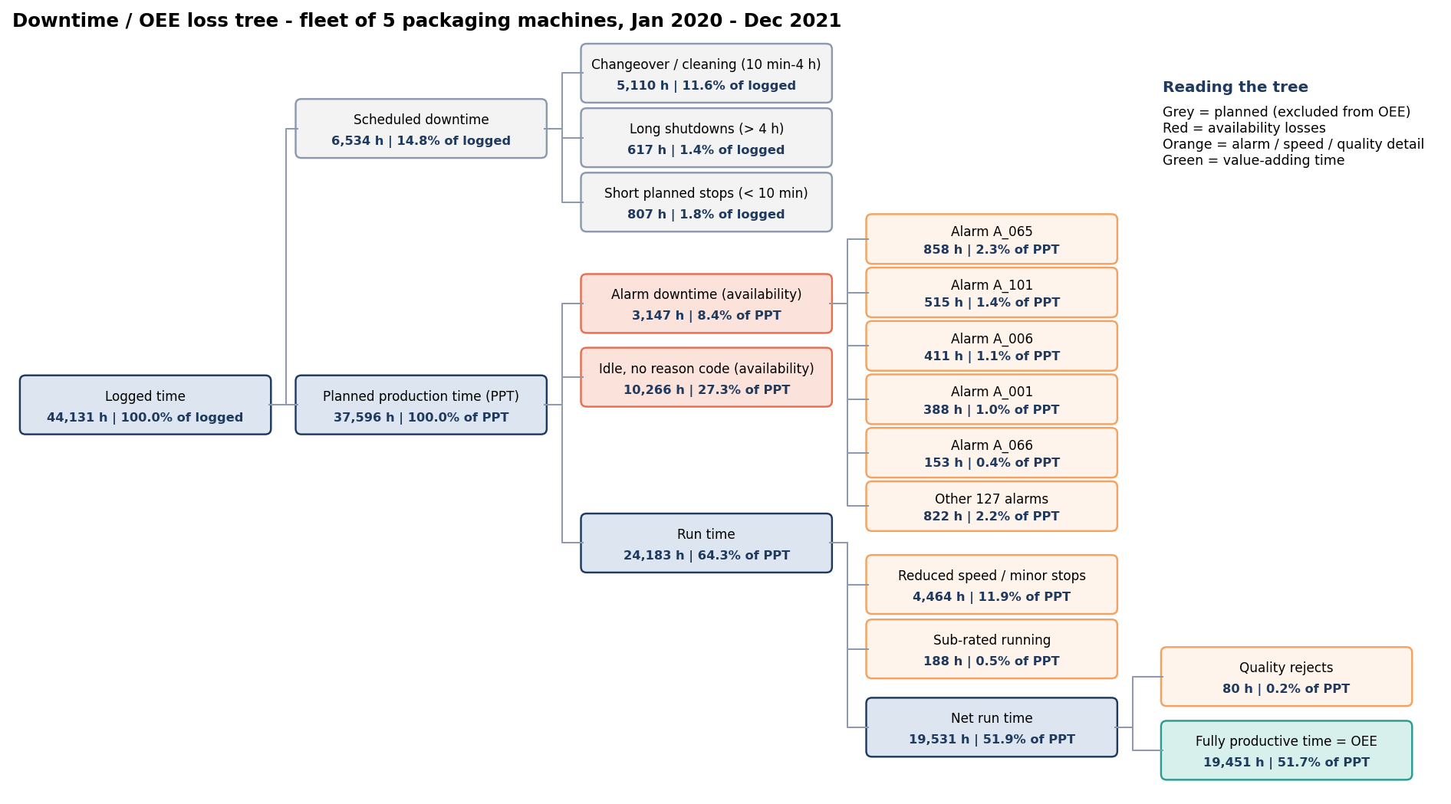
Figure 2 - Loss tree. Idle (27.3% of planned time) is 3x bigger than all alarm downtime combined.
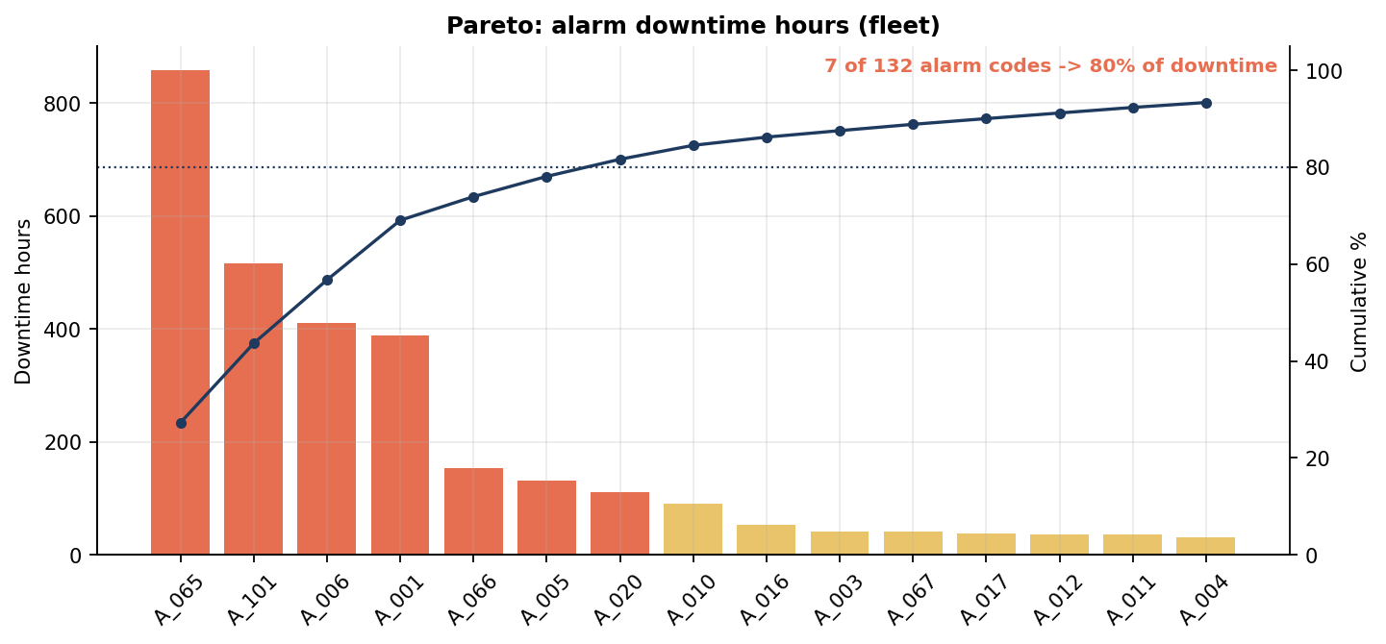
Figure 3 - Pareto: 7 of 132 alarm codes cause 81.6% of alarm downtime.

What it tells you
- Idle is the elephant. 10,266 h of idle carry no reason code. The data system never asks why the machine is waiting. That is a measurement failure before it is a process failure.
- Stops are micro-stops, not breakdowns. MTTR is 1-4 min and MTBF is 6-26 run-minutes. The right tools are Kaizen, autonomous maintenance and Poka-Yoke, not spare parts or big repairs.
- Quality is not the problem. Rejects run at 4,088 DPMO (4.1 sigma). Measured against the OEE target instead, s_1 is only a 1.6-sigma process. Lost time, not defects, is the real defect here.
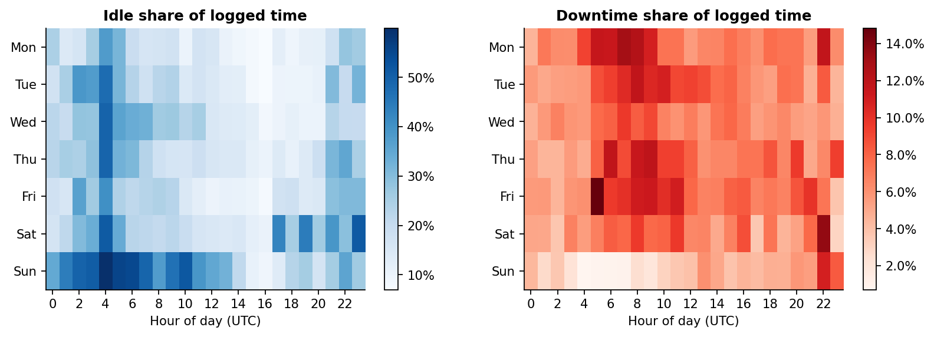
Figure 4 - Idle concentrates at night (UTC 02-05) and on Sundays; alarm downtime peaks at the start of the day shift.

3. ANALYZE - which causes actually drive the losses?

What you do
- Brainstorm causes on a fishbone (A1). Tag every cause either [data] (verified in PIADE) or [hyp.] (must be checked on the shop floor).
- Run 5 Whys on the two biggest problems: A_065 micro-stops and idle time.
- Score a data-driven FMEA (A2). S comes from MTTR, O from stops per 1,000 run-hours, D from how often the stop repeats within 30 minutes.
- Test the hypotheses with Excel-native formulas (A3): ANOVA, Welch t, chi-square and regression, all built from SUMPRODUCT, FDIST, TDIST and CHITEST so you can explain every number.
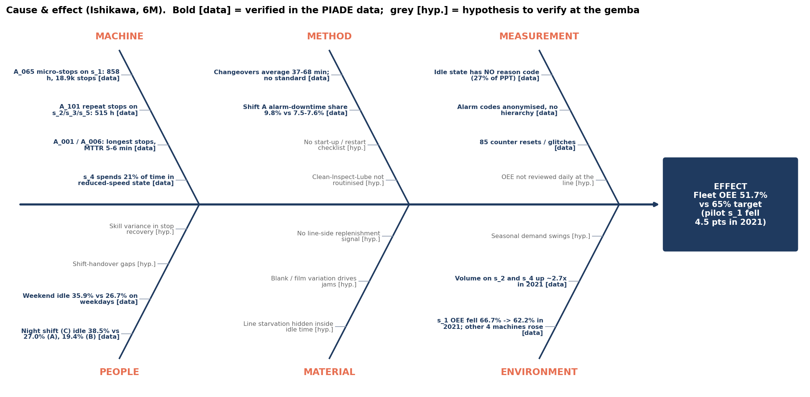
Figure 5 - Ishikawa (6M). Bold = verified in data; grey = hypothesis for the gemba.

Hypothesis test results
Test | Result | p-value | So what
H1 ANOVA: idle share by shift | A 27.0% | B 19.4% | C (night) 38.5%; F = 167.7 | < 0.001 | Night shift is where idle lives
H2 ANOVA: alarm-downtime share by shift | A 9.8% | B 7.6% | C 7.5%; F = 40.8 | < 0.001 | Start-of-day restarts cost the most
H3 Welch t: weekend vs weekday idle | 35.9% vs 26.7%; t = 8.3 | < 0.001 | Staffing / scheduling, not the machine
H4 Chi-square: alarm mix vs shift | Chi2 = 6,386; Cramer's V = 0.19 | ~0 | Significant but a weak effect: do not over-sell it
H5 Welch t per machine: 2020 vs 2021 | s_1 -4.5 pts (drop); s_2 +9.5, s_3 +8.2, s_4 +4.0, s_5 +3.8 (rises) | all < 0.05 | Pooled fleet 'decline' is a MIX effect
H6 Regression: OEE vs stops per run-h | slope -0.017 per stop/run-h; R2 = 0.14 | < 0.001 | Stops explain only 14% of OEE variance

The stratification lesson (H5). Pooled across machines, daily OEE looks like it fell from about 56% in 2020 to about 49% in 2021. Stratified, four of five machines actually improved. The pooled drop comes from s_2 and s_3, two low-OEE machines that only joined the data in mid and late 2020, getting a full year of weight in 2021. This is Simpson's paradox. Stratify before you conclude; it is a strong interview story.
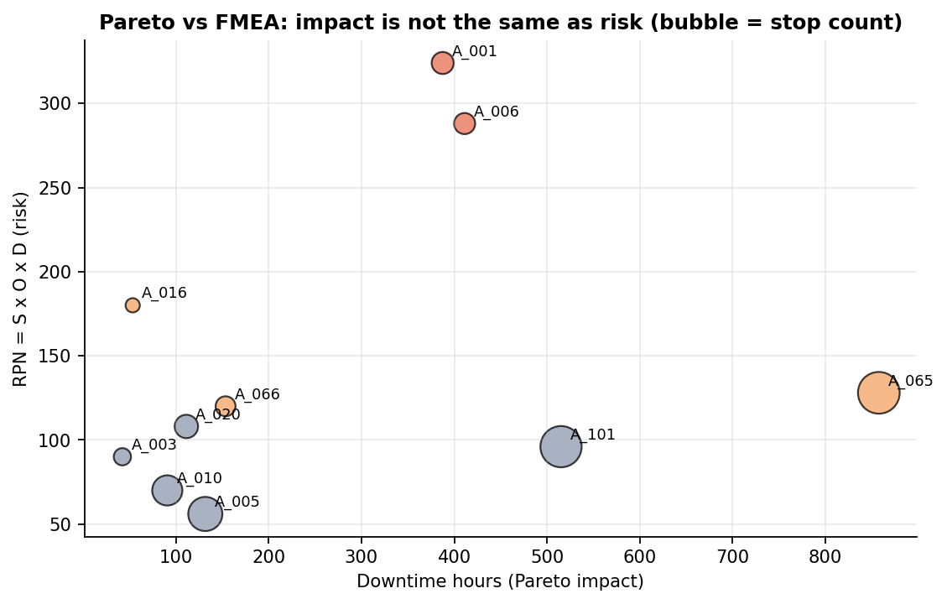
Figure 6 - Pareto ranks by impact (A_065 first). FMEA ranks by risk (A_001 RPN 324, A_006 RPN 288).

Verified root causes
- Idle time has no reason code; it concentrates at night and on weekends (H1, H3). The likely causes are staffing, material staging and scheduling. The root cause is a measurement gap.
- A_065 micro-stops on s_1 cause 858 h and 18,864 stops, and 81% repeat within 30 minutes. The trigger condition is not being removed.
- A_001 and A_006 are rarer but long, unpredictable stops, making them the highest risk. They need error-proofing and a standard repair kit.
- Speed loss is 12.4% of planned time; s_4 runs 21% of its time in reduced-speed state.
- Changeovers average 37-68 min with no standard (SMED opportunity).

4. IMPROVE - what do we change, and what is it worth?

What you do
- Score the countermeasures in I1 (Impact x (6 - Effort)) and pick wave 1.
- Draw the current- and future-state value stream map of the pilot s_1.
- Quantify each lever in I2. Every assumed reduction is a yellow cell, so a reviewer can challenge any of them.
- Design the Lean countermeasures: SMED (I3), Poka-Yoke (I4), 5S audit (I5), Kaizen event and PDCA tracker (I6), Kanban (I7).
- Set the packaging-material inventory policy (I8): safety stock, reorder point and EOQ from the service-level target.
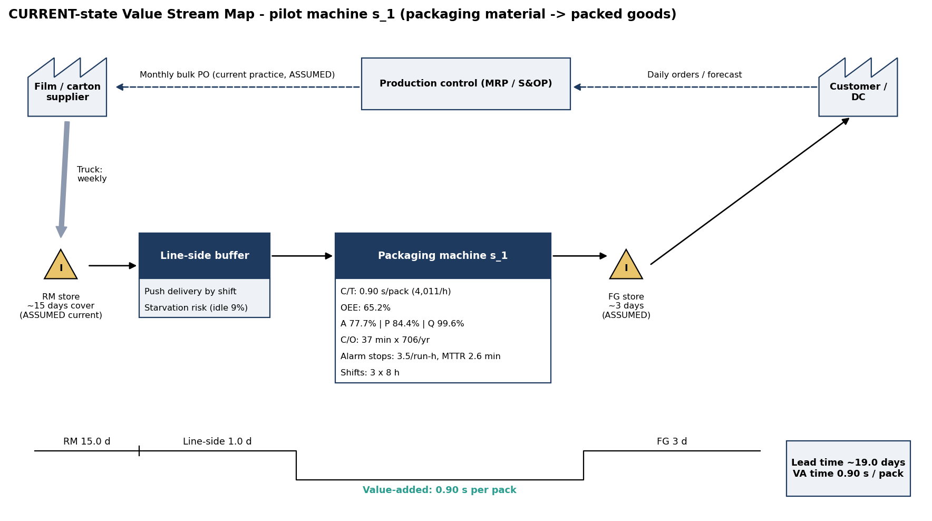
Figure 7 - Current-state VSM, s_1. Lead time about 19 days against 0.9 s of value-added time per pack. RM and FG days are ASSUMED.
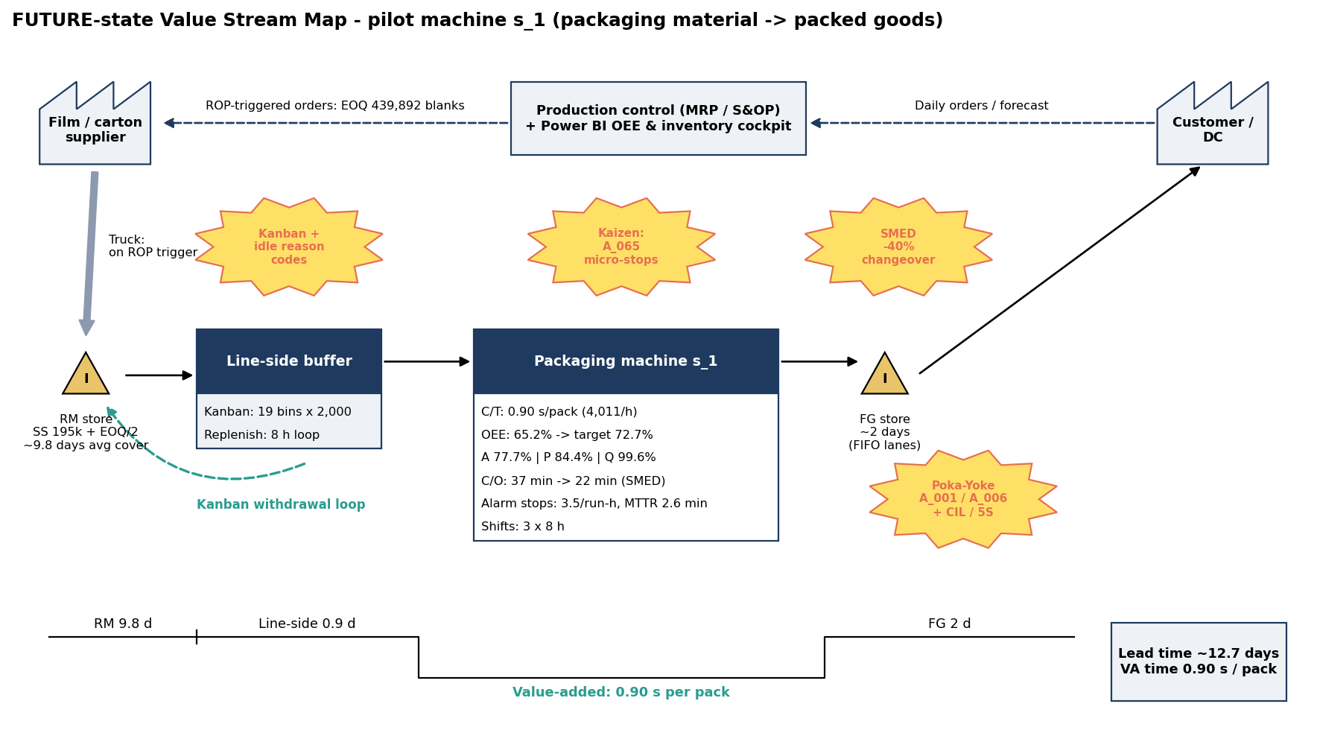
Figure 8 - Future-state VSM: ROP/EOQ supplier orders, a Kanban line-side loop, and kaizen bursts for SMED, micro-stops and Poka-Yoke.
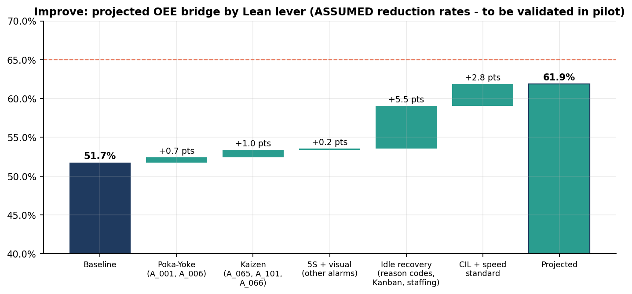
Figure 9 - Projected OEE bridge: 51.7% to 61.9%. The idle lever (+5.5 pts) beats all alarm levers combined (+1.9 pts).

Lean toolkit applied
Tool | Where it is applied | Key number
Kaizen (5-day blitz) | A_065 micro-stops on s_1; then roll out to A_101 on s_2/s_3/s_5 | Target -30% stop hours; +1.0 OEE pts
Poka-Yoke | Forced idle reason code on the HMI; keyed change parts for A_001/A_006; lot scan | Idle coded >= 95%; +0.7 pts from A_001/A_006
SMED | Changeovers (planned stops 10 min - 4 h) | Fleet mean 51 min; -40% releases ~1,020 h/yr of capacity
5S + CIL | Shadow boards, Clean-Inspect-Lube, rated-speed standard | Speed loss -20% gives +2.8 pts
Kanban | Line-side packaging blanks | s_1: 19 bins x 2,000 sized on peak (rated) draw
Standard work | Night / weekend staffing and shift handover | Idle -25% gives +5.5 pts

Inventory optimisation (service-level based)
Formulas: SS = z x SQRT(L x sd_d^2 + d^2 x sd_L^2); ROP = d x L + SS; EOQ = SQRT(2DS/H). Here z = NORMSINV(service level), L = 7 days and sd_L = 1.5 days (assumed). Demand = daily packaging blanks consumed (1 blank per input package).
Machine (98% CSL) | Mean daily demand | Safety stock | Reorder point | EOQ | Days of cover
s_1 | 42,412 | 194,494 | 491,378 | 439,892 | 9.8
s_2 | 6,980 | 48,348 | 97,209 | 178,457 | 19.7
s_3 | 24,067 | 104,371 | 272,840 | 331,369 | 11.2
s_4 | 11,153 | 112,115 | 190,185 | 225,577 | 20.2
s_5 | 39,618 | 239,396 | 516,725 | 425,158 | 11.4

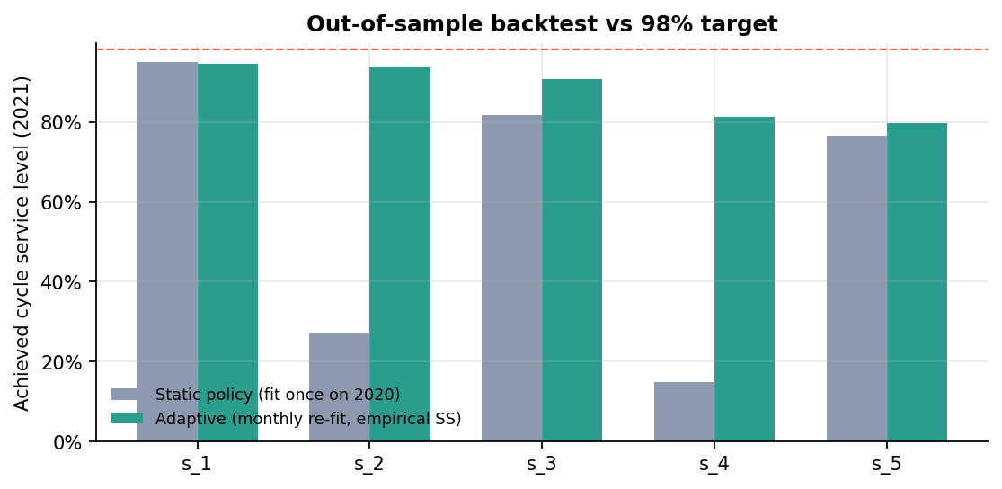
Figure 10 - Out-of-sample test: the policy was fit on 2020 and replayed on real 2021 consumption.
What the backtest proves. A policy fitted once breaks when demand shifts. s_2 and s_4 volume rose about 2.7x in 2021, and their service level collapsed to 28% and 15%. Re-fitting monthly with the larger of the normal-theory and empirical safety stock recovers them to 93.5% and 81%. Even so, lumpy daily demand keeps s_4 and s_5 below 98%. That is the honest limit of normal-theory safety stock. Spare kits for the high-risk failure modes use a Poisson reorder point: A_065 = 8, A_001 = 6, A_006 = 5 kits.

5. CONTROL - how do we hold the gain?

X-bar and R chart design
- Characteristic. Shift-level OEE of the pilot machine s_1.
- Rational subgroup. One production day, 06:00 to 06:00, with n = 3 shifts (A, B, C). The X-bar chart tracks the day-to-day level. The R chart tracks shift-to-shift inconsistency, which is exactly where Analyze found the night-shift problem.
- Inclusion rule. A day enters the chart only if all 3 shifts had at least 2 h of planned time.
- Constants (n = 3). A2 = 1.023, D3 = 0, D4 = 2.574, d2 = 1.693.
- Phase I (2020) sets the limits. Points beyond the first-pass limits are treated as assignable-cause candidates and removed once, then the limits are recomputed. Phase II (2021) is monitored against those limits.
Limit | Pass 1 (all 2020) | Revised (39 of 255 removed)
Centre line (X-double-bar) | 61.5% | 67.3%
UCL X | 94.9% | 95.9%
LCL X | 28.0% | 38.6%
R-bar | 32.7% | 28.0%
UCL R | 84.2% | 72.1%
Sigma within (R-bar / d2) | - | 16.5%

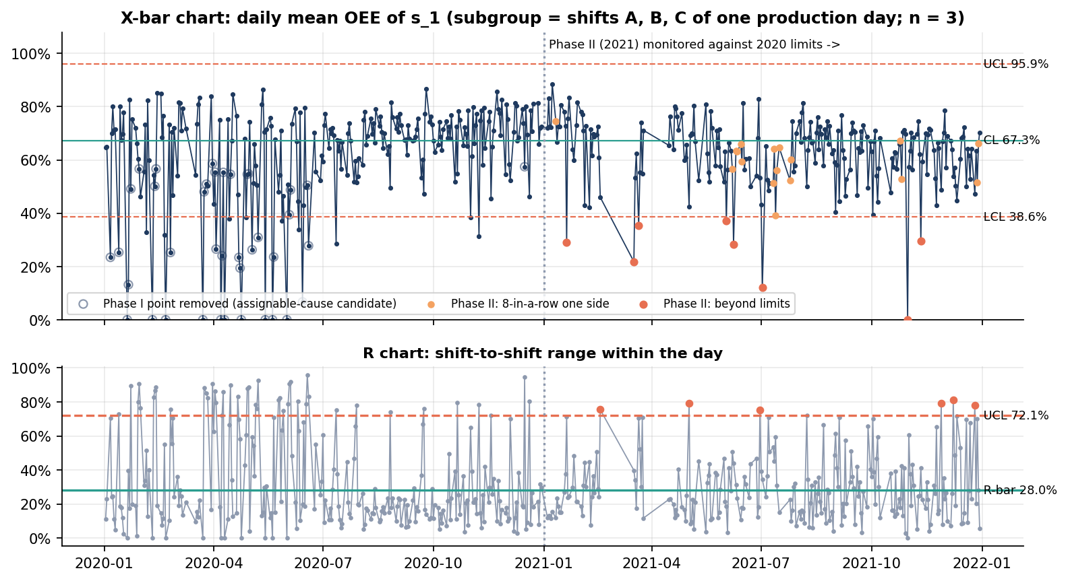
Figure 11 - X-bar and R chart for s_1. Early 2020 is chaotic; from mid-2020 the process settles. In 2021 the chart signals a downward shift.
Reading the chart. Phase II has 224 subgroups: 8 X-bar points beyond the limits, 6 R points above UCL, and 18 eight-in-a-row run-rule signals. The 2021 mean is 62.7%, 4.6 points below the revised centre line. The chart independently detects the s_1 degradation found by the t-test in Analyze. That is the point of a control chart: it would have raised the alarm in real time.
Caveat to state yourself. In a real plant you remove a Phase I point only after finding its cause. Here the 39 removed days are candidates. Most are near-zero-OEE days in the first half of 2020, which look like start-up or commissioning disruption.
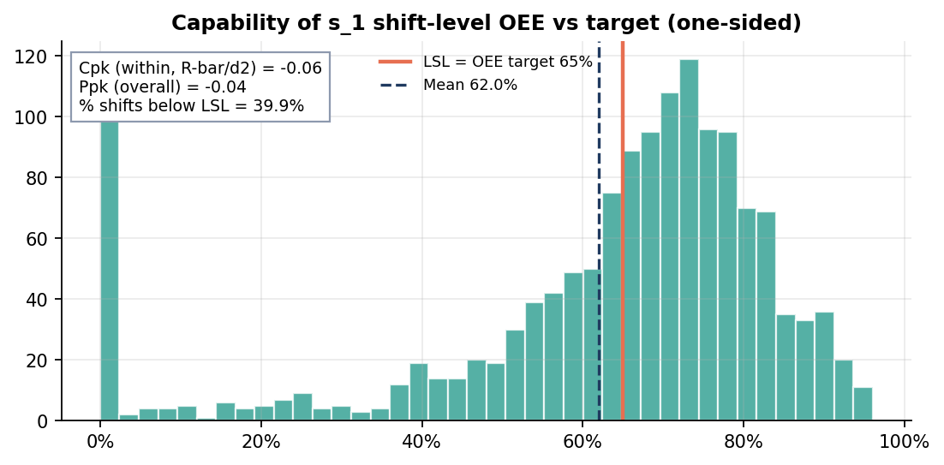
Figure 12 - Capability vs the 65% target: Cpk -0.06, Ppk -0.04, 39.9% of shifts below LSL.
Capability verdict. s_1 is not capable: it is centred below target. SPC tells you whether the process is stable; capability tells you whether stable is good enough. Here it is not, so the answer is improve, then monitor.

Control plan and reaction plan
Metric | Target | Method | Frequency | Owner
s_1 daily OEE (3-shift subgroup) | Revised limits; >= 65% | X-bar & R chart | Daily | Shift lead
Idle share by shift | <= 20% | Run chart + idle-reason Pareto | Every shift | Production mgr
% idle minutes with a reason code | >= 95% | HMI Poka-Yoke + audit | Daily | IT + shift lead
A_065 stops per run-hour | -30% vs baseline | Pareto trend | Weekly | Maintenance
Changeover minutes | -40% vs baseline | SMED standard + timing log | Each changeover | Setup lead
Material cycle service level | >= 98% | Monthly ROP/EOQ re-fit + Kanban audit | Monthly | Stores / planning
5S audit score | >= 80% | I5 checklist | Weekly then monthly | Area owner

OCAP (C4). One X-bar point below LCL: find that day's idle reasons and top alarms within the shift. R above UCL: compare the three shifts on staffing, material and changeovers. Eight in a row below the centre line: reopen the root-cause analysis.

Power BI control cockpit
Connect Power BI to PostgreSQL (the views are the model) or load the CSVs. The DAX file gives every measure: OEE, A/P/Q, DPMO and sigma, Pareto cumulative %, MTBF/MTTR, the X-bar/R lines and a service-level what-if parameter for SS, ROP and EOQ. Build six pages: OEE cockpit, loss tree (decomposition tree), Pareto & RCA, shift & idle, SPC, inventory.

6. How to execute and own this project (4-week plan)
You will be questioned on every number. Rebuild it yourself rather than presenting it as-is.
Week | Do this yourself | Proof you own it
1 - Define + SQL | Install PostgreSQL. Run 01. Read every CTE in f_interval and explain LAG, the counter delta and the production day. Rewrite the charter in your own words. | You can explain why elapsed / 1000 and why pi is read at interval end
2 - Measure | Recreate M2 and M3 formulas on a blank sheet from v_daily_machine. Reproduce 51.7% by hand. Write the Pareto query from scratch with a window function. | Loss-tree checks = 0 in your version
3 - Analyze | Redo the ANOVA and Welch t in Excel with the Data Analysis ToolPak and match A3. Find the Simpson's paradox yourself in a pivot (machine x year). | You can defend each p-value and effect size
4 - Improve + Control | Change one assumption in I2 and I8 and explain the effect. Rebuild the X-bar/R chart for s_5 by changing the machine in the SQL export. Build Power BI pages 1, 3 and 5. | A 5-minute walk-through of the X-bar/R chart

Interview talking points
- 'The biggest loss had no data behind it: 27% of planned time was idle with no reason code. My first recommendation was a measurement fix, a Poka-Yoke on data capture, before any process fix.'
- 'Pareto and FMEA disagreed. A_065 had the most hours, but A_001 and A_006 had the highest risk. I used Kaizen for the frequent stops and error-proofing for the risky ones.'
- 'The fleet looked like it got worse in 2021. Stratified, four of five machines improved. It was a mix effect, and only s_1 really declined, which is why it became the pilot.'
- 'I chose the rational subgroup deliberately: three shifts per day. The R chart then measures shift inconsistency, the exact cause Analyze found.'
- 'I backtested the inventory policy out of sample. It failed when demand shifted, so the control plan re-fits it monthly.'

Limitations (state them before you are asked)
- Improve-phase gains are projections; nothing was implemented.
- Alarm codes are anonymised, so physical root causes remain hypotheses.
- Shift times assume UTC 06/14/22 boundaries; the plant's real shift pattern is unknown.
- Costs, lead times, changeover identification and RM/FG days on the VSM are assumptions, all listed on the Inputs tab.
- OEE is bounded between 0 and 1 and skewed, so Cpk and Ppk are indicative rather than exact.

