**Task 01 – INRIA Intern (Monday – 10/2/2025)**

1. Finish the web semantic class.
2. Study some tutorial web components: provide some example.
3. Check how to export components at npm package.

**📌 1. The web semantic’s course:**

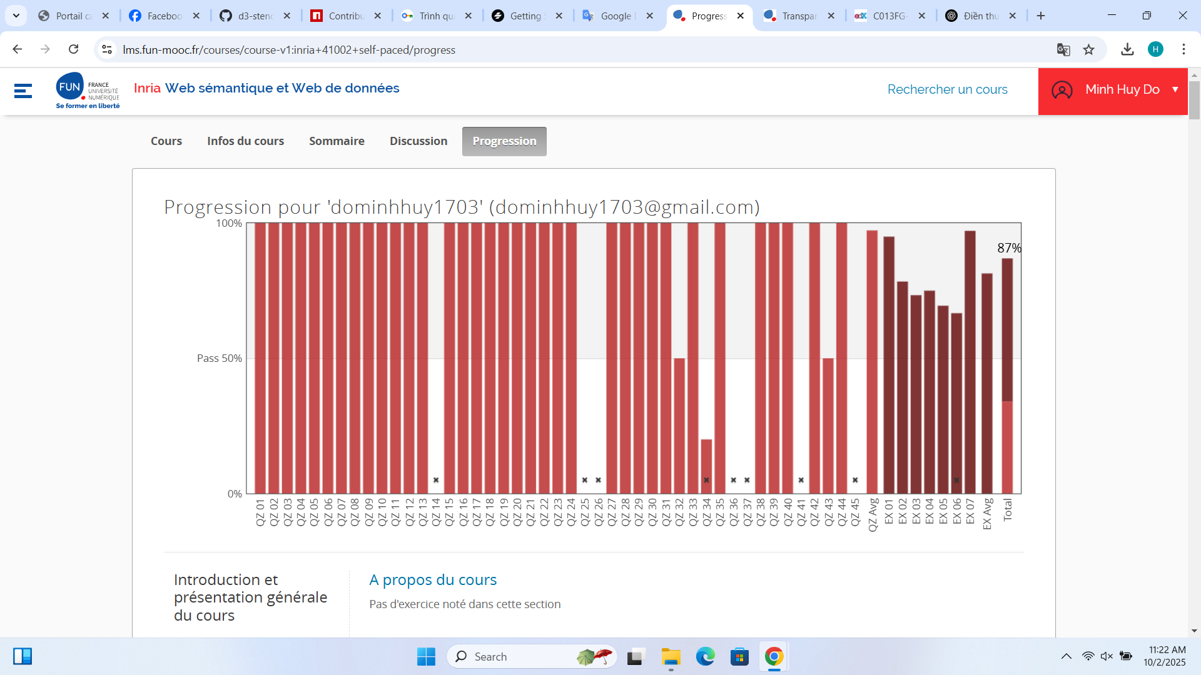

**📌 2. Tutorial web components with Stencil:**

npm init stencil

✔ Pick a starter › component  
? Project name › my-first-stencil-project

npm install  
npm start

After running these lines, our task is doing with my-component.tsx in src/components/my-component/

And changing in src/index.html

**📌 3. Export components at npm package:**

npm login

npm publish --access public

If package name is duplicated, add the scope belike @yourname/my-web-component or change the name of package

**Task 02 – INRIA Intern (Thursday – 13/2/2025) – Next meeting (Tuesday at 10 a.m)**

1. Create Bar chart.
2. Create Map.
3. Create Node link diagram.
4. Course: <https://lms.fun-mooc.fr/courses/course-v1:inria+41013+archiveouvert/info>

**Task 03 - INRIA Intern (Thursday – 13/2/2025) (Post document in ggdocs) – Next meeting (Tuesday at 11:15 a.m)**

1. Separate each chart component
2. Import the package for the new project
3. Find a way to hide the data
4. Change the chart color according to the user’s need
5. Do the lab on the LMS (Professor Catherine gave)