**WIMMICS/INRIA SOPHIA ANTIPOLIS**

Name: Minh Huy Do – Intern: Data Visualization

Source: <https://github.com/dominhhuy1703/Data_Visualization.git>

**Task 01 – Monday (10/2/2025)**

**Next meeting - Thursday (10 a.m 13/2/2025)**

1. Finish the web semantic class.
2. Study some tutorial web components: provide some example.
3. Check how to export components at npm package.

**📌 1. The web semantic’s course:**

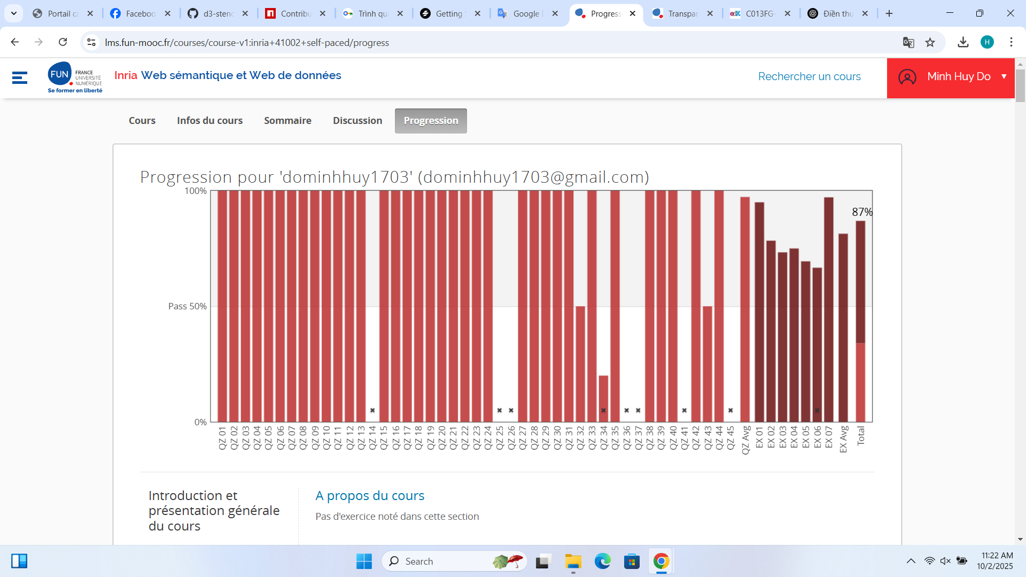

**📌 2. Tutorial web components with Stencil:**

npm init stencil

✔ Pick a starter › component  
? Project name › my-first-stencil-project

npm install  
npm start

After running these lines, our task is doing with my-component.tsx in src/components/my-component/

And changing in src/index.html

**📌 3. Export components at npm package:**

npm login

npm publish --access public

If package name is duplicated, add the scope belike @yourname/my-web-component or change the name of package

**Task 02 – Thursday (13/2/2025)**

**Next meeting - Tuesday (10 a.m 17/2/2025)**

1. Create Bar chart.
2. Create Node Link diagram.
3. Create Map.
4. Do English version course: <https://lms.fun-mooc.fr/courses/course-v1:inria+41013+archiveouvert/info>

**📌 1. Create Bar chart:**

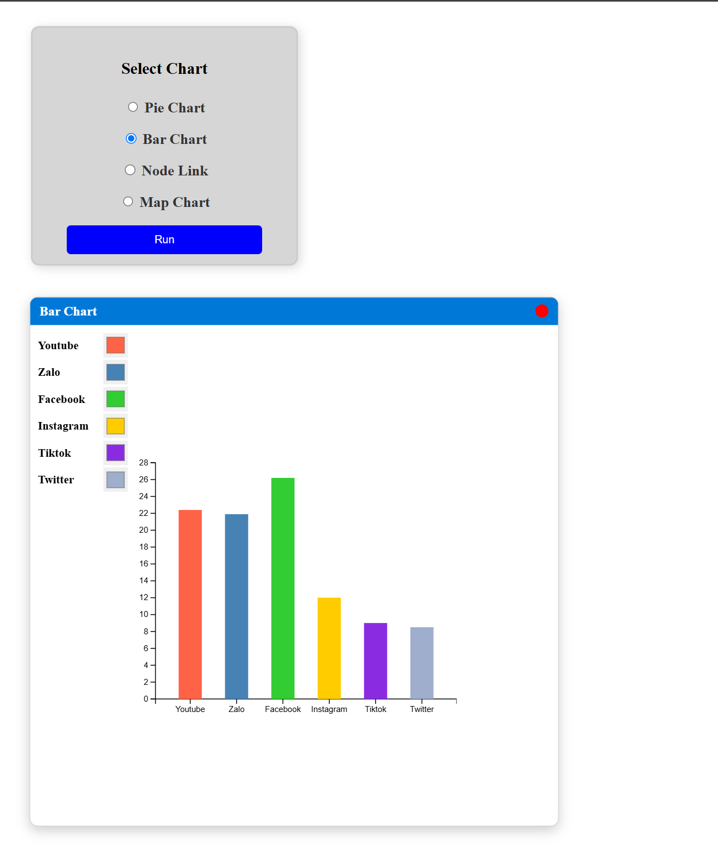

**📌 2. Create Node Link diagram:**

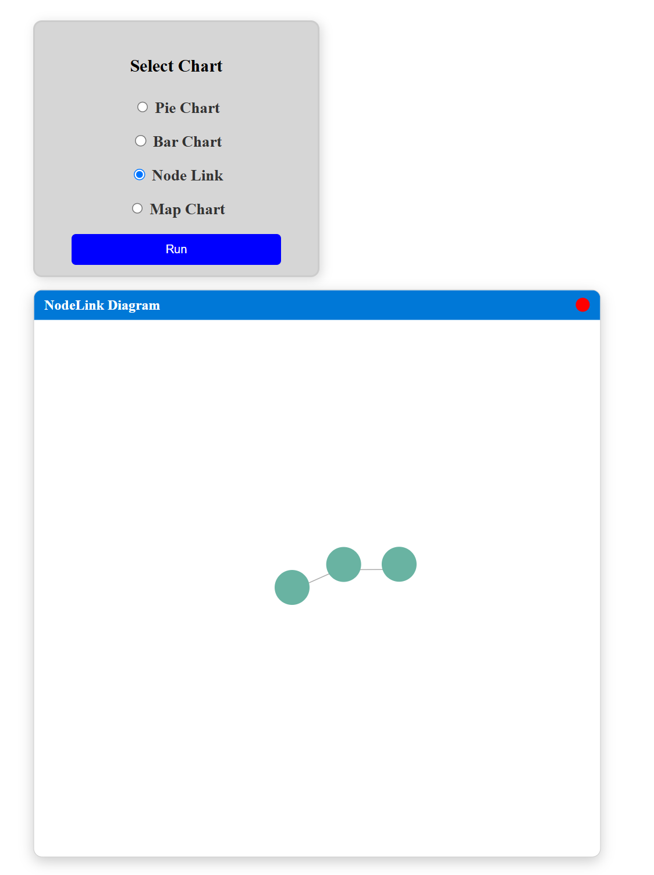

**📌 3. Create Map:**

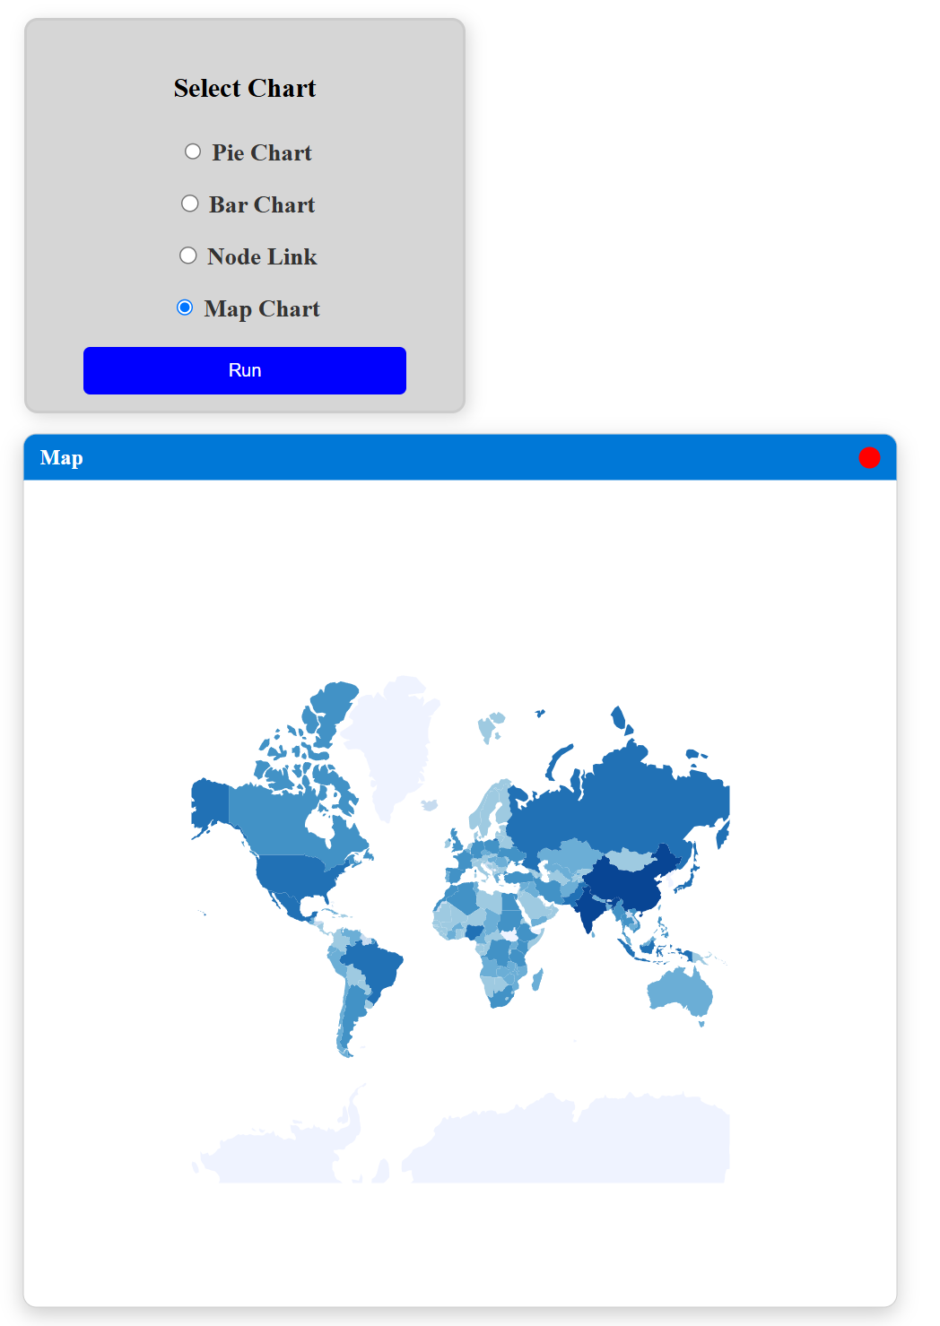

**📌 4. Do the LMS course**

**Task 03 - Thursday (13/2/2025)**

**Next meeting - Tuesday (11:15 a.m 25/2/2025)**

1. Separate each chart component.
2. Find a way to hide the data from outside.
3. Create a color picker to change chart’s color according to the user’s need.
4. Import the package for the new project.
5. Do the RDF Lab. (Given by Professor Catherine)

**📌 1. Separation each chart component (Remove the component outside):**

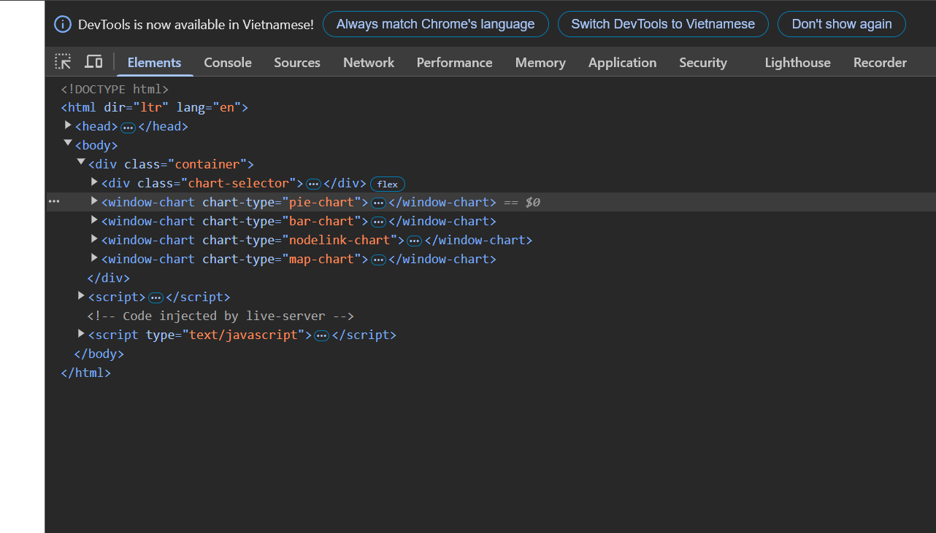

**📌 2. Find a way to hide data from outside (Use private property)**

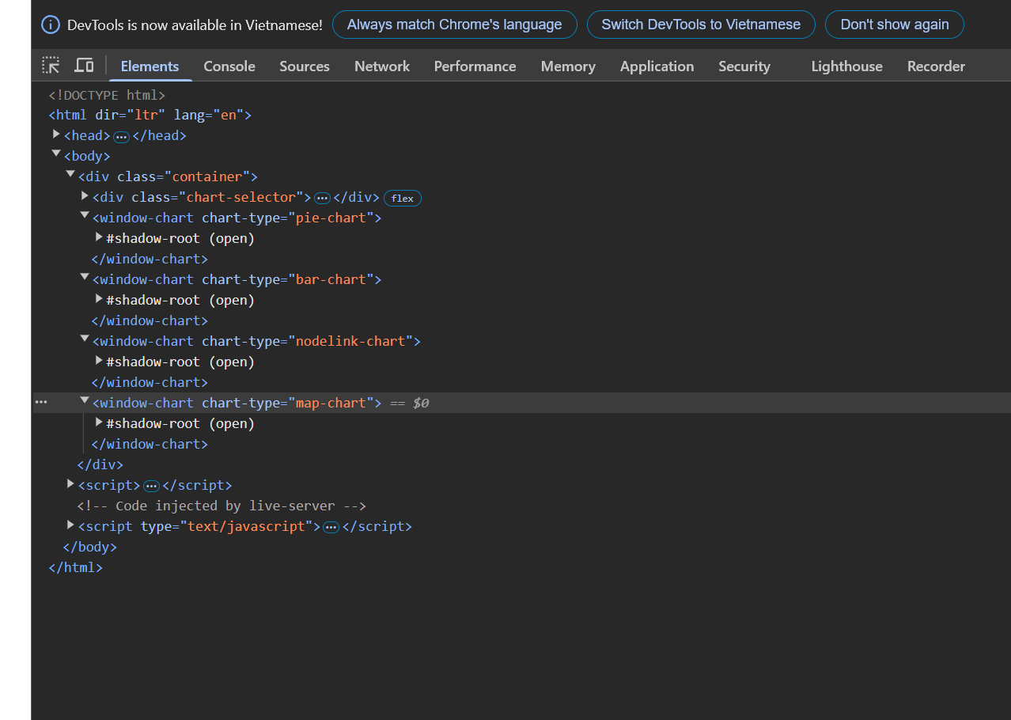

**📌 3. Create a color picker to change chart’s color according to the user’s need**

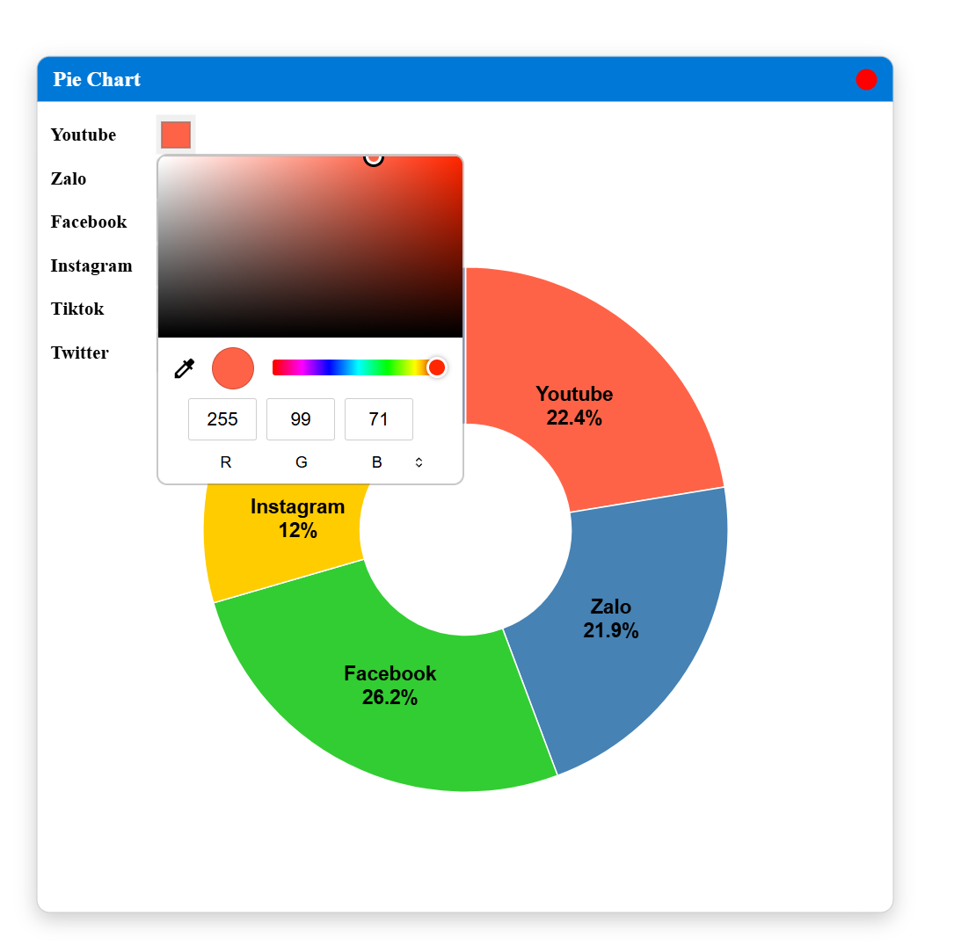

**📌 4. Import the package for the new project**

