Foothill College
Governance Model Proposal

March 1, 2018

Draft – For Discussion

Table of Contents

- Introduction, Mission, Institutional Learning Outcomes

- Educational Master Plan Goals

- Proposed Governance Committee Structure and Topic Areas

- Role Governance at Foothill College

- Committee Structure

- Governance Group Descriptions – Governance Council, Education/Equity, Community, Resources

- Proposal for 1 Year Phase-in (transition year)

- Proposed Annual Governance Calendar

Appendix A - Foothill College Quality Focused Essay

Appendix B - FHDA Board of Trustees Policies Supporting Governance

Appendix C - Legal Definition of Governance in California Community Colleges

Introduction

The Foothill College Governance Redesign effort began in fall 2016 at the Accreditation Leadership Retreat where governance was identified as an important initiative to be included in the college’s Accreditation Quality Focused Essay (see Appendix A). Discussions on a redesign began in summer 2017 and included the Governance Summit in September 2017. The Governance Redesign Leadership Council, made up of classified staff, faculty, administrators, and students, met several times in fall 2017 and winter 2018. The principles adopted by the Governance Redesign Leadership Council include:
- Governance should allow participants to feel engaged and empowered.
- Governance should be fun - enjoying each-others company / brainstorming ideas together.

Governance is guided by the Foothill College Mission Statement, particularly:
“our core values of honesty, integrity, trust, openness, transparency, forgiveness, and sustainability. “

The group explored seven different governance models. After careful review the committee recommended the Educational Master Plan model proposed below. This document serves a Governance Handbook 1.0 to facilitate discussion about the proposed model. The proposed timeline for implementation is outline below.

Governance Redesign Timeline
Governance Town Hall Feb 28
PaRC Review Feb 21 and March 7
The proposed governance model is driven by the Educational Master Plan Goals which are included below.
Educational Master Plan Goals Revised 11.13.15

These goals are approached in a way that exemplifies Foothill College’s culture of innovation and problem solving, with emphasis on eliminating disproportionate impact among student groups:

Create a culture of equity that promotes student success, particularly for underserved students.
- Implement activities to improve achievement of student outcomes among those population groups experiencing disproportionate impact.
- Reduce barriers and facilitate students’ ease of access across the District and region.
- Enhance support for online quality and growth for instruction and student services.
- Collaborate with K-12, adult education and four-year institutions in ways that serve students and society.
- Partner with business and industry to prepare students for the workforce.

Strengthen a sense of community and commitment to the College’s mission; expand participation from all constituencies in shared governance.
- Encourage student participation in leadership and activities outside the classroom (including service/work-based learning) that engages students with the College and the community.
- Provide effective onboarding, support and professional development for all college employees.
- Encourage employee participation in leadership and activities that engages them with the College and the community.
- Promote consistent and clear communication in order to create a more informed, cohesive and engaged community.
- Increase lifelong learning opportunities for our community.
- Promote decision-making that respects the diverse needs of the entire college community.

Recognize and support a campus culture that values ongoing improvement and stewardship of resources.
- Increase advocacy at the state level, increase grants and private donations to secure stable and sustainable funding, and manage college resources strategically.
- Expand college practices and initiatives to support environmental stewardship.
- Employ data-driven decision-making.

Proposed Governance Committee Structure and Topic Areas

The proposed model will follow the three Educational Master Plan Goals of Equity, Community and Resources. Below is a list of existing topic areas that would fall under each committee.

Governance Council: Strategic Objectives, Planning, College Resource Allocation, Accreditation, Program Approval and Discontinuance

Equity / Education: Instruction, Equity, Basic Skills, Program Review, 3SP, Workforce, Transfer, Assessment, Online Enrollment, Dual Enrollment

Community / Institutional Effectiveness: Professional Development, Workforce, Service Leadership, Institutional Learning Outcomes, Alumni, Governance, Communication

Resources/Sustainability: OPC / Budget, Technology, Sustainability, Facilities, Buildings and Grounds

Note: strategic resource allocation will be areas discussed by all the communities in relation to their assessment of Educational Master Plan goals.

Proposed Educational Master Plan Model

Role Governance at Foothill College

The focus of the governance committees will be on the assessment of progress on the Educational Master Plan and related college plans:
- Planning
- Strategic allocation of resources
[Implementation]
- Evaluate / review / assess institutional effectiveness (I.E.)
- Re-plan – identify changes to the plan

Governance may also involve the opportunity to share information and get feedback on issues facing the college.

Committee Structure

Critical Decision-making items for Governance
- Assess progress and changes to institutional plans
- Assess progress on Educational Master Plan goal activities
- Program Review, Creation, Discontinuance
- Strategic Objectives
- Resource Prioritization (positions / operational $)
- Evaluate Governance Processes

Operation of Committees
- Each committee will have 12 members – 3 Faculty, 3 Classified Staff, 3 Students, and 3 Administrators. Members will be on only one committee.
- Each committee will be assigned a recorder.
- Each committee will be assigned ex-officio members to support the work of the committee.
- Every recommendation must be in a memo in writing. President writes back to the committee.
- Committees will have a trained facilitator assigned by the President who is a Foothill employee but not a member (OR a tri-chair –still under discussion).
- Each of the 4 committees would meet on the same Friday of the month (e.g. Community Committee would meet on the first Friday of the month).
Governance Group Descriptions

Governance Council

Mission
The purpose of the committee is to monitor and assess progress on the Educational Master Plan Goals.

Critical decision-making items
- Strategic Objectives
- Faculty Hiring
- Program Creation or Discontinuance
- Assessment of Accreditation Metrics - Institutional Standards- Annual Report
- Review Mission Statement
- Program Review

Topic Areas
Strategic Objectives, Planning, College Resource Allocation, Accreditation, Program Approval and Discontinuance

Ex-Officio:
College Researcher

Membership terms – 3 year terms with Tri-Chair rotation.

Meeting schedule
Governance Council will meet on the fourth Friday of the month.

Equity / Education Committee

Mission
The purpose of the committee is to monitor and assess progress on the Educational Master Plan Goal related to creating a culture of equity that promotes student success.

Create a culture of equity that promotes student success, particularly for underserved students.
- Implement activities to improve achievement of student outcomes among those population groups experiencing disproportionate impact.
- Reduce barriers and facilitate students’ ease of access across the District and region.
- Enhance support for online quality and growth for instruction and student services.
- Collaborate with K-12, adult education and four-year institutions in ways that serve students and society.
- Partner with business and industry to prepare students for the workforce.

Critical decision-making items
- Faculty Hiring
- Program Creation or Discontinuance
- Assessment of Accreditation Metrics - Institutional Standards- Annual Report
- Review Mission Statement
- Program Review
- Related strategic resource allocations

Topic Areas
Instruction, Equity, Basic Skills, Program Review, 3SP, Workforce, Transfer, Assessment, Online Enrollment, Dual Enrollment

Ex-Officio:
AVP Workforce
Equity Researcher

Membership terms – 3 year terms with Tri-Chair rotation.

Meeting schedule
The Equity / Education Committee will meet on the first Friday of the month.

Community and Institutional Effectiveness Committee

Mission
The purpose of the committee is to monitor and assess progress on the Educational Master Plan Goal related to Community.

Strengthen a sense of community and commitment to the College’s mission; expand participation from all constituencies in shared governance.
- Encourage student participation in leadership and activities outside the classroom (including service/work-based learning) that engages students with the College and the community.
- Provide effective onboarding, support and professional development for all college employees.
- Encourage employee participation in leadership and activities that engages them with the College and the community.
- Promote consistent and clear communication in order to create a more informed, cohesive and engaged community.
- Increase lifelong learning opportunities for our community.
- Promote decision-making that respects the diverse needs of the entire college community.

Critical decision-making items
- Professional Development
- Service Leadership
- Community Education
- Related strategic resource allocations

Topic Areas
Professional Development, Workforce, Service Leadership, Institutional Learning Outcomes, Alumni, Governance, Communication

Ex-Officio:
Vice President of Student Services
Director of Marketing

Membership terms – 3 year terms with Tri-Chair rotation.

Meeting schedule
The Community Committee will meet on the second Friday of the month.

Resources Committee

Mission
The purpose of the committee is to monitor and assess progress on the Educational Master Plan Goal related to stewardship of resources.

Recognize and support a campus culture that values ongoing improvement and stewardship of resources.
- Increase advocacy at the state level, increase grants and private donations to secure stable and sustainable funding, and manage college resources strategically.
- Expand college practices and initiatives to support environmental stewardship.
- Employ data-driven decision-making.

Critical decision-making items
- Budget Allocations
- Facilities Plan Review
- Environmental Sustainability Plan Review
- Technology Plan Review
- Related strategic resource allocations

Topic Areas
OPC / Budget, Technology, Sustainability, Facilities, Buildings and Grounds

Ex-Officio:
AVP Finance

Membership terms – 3 year terms with Tri-Chair rotation.

Meeting schedule

The Resources Committee will meet on the third Friday of the month.

Proposal for 1 Year Phase-in (transition year)

- Suspension of program reviews (with exception of those receiving out-of-cycle recommendations).

- Each committee will review program review needs and propose suggestions for the next year.

- Committees will review process after the first year and propose revisions to the Governance Handbook for year two.

Proposed Annual Governance Calendar

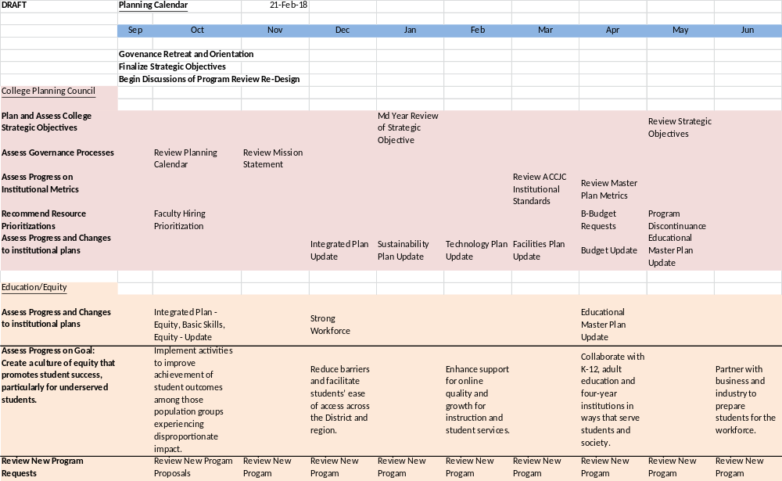
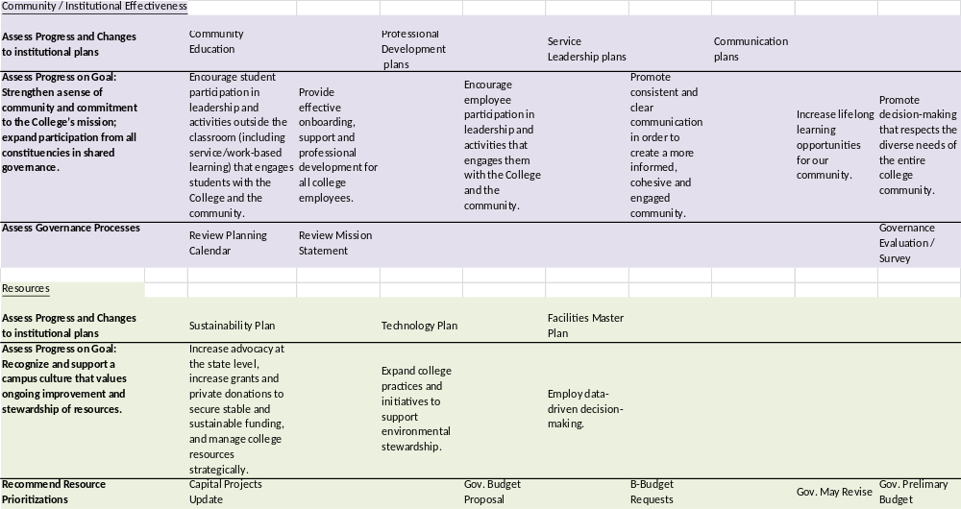

Appendix A - Foothill College Quality Focused Essay

Create a new College participatory governance system that actively involves a majority of College employees and is recognized by learning and dialogue about how to achieve College goals.

Desired Goals/Outcomes
- Redesign participatory governance system to include integrated planning that is the common denominator for promoting equitable student outcomes. Use the participatory governance meetings held in spring 2016 as a starting point. See minutes:
http://www.foothill.edu/president/parc/parc_archive2015-16.php

- Develop a more efficient participatory governance system that allows deeper involvement, including:
  - Student voice
  - Discussion of student learning and achievement information
  - Standard meeting times for committees and department discussions
  - Scheduling meeting times when classes are not in progress
  - An examination of incentives to promote involvement
  - Development of service outcomes for the committees and a rubric for ongoing assessment
  - Development of a process that integrates College planning and allocation efforts based on Educational Master Plan goals and metrics

- Develop information to be added to employee orientation (faculty and staff) on the governance structure and how employee groups can participate.

- Create Online/Hybrid competency-based training modules for governance committee onboarding.

- Develop an online communication system by creating a “community of practice” around participatory governance committees.

- Develop a mentoring system for participatory governance in order to share institutional knowledge and effective practices.

- Review and revise Governance Handbook to articulate each committee’s charge, membership and communication responsibilities.

Appendix B - FHDA Board of Trustees Policies Supporting Governance

BP 3250 Institutional Planning

The Chancellor shall ensure that the District has and implements a broad-based, comprehensive, systematic and integrated system of planning that involves participatory governance representatives and appropriate segments of the college community, is supported by institutional research, and informs the District’s resource allocation processes.

The planning system shall incorporate plans required by law or regulation, as well as plans for each major function of the District, including but not limited to:
- Long-range Educational or Academic Master Plan, which shall be updated periodically as deemed necessary by the governing board
- Facilities Plan
- Technology Plan
- Equal Employment Opportunity Plan
- Student Equity Plan
- Student Success and Support Program Plan
- Transfer Center Plan
- EOPS Plan
The Chancellor shall ensure that the District maintains a commitment to the effectiveness of its ongoing planning process by systematically reviewing, evaluating and modifying, as appropriate, all parts of the planning system.

The Chancellor shall ensure that institutional plans contain goals, objectives, and measurable outcomes, are integrated into the annual budget process, and that the results of institutional planning are broadly communicated.

The Chancellor shall submit those plans for which Board approval is required to the Board and shall inform the Board periodically as to the status of the District’s planning efforts.

Approved 7/12/04
Amended and renumbered 3/2/15 (formerly BP 3050)

Other Board Policies on Governance

Board Policy 2222: Student Role in Governance
Board Policy 2223: Role of the Academic Senate in Academic and Professional Matters
Board Policy 2224: Role of Classified Staff in Governance

ACCJC Accreditation Standard Related to Governance

Standard IV.B.3
Through established policies and procedures, the CEO guides institutional improvement of the teaching and learning environment by:

- establishing a collegial process that sets values, goals, and priorities;
- ensuring the college sets institutional performance standards for student achievement;
- ensuring that evaluation and planning rely on high quality research and analysis of external and internal conditions;
- ensuring that educational planning is integrated with resource planning and allocation to support student achievement and learning;
- ensuring that the allocation of resources supports and improves learning and achievement; and
- establishing procedures to evaluate overall institutional planning and implementation efforts to achieve the mission of the institution.

Appendix C - Legal Definition of Governance in California Community Colleges

Education Code defines Collegial Consultation as follows:

Education Code-70902
Establish procedures that are consistent with minimum standards established by the board of governors to ensure faculty, staff, and students the opportunity to express their opinions at the campus level, to ensure that these opinions are given every reasonable consideration, to ensure the right to participate effectively in district and college governance, and to ensure the right of academic senates to assume primary responsibility for making recommendations in the areas of curriculum and academic standards.

