KOGI
Independent Worker Operating System
High-Fidelity Screen Flows
24 Screens · 11 Module Groups · Full Platform Coverage
Portfolio + Programs + Projects
Marketplace + Exchange
Gantt + Roadmap + Schedule
Governance + Cooperative + Capital
AI Assistant + Discover + Search
Spaces + Social + Chat
Team + Org + Profile
Developer + Integrations + Analytics
Version 1.0 · Q2 2025

Table of Contents
▸ Home & Navigation
01 Dashboard — Home Overview
▸ Portfolio Views
02 Portfolio — Grid Gallery View
03 Programs + Projects — Tiles View
04 Template Gallery — Workspace Starters
▸ Work & Operations
05 Work Board — Kanban View
06 Strategy — OKR View
07 Roadmap — Now / Next / Later
▸ Timeline & Schedule
08 Gantt Chart
09 Schedule — Weekly Calendar
▸ Marketplace & Exchange
10 Marketplace — Tiled Browse View
11 Exchange Wallet — Tiled Transactions
▸ Governance & Cooperative
12 Governance — Cooperative AO
13 Capital Pool — Democratic Finance
14 Team + Organization Structure
15 Individual Profile — Public View
▸ Community & Social
16 Spaces — Social Network Feed
17 Messages — Direct + Group Chat
▸ AI & Intelligence
18 AI Assistant — Contextual Chat
19 Discover — AI Recommendations + Search
20 AI Workflows — Automation Builder
▸ Resources & Assets
21 Resources — Assets, Capital & Labor
▸ Developer & Integrations
22 Developer — API Keys & Webhooks
23 Integrations — 3rd Party Tools
▸ Analytics & Reporting
24 Analytics — Performance Dashboard

Home & Navigation
01 Dashboard — Home Overview
Unified command center showing project health, activity feed, OKR progress, and AI-powered daily briefing with 6 key metrics across the portfolio.
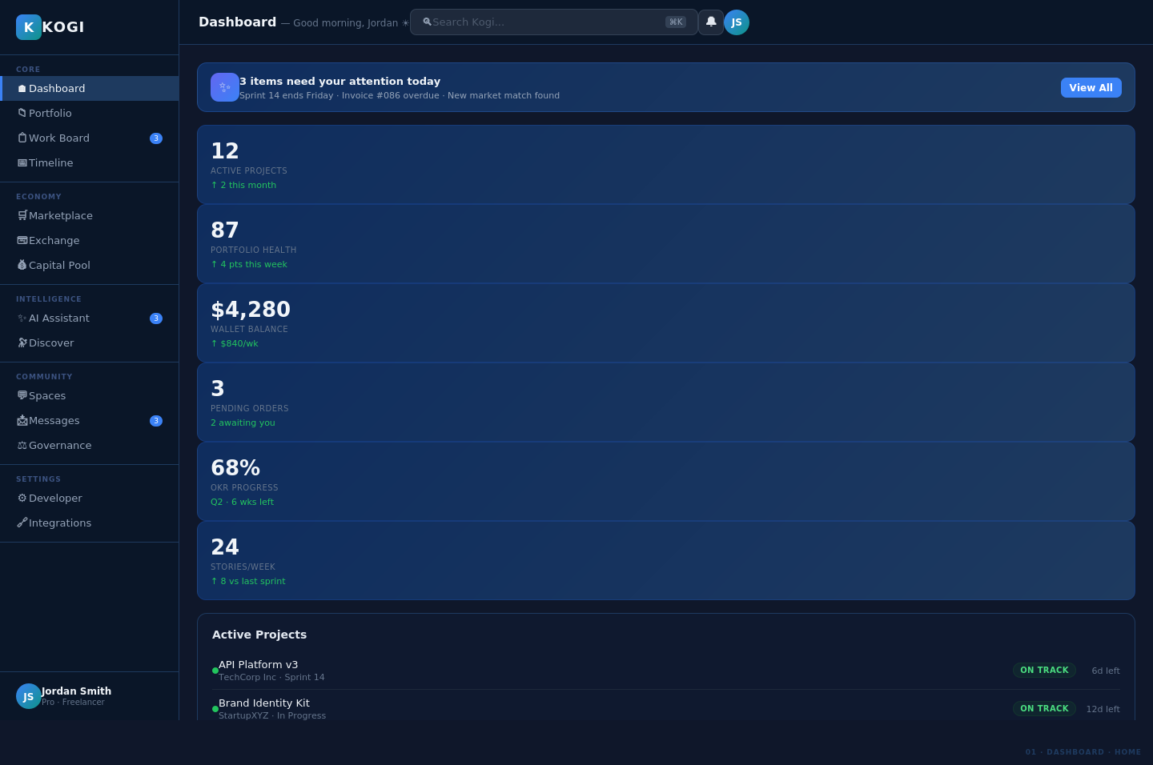

Portfolio Views
02 Portfolio — Grid Gallery View
Visual grid of all portfolio items (programs, projects, resources) with health scores, progress bars, and revenue tracking. Supports 4-column grid layout.
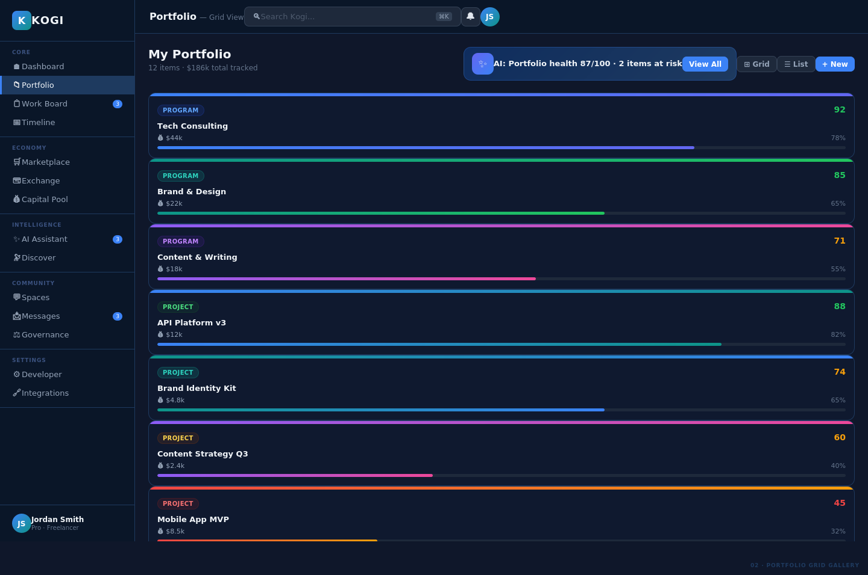

03 Programs + Projects — Tiles View
Rich program tiles showing nested projects, client details, skill tags, 4-metric stats grid, and gradient progress bars for each program.
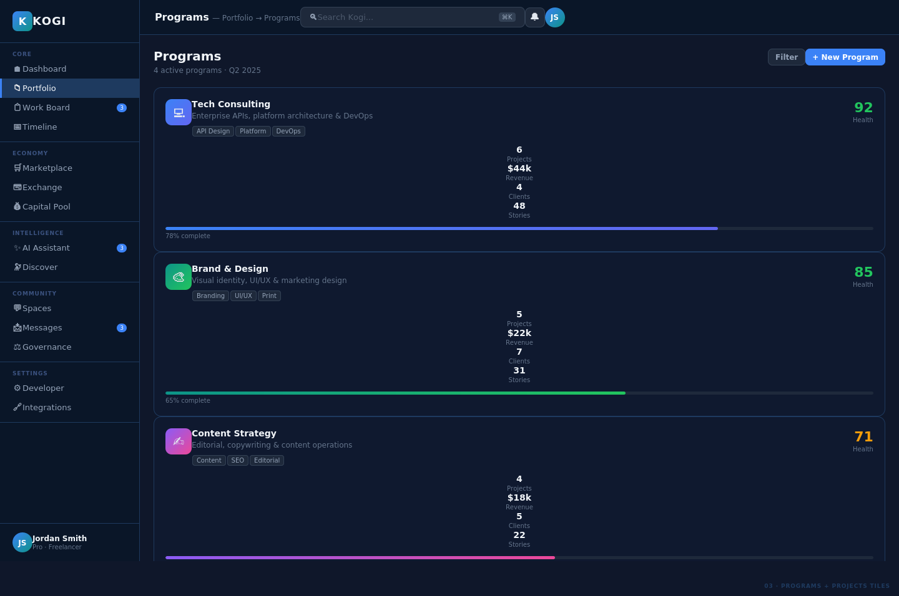

04 Template Gallery — Workspace Starters
Curated library of 8+ workspace templates organized by worker type: Freelance, Agency, Cooperative, OKR, Indie Maker, and more.
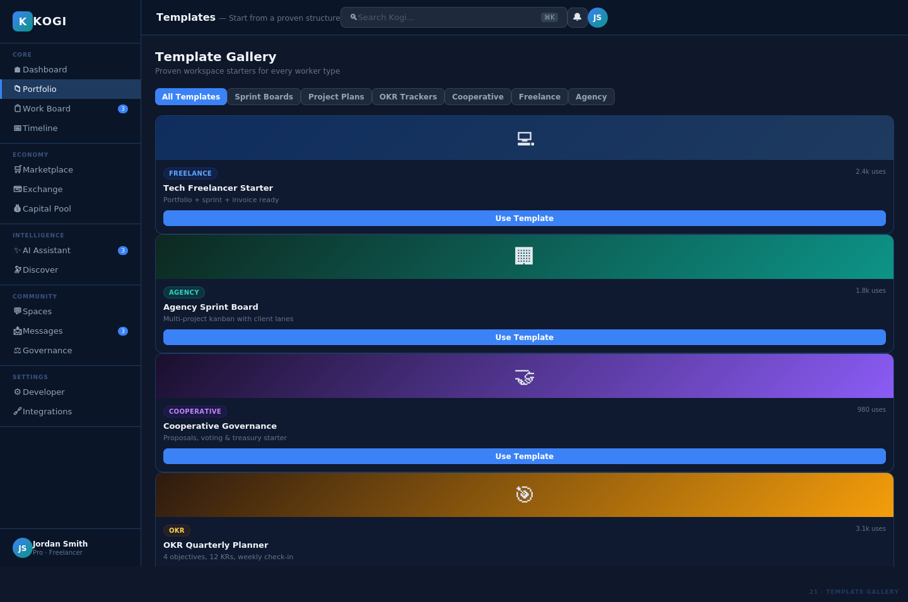

Work & Operations
05 Work Board — Kanban View
Five-column Kanban board (Backlog, In Progress, In Review, Done, Blocked) with story cards, point estimates, assignees, and AI blocker suggestions.
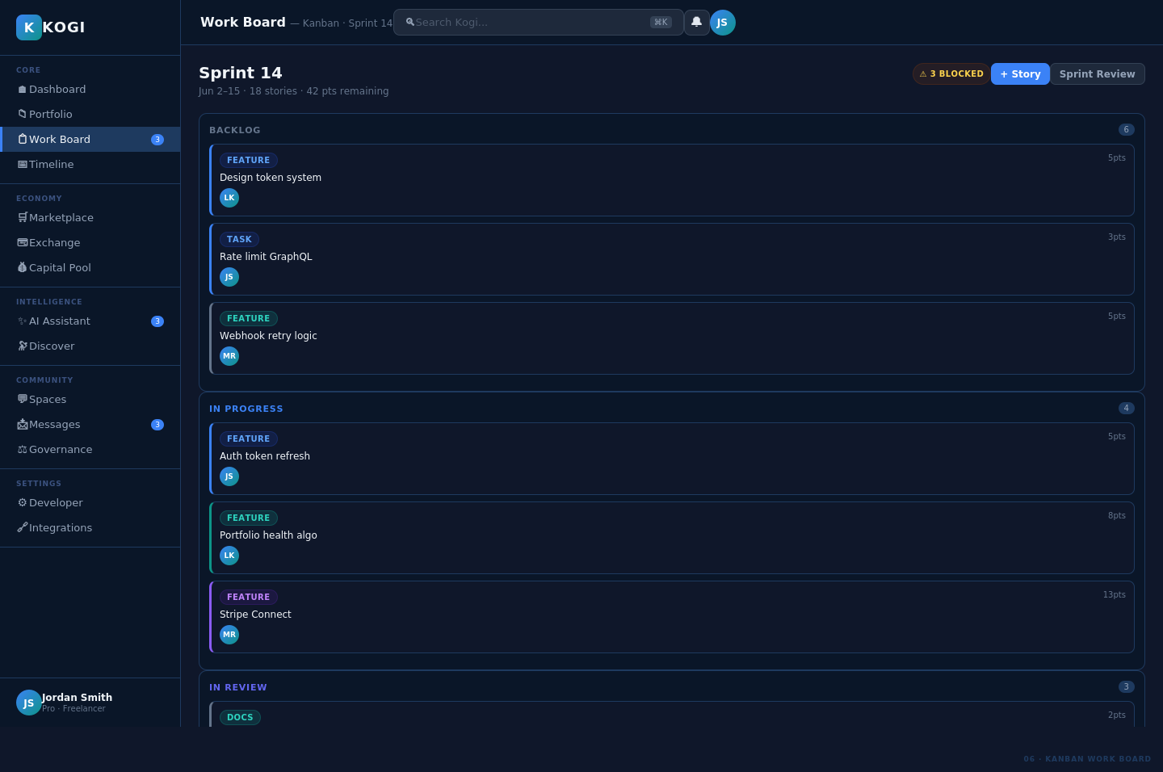

06 Strategy — OKR View
Four strategic objectives each with 3 key results shown as individual cards with current vs. target values, progress bars, and overall completion percentage.
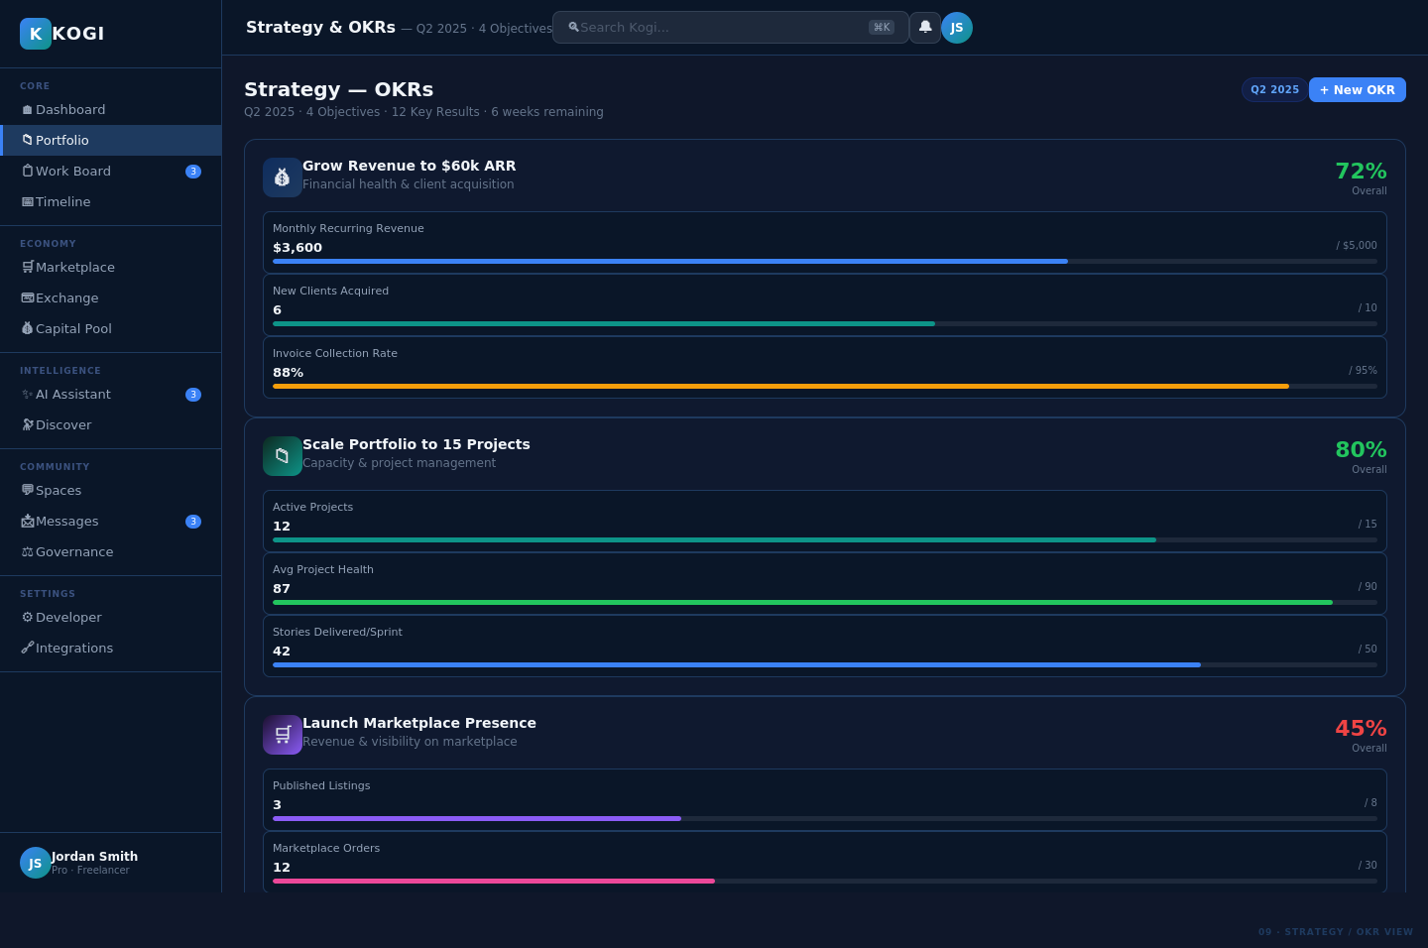

07 Roadmap — Now / Next / Later
Product roadmap organized into three phases (Now Q2, Next Q3, Later Q4+) showing initiatives tagged by team, effort size, and strategic theme.
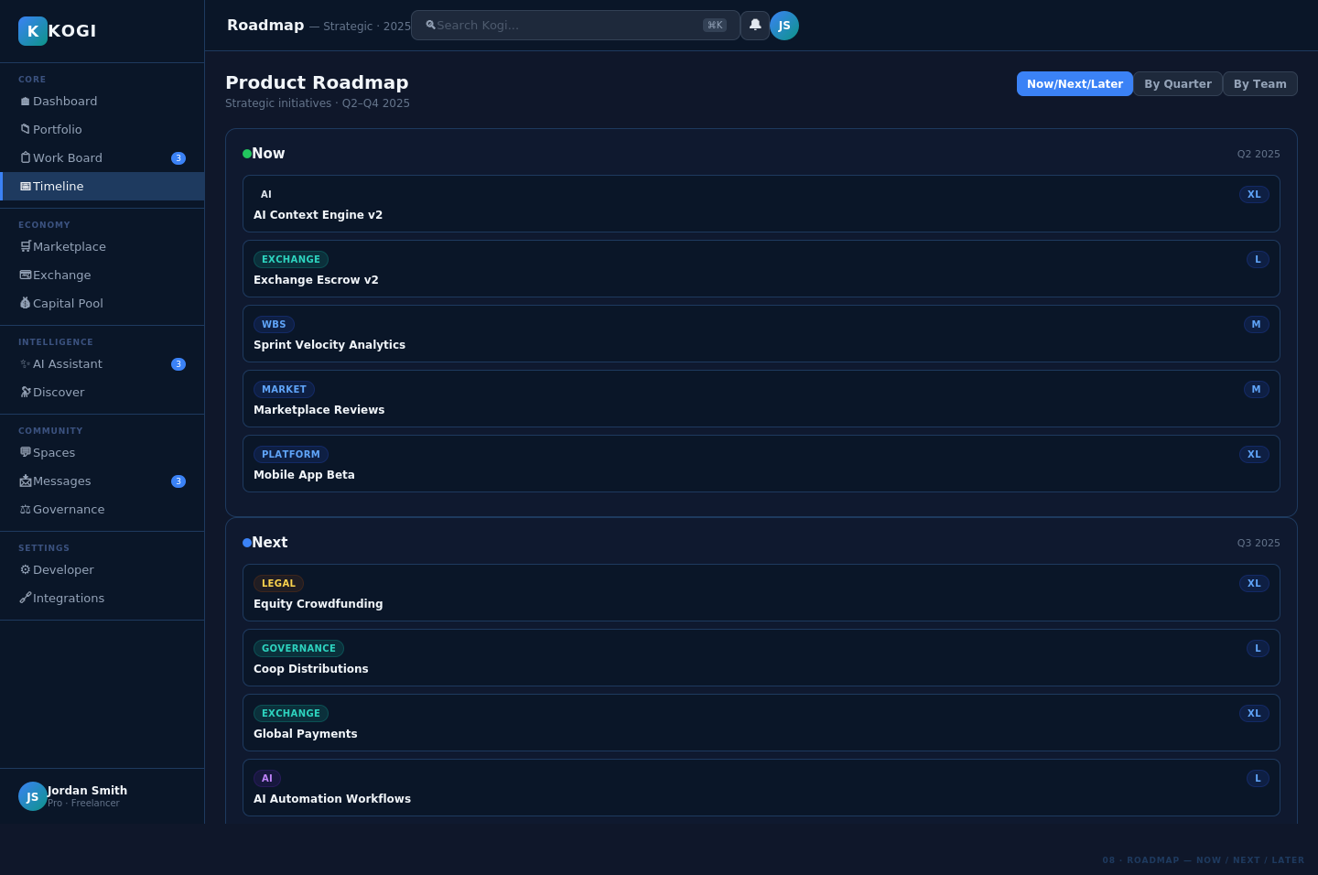

Timeline & Schedule
08 Gantt Chart
Full Gantt chart view with 12 tasks across 20 days. Hierarchical epics/stories, gradient completion bars, assignee avatars, and percentage complete indicators.
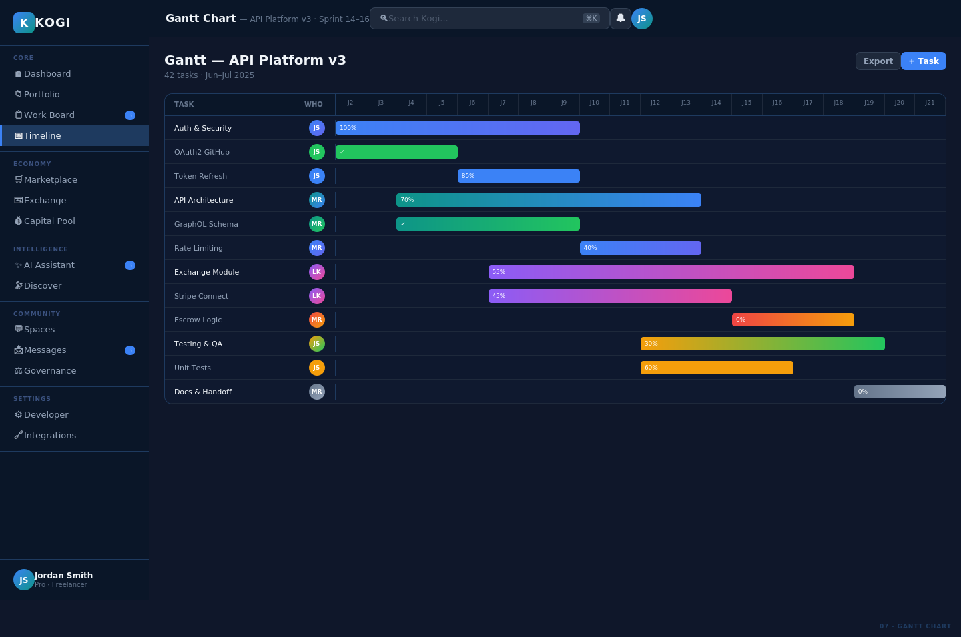

09 Schedule — Weekly Calendar
Weekly calendar grid (Mon–Sun) with color-coded event blocks by type (client, team, milestone, governance) alongside an upcoming events sidebar.
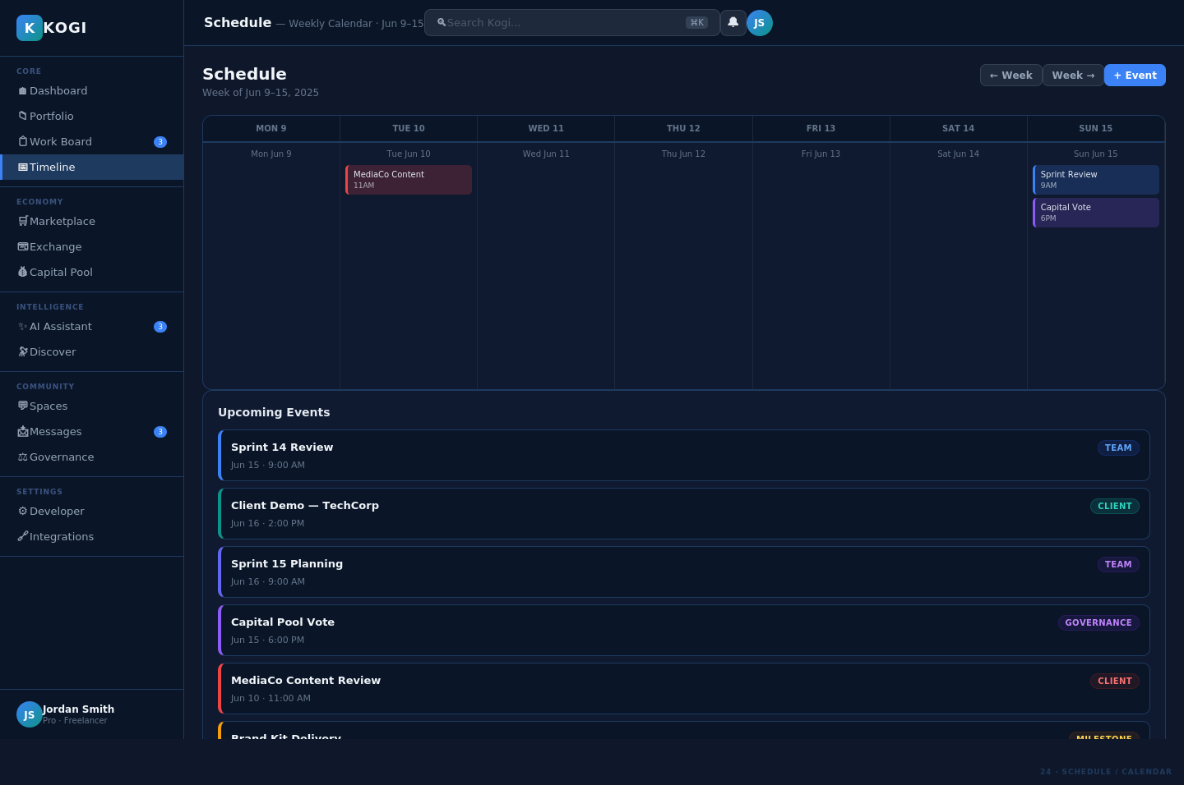

Marketplace & Exchange
10 Marketplace — Tiled Browse View
Service marketplace showing 8 tiled listings with cover gradients, category badges, seller ratings, delivery times, and direct order buttons.
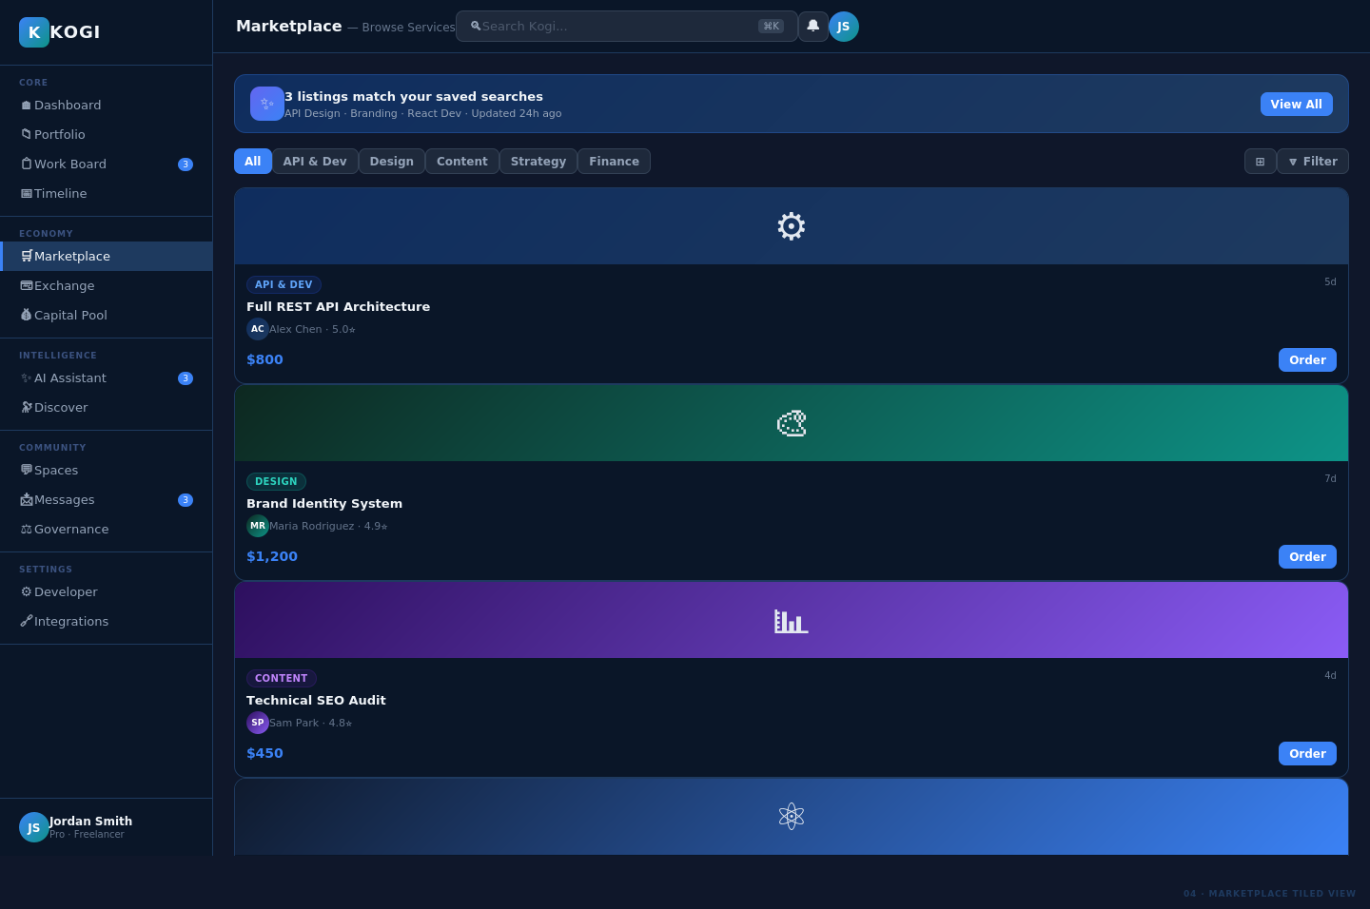

11 Exchange Wallet — Tiled Transactions
Wallet dashboard with balance card, payment methods, and 8 tiled recent transactions showing status badges, amounts, and date.
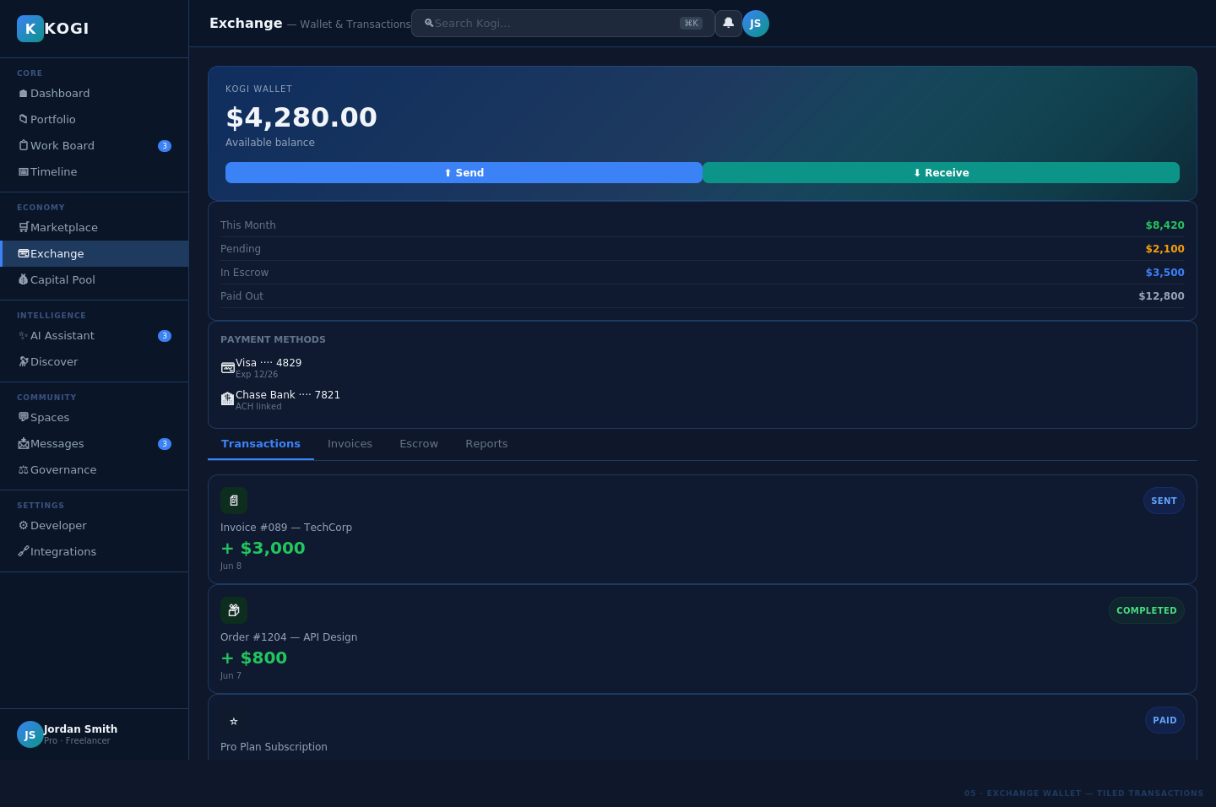

Governance & Cooperative
12 Governance — Cooperative AO
Autonomous Organization governance view with live voting proposals, donut-chart treasury allocation, and member roster with role badges.
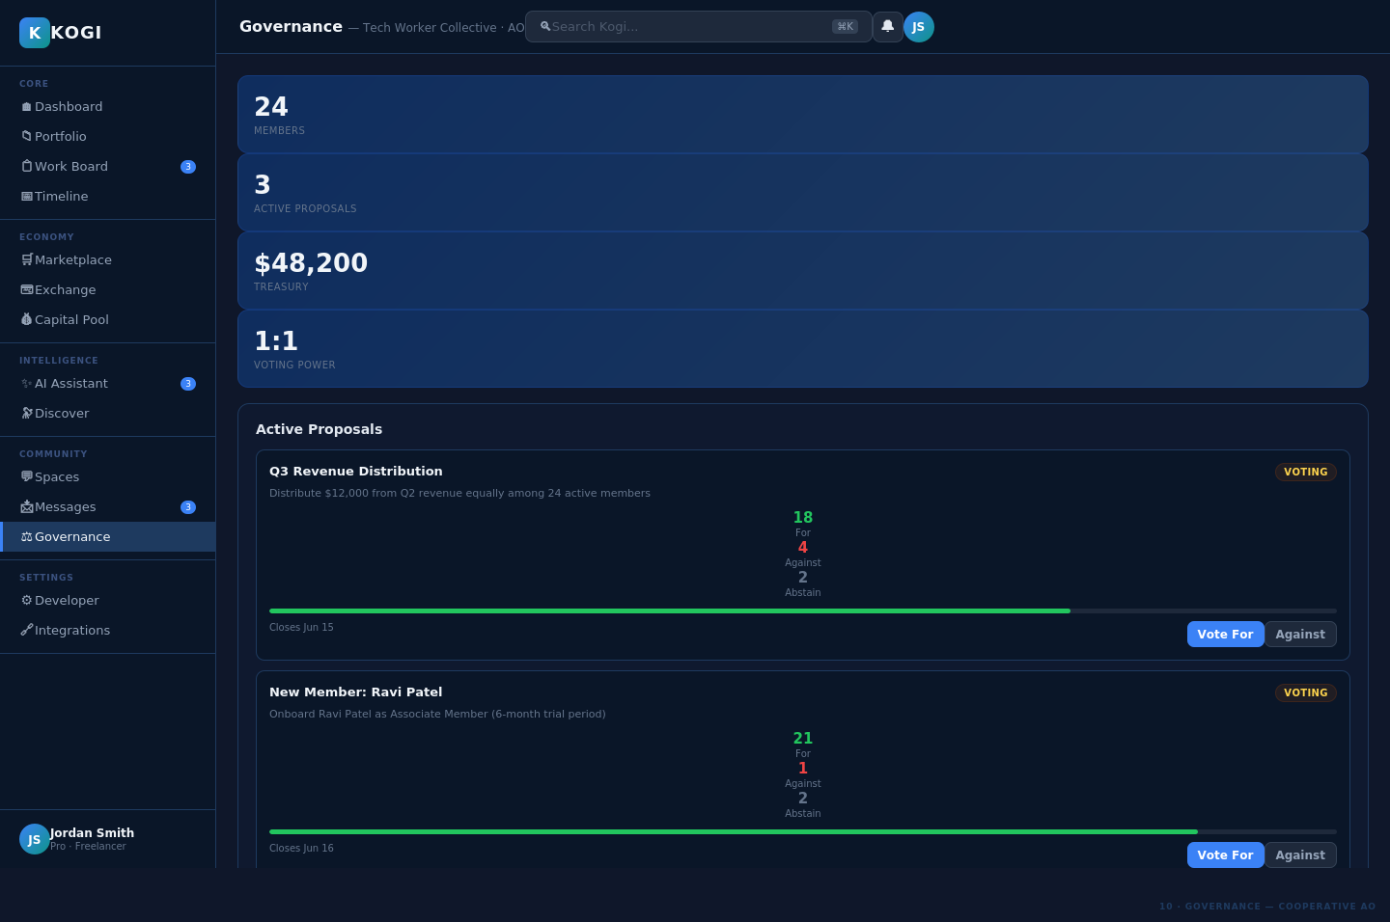

13 Capital Pool — Democratic Finance
Cooperative capital management with allocation breakdown by category, distribution history, personal stake tracker, and contribution timeline.
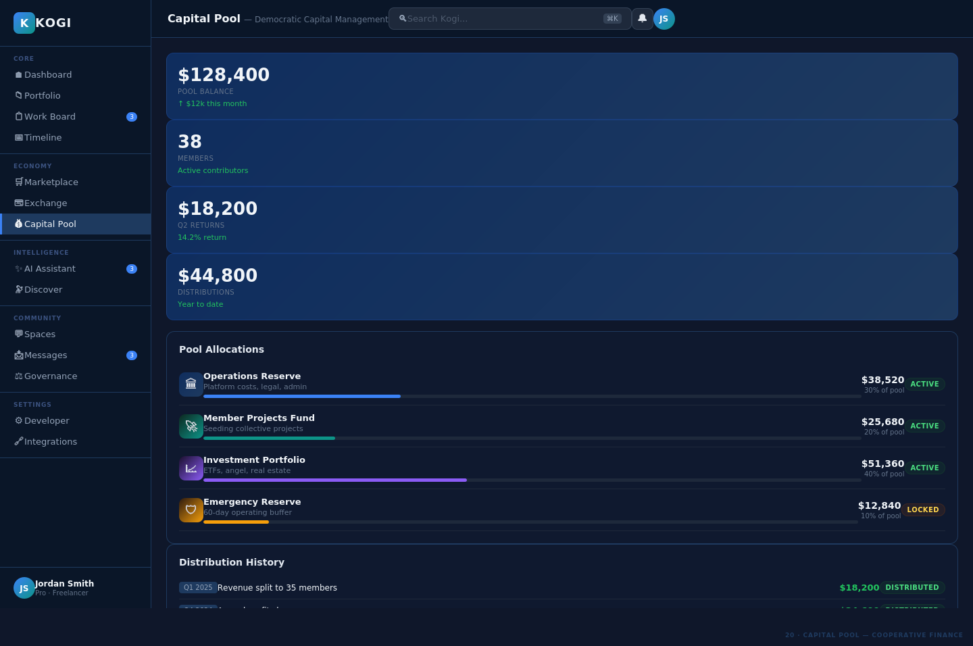

14 Team + Organization Structure
Team member cards with online status, story/point counts, department org chart, and sprint velocity bar chart across 5 sprints.
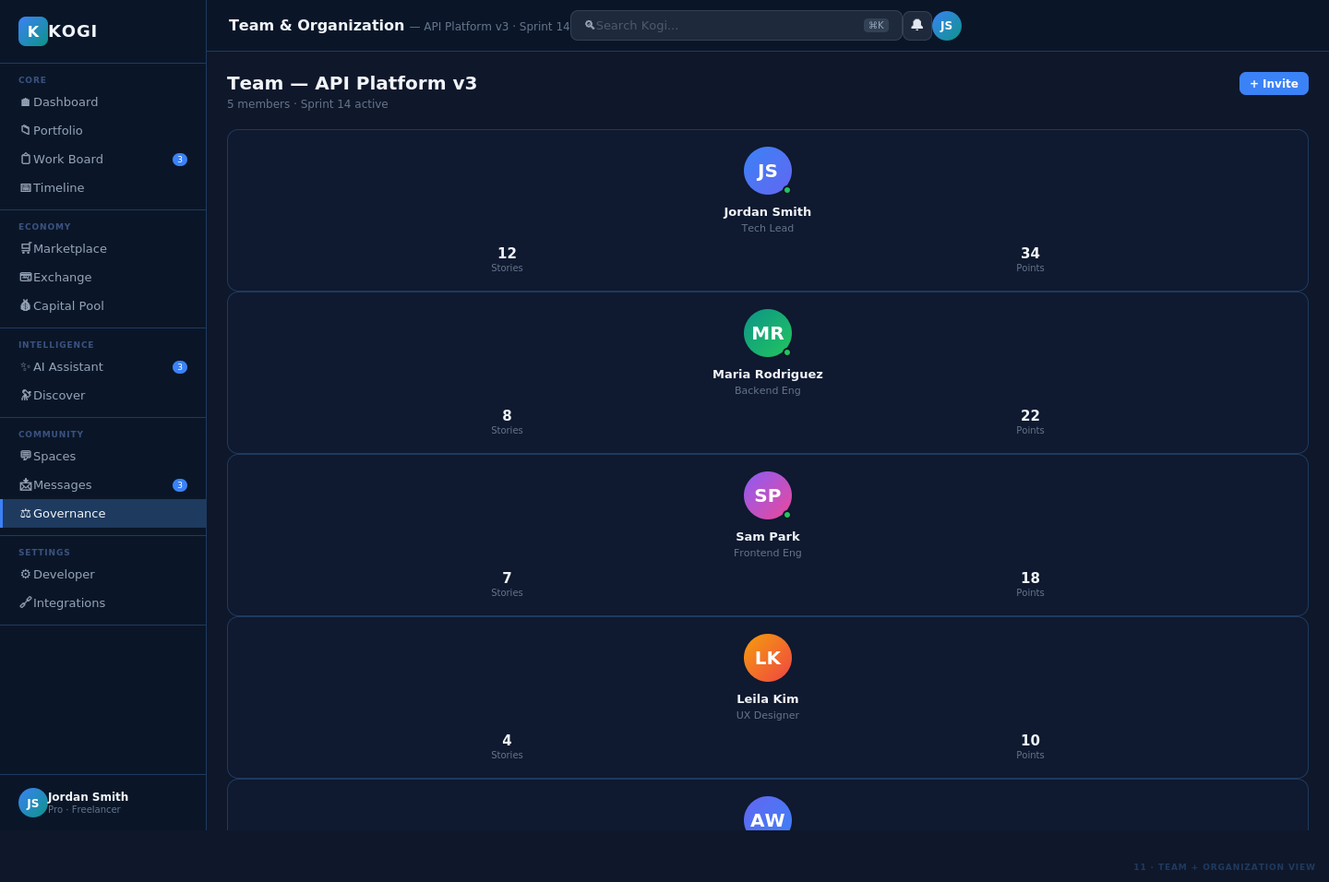

15 Individual Profile — Public View
Worker profile with avatar, stats, skill proficiency bars, portfolio highlights grid, availability badge, and verified client reviews.
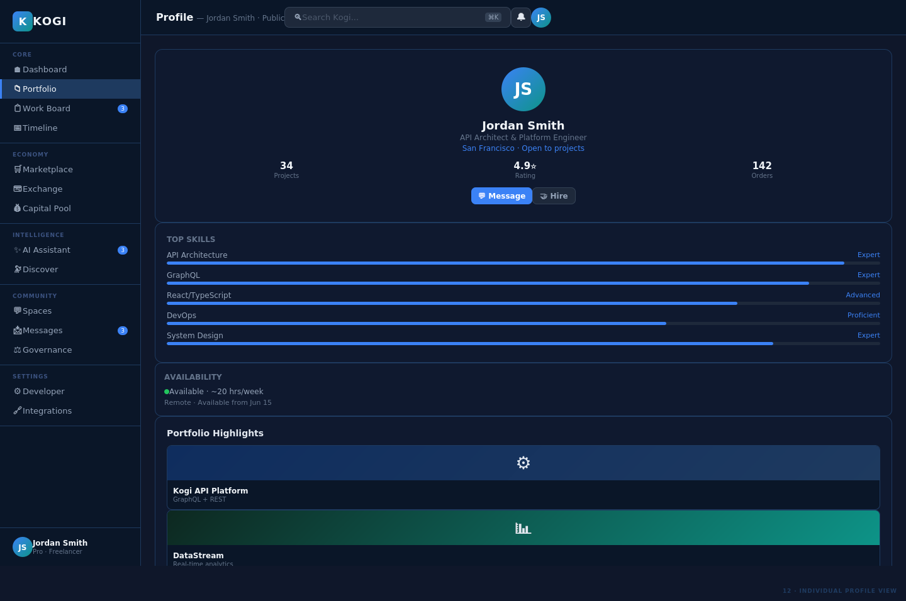

Community & Social
16 Spaces — Social Network Feed
Community spaces with sidebar navigation of joined spaces, trending topics, and a live social feed with posts, likes, comments, and sharing.
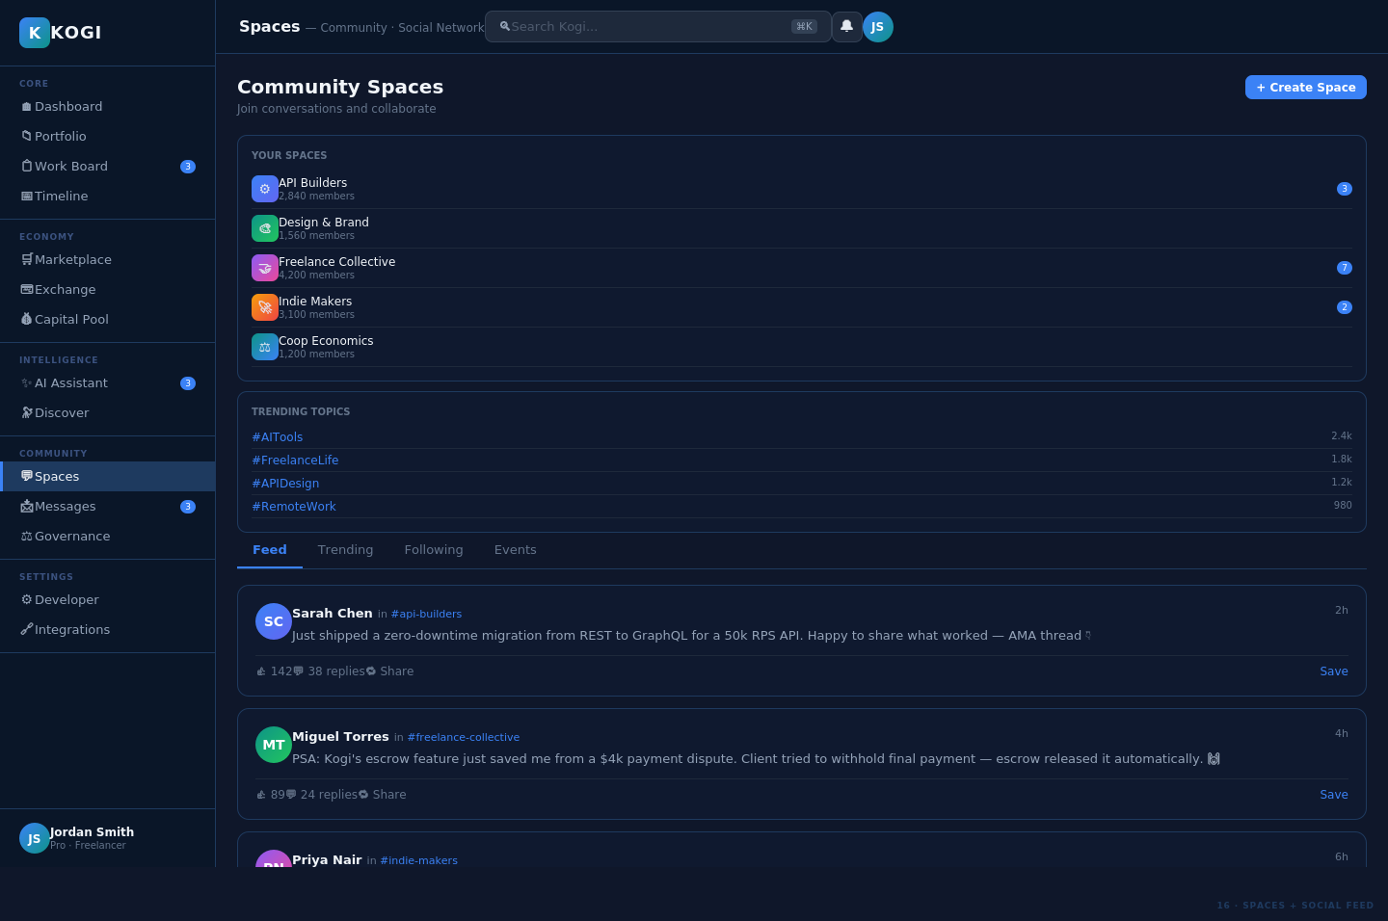

17 Messages — Direct + Group Chat
Two-panel messaging interface with conversation list (online indicators, unread counts) and full chat thread with file attachments and project linking.
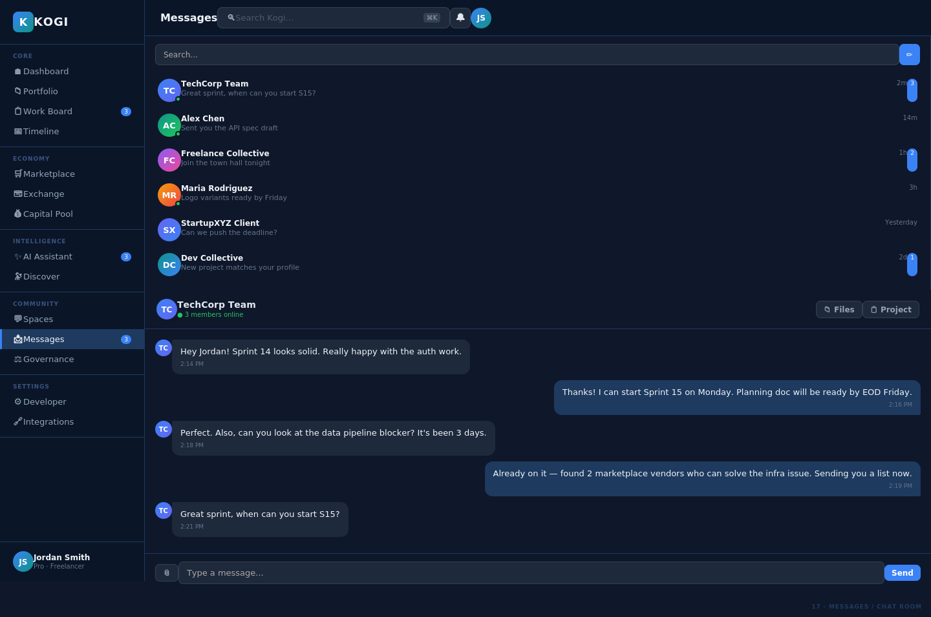

AI & Intelligence
18 AI Assistant — Contextual Chat
Three-panel AI assistant with context panel, conversational chat interface with action buttons on responses, and AI capabilities sidebar.
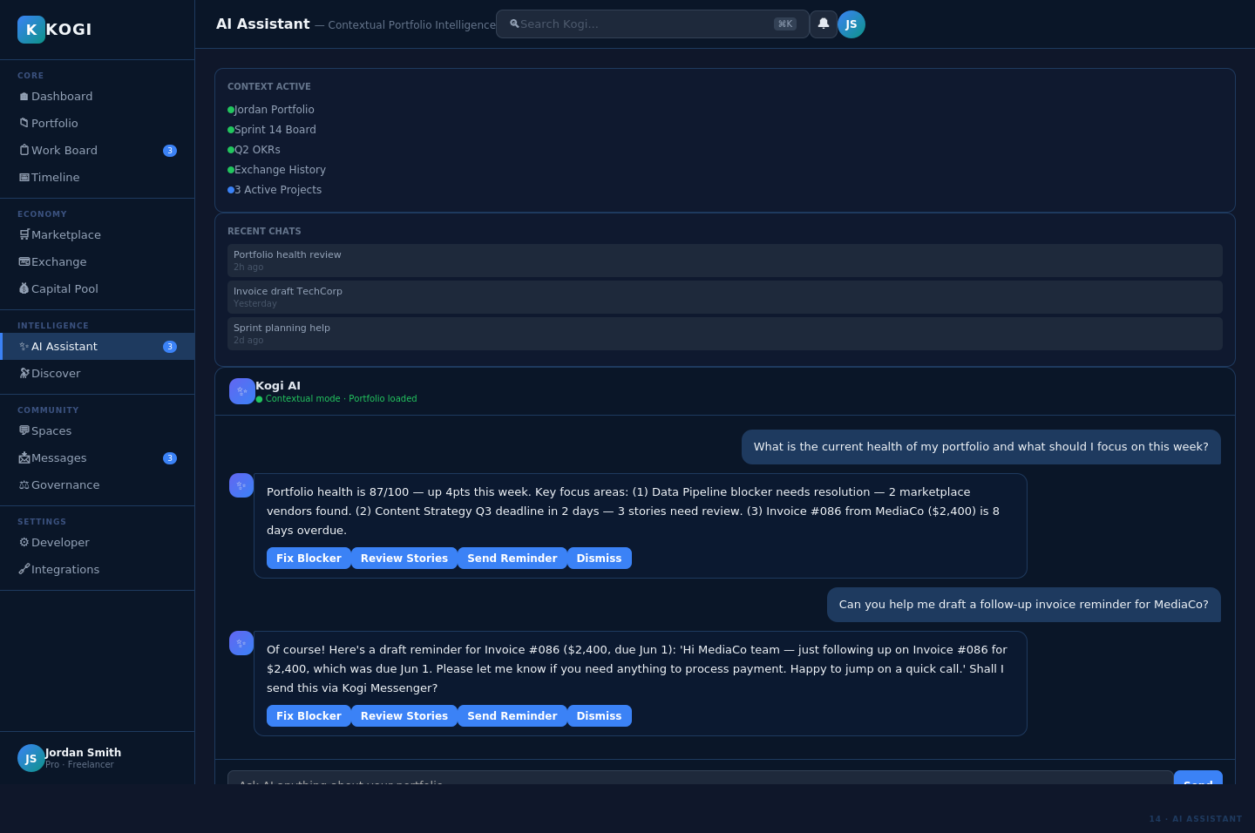

19 Discover — AI Recommendations + Search
AI-powered discovery with filter sidebar (keywords, type, skills match), personalized recommendation grid with match percentages, and multiple feed tabs.
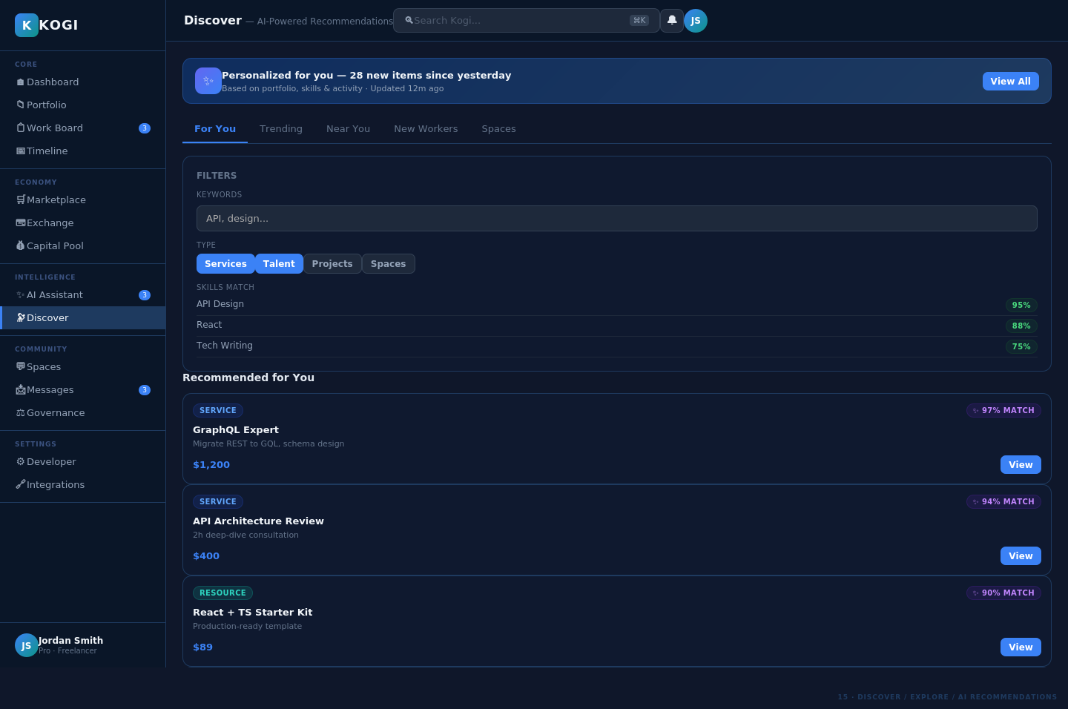

20 AI Workflows — Automation Builder
Visual workflow builder showing active automations list and a step-by-step workflow pipeline with status indicators (Done, Running, Pending).
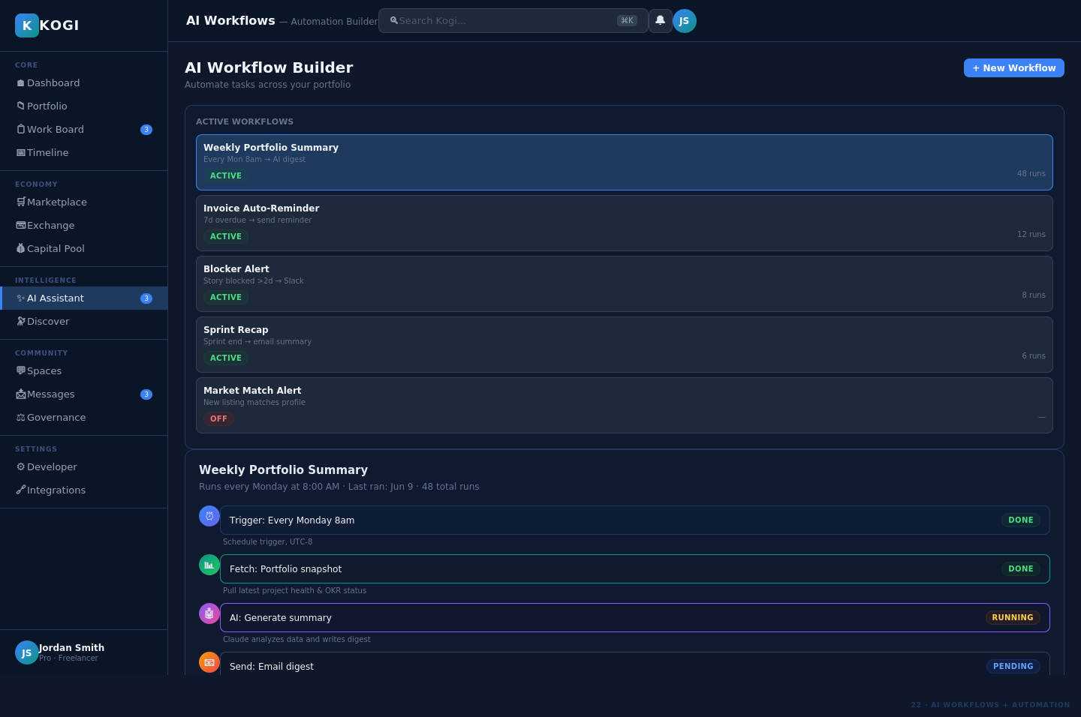

Resources & Assets
21 Resources — Assets, Capital & Labor
Resource management across three categories: Capital & Investments (with YTD returns), Tools & Software (with monthly costs), and Labor & Contractors.
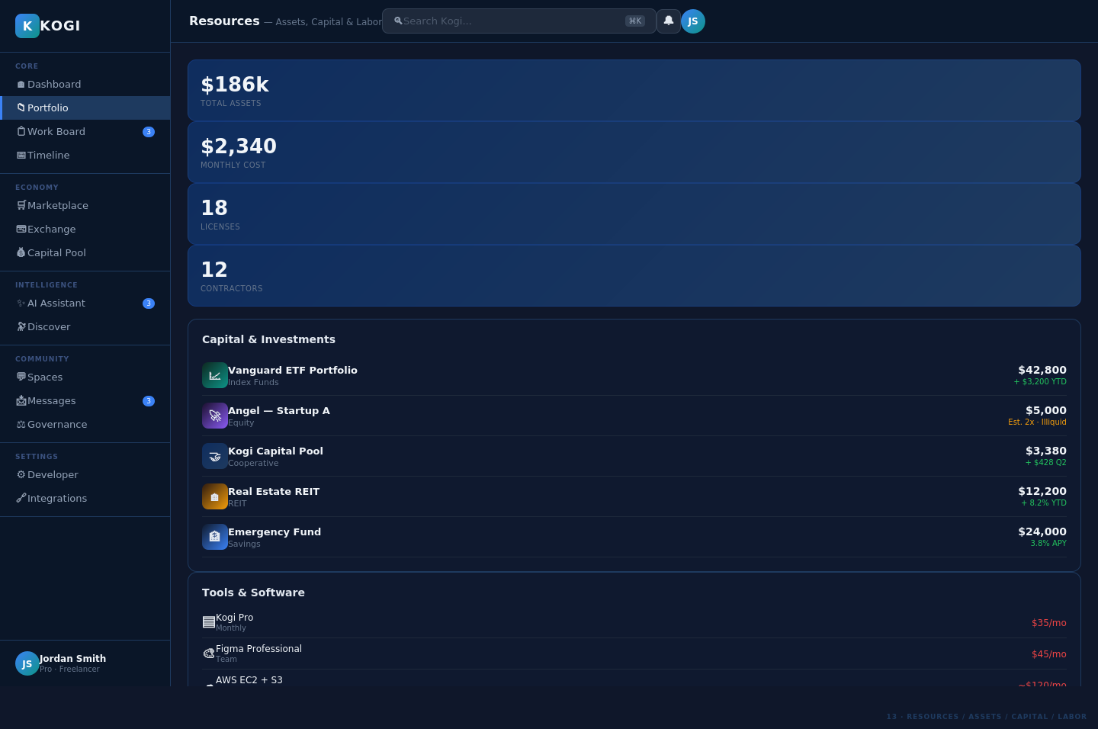

Developer & Integrations
22 Developer — API Keys & Webhooks
Developer portal with API key management (live/test/webhook keys), webhook endpoints with status, API usage progress bars, and SDK quick-start code snippet.
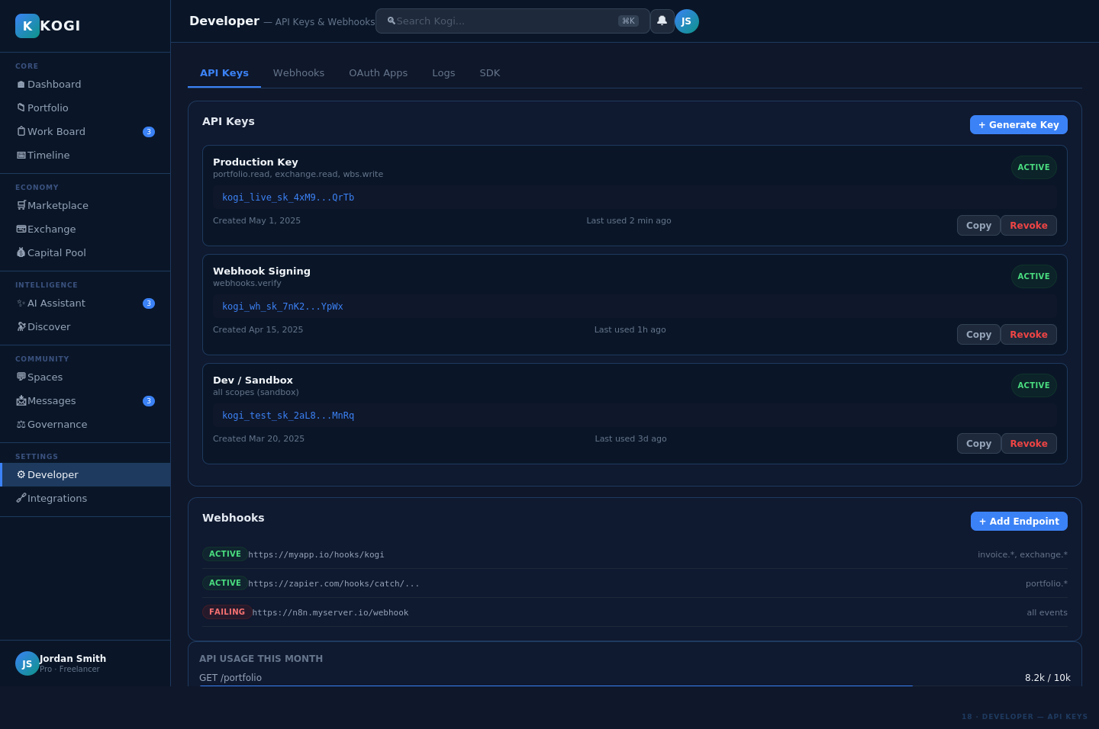

23 Integrations — 3rd Party Tools
12-tile integration gallery with connection status for Stripe, GitHub, Slack, Notion (connected) and Jira, Linear, Zapier, QuickBooks, and more (available).
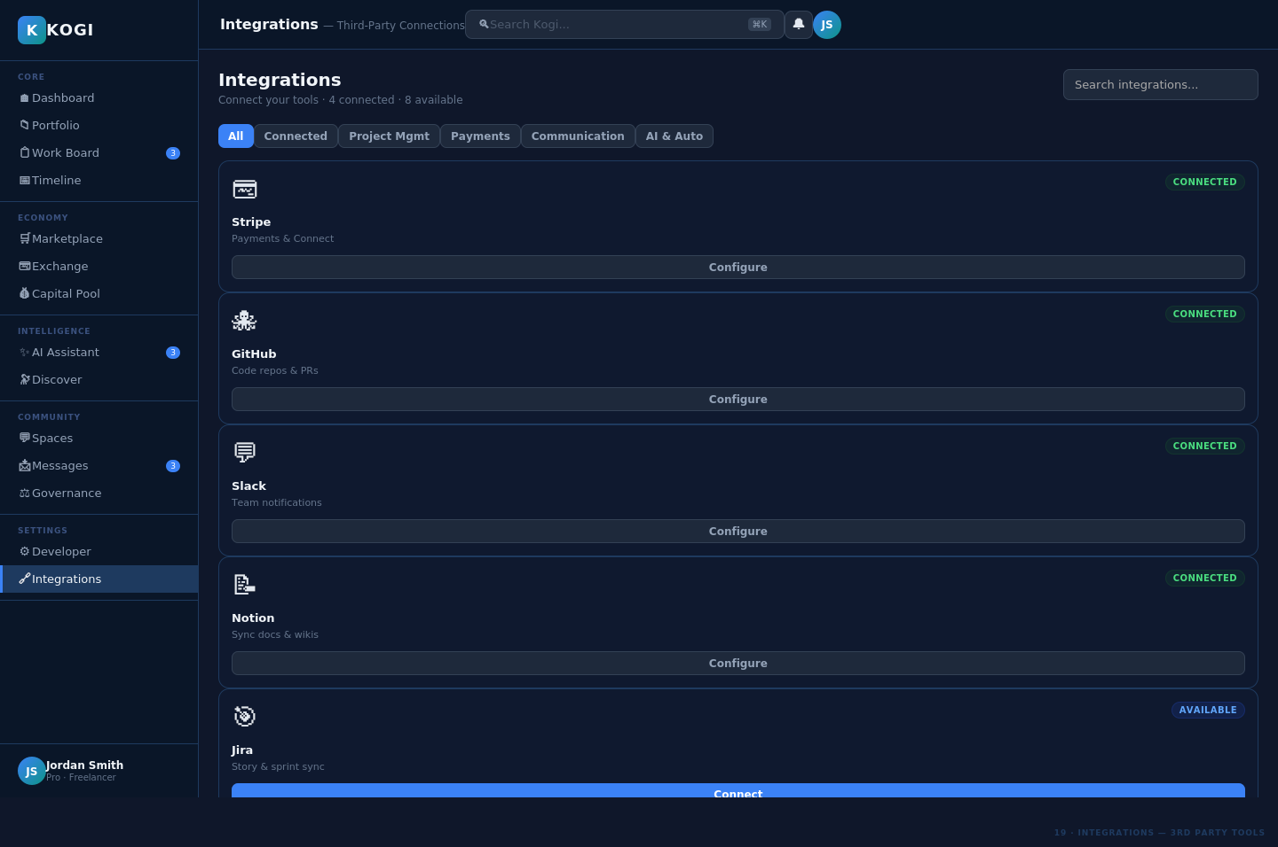

Analytics & Reporting
24 Analytics — Performance Dashboard
Analytics dashboard with 4 KPI stat cards, 6-month revenue bar chart, revenue-by-source donut chart, and top 5 projects ranked by revenue.
