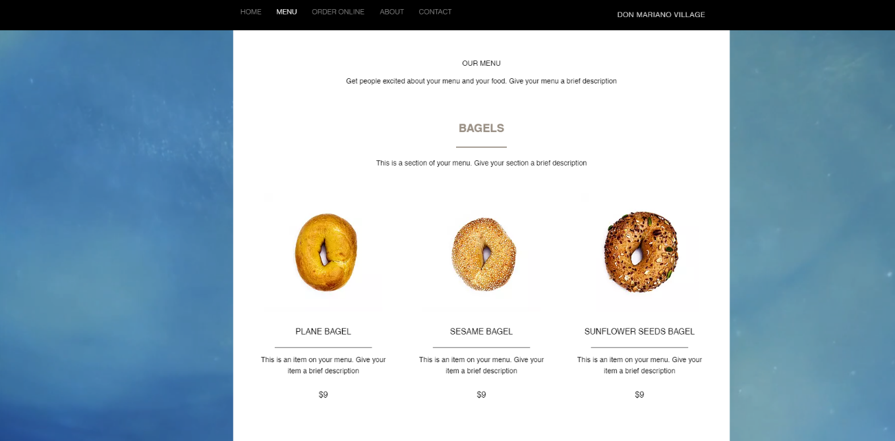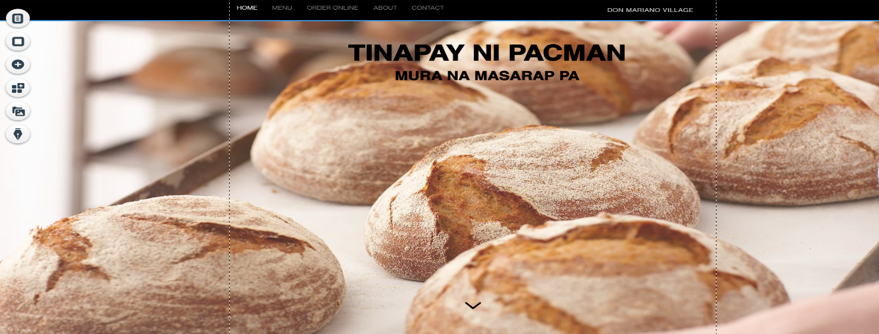

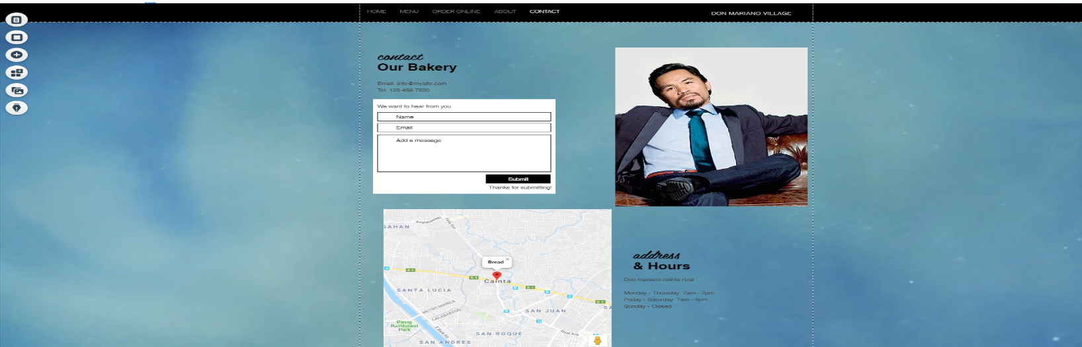

I create this website tinapay ni pacman because it will to the consumer to easily access our bread products and drinks. and it very easy to use by the people who visited the sites and the website consist the all of the menu and other things about the websites