Online Energy Utility Platform

Assignment 1

Name: Groza Dominic

Group: 30443

Teaching Assistant: Mitrea Dan

# Conceptual architecture of the online platform

The entities contained within the platform are:

* User
* Device
* Measurement

For each user, we have two roles:

* Client
* Administrator

Each client can:

* View all his/her devices
* Generate charts containing the energy consumption [kWh] for each hour in a selected day

Each administrator can:

* Create, edit, delete & view all users
* Create, edit, delete devices
* Assign a device to a user

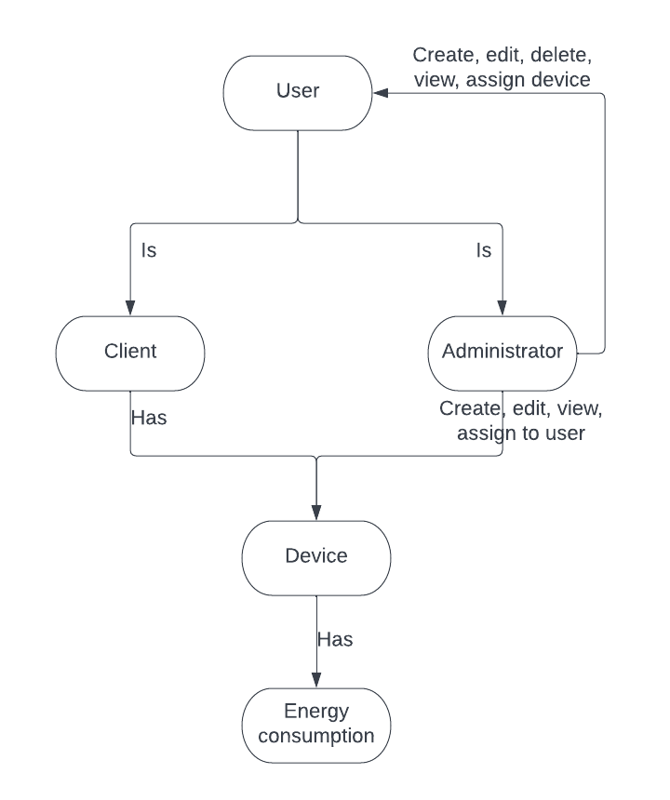

# Database design

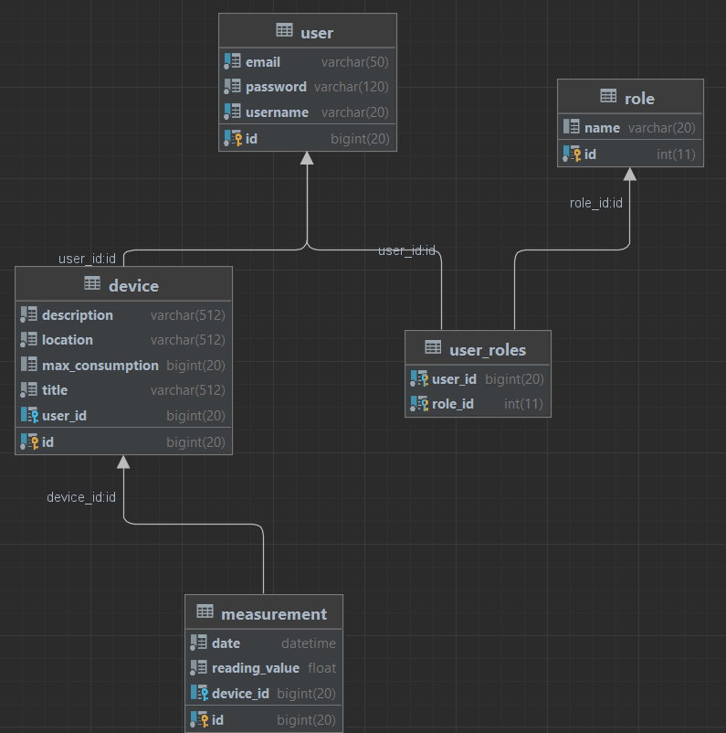

# UML Deployment Diagram

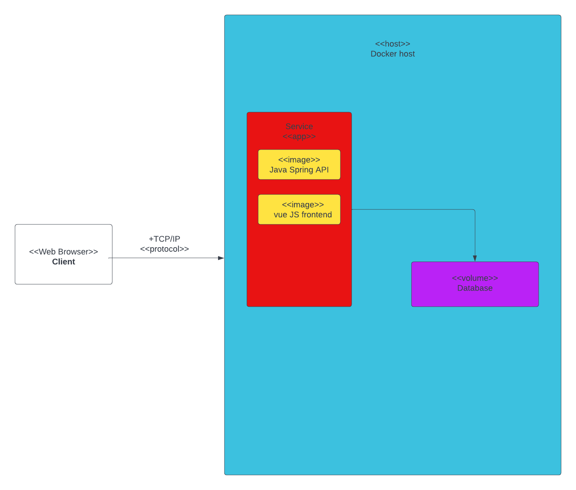

# Readme

