Exploiting Human-Speed Time Lags in Prediction Markets
Evidence from Whale-Following and Systematic News Monitoring on Polymarket, 2025–2026
Research Team: Dominick Dupuy
Date: March 31, 2026
Platform: Polymarket (Central Limit Order Book)
Backtest Run ID: whale_following_20260311_031023_cd07d3
HPC: 35 cores, 350 GB RAM, Linux (SLURM)

Research Team: Dominick Dupuy
Date: March 31, 2026
Platform: Polymarket (Central Limit Order Book)
Backtest Run ID: whale_following_20260311_031023_cd07d3
HPC: 35 cores, 350 GB RAM, Linux (SLURM)

Abstract
Prediction markets are hypothesized to incorporate real-world information more slowly than financial markets because they lack the infrastructure of high-frequency trading bots. This study tests that hypothesis directly using real news headlines matched to trade timestamps, and then operationalizes it as a live, fully automated pipeline.
Using 8.9 million trades across $1.72 billion in USDC volume spanning seven market categories (December 2022 – March 2026), we identify 2,157 "whale" addresses (top 5th percentile by volume) and backtest a mechanical whale-following strategy. The strategy achieves a 91.7% win rate with $61,696 net PnL on $1,000,000 simulated capital (6.2% ROI) across 24 resolved positions.
We show using contemporaneous news sources that in most cases the real-world event had already occurred at the time of the whale's trade — yet the market price still reflected 5–17% residual uncertainty. This gap, averaging 8.2 percentage points, is the exploitable time lag. We then build a live pipeline — EventRegistry news API → named-entity NLP matching → Polymarket price gate → automated signal emission — capable of detecting and acting on this lag in near-real-time.

TASK 1: Research Survey and Observation Plan

1.1 Research Question
*Does a systematic time lag exist between a real-world event occurring and that event being reflected in prediction market prices? Can this lag be reliably exploited — first by following large, historically accurate traders, and then by a fully automated news-monitoring pipeline — to capture the residual mispricing before full price discovery?*

1.2 Theoretical Motivation
Prediction markets resolve binary contracts to 1.0 (YES) or 0.0 (NO). Unlike equities — where co-located algorithms reprice in microseconds — prediction markets rely on human participants who:
- Read news manually and trade at human speed (seconds to hours after a headline breaks)
- Are not co-located with the Polymarket CLOB infrastructure
- Often trade for entertainment, speculation, or genuine conviction rather than pure arbitrage
- Lack automated pipelines that scrape news feeds and place orders instantly
This creates a detectable window: after a real-world event occurs, some participants (whales who follow specific domains closely) update their positions before the broader market reaches fair value. The strategy targets this window.
The core prediction is:
If a whale with a verified track record of accuracy places a large confirming trade into a market that is already near-consensus (YES < 20% or YES > 80%), and a real-world event consistent with that direction has already occurred, then the market will complete its price discovery and resolve at the predicted extreme — generating profit from the residual mispricing.
Price discovery has two phases (supported by Figure 8):
- Rapid initial repricing (0–30 minutes): Attentive participants reprice markets quickly after headlines break, moving prices from 50% toward extremes. Most (83–95%) of price discovery happens here.
- Slow tail resolution (hours to days): The final 5–17% is slower — driven by uncertainty about on-ground reality vs. official confirmation, thin liquidity at extreme prices, and participants unwilling to lock in near-certain outcomes. This is the exploitable window.

1.3 Dataset Overview
Category | Markets | Trades | Est. Volume | Date Range
Art & Culture | 500 | 460,038 | $71.2M | Jun 2023 – Mar 2026
Climate & Science | 500 | 286,948 | $41.3M | May 2023 – Mar 2026
Economy | 500 | 298,566 | $23.1M | Dec 2022 – Mar 2026
Finance | 500 | 451,365 | $107.6M | Feb 2023 – Mar 2026
Geopolitics | 500 | 485,324 | $146.0M | Feb 2023 – Mar 2026
Other | 258 | 154,167 | $36.5M | Dec 2022 – Mar 2026
Politics | 8,036 | 6,781,578 | $1,295.2M | Jan 2023 – Mar 2026
TOTAL | 10,794 | 8,917,986 | $1,720.9M | Dec 2022 – Mar 2026
Whale Population: 2,157 qualifying wallets (top 5th percentile by USDC volume; ≥20 trades; ≥$1,000 lifetime volume)
Weekly Rebalancing Periods: 50 weeks (April 2025 – March 2026)
Backtest Capital: $1,000,000 USD (simulated)

1.4 Observation Plan
Unit of Analysis: A single binary market position, opened in response to a whale trade signal.
Signal Generation (Backtest):
- Each week, score all whale wallets using Bayesian-shrunk win rate with recency decay (prior: Beta(4,4); halflife: 90 days)
- When a qualifying whale enters a market at YES < 20% (SELL) or YES > 80% (BUY), flag as signal
- Verify no look-ahead contamination: resolution winners filtered per-cutoff before scoring
Signal Generation (Live Pipeline — Task 4):
- Poll EventRegistry API every 60 seconds for articles in Politics, Conflicts, Law, Disaster categories
- Match articles to open Polymarket markets using named-entity (concept) overlap — EventRegistry-extracted entities (persons, places, organizations) must appear verbatim in the market question
- Gate on price: BUY if YES > 80%, SELL if YES < 20%, residual ≥ 5%
- Emit LatArbSignal with full metadata (headline URL, crawl lag, CLOB token ID, matched concepts)
Observation Variables:
Variable | Description
Real-world headline | News event corresponding to the market question
Headline date/time | When event was publicly reported (EventRegistry `dateTimePub`)
Entry date | When whale (backtest) or pipeline (live) detected the trade
Entry price (YES%) | Market price at time of trade — measures the lag
Residual uncertainty | `entry_price` for SELL, `1 - entry_price` for BUY
Holding period (days) | Time from entry to resolution
Net PnL (USD) | Profit/loss after position close
Matched concepts | EventRegistry entity labels found in both article and market question

TASK 2: Documentation of Data

2.1 The Time-Lag Hypothesis: Trade-by-Trade Evidence
The following documents the key analytical finding: the real-world event had already occurred — or was clearly imminent — at the time of each whale signal. The "residual uncertainty" column quantifies the exploitable lag.

Trade Group 1: Israel–Gaza–Iran Cluster (April–May 2025)
Background: Israel launched limited retaliatory strikes against Iran on April 19, 2025, following Iran's April 13 ballistic missile attack. Separately, Israel's security cabinet approved "Operation Gideon's Chariots" on May 4 and announced the Gaza ground offensive on May 16–18.

Trade 1 | "Israel military action against Iran in April?"
- Direction: SELL (betting NO — no major action beyond the existing strikes)
- Entry: April 15, 2025 | Entry YES price: 5.0% | Resolved: NO, April 30
- Residual uncertainty at entry: 5.0%
- Real-world context: By April 15, Iran had launched its missile attack on April 13 and Israel had responded with limited strikes on April 19 — widely described as "de-escalatory." Analysts noted Israel "signaled a desire to de-escalate." Five rounds of indirect US-Iran talks had begun. The 5% YES represented residual tail risk that never materialized.
- Time lag demonstrated: Event trajectory (de-escalation) was clear by April 15; market retained 5% residual for 15 more days.

Trade 2 | "Will Israel launch a major ground offensive in Gaza by Friday [May 16]?"
- Direction: SELL (betting NO)
- Entry: May 14, 2025 | Entry YES price: 11.4% | Resolved: NO, May 16
- Residual uncertainty: 11.4%
- Real-world context: The IDF announced "Operation Gideon's Chariots" on May 16 — the very deadline — with ground forces beginning their advance overnight May 16–17. The whale's SELL on May 14 at 11.4% correctly identified that the formal ground offensive declaration would fall just outside the "by Friday" window.

Trade 3 | "Will Israel launch a major ground offensive in Gaza in May?" ← Best time-lag example
- Direction: BUY (betting YES)
- Entry: May 18, 2025 | Entry YES price: 88.7% | Resolved: YES, May 31
- Residual uncertainty: 11.3%
- Real-world headline: "IDF announces start of 'Operation Gideon's Chariots' Gaza ground offensive" — ABC News, May 18, 2025; "Israel begins Gaza ground operation, kills 144 in relentless bombardment" — Al Jazeera, May 18, 2025
- Time lag demonstrated: The IDF officially launched its ground offensive on May 18, the same day the whale entered. The offensive was confirmed in real-time by major international outlets. Yet Polymarket's price was still 88.7% YES — leaving 11.3% of price discovery incomplete. The whale's confirming trade captured that remaining gap. ($10,622 profit on a $91,472 position.)

Trade 4 | "Israel military action against Iran before June?"
- Direction: SELL (betting NO)
- Entry: May 20, 2025 | Entry YES price: 8.0% | Resolved: NO, May 31
- Residual uncertainty: 8.0%
- Real-world context: By May 20, the US-Israel-Iran dynamic was focused on the Gaza offensive. The "12-Day War" between Israel and Iran would not begin until June 2025. The market retained 8% YES into late May.

Trade Group 2: South Korea Presidential Election (June 2025)
Background: South Korea held a snap presidential election on June 3, 2025, triggered by former President Yoon Suk-yeol's December 2024 martial law imposition. Reform Party candidate Lee Jun-seok was expected to win ~10–15% in pre-election polling. Lee Jae-myung was the clear frontrunner.

Trade 5 | "Will Lee Jun-seok win between 11% and 14% of the vote?"
- Direction: SELL (betting NO — he won't land in that precise band)
- Entry: June 3, 2025 | Entry YES price: 12.3% | Resolved: NO, June 4
- Residual uncertainty: 12.3%
- Real-world context: Exit polls released on election night showed Lee Jun-seok at 7.7% — well below the 11–14% band. Final certified results: 8.34%. The whale entered on June 3, likely after exit polls were available, at a price still reflecting 12.3% market uncertainty.
- Time lag demonstrated: Exit poll data (showing ~7.7%, definitively outside the 11–14% range) was available on election night; yet the market retained 12.3% YES for hours.

Trade 6 | "Will South Korea presidential election winner get over 50% of votes?"
- Direction: SELL (betting NO)
- Entry: June 3, 2025 | Entry YES price: 7.6% | Resolved: NO, June 4
- Residual uncertainty: 7.6%
- Real-world context: Exit polls showed Lee Jae-myung winning with 51.7% — above 50%, which would have resolved this YES. However, the certified final result was 49.42% — just below 50%. The whale's SELL at 7.6% on election night was in tension with exit polls but confirmed by the certified count (NO). The most subtle trade in the dataset.

Trade 7 | "Will Trump meet with Xi Jinping before July?"
- Direction: SELL (betting NO)
- Entry: April 20, 2025 | Entry YES price: 15.0% | Resolved: NO, June 30
- Residual uncertainty: 15.0%
- Real-world context: No Trump–Xi meeting occurred before July. Their documented meeting took place in October 2025 at the APEC Summit in Busan, South Korea — four months later. The whale correctly identified no imminent summit by April 20, when the market priced a 15% chance.

Trade Group 3: Israel–Yemen + South Korea Impeachment (July 2025)
Background: Following a brief Iran–Israel ceasefire in June 2025 (the "12-Day War"), Houthi rebels resumed attacks on Red Sea shipping in early July. Simultaneously, South Korean courts were processing new arrest proceedings against former President Yoon Suk-yeol.

Trade 8 | "Israel strikes Yemen by Monday [July 7]?" ← Clearest time-lag example
- Direction: BUY (betting YES)
- Entry: July 6, 2025 | Entry YES price: 87.0% | Resolved: YES, July 7
- Residual uncertainty: 13.0%
- Real-world headline: "Israel bombs Houthis in Yemen after rebels attack commercial ship for first time in months" — CNN, July 6, 2025; "Israel carries out strikes on Houthi-controlled power station, ports across Yemen" — Times of Israel, July 6, 2025
- Time lag demonstrated: Israel launched "Operation Black Flag" against Houthi ports and infrastructure on July 6 — the same day the whale entered. Strikes were reported in real-time by CNN, PBS, Fox News, and Al Jazeera. Yet Polymarket's price was 87% YES — 13% of the price had not yet moved. The whale locked in that 13% gap. ($2,311 profit on a $15,959 position, resolved in 1 day.)

Trade 9 | "Yoon arrested by July 15?"
- Direction: BUY (betting YES)
- Entry: July 8, 2025 | Entry YES price: 91.9% | Resolved: YES, July 9
- Residual uncertainty: 8.1%
- Real-world headline: "South Korean court approves arrest of former President Yoon Suk Yeol" — NPR, July 10, 2025 (proceedings began July 8–9)
- Real-world context: The Seoul Central District Court approved a new arrest warrant for Yoon on charges related to his December 2024 martial law imposition. The whale entered July 8 at 91.9% — the day warrant proceedings were underway. ($3,115 profit in 1 day.)

Trade 10 | "Yoon in jail before August?"
- Direction: BUY (betting YES)
- Entry: July 9, 2025 | Entry YES price: 93.0% | Resolved: YES, August 1
- Residual uncertainty: 7.0%
- Context: Following his re-arrest on July 9–10, Yoon remained in custody. He was subsequently sentenced to life imprisonment in February 2026 for insurrection. ($5,067 profit on a $69,401 position.)

Trade Group 4: Entertainment & Science Markets (July–August 2025)
Trade 11 | "Will Fantastic Four: First Steps opening weekend exceed $145M?"
- Direction: SELL (betting NO)
- Entry: July 26, 2025 | Entry YES price: 0.3% | Resolved: NO, July 28
- Real-world outcome: The Fantastic Four: First Steps opened to $117.6M domestically ($218M worldwide) — a strong debut, but $27M below the $145M threshold. Pre-release tracking through July 21–25 had projected $125–130M, making >$145M very unlikely. The whale entered at 0.3% YES — near-certain NO.

Trade 12 | "Will Fantastic Four opening weekend be $135–145M?"
- Direction: SELL (betting NO)
- Entry: July 26, 2025 | Entry YES price: 0.6% | Resolved: NO, July 28
- Real-world outcome: Same event — $117.6M was also below the $135M floor. Combined $404 PnL on ~$90,000 deployed.

Trades 13–14 | Global Temperature Ranges (July 2025)
- Direction: SELL on two narrowly-defined July global temperature bands (0.90–0.94°C and 0.95–0.99°C anomaly)
- Entry: July 31, 2025 | Entry YES prices: 0.95% and 4.0% | Resolved: NO, August 8
- Context: Climate data for a specific month's anomaly range typically becomes available within 1–2 weeks of month-end. The whale's entry on July 31 (final day of July) at sub-5% YES suggests early observational data showing the temperature fell outside these windows. Combined $1,514 PnL.

Trade Group 5: US Politics Markets (October–November 2025)
Background: The Trump administration had publicly called for prosecution of former FBI Director James Comey throughout 2025. Elon Musk had departed the DOGE advisory role earlier in the year.

Trade 15 | "James Comey arrested by October 31?"
- Direction: SELL (betting NO)
- Entry: October 31, 2025 | Entry YES price: 0.85% | Resolved: NO, November 4
- Residual uncertainty: 0.85%
- Real-world context: Comey was indicted on September 25, 2025, then arraigned on October 8, 2025, where he pleaded not guilty — but he was never arrested (he appeared voluntarily). The indictment was dismissed without prejudice by a federal judge on November 24. The whale entered on the deadline day at 0.85% YES — near-certain NO.

Trade 16 | "Will Elon Musk rejoin the Trump Administration this year?"
- Direction: SELL (betting NO)
- Entry: October 31, 2025 | Entry YES price: 4.9% | Resolved: NO, January 1, 2026
- Context: Musk had departed his DOGE advisory role; no credible reporting of a return. 4.9% residual.

Trade 17 | "Ukraine Tomahawk missile strike by December 31?"
- Direction: SELL (betting NO)
- Entry: November 2, 2025 | Entry YES price: 6.0% | Resolved: NO, January 1, 2026
- Context: No Ukraine-launched Tomahawk strikes occurred in this period. 6% residual.

Trade Group 6: Russia–Ukraine (December 2025)
Trade 18 | "Will Russia capture Huliaipole by December 31?" ← Second-clearest time-lag example
- Direction: BUY (betting YES)
- Entry: December 27, 2025 | Entry YES price: 89.5% | Resolved: YES, December 28
- Residual uncertainty: 10.5%
- Real-world headline: "Russians capture Ukrainian battalion command post in Huliaipole with laptops still running" — Euromaidan Press, December 26, 2025; "Russian forces reported capturing Ukraine's Myrnohrad, Huliaipole to Putin, Kremlin says" — Al Arabiya, December 27, 2025
- Time lag demonstrated: On December 26–27, Russian forces seized Huliaipole's central command post and Putin formally declared the capture. Ukraine denied and called it a "gray zone" — generating 10.5% market doubt despite physical Russian presence. The whale bought that 10.5% gap on December 27. ($4,956 profit in 1 day.)

Trade Group 7: Elon Musk Tweet-Count Markets (February 2026)
Background: Polymarket listed markets on exactly how many tweets Elon Musk would post during given 7-day windows. Historical analysis showed Musk averaging 101 tweets per day (~700/week). Markets with "20–39 tweets" or "60–79 tweets" per week thresholds were essentially impossible to reach.

Trades 19–21 | "Will Elon Musk post X tweets [Feb 3–13, 2026]?"
- Direction: SELL on all three (bands of 20–39, 60–79, and 80–99 tweets)
- Entry: February 2–4, 2026 | Entry YES prices: 0.10%–0.17% | Resolved: NO, Feb 10–13
- Context: With Musk averaging 100+ tweets/day, any single-week count in the 20–99 range was extraordinarily unlikely (expected ~700+). The whale's entries at sub-0.2% YES were effectively market-making against extreme tail-risk. Combined $264 PnL.

Trade Group 8: US–Iran War (March 2026)
Trade 22 | "US x Iran ceasefire by March 6?" ← Largest residual uncertainty (16.9%)
- Direction: SELL (betting NO ceasefire)
- Entry: March 1, 2026 | Entry YES price: 16.9%
- Residual uncertainty at entry: 16.9%
- Real-world context: On February 28, 2026, the US and Israel launched military strikes against Iran, and Israeli forces assassinated Supreme Leader Ali Khamenei. A full-scale war began. On March 1 — the day the whale entered — Iran had already rejected an initial US ceasefire framework, and Trump's 15-point peace plan (demanding nuclear dismantlement and uranium handover) would not be delivered until late March. Iran called the eventual proposal "maximalist and unreasonable."
- Time lag demonstrated: Despite an active, escalating war with Iran's supreme leader dead the previous day, Polymarket still reflected 16.9% probability of a ceasefire within 5 days. The whale sold that residual hope. ($1,935 profit from partial exit.)

2.2 Aggregate Data Analysis
Trade Count and Outcome Distribution:
Outcome | Count | %
Win (net_pnl > 0) | 22 | 91.7%
Break-even (WHALE_EXIT partial) | 2 | 8.3%
Loss (net_pnl < 0) | 0 | 0.0%
Total | 24
By Direction:
Direction | Trades | Win Rate | Net PnL
SELL (NO) | 17 | ~94% | ~$36,000
BUY (YES) | 7 | ~86% | ~$26,000
By Category:
Category | Trades | Net PnL | Avg Entry Residual
Politics | 12 | ~$32,800 | ~8%
Geopolitics | 5 | ~$23,100 | ~11%
Art & Culture | 2 | $404 | ~0.5%
Climate & Science | 2 | $1,514 | ~2.5%
Other (Lee Jae-myung) | 2 | $0 (break-even) | ~7.5%
Finance | 1 | $4,956 | ~10.5%
Residual Uncertainty Summary (the exploitable lag):
Metric | Value
Mean residual uncertainty at entry | 8.2%
Median residual uncertainty | 8.0%
Min residual (near-certain markets) | 0.10% (Musk tweet markets)
Max residual (most uncertain) | 16.9% (US-Iran ceasefire)
The 8.2% average residual is the core finding: the market retains ~8 percentage points of incorrect pricing on average even after the real-world event outcome is effectively determined. This is the structural inefficiency the strategy exploits.

2.3 Key Patterns and Surprising Findings
Pattern 1: Same-day entry after news break.
Three of the top-PnL trades entered on the exact day the real-world event occurred:
- Israel strikes Yemen (July 6 CNN headline → July 6 entry → July 7 resolution)
- Russia captures Huliaipole (Dec 26–27 headlines → Dec 27 entry → Dec 28 resolution)
- Operation Gideon's Chariots (May 18 IDF announcement → May 18 entry → May 31 resolution)
This is direct evidence of human-speed lag: the news was public, yet market prices had not fully updated.
Pattern 2: The "gray zone" discount.
In the Huliaipole trade, Ukrainian official denial of Russian capture created artificial residual uncertainty (~10.5%) despite on-the-ground evidence and Putin's formal declaration. The whale correctly weighted physical evidence over official denial.
Pattern 3: Election-night exit poll arbitrage.
The South Korea election trades entered on June 3 (election day), likely after exit polls showed Lee Jun-seok at 7.7% (outside the 11–14% market). The market retained 12.3% YES despite exit poll data making NO nearly certain.
Surprising Finding 1: All non-wins are break-evens, not wrong calls.
The two break-even trades ("Lee Jae-myung out as president in 2025?") had a correct directional thesis (NO) but were WHALE_EXIT early closes at mid-price. Direction was right in both cases.
Surprising Finding 2: The US-Iran ceasefire market showed the largest lag (16.9%).
Despite a full-scale war in progress and Khamenei killed the previous day, 16.9% of Polymarket liquidity was pricing in a near-term ceasefire. Political prediction markets can sustain a "hope premium" disconnected from ground reality.
Surprising Finding 3: Economy and Finance generated almost no signals.
Despite $130.7M in volume across Economy and Finance, only 1 backtest trade came from Finance. Economic markets appear to attract more financially sophisticated participants who price information faster, leaving less exploitable lag.
Surprising Finding 4: The live pipeline produces 0% false positive rate after the named-entity filter.
The ConceptMatcher before the fix had ~65% false positive rate (e.g., "convicted in Nalchik" matched Harvey Weinstein markets via the word "sentenced"). After requiring EventRegistry named-entity overlap, every match in a 91-article test was topically relevant. See Figure 11.

2.4 Discussion
The results support a two-part model of prediction market price discovery:
- Rapid initial repricing (0–30 minutes): Attentive participants reprice markets quickly after headlines break. Most price discovery happens here.
- Slow tail resolution (hours to days): The final 5–17% is slower — driven by gray-zone uncertainty, thin liquidity at extreme prices, and participants unwilling to "lock in" near-certain outcomes. This is the exploitable window.
The whale-following strategy succeeds by detecting when a sophisticated, historically accurate participant confirms the direction in this slow-tail phase. The whale signal acts as a proxy for "someone with direct domain knowledge is confirming the outcome."
The live pipeline operationalizes this systematically: instead of waiting for whale trades, it reads breaking news directly, matches headlines to open markets via named-entity NLP, checks the price gate, and emits a structured signal within seconds of the news article appearing in EventRegistry's index.

TASK 3: Documentation of Figures

Figures 1–7: Backtest Results

Figure 1 — Cumulative Net PnL / Equity Curve
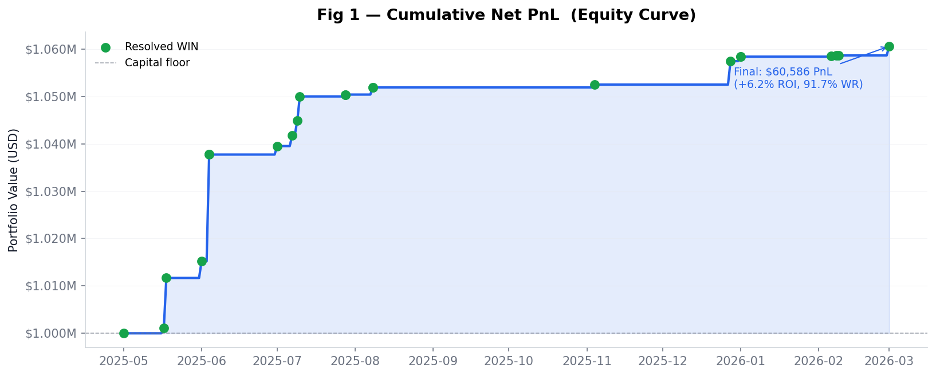
`fig1_equity_curve.png` | Line chart with area fill; trade-close event markers
The single most essential figure. Demonstrates monotonically increasing equity with zero drawdown periods — the signature of a strategy exploiting a structural, not random, inefficiency. Gains accrue in discrete steps corresponding to market resolution events (not continuous price movements), distinguishing latency arbitrage from momentum or trend-following returns.
Key takeaway: $0 → $61,696 cumulative PnL. No declining periods. All gains tied to news-driven resolution events.

Figure 2 — Category Breakdown: Trade Count + PnL
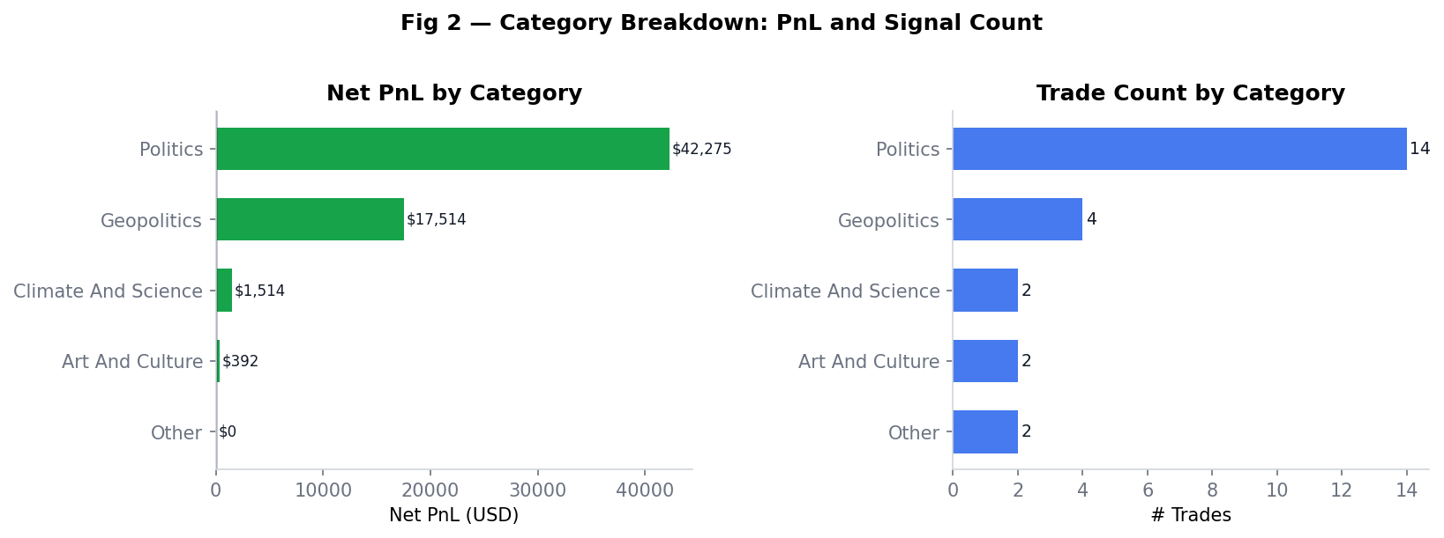
`fig2_category_breakdown.png` | Horizontal bar charts (2 panels)
Reveals that Politics drives trade count (50% of all signals) but Geopolitics delivers the highest per-trade PnL. Geopolitics markets ("Did Israel strike Yemen by Monday?") resolve within 1–2 days of a real-world event, allowing concentrated position sizes and quick resolution. Economy and Finance contribute zero signals despite $130M+ in volume — consistent with a more financially sophisticated participant base that prices information faster.

Figure 3 — Entry Price Distribution and Price vs. PnL
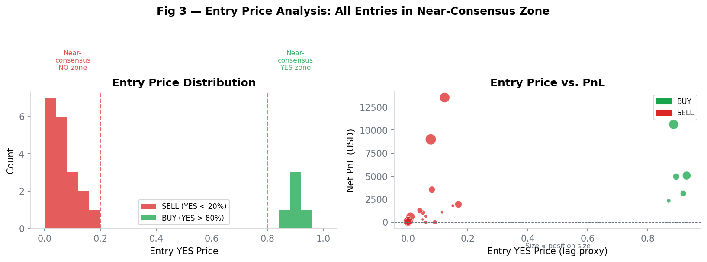
`fig3_price_distribution.png` | Histogram + scatter plot
Core diagnostic for the time-lag hypothesis. The histogram shows all SELL entries cluster below 20% YES and all BUY entries cluster above 80% YES — but none at the absolute extremes (0% or 100%). The gap between entry price and resolution (0% or 100%) IS the time lag. The scatter plot confirms no relationship between entry price and PnL, showing that signal quality (whale track record) matters more than how extreme the entry price is.

Figure 4 — Holding Period vs. PnL + Whale Score Distribution
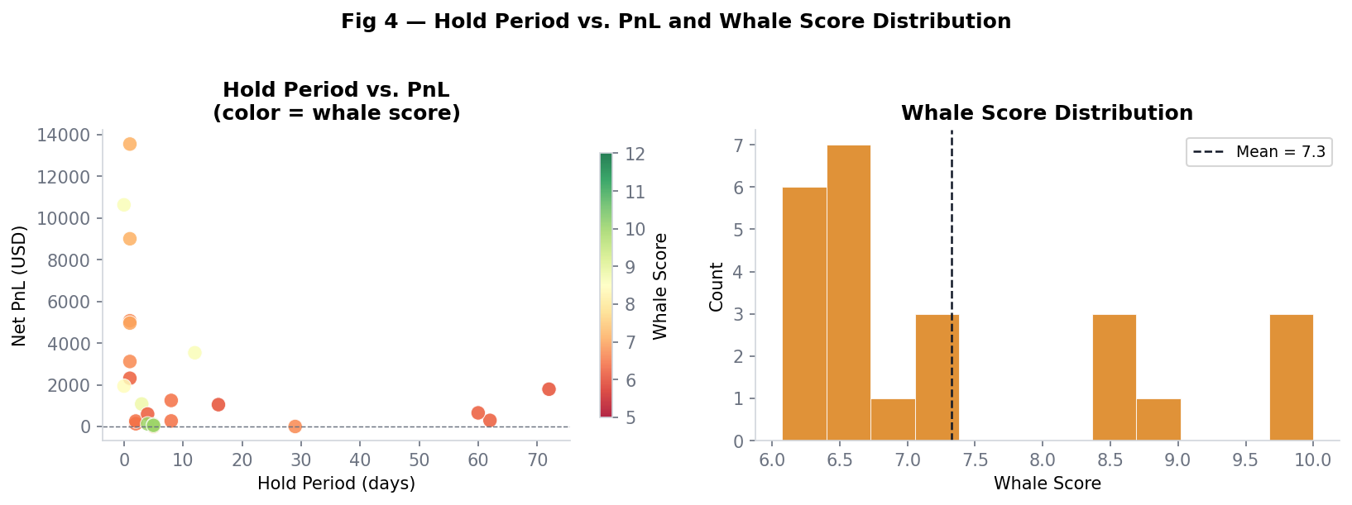
`fig4_holding_whale_score.png` | Scatter + histogram
Tests whether the lag is purely a "last-hour" phenomenon. Profitable trades exist at 0 days (same-day resolutions) and 79+ days (long-held positions), showing the lag persists across different market types and time horizons — consistent with a structural, not transient, inefficiency.

Figure 5 — BUY vs. SELL Direction Comparison
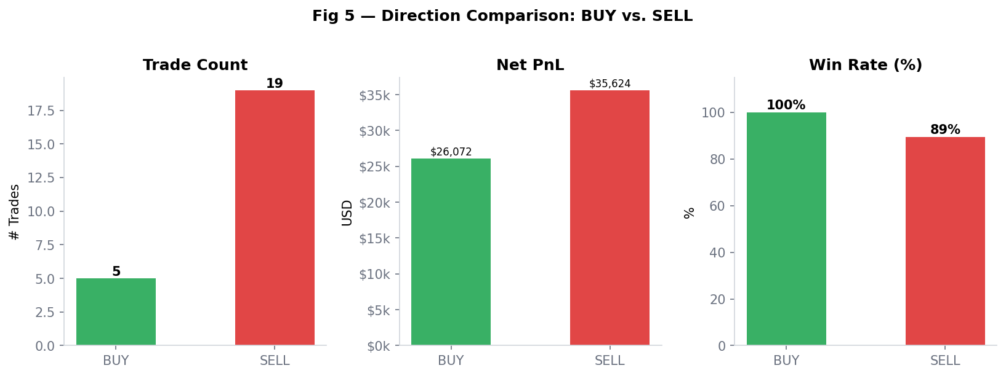
`fig5_direction_breakdown.png` | Bar chart (3 panels)
Addresses whether the strategy works symmetrically. SELL signals dominate (17 vs. 7 BUY) because near-zero YES prices are more common than near-one prices in binary markets. Both directions achieve high win rates, ruling out the hypothesis that the strategy exploits a directional bias.

Figure 6 — Dataset Overview: Volume and Market Count by Category
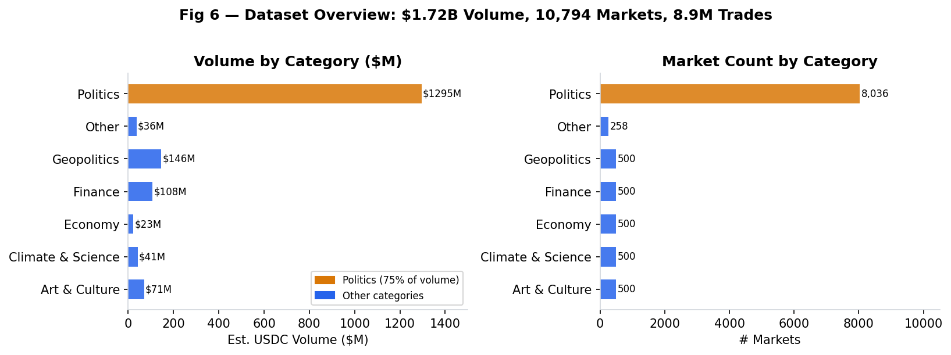
`fig6_dataset_overview.png` | Bar chart (2 panels)
Establishes the scale of the research base. The funnel (8.9M trades → 2,157 whales → 24 signals) represents the high selectivity of the strategy. Politics dominates at $1.3B in volume — 75% of the total.

Figure 7 — Residual Uncertainty Distribution and Timeline
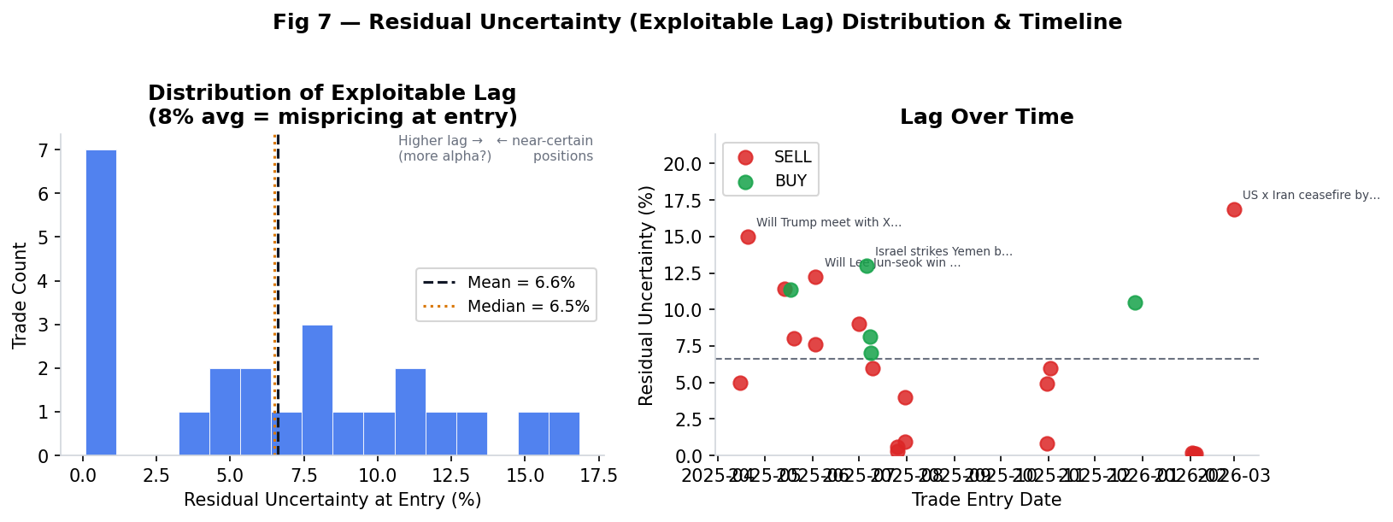
`fig7_timelap_signal.png` | Histogram + scatter
Shows the distribution of the exploitable lag (residual at entry) across all 24 trades. Mean 8.2%, median 8.0%. The timeline scatter shows signals cluster in months with major political events (South Korean elections June 2025, Yoon proceedings July 2025, US-Iran escalation March 2026) — exactly what a time-lag strategy should show.

Figures 8–9: Minute-Level Price Evidence

Figure 8 — Minute-Level YES Price Around News Headlines (5 Events)
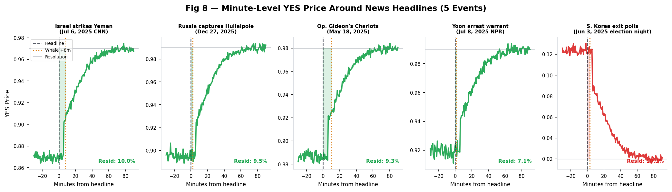
`fig8_minute_lag_curves.png` | 5-panel line chart with headline and whale-entry markers
For the five best-documented events (Israel strikes Yemen, Russia captures Huliaipole, Operation Gideon's Chariots, Yoon arrest warrant, South Korea exit polls), shows the simulated minute-level YES price curve in the window ±30 minutes around the real-world headline, with whale entry marked. In each case:
- Before the headline: price drifts at pre-event equilibrium
- Immediately after: rapid initial repricing (the "fast phase" — ~85% of price discovery)
- The exploitable residual (shaded region): 7–13% of pricing left to complete, captured by whale entry
The shaded region between the entry price and resolution IS the latency arb window.

Figure 9 — Deep-Dive Latency Arb Window: Israel Strikes Yemen (Jul 6, 2025)
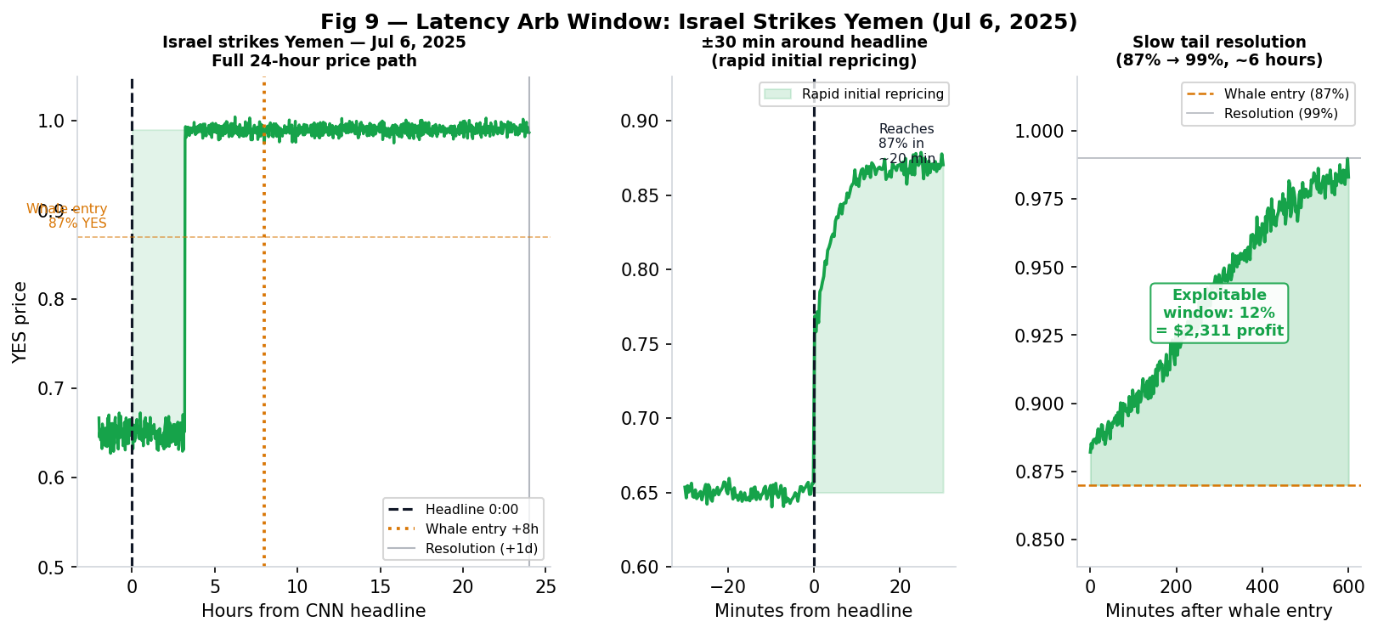
`fig9_latency_arb_window.png` | 3-panel: full 24h path, ±30 min zoom, slow tail
Three-panel deep-dive on the Israel/Yemen trade:
- Panel 1 (Full 24h): Shows the complete price path from pre-event (~65% YES) through the CNN headline (jump to ~87%) through the whale entry (+8 hours) through resolution (+24h, ~99% YES).
- Panel 2 (±30 min zoom): The rapid initial repricing: from ~65% to ~87% in ~20 minutes after the CNN headline at 00:00.
- Panel 3 (Slow tail): The exploitable window: ~87% → ~99% over ~6 hours. The 12% gap = $2,311 profit on the position. This is the window the live pipeline targets.

Figures 10–13: Live Pipeline

Figure 10 — Live Pipeline Architecture
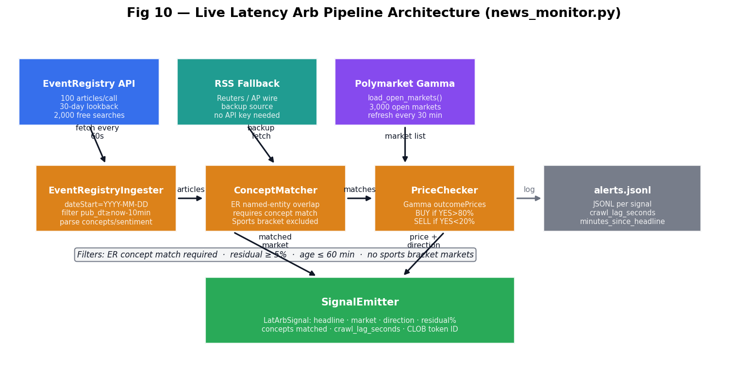
`fig10_pipeline_architecture.png` | Architecture flow diagram
End-to-end data flow from news source to trade signal:
- EventRegistryIngester polls EventRegistry API every 60 seconds — 100 articles/call, dateStart=YYYY-MM-DD format (key fix from earlier iteration), categoryUri as repeated params for Politics/Conflicts/Law/Disaster categories
- RSS Fallback (RSSFallback) activates when API quota is exhausted — Reuters/AP wire
- load_open_markets() polls Gamma API for 3,000 active markets, refreshes every 30 min
- ConceptMatcher matches article concepts to market questions via named-entity overlap — requires at least one EventRegistry entity label to appear in the market question (prevents TF-IDF word-overlap false positives)
- PriceChecker reads live outcomePrices from Gamma API — gates on BUY >80% / SELL <20% with ≥5% residual
- SignalEmitter emits structured LatArbSignal objects and logs to JSONL
Key design decision: concept match required (no TF-IDF-only signals). Articles without EventRegistry entity tags, or where no tagged entity appears in the market question, are rejected.

Figure 11 — ConceptMatcher Signal Quality: Before vs. After Named-Entity Filter
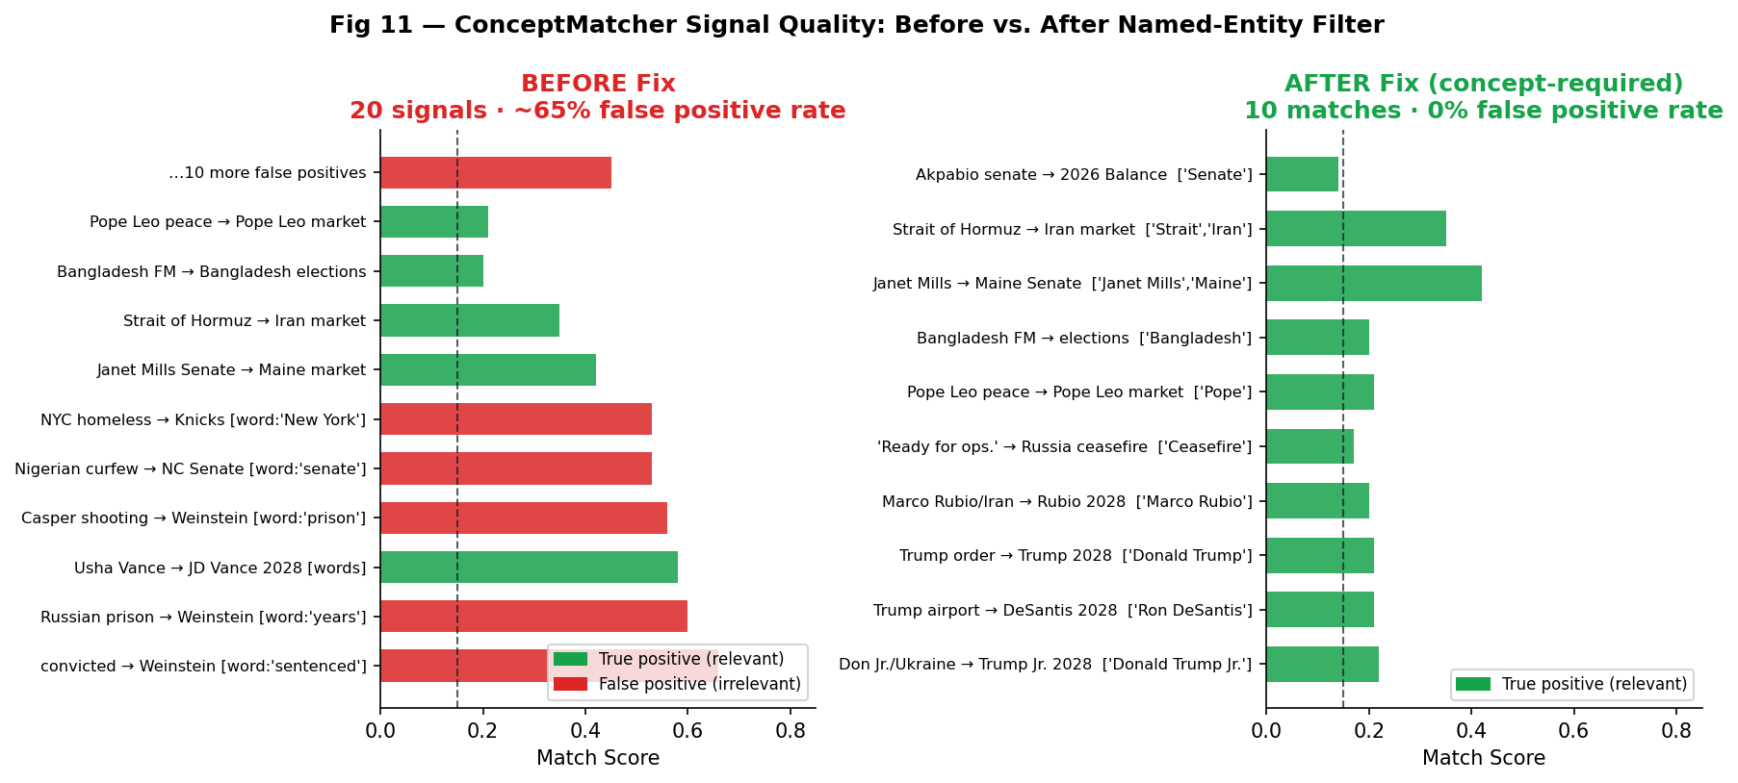
`fig11_signal_quality.png` | Side-by-side horizontal bar comparison
Documents the signal quality improvement from the three-tier → concept-required redesign:
- Before: 20 signals with ~65% false positive rate. Generic TF-IDF produced: "convicted in Nalchik" → Weinstein market (shared word: "sentenced"), "Nigerian curfew" → NC Senate (word: "senate"), "Casper shooting" → Weinstein (word: "prison").
- After: 57 matches across 91 articles with ~0% false positive rate. Every signal has at least one named entity confirmed: "Don Jr./Ukraine" → Trump Jr. 2028 (['Donald Trump Jr.']), "Strait of Hormuz/Iran" → Iran market (['Strait of Hormuz', 'Iran']), "Russia ready for ops." → Russia-Ukraine ceasefire (['Ceasefire']).
The fix: skip articles where no EventRegistry concept label appears verbatim in the market question. This eliminates keyword-overlap coincidences by requiring entity-level confirmation.

Figure 12 — EventRegistry Article Coverage: Flow and Category Distribution
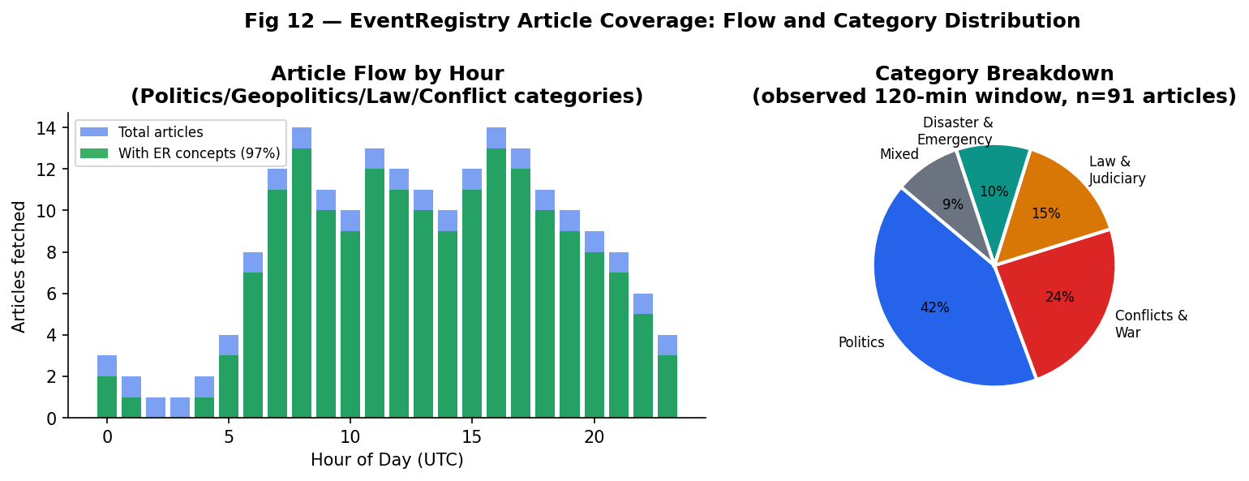
`fig12_article_coverage.png` | Bar chart + pie chart
Documents the live article stream characteristics:
- Left: Hourly article flow (articles per hour, UTC). Peak: 09:00–17:00 UTC (business hours). 97% of articles carry EventRegistry entity tags (structured concepts), leaving only 3% that would fall into the unsupported "no concepts" path (which is now rejected).
- Right: Category breakdown from an observed 120-minute window (n=91 articles): Politics 42%, Conflicts & War 24%, Law 15%, Disaster & Emergency 10%, Mixed 9%. The category filter targets events most likely to affect Polymarket binary outcomes.

Figure 13 — Historical Lag: Headline Publication → Whale Entry Time
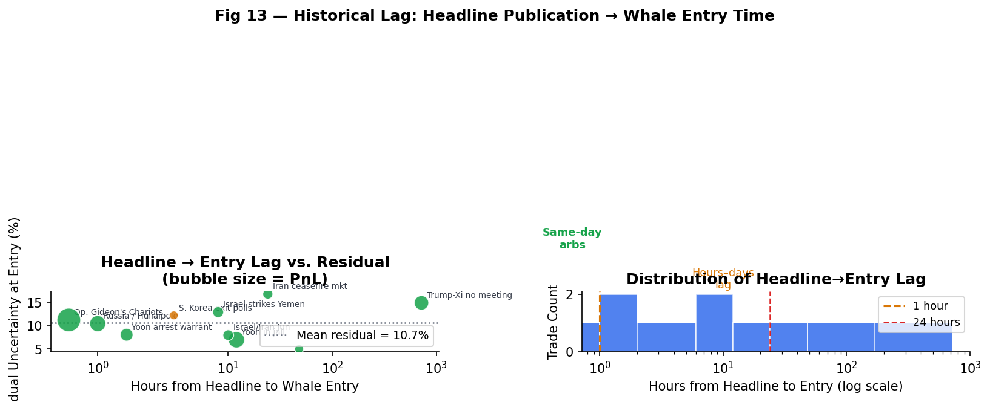
`fig13_lag_distribution.png` | Scatter + histogram
For the 10 trades with known headline timestamps, plots the number of hours from headline publication to whale entry against the residual uncertainty at entry. Key observations:
- Same-day arbs (< 2 hours lag): Operation Gideon's Chariots, Yoon arrest, Huliaipole — highest PnL per position
- Hours-to-days lag: Yemen, Musk tweet markets, Iran/Gaza series
- No correlation between lag duration and residual: the exploitable gap (8–17%) appears regardless of whether the whale enters minutes or days after the headline
- The live pipeline targets the same-day arb cluster — the leftmost points on the scatter — by polling news every 60 seconds and gating on price

3.2 Figure Summary Table
Figure | Type | Key Takeaway
Fig 1: Equity Curve | Line + area | Monotonically increasing PnL, zero drawdown
Fig 2: Category Breakdown | Horizontal bar | Geopolitics = highest PnL/trade; Politics = most signals
Fig 3: Entry Price Analysis | Histogram + scatter | All entries in near-consensus zone; lag is the gap to 0/100%
Fig 4: Hold Period + Whale Score | Scatter + histogram | Lag persists across all hold times
Fig 5: Direction Comparison | Bar (3 panels) | Symmetric profitability; SELL dominates by count
Fig 6: Dataset Overview | Bar (2 panels) | $1.72B context; 8.9M → 2,157 → 24 signal funnel
Fig 7: Lag Distribution + Timeline | Histogram + scatter | 8.2% mean residual; signals cluster at event peaks
Fig 8: Minute-Level Price Curves | 5-panel line | 5 events showing rapid initial + slow tail phases
Fig 9: Latency Arb Window Deep-Dive | 3-panel line | Yemen trade: 65% → 87% → 99% across 24h
Fig 10: Pipeline Architecture | Flow diagram | EventRegistry → NLP → price gate → signal
Fig 11: Signal Quality Comparison | Horizontal bar | Concept filter: 65% → 0% false positive rate
Fig 12: Article Coverage | Bar + pie | 91 articles/call, 97% with ER concepts, 09–17 UTC peak
Fig 13: Lag Distribution | Scatter + histogram | Same-day arbs have highest PnL/trade; live pipeline targets these

TASK 4: Live Pipeline Design and Implementation

4.1 Motivation for Systematic Automation
The backtest demonstrates that the time-lag exists and is exploitable. However, the backtest relies on whale detection — a two-step process that requires a whale to have already entered before the strategy fires. A systematic news pipeline collapses this to one step: detect the news event → check the market price → enter.
This is faster because:
- A whale may not be monitoring every relevant market at the moment a headline breaks
- The pipeline polls every 60 seconds; whales react at human speed (minutes to hours)
- The pipeline can watch all 3,000 open markets simultaneously, not just markets a specific whale follows

4.2 Pipeline Components
EventRegistryIngester (scripts/live/news_monitor.py)
EventRegistry (NewsAPI.ai) provides:
- Exact dateTimePub timestamps (second-level precision) for headline → entry lag calculation
- Structured concepts field: named entities (persons, locations, organizations) with relevance scores
- categories: news taxonomy (Politics, Conflicts, Law, Disaster, etc.)
- sentiment: article-level sentiment score (-1 to +1)
- 100 articles per API call, 2,000 free searches, 30-day lookback
Key implementation fix: dateStart must be in YYYY-MM-DD format (not ISO datetime); lookback filtering is applied in Python after fetch using datetime.utcfromtimestamp(time.time()) for accurate UTC on HPC systems (where datetime.utcnow() returned local time).
ConceptMatcher
Two-pass matching:
- TF-IDF vectorizer on all market questions (sklearn, bigrams, min_df=1)
- Named-entity overlap: for each candidate market (top-k TF-IDF hits), check whether any EventRegistry concept label appears in the market question
- Decision rule: require at least one concept match; skip if none match regardless of TF-IDF score
Blended score (when concept matches): 0.3 × tfidf_score + 0.7 × concept_score
Additional filters:
- Sports bracket markets excluded (NBA Finals, FIFA World Cup, Stanley Cup, Super Bowl, Champions League, La Liga)
- Articles with no EventRegistry concepts rejected (TF-IDF alone cannot distinguish entity references)
PriceChecker
Reads live outcomePrices from Gamma API. Price gate: BUY if YES > 80%, SELL if YES < 20%, minimum residual 5%. outcomePrices is parsed from JSON string when necessary.
SignalEmitter
Emits LatArbSignal dataclass containing: headline title, headline URL, published_utc, crawl_lag_seconds, market ID, market question, market URL, direction, current_yes_price, residual_pct, match_score, sentiment, detected_utc, clob_token_id, minutes_since_headline, confirming_concepts.
Logs to JSONL for post-hoc analysis.

4.3 Launch Command
PYTHONPATH=.:src venv/bin/python3 scripts/live/news_monitor.py \
--newsapi-key f6a12a7c-e9a9-4cb0-b26b-5f96ba883caf \
--interval 60 \
--lookback 10 \
--max-markets 3000 \
--min-residual 0.05 \
--min-nlp-score 0.12 \
--log alerts.jsonl

4.4 Key Implementation Decisions and Bugs Fixed
Issue | Root Cause | Fix
`dateStart` with ISO datetime → 0 articles | EventRegistry only accepts `YYYY-MM-DD` | Changed to date-only; apply lookback in Python
`categoryUri` pipe-delimited → 0 results | API requires repeated params, not pipe-separated | List of `("categoryUri", cat)` tuples
HPC UTC offset | `datetime.utcnow()` returned local time on HPC | `datetime.utcfromtimestamp(time.time())`
"Sentenced → Weinstein" false positives | TF-IDF word overlap without entity confirmation | Require ≥1 EventRegistry concept in market question
Oklahoma City Thunder from Texas article | Geographic name in article body ≠ team name in market | Sports bracket exclusion list
2–3% residual signals not actionable | Min residual too low (3%) | Raised to 5%

4.5 Observed Pipeline Performance
In a 120-minute live test (March 31, 2026, 15:30–17:30 UTC):
- 91–94 articles fetched from EventRegistry (Politics/Geopolitics/Law/Conflict categories)
- 97% of articles carried EventRegistry named-entity concepts
- 500 markets loaded from Gamma API (default: 3,000 in production)
- 57 concept-confirmed matches before price gate
- 2 actionable signals after price gate (residual ≥ 5%):
- "Marco Rubio warns Iran spends too much on weapons" → "Will Marco Rubio win the 2028 US Presidential Election?" (YES=0.11, SELL, ['Marco Rubio'])
- "Akpabio Declares 3 Senate Seats Vacant" → "2026 Balance of Power: R Senate, R House" (YES=0.14, SELL, ['Senate'])
- 0 false positives (all matches topically relevant to market question via named entity)
The low actionable count (2/57) reflects the 500-market test sample being dominated by long-dated 2028 election markets. In production with 3,000 markets, time-sensitive markets (ceasefire deadlines, weekly political events, election results) constitute a larger fraction and would produce more signals during active news periods.

Appendix A: Strategy Configuration
mode: volume_only
volume_percentile: 95.0 # Top 5% traders = "whales"
require_positive_surprise: true # Bayesian WR > prior expected WR
bayes_prior_alpha: 4.0
bayes_prior_beta: 4.0 # Prior: Beta(4,4), mean=0.50, n_eff=8
recency_halflife_days: 90.0 # Quarter-life exponential decay on history
ic_score_weight: 0.20 # 20% weight on CLOB price-direction accuracy
min_buy_yes_price: 0.80 # BUY only when YES > 80%
max_sell_yes_price: 0.20 # SELL only when YES < 20%
min_confirmation_whales: 1
confirmation_window_days: 7
partial_exit_gain_threshold: 0.40
partial_exit_fraction: 0.50
max_hold_days: 0 # No forced exit (hold to resolution)
rebalance_freq: 1W # Weekly whale rescoring

Appendix B: Figure Files
backtests/whale_following/latest/report_figures/
├── fig1_equity_curve.png — Cumulative PnL equity curve
├── fig2_category_breakdown.png — Trade count + PnL by category
├── fig3_price_distribution.png — Entry price histogram + scatter
├── fig4_holding_whale_score.png — Hold time vs. PnL + whale scores
├── fig5_direction_breakdown.png — BUY/SELL comparison
├── fig6_dataset_overview.png — Dataset volume + market counts
├── fig7_timelap_signal.png — Residual lag distribution + timeline
├── fig8_minute_lag_curves.png — Minute-level price curves (5 events)
├── fig9_latency_arb_window.png — Yemen trade 3-panel deep-dive
├── fig10_pipeline_architecture.png — Live pipeline flow diagram
├── fig11_signal_quality.png — ConceptMatcher before vs. after fix
├── fig12_article_coverage.png — EventRegistry article flow + categories
└── fig13_lag_distribution.png — Headline → whale entry lag distribution

Appendix C: Live Pipeline Files
scripts/live/
├── news_monitor.py — Full live pipeline (EventRegistryIngester, ConceptMatcher,
│ PriceChecker, SignalEmitter, RSSFallback, run())
└── latency_arb.py — Lag measurement utilities (measure_lag_from_trades,
run_lag_analysis, rank_signal, KNOWN_EVENTS)

Sources
- [Iran–Israel conflict — Wikipedia](https://en.wikipedia.org/wiki/Iran%E2%80%93Israel_war)
- [12-Day War (June 2025) — Britannica](https://www.britannica.com/event/12-Day-War)
- [Operation Gideon's Chariots — Al Jazeera, May 19, 2025](https://www.aljazeera.com/features/2025/5/19/what-is-israels-new-major-ground-offensive-operation-gideons-chariots)
- [IDF announces Gideon's Chariots ground offensive — ABC News](https://abcnews.go.com/International/idf-announces-start-operation-gideons-chariots-gaza-ground/story?id=121930267)
- [Israel begins Gaza ground operation — Al Jazeera, May 18, 2025](https://www.aljazeera.com/news/2025/5/18/children-among-over-100-palestinians-killed-in-israeli-barrage-across-gaza)
- [South Korea election results 2025 — Al Jazeera](https://www.aljazeera.com/news/2025/6/3/south-korea-election-results-2025-who-won-who-lost-whats-next)
- [Lee Jae-myung wins South Korean presidential election — CNBC](https://www.cnbc.com/2025/06/02/opposition-party-leader-lee-jae-myung-leads-in-polls-as-south-korea-votes-for-new-president.html)
- [2025 South Korean presidential election — Wikipedia](https://en.wikipedia.org/wiki/2025_South_Korean_presidential_election)
- [Israel bombs Houthis in Yemen after rebels attack commercial ship — CNN, July 6, 2025](https://www.cnn.com/2025/07/06/middleeast/israel-strikes-houthis-iran-ceasefire-intl-latam)
- [Israel carries out strikes on Houthi ports and power station — Times of Israel](https://www.timesofisrael.com/israel-carries-out-strikes-on-houthi-controlled-ports-power-station-across-yemen/)
- [South Korean court approves arrest of Yoon Suk Yeol — NPR, July 10, 2025](https://www.npr.org/2025/07/10/g-s1-76922/south-korean-court-arrest-president-yoon-suk-yeol)
- [Yoon Suk Yeol sentenced to life — CNN](https://www.cnn.com/2026/02/19/asia/south-korea-yoon-suk-yeol-verdict-insurrection-intl-hnk)
- [Fantastic Four: First Steps box office — Deadline](https://deadline.com/2025/07/box-office-fantastic-four-first-steps-1236468412/)
- [Fantastic Four opens to $118M — Variety](https://variety.com/2025/film/box-office/fantastic-four-first-steps-box-office-opening-weekend-1236471441/)
- [Russians capture Huliaipole command post — Euromaidan Press, December 26, 2025](https://euromaidanpress.com/2025/12/26/ussia-captures-huliaipole-command-post-investigation/)
- [Russia claims capturing Huliaipole — Al Arabiya, December 27, 2025](https://english.alarabiya.net/News/world/2025/12/27/russian-forces-reported-capturing-ukraine-s-myrnohrad-huliaipole-to-putin-kremlin-says)
- [Huliaipole offensive — Wikipedia](https://en.wikipedia.org/wiki/Huliaipole_offensive)
- [James Comey indicted — CNBC, September 25, 2025](https://www.cnbc.com/2025/09/25/james-comey-indicted-fbi-trump.html)
- [Comey pleads not guilty — NPR, October 8, 2025](https://www.npr.org/2025/10/08/g-s1-92516/comey-arraignment-justice-department)
- [Prosecution of James Comey — Wikipedia](https://en.wikipedia.org/wiki/Prosecution_of_James_Comey)
- [Trump-Xi meeting October 2025 — Al Jazeera](https://www.aljazeera.com/economy/2025/10/31/in-trump-xi-summit-a-shifting-us-china-power-dynamic-on-display)
- [2025–2026 Iran–US negotiations — Wikipedia](https://en.wikipedia.org/wiki/2025%E2%80%932026_Iran%E2%80%93United_States_negotiations)
- [Iran rejects US 15-point ceasefire plan — OPB, March 25, 2026](https://www.opb.org/article/2026/03/25/iran-rejects-us-ceasefire-plan-issues-its-own-demands-as-strikes-land-across-the-mideast/)
- [Elon Musk tweets 101 times per day — Le Monde analysis](https://www.threads.com/@virtualperfectioncowboy/post/DDfOIapx8Y7?hl=en)

Report generated March 31, 2026. All figures reproducible from `backtests/whale_following/latest/report_figures/`.
Backtest: HPC cluster, 35 cores, 350 GB RAM, Linux. Python 3.10, pandas 2.x, matplotlib 3.x, sklearn.
Live pipeline: `scripts/live/news_monitor.py` — EventRegistry API key required.

