Video Script: Section 1_CSS Foundations
Video Script: Video1_Overview
No | Action on screen | Narration
1 | 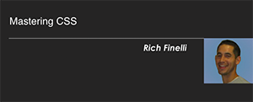  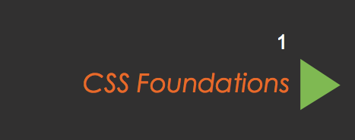  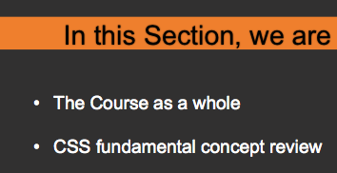 | Hello, my name is Rich Finelli I’m a front end web developer and I’ve been building stuff for the internet for about 6 years now. We're here to master CSS, the incredible presentation language of the web. I'm going to help you build modern, responsive, and beautiful websites at an advanced level using CSS.  In this first section, CSS Foundations, we are going to take a look at the course as a whole as well as go over the fundamental concepts necessary to master CSS.
 |   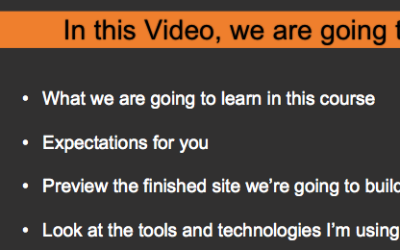 | This first video is an overview of the entire course.  We’re going to go over what we’re going to learn in this course, expectations of you and your skillset, we’ll also preview the site we’re going to build, and look at some tools I’m using and my workflow.
2 | 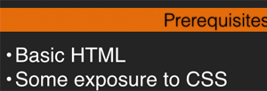 | CSS is the presentation language of the web. It describes things like the colors, fonts, and layout of your pages. As cascading Style Sheets along with html and JavaScript are the 3 core languages of the web; the more you know about all 3 of them, the better off you'll be.  There are some basic prerequisites. I expect that you understand how to write html and understand basic CSS, like styling fonts, adding margins, padding, and background-colors, and other stuff like what a hexadecimal color code is. In the next two videos, however, I will be covering some basic concept review like the box model, display properties, and types of style sheets.  Throughout this video course, I'll also touch on a small amount of javascript and jquery. You don’t need any prior knowledge of these but you will be getting a taste of it in this course.
3 | 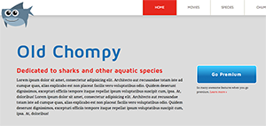  I’ll be walking through and displaying different aspects of the final web site. | In order to learn CSS, We are going to finish building this html5 website, which is all about sharks. I use the word “finish” building this site because the basic html and css is already in place. We’ll be adding the layout, navigation, make it responsive, add web fonts, and finally make it retina-device ready. This site also modular/re-usable css which will learn about. It has floats for layout and the main navigation has a drop down menu that uses css animations,, a call to action button with css gradients,, ghost buttons that use css transitions. Also, it’s fully responsive AND ready for hidpi devices like Apple's retina displays. Finally, it uses webfonts, an icon font, and SVG. So we're going to learn some reallyreally cool stuff.
4 | 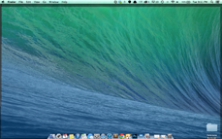 | Some of the tools I'm using.  I'm using a mac. So if you're a windows user any time I say COMMAND you should pretend like I said CONTROL. Other than that I don't think that will be an issue.
 | 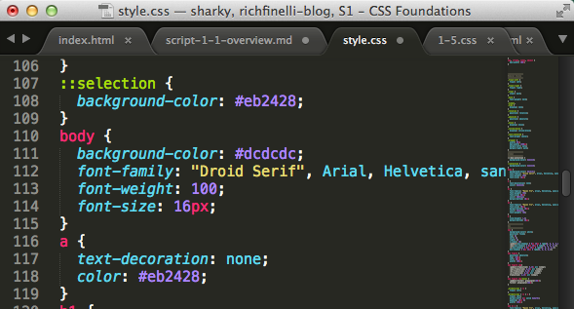 | My text editor is a great, light-weight product called Sublime Text 3. In Section 2, Ramping up, the first video is on Sublime and explains why I like it so much - and how a good text editor will make you a better developer. Sublime isn’t the only good one out there. Others like Atom, Brackets, Coda, Vim, Edge Code do many of the same things. But in this video course, I’ll be using Sublime Text.
8 | ( I will have the text editor and the browser open and i’ll change the background color of the site in the css and watch the change happen instantly in the browser) | I'm using livereload to automatically refresh the browser every time I save the css file. So you won't see me click the refresh button after I type every css rule set. I like this fast workflow and it will make these videos more fluid as we'll be seeing the changes in the browser immediately after they are typed in.
9 | 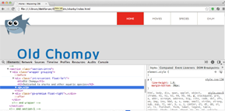 | I'll be using Chrome as my browser and the chrome dev tools to explore the code directly in the browser. There's a video on chrome dev tools in Section 2 that will help us troubleshoot when our css isn't working the way we want it to.
10 | 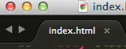 | So, even though this course is on mastering CSS, we can't do much with CSS without html. So we'll be working in html quite a bit. Very clean semantic html is what we want to shoot for and we'll be working in html often.
11 |  | Okay now lastly I have a disclaimer - We're going to learn about best practices in web development as of early 2015 when this video course was created. In the web design world things change often. For instance, In the past, tables were the technique of choice to layout a multicolumn web page. Today using a table for layout would be crazy and almost impossible to do responsively. Floats are the most common way to create a layout now and will be what we learn about. But in a year or maybe 5 years that could change. CSS is progressing with new css3 layout modules that are designed to supplant floats for laying out a page. Flexbox, Grid Layout, and CSS Regions may be the wave of the future. Since things rapidly evolve in the world of front end web development our key take away is that we can't stop learning CSS and web development. In general, once you stop learning you'll become outdated very quickly. My intent however is to teach the concepts and techniques that will benefit you for a long time.
 | 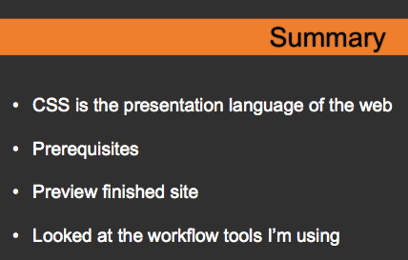 | In this video we talked about how CSS is the presentation language of the web and really makes your website look like a website. I also discussed how you should be familiar with basic HTML and CSS as we aren’t starting from scratch in this course. We previewed the final site and took a look at the tools I’m using.
12 | Conclusion  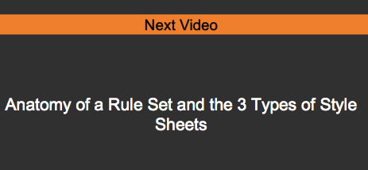 | So I hope that prepares you a little for what's to come. Now without any further ado can get started! In this first section, like I said before, we’ll be reviewing core concepts that are fundamental to web design and css. In the upcoming video, we’ll start by reviewing how to create the most fundamental thing in CSS, the Rule Set and the different places we use those rule sets.

