Project Proposal

Creating a barbell path tracking android application using the OpenCV for android library.

Date:
21/10/2015

Full Name:
Dominic Rathbone
Student number: 12843140

School of Computing, Engineering and Mathematics

1) Elevator pitch
I plan to produce an android application that will be able to track the path of a barbell during different movements in order to analyse the form of the weight lifter and improve on it. The user will be able to keep these to compare and track how their form improve over time. To track the barbell, I will utilise the android sdk in conjunction with the OpenCV library for android.

2) Rationale
The users I will be targetting will be strength athletes ranging from professional olympic weightlifters and powerlifters with coaches to complete beginners interested in strength and conditioning. Whilst for elite lifters, bad form during lifting isn't so much of an issue, slight improvements can increase how much you can lift and give you a competitive advantage. For beginners, bad form can not only limit how much you can lift but can cause serious injury in the long term, stopping them from exercising at all. Although bar path is not the only indicator of good or bad form as everyone has different proportions and shapes, trying to replicate the bar path associated with good form and sharing your results for critique by other more experienced lifters, can mitigate this risk. Previously, tracking bar paths has been done manually by watching videos of each lift and marking it down but this takes time and isn't as convenient as being able to do it near real-time with an application, especially in the middle of a gym.

3) Application
By using this application, the user can focus on improving their form during lifts by analysing the results with their coach (in the case of olympic weightlifters) or by comparing results online (in the case of beginners). The application will have one main function. The first will be the motion tracking of the barbell, the user will place the camera so it is pointing side on to the bar, record the video which they will then use to highlight the weight plates on the bar. The app will then calculate the centre of the plate, giving us the bar and track it as the user goes through the motion of lifting it.
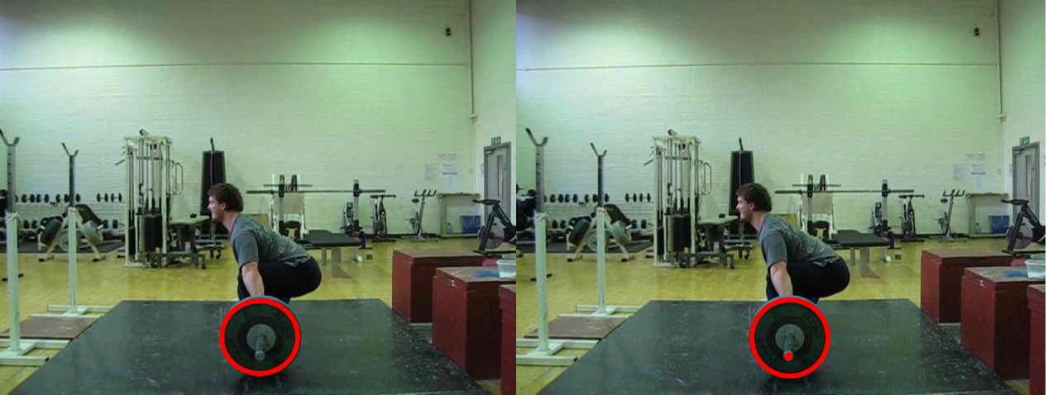

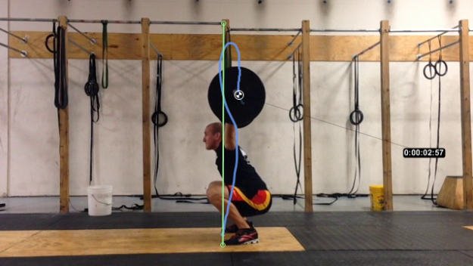
Each bar path will then be recorded, timestamped and added to a gallery to track how the user's form has progressed.
At the moment, I have found there to be two main applications that do this. One for android called BarSense and one for iOS called iron path.

How does your application address the issue described above? Give an overview of your application and describe how it works. Include a brief competitor analysis and explain how your application will be different. (max. 400 words)

4) Scenario of use
How will your application be used? Describe a brief scenario that illustrates how your application will be used in context. (max. 200 words)

5) Technical overview
Give a technical overview of your application. This may change during development, but at this stage you should have a rough idea of how the application could be implemented. Include details such as persistence, communications, significant processing, inputs, outputs, web services etc. (max. 500 words incl. diagrams)

6) Technical challenges
Describe briefly the main technical challenges you foresee. (max. 200 words).

7) UI design draft
Include first ideas for the main screen(s) of your application. (simple sketch)

8) Work plan
Describe the work needed to implement the application, and a timeline showing the different phases including requirements analysis, design and development, demo preparation and write-up at the end of the project. (max. 400 words incl. diagrams)

9) Ethical considerations
Discuss any ethical considerations related to the project or the application you develop. With respect to the application, think about privacy, data protection, health and safety or any moral implications. With respect to the development project, think about the involvement of users in your requirements analysis and testing. (max. 200 words)

10) Resources
List the resources you need to carry out the project, including access to specific hardware (e.g. smartphone), software (e.g. development environment), data sets, online services, organisations, people, etc. (up to 200 words).

References
List any references to literature, projects or products in your proposal.

