Project Proposal

Creating a barbell path tracking android application using the OpenCV for android library.

Date:
21/10/2015

Full Name:
Dominic Rathbone
Student number: 12843140

School of Computing, Engineering and Mathematics

1) Elevator pitch
I plan to produce an android application that will be able to track the path of a barbell during different movements in order to analyse the form of the weight lifter and improve on it. The user will be able to keep these to compare and track how their form improve over time. To track the barbell, I will utilise the android sdk in conjunction with the OpenCV library for android.

2) Rationale
The users I will be targetting will be strength athletes ranging from professional olympic weightlifters and powerlifters with coaches to complete beginners interested in strength and conditioning. Whilst for elite lifters, bad form during lifting isn't so much of an issue, slight improvements can increase how much you can lift and give you a competitive advantage. For beginners, bad form can not only limit how much you can lift but can cause serious injury in the long term, stopping them from exercising at all. Although bar path is not the only indicator of good or bad form as everyone has different proportions and shapes, trying to replicate the bar path associated with good form and sharing your results for critique by other more experienced lifters, can mitigate this risk. Previously, tracking bar paths has been done manually by watching videos of each lift and marking it down but this takes time and isn't as convenient as being able to do it near real-time with an application, especially in the middle of a gym.

3) Application
By using this application, the user can focus on improving their form during lifts by analysing the results with their coach (in the case of olympic weightlifters) or by comparing results online (in the case of beginners). The application will be based around one main function which will be the motion tracking of the barbell, the user will place the camera so it is pointing side on to the bar at a neutral angle, record the video which they will then use to highlight the weight plates on the bar. The use will then click a “track” button which will trigger the app to calculate the position of the bar and track it as the user goes through the motion of lifting it.
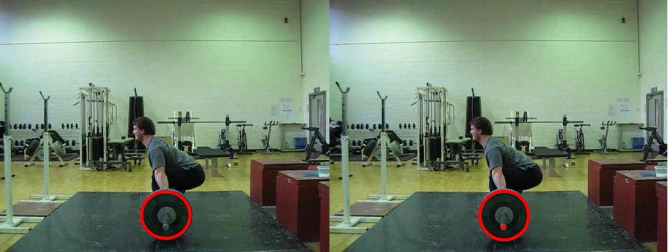

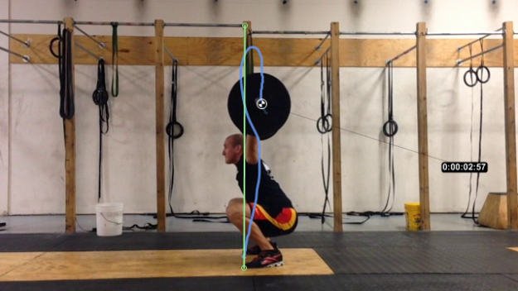
Each tracked video will then be timestamped and persisted to a gallery for the user to view along with an image of the bar path, allowing them to track how the user's form has progressed over time. They will also have the ability to upload the image to an image hosting site such as imgur for sharing and upload the video to youtube through the application.

Currently, I have found there to be two main competitors developing applications that record bar path. One for Android called BarSense and an iOS app called iron path. Whilst, I haven't used the iOS App, it seems to be pretty small and does not have many reviews. BarSense, the android application does seem to be well established and has many good reviews. Whilst the UI isn't very nice, it does track the bar relatively well and also calculates the velocity of the movement which is useful for olympic weightlifters trying to improve the explovesiveness of their movements.
The main difference between my application and BarSense would be the improvements on UI using google's design guidelines for Android applications.

4) Scenario of use
A use case for this application would be a beginner rejoining a gym after recovering from a minor injury whilst performing a squat. They have researched how to prevent this injury and decide to focus on fixing their squat form and started recording their squats to analyse and share with others for advice. After being recommended the application and downloading it, they would then use the set of videos they have collected within it to retroactively assess the bar path of their squats and share them by uploading them to youtube. Over time, they notice that their form is progressing and they are less likely to reinjure themselves.

5) Technical overview
The user interface will be created using the android sdk following the ux design guidelines produced by google, in particular, I will implement material design where I can. I will use JavaCV which is a java wrapper for the OpenCV which in turn is a library for computer vision to detect and process the path of the bar. Each video will be persisted to the file system. To record the video, I will allow the user to select which camera application they want to use.

Give a technical overview of your application. This may change during development, but at this stage you should have a rough idea of how the application could be implemented. Include details such as persistence, communications, significant processing, inputs, outputs, web services etc. (max. 500 words incl. diagrams)

6) Technical challenges
Describe briefly the main technical challenges you foresee. (max. 200 words).

7) UI design draft
Include first ideas for the main screen(s) of your application. (simple sketch)

8) Work plan
Describe the work needed to implement the application, and a timeline showing the different phases including requirements analysis, design and development, demo preparation and write-up at the end of the project. (max. 400 words incl. diagrams)

9) Ethical considerations
Discuss any ethical considerations related to the project or the application you develop. With respect to the application, think about privacy, data protection, health and safety or any moral implications. With respect to the development project, think about the involvement of users in your requirements analysis and testing. (max. 200 words)

10) Resources
List the resources you need to carry out the project, including access to specific hardware (e.g. smartphone), software (e.g. development environment), data sets, online services, organisations, people, etc. (up to 200 words).

References
List any references to literature, projects or products in your proposal.

