CCNA 200-301 — Video Notes Capture Sheet (v2)
Action for Claude (tick one): ☐ Add these notes to the CCNA document and cross-check against what is already there ☐ Review only, do not change anything ☐ Other:

Session Details
Video / day number and title | CCNA Day 37 – NTP – Network Time Protocol
Video link (optional) | https://www.youtube.com/watch?v=qGJaJx7OfUo&list=PLxbwE86jKRgMpuZuLBivzlM8s2Dk5lXBQ&index=75
Blueprint objectives (e.g. 3.1, 3.2) | 4.2 Configure and verify NTP operating in a client and server mode
Where it goes in the document (Part / section, if you know)
Date studied | 27/10/2026
Tracker status I would give this topic (✅ confident, 🔄 in progress, ⚠ not yet)
The tracker status is your call. Claude does not change a status mark unless you ask.

Main Notes
Write bullet points, one idea per line.
Marks: * = expand this (add detail or an example) ? = I am not sure this is right, please check it ** or bold = a highlighted term to keep and highlight.
Pasted image? Add a caption on the line above it, for example "Image: administrative distance table". Claude turns images into text or tables.
📝 Key concepts and dot points
- All devices have and internal clock
- In cisco IOS, you can view the time with the Show Clock command.
- Default time zone of UTC
- If you use the show clock detail command, you can see the time source
- Hardware Calander is the built-in internal clock of the device.
- * = time is not considered authoritative. Pic is of the output on the device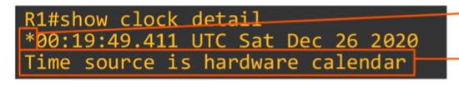
- The internal clock is of a device will drift over time, so it is not the ideal time source.
- From a CCNA perspective, the most important reason to have accurate time on a device is to have accurate logs for troubleshooting.
- Syslog, the protocol used to keep device logs
- Although the hardware calendar (Bulit in clock) is the default time source, the hardware clock and software clock are separate and can be configured separately.
- Typically, you will want to synchronize the ‘clock and calendar’
- Use the command: clock update-calendar to sync the calendar to the clocks time
- Use the command: clock read-calendar to sync the clock to the calendar time.
- You can configure the time zone with the clock timezone command
  - Clock timezone ** (just a name for the timezone – doesn’t need to match the actual timezone) ** hours (hours offset from utc)
  - i.e. clock timezone JST 9 (9 is plus 9 hours from utc)
- Time is configured from global configuration mode, not privilege exec mode
- Daylight savings time (summertime)
  - Clock summer-time Name recurring **
- 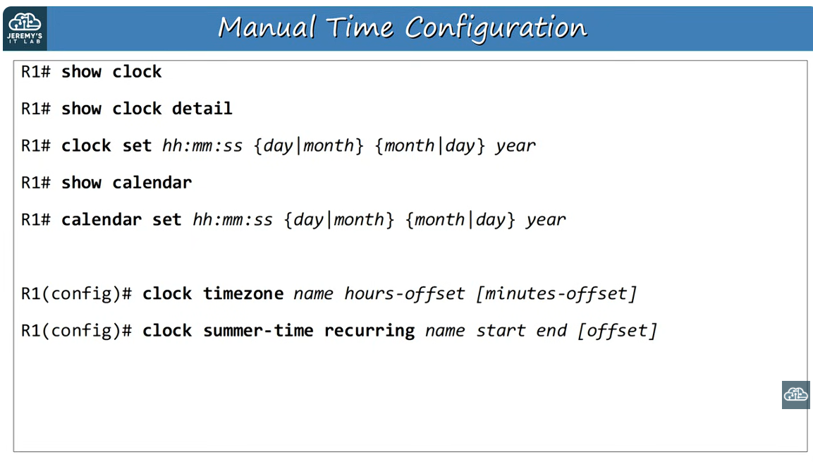
Screenshot of commands 1

Network time protocol
- Manually configuring the time on devices is not scalable
- The manually configured clocks will drift, resulting in inaccurate time
- NTP (network time protocol) allows automatic syncing of time over a network
- NTP clients request the time from NTP servers
- A device can be an NTP server and an NTP client at the same time
- NTP allows accuracy of time within ~1 millisecond if the NTP server is in the same LAN, or withing 50~ milliseconds if connecting to the ntp server over a WAN/The internet
- Some NTP servers are better than others. The distance of an NTP server from the original Reference clock is called Stratum.
- NTP uses UDP port 123 to communicate

Reference Clocks
- A reference clock is usually a very accurate time device like an atomic clock or a GPS clock.
- Reference clocks are Stratum 0 within the NTP hierarchy
- NTP servers are directly connected to reference clocks are Stratum 1.
- NTP Hierarchy image 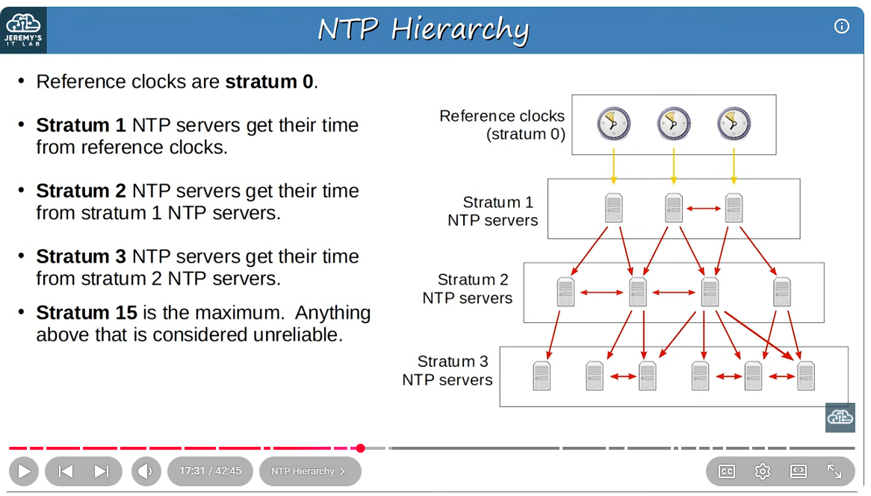
- Devices can also ‘peer’ with devices at the same stratum to provide more accurate time.
  - This is called Symmetric active mode
  - Cisco devices can operate in three NTP modes:
    - Server mode
    - Client mode
    - Symmetric active mode
- An NTP client can sync to multiple NTP Servers
  - R1 server will ask all ntp servers for the time and select whichever gives the best/quickest responses
  - The one it might sync to can change, if the selected server’s responses slow down or stops responding
  - Best practice is to have multiple NTP servers configured
  - If you want a R1 to use a particular NTP server add prefer to the end of the command
- Stratum 1 NTP servers: NTP servers which get their time directly from reference clocks are also called primary servers.
- Stratum 2 and 3 NTP servers which get their time from other NTP servers are called secondary servers. They operate in the server mode and the client mode at the same time.
- 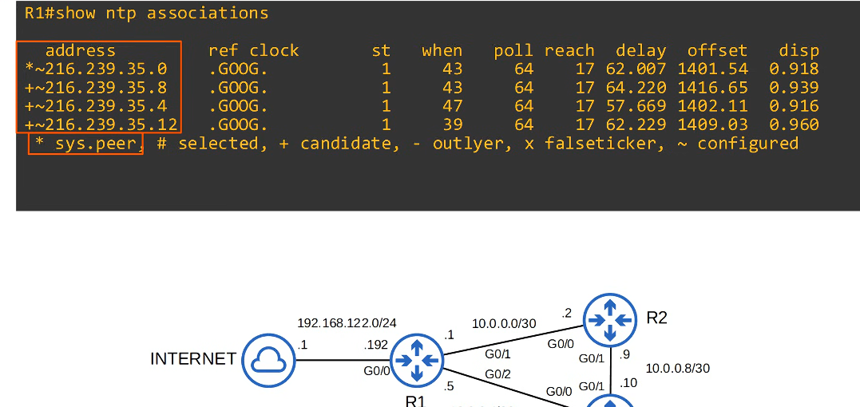 Command output 1
- * at the start of the command: Sys.peer = this means that this is the NTP server that is being used
- + means they are candidates and can be used
- ~ means that they were configured
- If you see a ntp server being set as a – outlier or, x falseticker – means that r1 will not sync to the server
- Ref clock – means that it is using googles reference clock – googles stratum clock is 1
- Because R1 is synchronising its time to googles NTP servers, it automatically becomes a NTP server itself (Stratum level 1 higher than googles NTP servers). Now other devices can synchronize their time to R1.
- NTP uses only the UTC time zone. You must configure the appropriate time zone on each device.
- The hardware clock tracks the date and time on the device even if it restarts or power is lost. When the system is restarted, the hardware clock is used to initialize the software clock.
- **Reminder – remember to use ntp source command to specify the loopback interface as the source of NTP packets on R1
  - If you don’t do this – R2 and R3 won’t want to sync with R1
- Loopback addresses and loopback interfaces are different concepts. So don’t confuse the terms
- Loopback interfaces are virtual interfaces in the router and their addresses can be advertised using ospf etc
- Loopback addresses are totally internal to the device and cant be reached by other devices. R1 is using itself as a stratum clock.
- The default stratum of the NTP master is 8
- 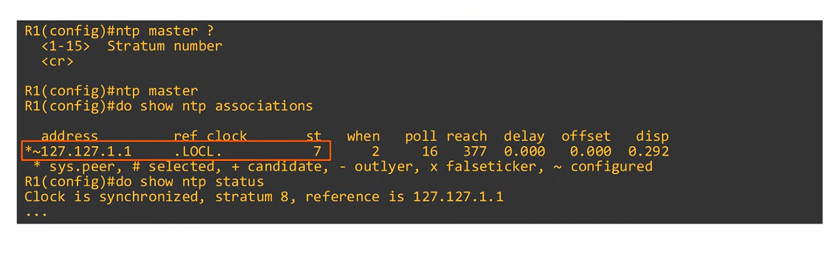

Symmetric active mode
- They can become peers and sync their time and also act as backups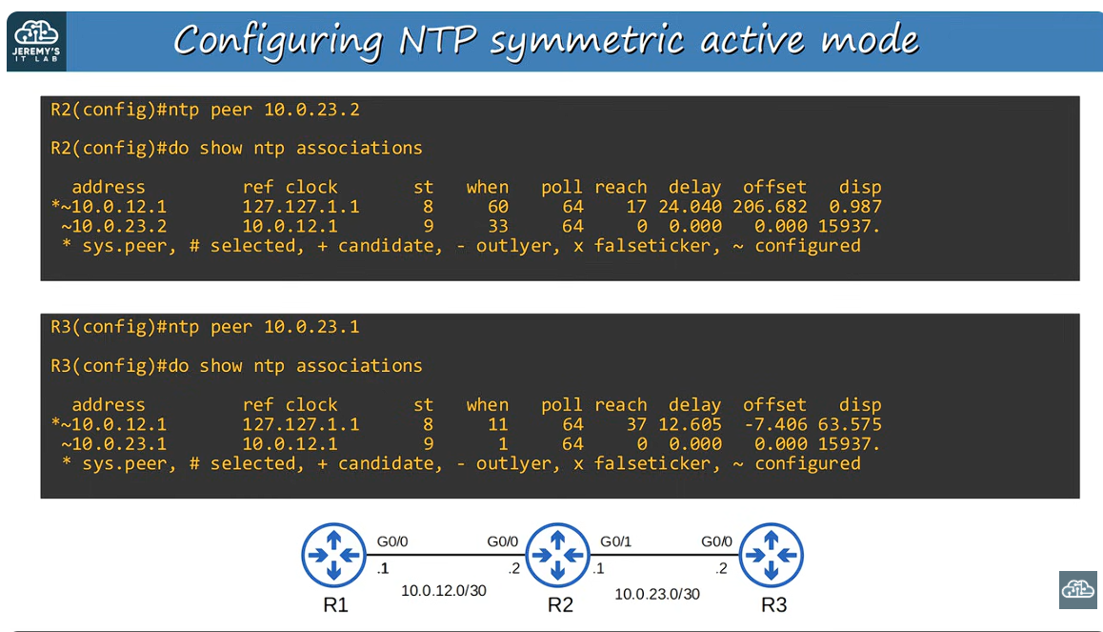
- Configuring NTP authentication
  - NTP authentication can be configured, although it is optional
  - It allows NTP clients to ensure they only sync to the intended servers

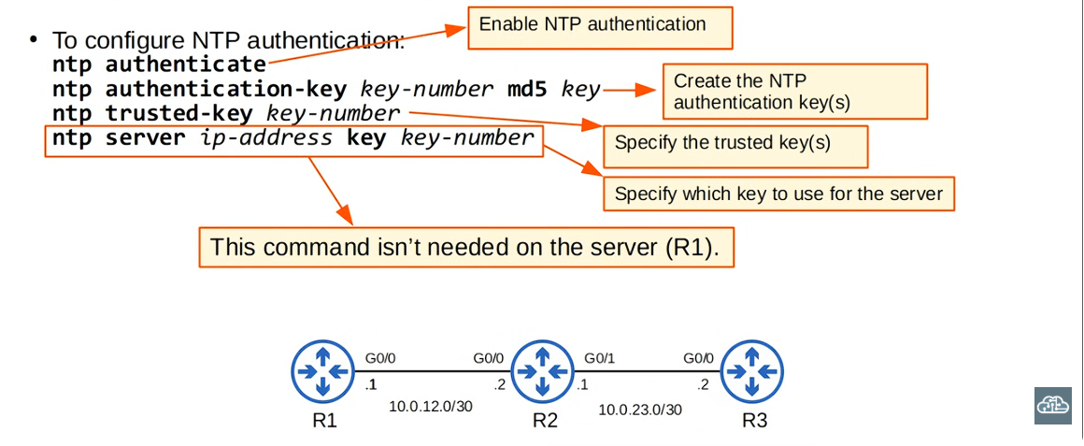
Configuring NTP auth 1

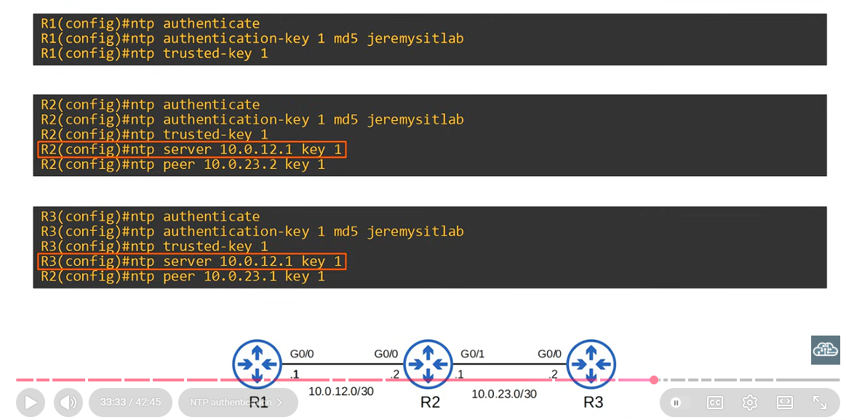
Configuring NTP auth 2

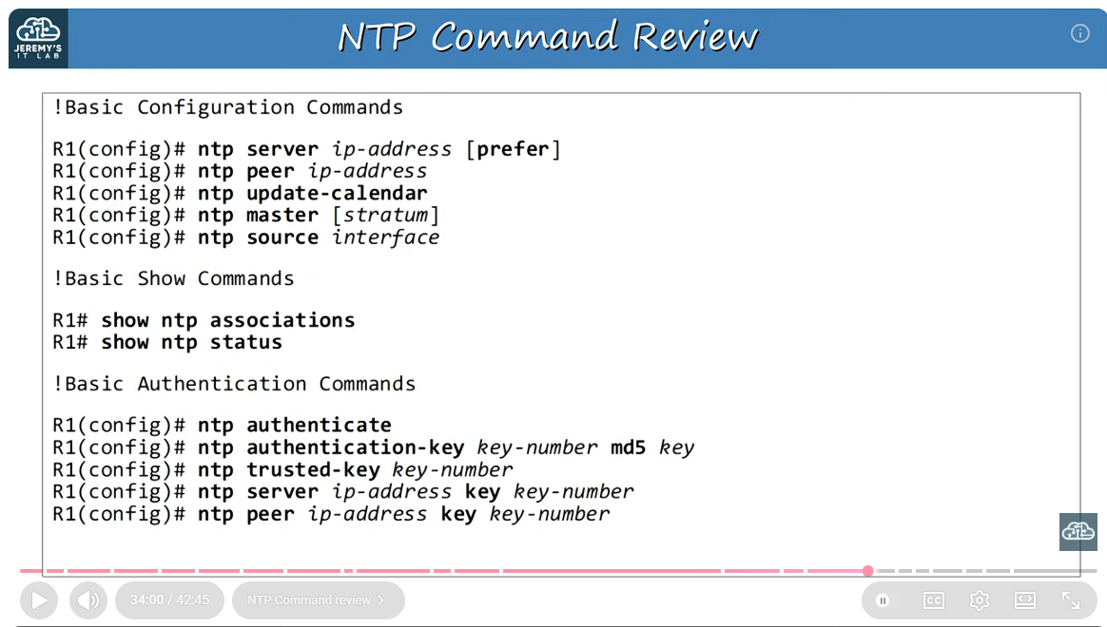
NTP Command review 1

Commands
One row per command. Mode = where you type it (privileged EXEC, global config, interface config, router config, VLAN config). Device = router, switch or both.
Command | What it does | Mode | Device
Show Clock | View the time
Do Show clock detail | See the time source
Show Logging | Is the command used to view logs
Clock set | Use this command to manually configure the time on the device (software)
Calendar set | Manually configure the hardware clock
Ntp server <ip address> | Configures the connection NTP server
Show ntp associations | It shows all of the NTP servers
Show ntp status | 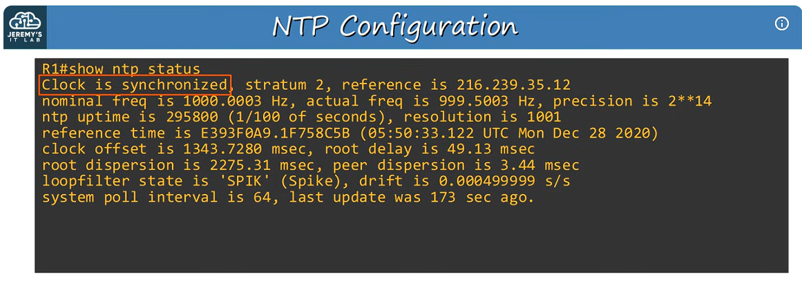
NTP master <1-15> stratum number | Allows the device to act as a NTP master clock
NTP Master | Same as above but uses the default stratum level
NTP peer <ip address> | Configures NTP symmetric active mode

New Acronyms
Anything new that may not be in the Acronyms document yet.
Acronym | Full name | What it means

Things to Expand / Clarify
Anything you want Claude to explain further, add more context to, or correct in the document. Be specific about where it is.

Corrections
Note anything in the current document that you found is wrong or needs updating.
Location (Part / section) | Current text (approx) | What it should say

Real-World Notes
Anything from work that relates to this topic. It goes into the CCNA vs Real World document.

Lab and Quiz Check
Lab done: ☐ Yes ☐ No Which lab:
What I broke on purpose and what I learned:

Practice or YouTube quiz questions I got wrong:
These feed the "common traps" notes in the CCNA document.
Question (short) | What I answered | Correct answer and why

How to Submit These Notes
1. Fill in what you can. Blank sections are fine.
2. Upload the sheet and type: "Please add these notes to the CCNA integrated document (latest). Cross-check against what's already there." Or tick the Action box at the top and just upload it.
3. Save a copy of this template for each topic and keep the original unchanged.

Tip: the more specific your notes, the better Claude can place them. Mention the section heading if you know it.

