CCNA 200-301 — Video Notes Capture Sheet

Session Details
Video / Topic: Dynamic Routing
3.0, 3.1, 3.2, 3.3, 3.4

Main Notes
Write bullet points — one idea per line. Star (*) anything you are unsure about or want Claude to expand on.
** or bolded is a highlighted term that needs to be kept and highlighted
📝 Key concepts and dot points
- A Network Route is a route to network or subnet (Mask length </32) it is not a route to a single host – to a whole subnet – i.e. 10.0.12.0/30
- A Host route is a route to a single host – 10.0.12.1/32
- A default route is a route to the default gateway
- A Default route is a route to a network (/32)
- Dynamic routing advertises its routes (you can reach network) via me
- Routers can use dynamic routing protocols to advertise information about the routes they know to other routers and routes they have learned from other routers
- They for ‘adjancies’ / neighbour relationships/ neighborships’ with adjacent routes to exchange this information
- If multiple routes to a destination are learned, the router determines which route is superior and adds it to the routing table. It uses the ‘metric’ of the route to decide which route is superior – lower metric = superior
- Dynamic routing protocols can be divided into two main categories:
  - IGP (interior gateway Protocol)
  - EGP (exterior gateway protocol)
- IGP – used to share routes within a single autonomous system (AS), which is a single organisation (i.e. a company)
- EGP – used to share routes between different autonomous systems
  - 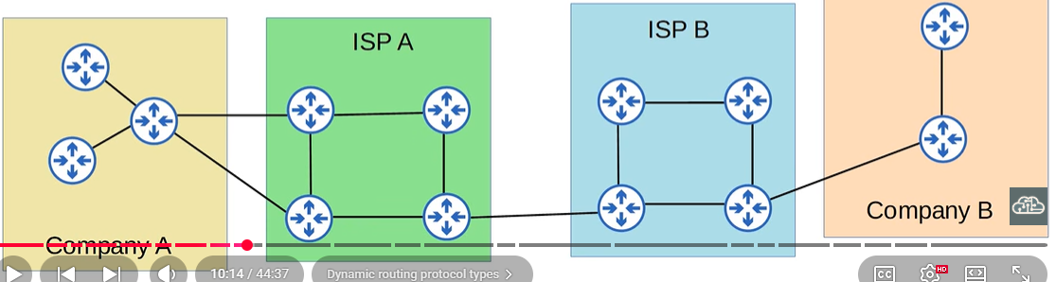
- IGP
  - Distance Vector –
    - Routing Information Protocol (RIP)
    - Enhanced Interior Gateway Routing Protocol (EIGRP)
  - Link State
    - Open Shortest Path First (OSPF)
    - Intermediate System to Intermediate System (IS-IS)
- EGP
  - Path Vector – Border Gateway Protocol (BGP)
- Distance vector protocols were invented before link state protocols
- Early examples are RIPv1 and Cisco’s proprietary protocol IGRP (Which was updated to (EIGRP)
- Distance Vector Protocols operate by sending the following to their directly connected neighbours:
  - Their known destination networks
  - Their metric to reach their known destination networks
- This method of sharing rout information is often called ‘routing by rumour’
- This is because the router doesn’t know about the network beyond its neighbours. It only knows the information that its neighbours tell it
- Called distance vector because the routers only learn the ‘Distance’ (metric) and vector (Direction, the next hop router of each route
- When using a link state routing protocol, every router creates a connectivity map of the network
- To allow thus, each router advertises information about its interfaces (connected networks) to its neighbours These advertisements are passed along to the other routers, until all routers in the network develop the same map of the network.
- Each router independently uses this map to calculate the best routes to each destination
- Link state protocols use more resources (CPU) on the router, because more information is shared
- However, link state protocols tend to be faster in reacting to changes in the network than distance-based vector protocols
- ** If a router learns two (or more) routes via the same routing protocol to the same destination (same network address, same subnet mask) with the same metric, both will be added to the routing table. Traffic will be load balanced over both routes
- ECMP (equal cost multi-Path)
- 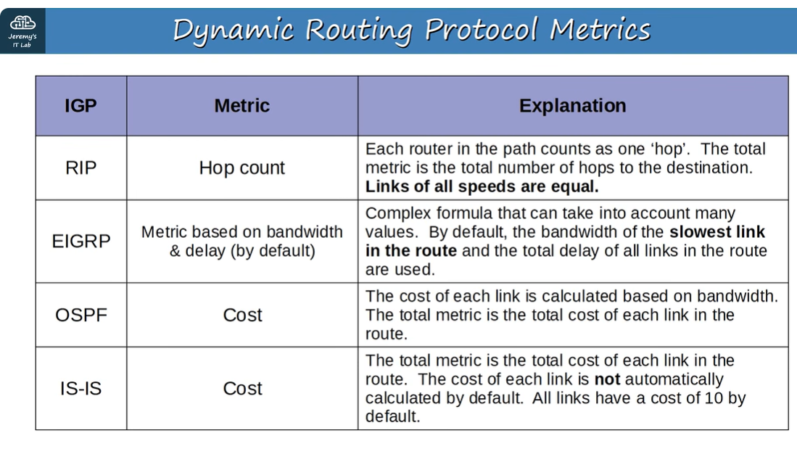
- Administrative Distance
- In most cases a company will only use a single IGP – usually OSPF or EIGRP
- However, in some rare cases they might use two. For example, if two companies connect their networks to share information, two different routing protocols might be in use.
- Metric is used to compare routes learned via the same routing protocol.
- Different routing protocols use totally different metrics, so they cannot be compared.
- For example, an ospf route 192.168.4.0/24 might have a metric of 30, while an EIGRP route to the same destination might have a metric of 33280. Which route is better? Which route should be the router put in the route table?
- The Administrative Distance (AD) is used to determine which routing protocol is preferred.
- A lower AD is preferred, and indicates that the routing protocol is considered more ‘trustworthy’ (more likely to select good routes)
- 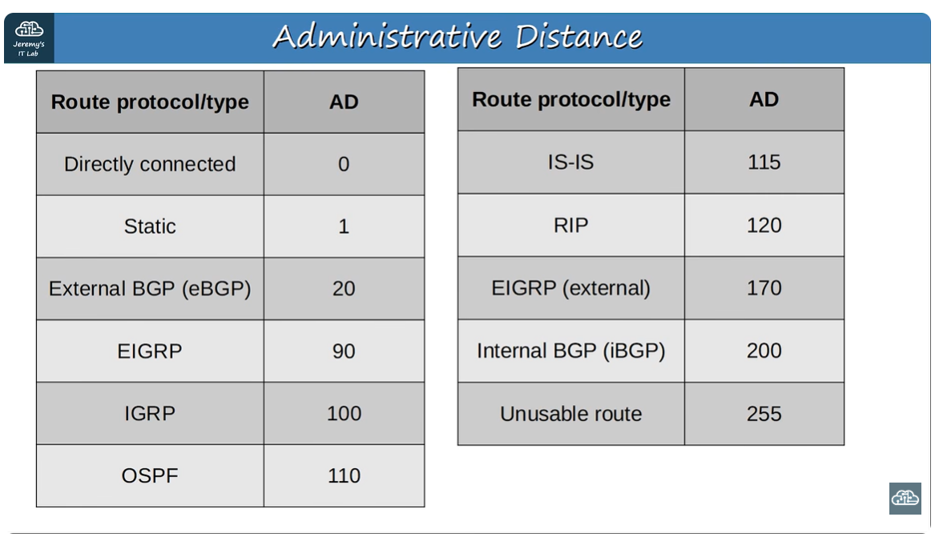
- You can change the AD of a routing protocol
- You can also change the AD if a static route:
- By changing the AD of a static route, you can make it less preferred than routes learned by a dynamic routing protocol to the same destination (Make sure the AD is higher than the routing protocols AD)
- This is called a floating static route
- The route will be inactive (not in the routing table) unless the route learned bu the dynamic routing protocol is removed (for example, the more router stops advertising it for some reason, or an interface failure causes an adjacency with a neighbour to be lost).

Commands
- to configure a static route to a single host = Command ip route host ip address subnet mask

Things to Expand / Clarify
Anything you want Claude to explain further, add more context to, or correct in the document. Be specific about where it is.

Corrections
Note anything in the current document that you found is wrong or needs updating.
Location (Part / section) | Current text (approx) | What it should say

How to Submit These Notes
1. Type: "Please add these notes to the CCNA integrated document (latest). Cross-check against what's already there."

Tip: The more specific your notes, the better Claude can place them. Mention the section heading if you know it.

