*QCT2018* –notes

*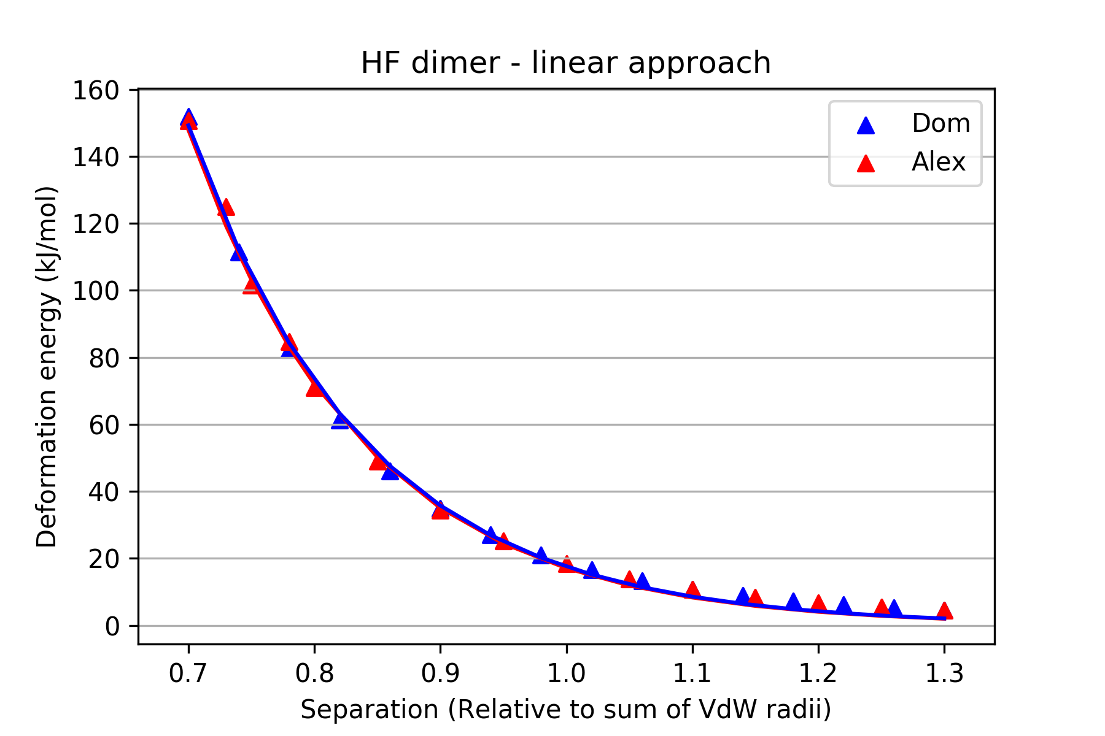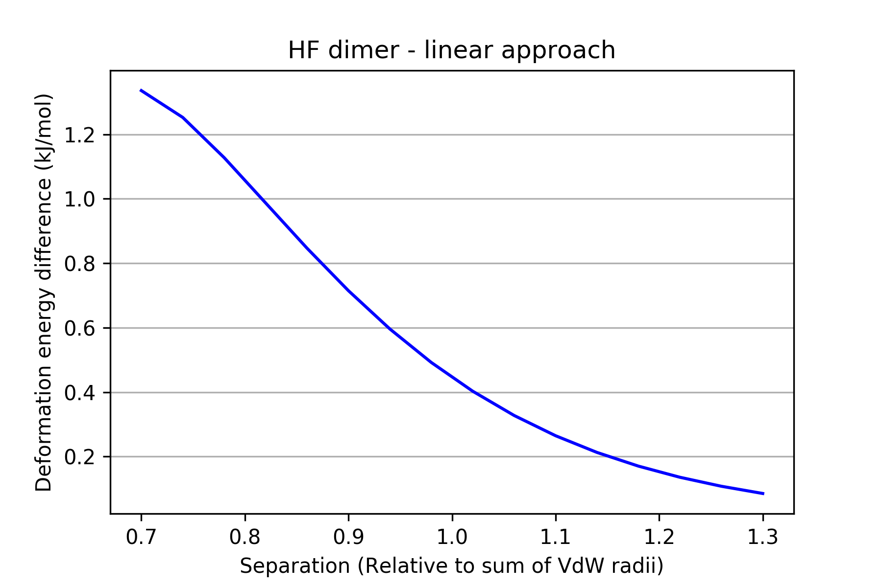*The first important task was to replicate Alex’s original (linear) results so that we knew that both the input files and method that we were using was correct. Initially, I picked the HF dimer to analyse. The results, presented in Figures 1 and 2, show that the difference between our two datasets was reasonably small but not down to machine precision (N.B. since the separations analysed by Alex and myself were not always identical, the ‘difference’ curve in Figure 2 was created by subtracting the exponential fits of each curve) Since the same format of Gaussian input files were used in both experiments and the level of theory was identical, it is likely that the difference in the results was due to the different versions of AIMAll used (v17 in our case, v16 in Alex’s). This change meant that, unlike Alex, we did not have to specify a grid resolution when using AIMAll (ours was set to ‘Auto’, his to ‘superhigh-leb’). Among other details, we concluded that this is likely to have led to the inequality of our results.

I then proceeded to test all of the possible orientations of approach for a HF dimer, specifically: a 180º rotation of one HF about the other, with the bond between ‘F1’ and ‘H2’ placed at the origin, and ‘F3’ initially pointing towards it from above; a similar 180º rotation but with the H and F exchanged in both molecules; an approach whereby each HF is horizontal to each other, so that the F and H of one molecule approaches the F and H of the other; a similar horizontal approach where one HF is flipped so that only the F’s approach each other identically while the H’s are both on opposite sides of the interaction line. With regard to the first orientation/method of approach, I decided to do a full 360º run to confirm the symmetry of the system – returning a positive (identical to the first 180º) result. The comprehensive results for each approach can be found in the Excel spreadsheet.

An interesting difficulty when analysing the data after rotating one HF about the other, with ‘F3’ as the ‘probe’ (say), is that the deformation energy *relevant* to each approach is not necessarily identical for each angle. For example, it is not necessarily meaningful to plot the total deformation energy of the two F’s at the 180º run, since it is ‘H2’ which is being probed directly rather than ‘F1’ at the larger angles.

Collectively we decided to look at homonuclear diatomics in 180º rotations to analyse how more simple systems (in the absence of additional hydrogens) vary with theta. The decision was taken that it was best to place the origin at the centre of the bond, rather than at one of the atoms, so that any symmetry would be better exhibited. Upon discussion, it was agreed that it would be advantageous to look at a 0.5 – 1.5 VdV diameter range, with 25 increments, to get a more total range of results for each angle (such that both 0.7 and 1.3 of the VdV diameter was also measured). These were done for angles between 0º and 180º in steps of 5º. I analysed F2, Cl2 and S2 while Ben and Campbell looked at N2 and O2 respectively (alongside H2). I also decided to experiment with HCl, HBr and CO in order to compare to HF and how they may be similar/different.

Partial optimisations of the approaches were later tested. For linear molecules, the various dihedral angles were kept constant for each scan (otherwise the approach angle would change) while the bond lengths were allowed to vary within each molecule. Such an optimisation would be more interesting in more complex molecules as there would be more internal degrees of freedom which may be optimised without altering the line of approach.

General conclusions from work so far:

* Following on from Alex’s work, we investigated the repulsion due to compression for atoms in a variety of molecules. This was done for varying lines of approach (0 to 180º) and from 1.5 to 0.5 of the combined VdV radii.
* We found that exponential repulsion holds when the atoms being probed have core electrons (i.e. not H), while H exhibits different behaviour. It was found that under compression H’s charge was becoming more positive so Vne increased in value. This is while T was decreasing from the effect of volume compression and charge leaving the atom. The increase in charge (i.e. further loss of electrons) is thought to be due to the lack of a core of electrons in H, leading to H being more susceptible to losing/transferring charge (density) to neighbouring (more electronegative) atoms (which do have core electrons) and so the Vne and T intra-atomic energy terms vary in a non-standard way.
* When H itself is electronegative, as in BH3, it was found to have an effective core of electrons (since it always had some negative charge) and as a result its intra-atomic energies behaved in the standard manner. This helps to illustrate that the unique behaviour of H is due to it lacking a core in almost all molecules in which it is bonded (where its neighbours are more electronegative). In CH4, where the bonds are non-polar, we find that H also compresses in the regular way.
* The approach of two H atoms (bonded to a variety of molecules where H is electropositive) does not exhibit standard behaviour. Will investigate further with HBr, HCl and PH3 hydrogen approaches.

Relaxed Scans

While the majority of the experiments involved rigid molecules with fixed geometries, partial optimisations of the approaches were later tested to verify the conclusions of the theta study for relaxed systems.

For HF, the dihedral angles between the two molecules were kept constant for each scan (otherwise the approach angle would change) while the bond lengths were allowed to vary. The H2O dimer had fixed dihedral angles as well as a single O-O-H angle fixed. Such an optimisation would be more interesting in more complex molecules as there would be more internal degrees of freedom which may be optimised without altering the line of approach.