

Data Technician

Name: Dominika Adrianna Ochecka
Course Date: 2025/09/22
Table of contents
Day 1: Task 1 2
Day 2: Task 1 2
Day 2: Task 2 3
Day 2: Task 3 4
Day 3: Task 1 4
Day 3: Task 2 5
Dataset: 5
Step 1: Create a Pivot Table 5
Step 2: Use the SWITCH Function 5
Submission: 6
Day 3: Task 3 6
Day 4: Task 1 7
Course Notes 9
Additional Information 10

Day 1: Task 1

Please research and complete the below boxes on common laws and regulations that must be followed when working with customers data, use the below bulleted list to support your answers.

- What is it
- Why is it important
- Provide a real-world example of how you can follow it
- How does it impact working with data
- What could happen if you breached it

Data Protection Act | - What is it  Set of rules and guidelines to protect any parties using or working with data only within UK.  - Why is it important  To keep privacy and any sensitive information- protected and secured in an appropriate way and held companies and professionals accountable for their work.  - Provide a real-world example of how you can follow it  Health care sector it’s a very good example of why data should be handled with care and certain rules. Especially to secure and protect sensitive information, employee who is required to store and respect job seekers data.  - How does it impact working with data  Sets (inside of the country ) control over the health care, policing , public service in general.  - What could happen if you breached it  Investigations for those who breach it , fines, lose of public trust
GDPR | - What is it  General Data Protection Regulation – European Union Regulation (in UK since 2018)  - Why is it important  Was build up with a purpose of controlling the data base and IT -information, storage, etc EU wise, not only in UK. To protect and build trust with users and held companies and professionals accountable for their work.  - How does it impact working with data  Forces companies and professionals to handle data with care, respect applying rules and acts.  Make consent and transparency a priority.  - Provide a real-world example of how you can follow it  It’ very useful to control EU wise companies and make sure users and their rights are protected and rules are followed .  - What could happen if you breached it  Legal actions can be taken against the ones who breached.  Loss of customers and their trust  Large fines
Freedom of Information Act | - What is it  Gives members of public right to view any public documents. Information/ data  - Why is it important  Promotes transparency and builds up trust  - Provide a real-world example of how you can follow it  like what they spent your council tax on, statistics about any local issues, etc  - How does it impact working with data  Forces public authorities to keep everything in order, transparent and accessible for the public.  Balances what is for public information and what is sensitive information  - What could happen if you breached it  Lose of public trust  Complains or orders or from the Information Commissioner
Computer Misuse Act | - What is it  Protects against illegal access to data and computers  - Why is it important  Gives user set of rules to follow in order to protect everyone data .  - Provide a real-world example of how you can follow it  Hacker breaks into a bank account which can result in fine or prison  - How does it impact working with data  Creates a legal framework against cybercrime  - What could happen if you breached it  Lose of trust, bad reputation, legal consequences

Day 2: Task 1

Please research and complete the following tasks within the retail-sales_dataset.xlsx document, paste a print screen into the provided boxes below:

- In the sheet ‘retail_sales_dataset’ add all available data between columns A – J into a ‘Table’. Remember to select only the data you want to convert.
- Using the dropdown menu in the ‘Age’ column, sort the data by age, ‘largest to smallest’
- Using the ‘SUM’ function, show me the commission total in cell ‘M10’
- Using the ‘AVERAGE’ function, show me the average commission in cell ‘M11’

Print screen 1 | 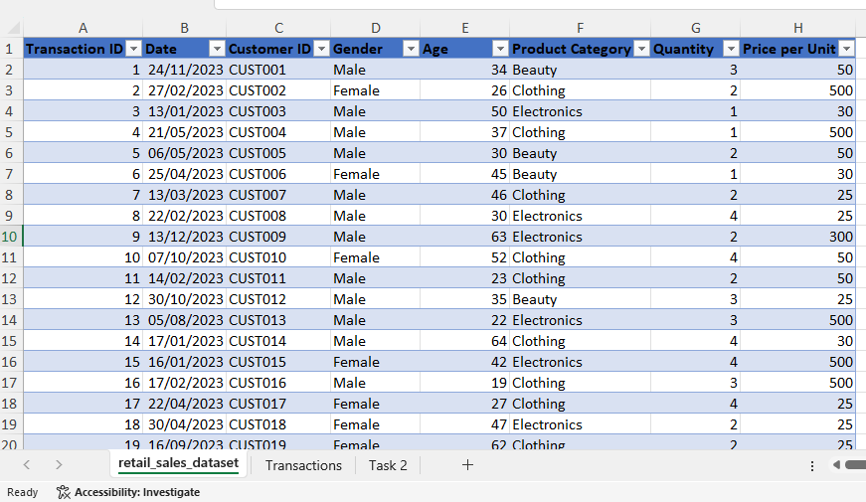
Print screen 2 | 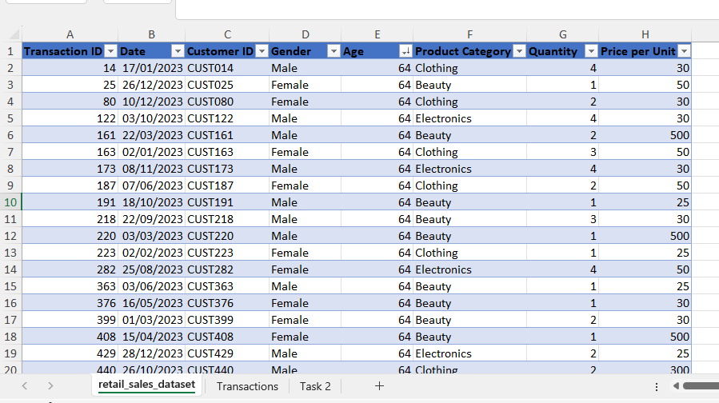
Print screen 3
Print screen 4 | 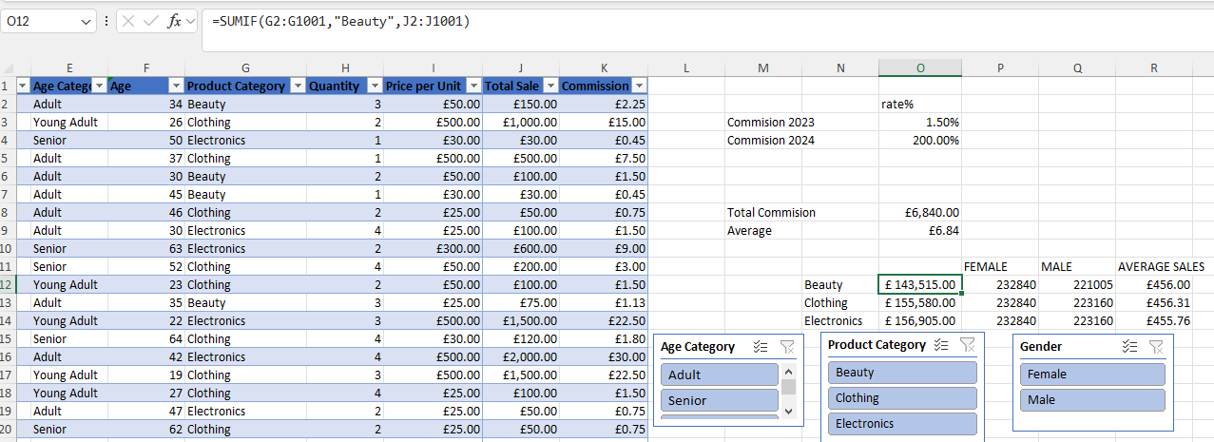

Day 2: Task 2

Please research and complete the following tasks within the retail-sales_dataset.xlsx document, paste print screens into the provided box below:

Print screen 1 | 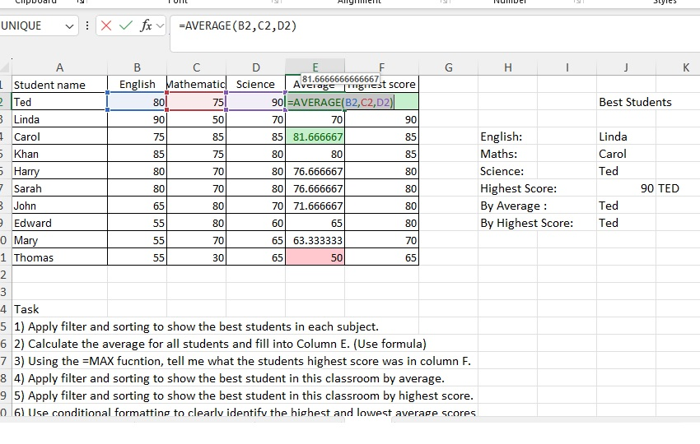

Day 2: Task 3

Using the skills developed today, have some fun with the data set you have imported. Paste your work below and enjoy!

Print screen 1 | 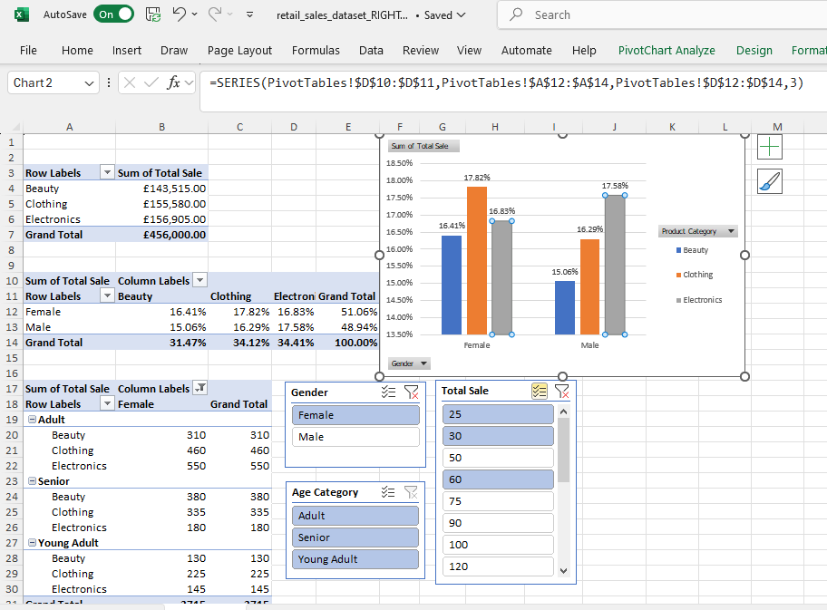

Day 3: Task 1

Please download the dataset ‘Day_3_Task_1_Bike_Sales_Pivot_Lab.xlsx’ from here.

The lab instructions can be found here. Do not worry if you do not complete the lab, just working with data and playing with the pivot table will be good experience.

Please paste your final pivot table below and complete the reflection questions:

Print screen 1 | 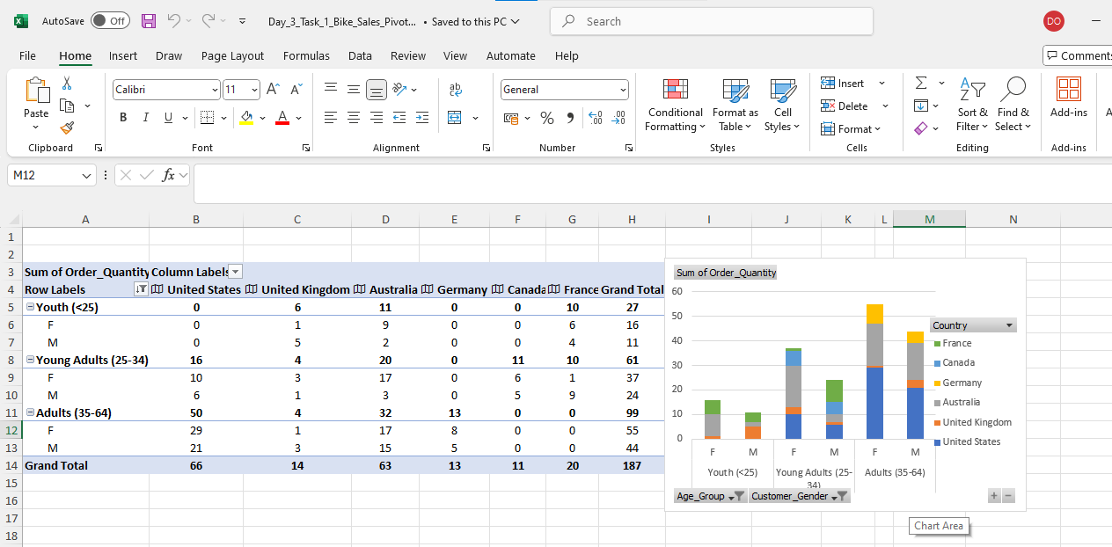
In which markets does Germany have customers?
What country has sales in all markets?
What are the most profitable markets by country, age group, and gender?
Any other findings?

Day 3: Task 2

The dataset below tracks the sales performance of different products in various counties in England. Please paste the dataset into a blank Excel workbook. Your task is to:
- Create a Pivot Table to summarise the data by county and product.
- Use the SWITCH function to categorise products based on their sales volume.

Dataset:
County | Product | Sales Volume
Yorkshire | Laptops | 500
Yorkshire | Smartphones | 200
Cornwall | Laptops | 700
Cornwall | Printers | 400
Lancashire | Smartphones | 150
Lancashire | Laptops | 600
Essex | Printers | 800
Essex | Smartphones | 300
Durham | Laptops | 250
Durham | Printers | 300
Greater Manchester | Smartphones | 600
Greater Manchester | Laptops | 400

Step 1: Create a Pivot Table
- Select the dataset (columns A to C).
- Insert a Pivot Table to summarise the data by County in the rows and Products in the columns. Use Sales Volume as the value to be summarised.

Step 2: Use the SWITCH Function
In a new column next to your data, use the SWITCH function to categorise products based on Sales Volume as follows:
  - For sales greater than 600: "High"
  - For sales between 300 and 600: "Medium"
  - For sales less than 300: "Low"
SWITCH Function Example:
=SWITCH(TRUE, C2 > 600, "High", C2 >= 300, "Medium", "Low")
- Apply this formula to each row, and check if the products are categorised correctly.
- In ‘Sales Volume’ you need to remove the space after each amount
- Confirm the data type is numerical

Submission:
- A completed Pivot Table summarising sales by county and product.
- A new column in the dataset categorising products by sales volume using the SWITCH function.
  - Please paste your completed work below

Print screen 1

Day 3: Task 3

Please download the dataset ‘Day_3_Task_3_Bike_Sales_Visualisations_Lab.xlsx’ from here.

The lab instructions can be found here. Do not worry if you do not complete the lab, just working with data and playing with the charts will be good experience.

Please paste your results below:

Print screen 1

Day 4: Task 1

You have been asked to deliver your analysis findings to the board of directors, within your analysis you have identified that customers are leaving your company at the 12-month point, this is typically when they receive their renewal price.

Conduct research and complete the below questions:

How would you prepare for the delivery?
What tools would you use for the delivery?
What is prospecting and why would you complete this before your delivery?
Tell me best practices for public speaking and providing updates to senior leaders
What will you show the board in your delivery?
How will you articulate the changes that are needed?
Provide a list of online resources and videos that will support your preparation for public speaking
Evaluate tools that provide visualisation.

Tell me what they are.

Tell me what you would choose when delivering your presentation and why

Course Notes

It is recommended to take notes from the course, use the space below to do so, or use the revision guide shared with the class:

Additional Information

We have included a range of additional links to further resources and information that you may find useful, these can be found within your revision guide.

END OF WORKBOOK

Please check through your work thoroughly before submitting and update the table of contents if required.

Please send your completed work booklet to your trainer.

