

Data Technician

Name:
Course Date:
Table of contents
Day 1: Task 1 3
Day 1: Task 2 3
Day 3: Task 1 4
Day 4: Task 1: Written 6
Day 4: Task 2: SQL Practical 9
Course Notes 19
Additional Information 19

Day 1: Task 1

Please research and complete the below questions relating to key concepts of databases.

What is a primary key? | Primary key it’s a unique identification for each rows(records) and helps establish to which column this record belongs too.
How does this differ from a secondary key? | Secondary key it’s like a backup for a Primary Key. We can always use it to see where the connection is but doesn’t need to be to primary key. (It can be something else where the relation is between a record and a column)
How are primary and foreign keys related? | When we have two separate tables but there is a relationship between them. Foreign key helps us to locate the primary key for a record in another table. It’s a link between the tables.
Provide a real-world example of a one-to-one relationship | Every resident/citizenship has a unique NIN number .
Provide a real-world example of a one-to-many relationship | One mother can have many kids but each child has only one mother.
Provide a real-world example of a many-to-many relationship | Student can be enrolled in many courses,  in the course many students can be enrolled.

Day 1: Task 2

Please research and complete the below questions relating to key concepts of databases.

What is the difference between a relational and non-relational database? | Rational database always needs to have relationship to another table .(Like when we have many spread sheets in Excel and we are looking for relationship between to establish the connection .  Data must be structured or follow a pattern and use SQL language.  When non-relational data base is more flexible, doesn’t need a pattern or structured data to handle it and also can manage large databases. Allows us to make real time analytics.
What type of data would benefit off the non-relational model?

Why?

Day 3: Task 1

Please research the below ‘JOIN’ types, explain what they are and provide an example of the types of data it would be used on.

Self-join | A table joined with itself. Compare rows within the same table but different column .  Like when we need list out something out of the same list.
Right join | It’s doing the same job as Left join but instead of left side being main one it’s the right table. Compering information with the left table and adding info to the right one. It will show as well data with no values on the main (right) table.
Full join | Combines information from both columns even if something doesn’t match it will show it on that (not matching)side.
Inner join | Returns only matching rows from both tables.
Cross join | Creates a Cartesian product – every row from one table is joined with every row from the other.
Left join | You choose one table as a left (main)table. The left join takes all rows from his table and adds matching information from the right table . If there is no matches it still shows rows with no values or nulls in left column.

Day 4: Task 1: Written

In your groups, discuss and complete the below activity. You can either nominate one writer or split the elements between you. Everyone however must have the completed work below:

Imagine you have been hired by a small retail business that wants to streamline its operations by creating a new database system. This database will be used to manage inventory, sales, and customer information. The business is a small corner shop that sells a range of groceries and domestic products. It might help to picture your local convenience store and think of what they sell. They also have a loyalty program, which you will need to consider when deciding what tables to create.

Write a 500-word essay explaining the steps you would take to set up and create this database. Your essay should cover the following points:
- Understanding the Business Requirements:
  - What kind of data will the database need to store?
  - Who will be the users of the database, and what will they need to accomplish?
- Designing the Database Schema:
  - How would you structure the database tables to efficiently store inventory, sales, and customer information?
  - What relationships between tables are necessary (e.g., how sales relate to inventory and customers)?
- Implementing the Database:
  - What SQL commands would you use to create the database and its tables?
  - Provide examples of SQL statements for creating tables and defining relationships between them.
- Populating the Database:
  - How would you input initial data into the database? Give examples of SQL INSERT statements.
- Maintaining the Database:
  - What measures would you take to ensure the database remains accurate and up to date?
  - How would you handle backups and data security?

Your essay should include specific examples of SQL commands and explain why each step is necessary for creating a functional and efficient database for the retail business.

Please write your 500-word essay here | - Understanding the Business Requirements:  - What kind of data will the database need to store?  - The most important thing is to understand the business requirements. The business wants help with streamlining by creating a database. The data that we will use are; Customer information (name, telephone number, email), Products, inventory (product categories, barcode, prices), loyalty programme for customers' purchase history, and sales records for reporting on e.g. best sellers.  - Who will be the users of the database, and what will they need to accomplish?  - The people dealing with the database will be anyone who is involved within the business interest and benefits from the database (for example, the owner, the managers, the shop staff). The shop staff will need to understand the database to help better manage the store and records for reporting on e.g. learning what best sellers are.  - Designing the Database Schema:  - How would you structure the database tables to efficiently store inventory, sales, and customer information?  - We would need three tables. We would create the three tables these would be called, store inventory, sales, and customer information. Within the store inventory table, we would have these columns product_id, product name, price. Within the customer information tables, we would include these columns; customer_id, customer_name, customer_email. Within the sales table, we would have these columns; order_id, customer_id, product_id, price, total sales.  - What relationships between tables are necessary (e.g., how sales relate to inventory and customers)?  - We are joining the tables through the primary keys. The primary keys are customer_id and product_id. Within the third table, sales, we will use those primary keys to act as foreign keys in order to join customer information and store inventory tables.  - Implementing the Database:  - What SQL commands would you use to create the database and its tables?  - These are the SQL commands we would use to create the database:  - Provide examples of SQL statements for creating tables and defining relationships between them.  - Populating the Database:  - How would you input initial data into the database? Give examples of SQL INSERT statements.  INSERT INTO Customers (customer_id, customer_name, customer_email )  - values (1,'Emma Thompson', 'emma.thompson@gmail.com'),  - (2,'Liam Johnson', 'liam.johnson@yahoo.com'),  - (3,'Olivia Brown', 'olivia.brown@outlook.com'),  - (4,'Noah Wilson', 'noah.wilson@company.com'),  - (5,'Ava Davis', 'ava.davis@hotmail.com');  - Maintaining the Database:  - What measures would you take to ensure the database remains accurate and up to date?  - How would you handle backups and data security?  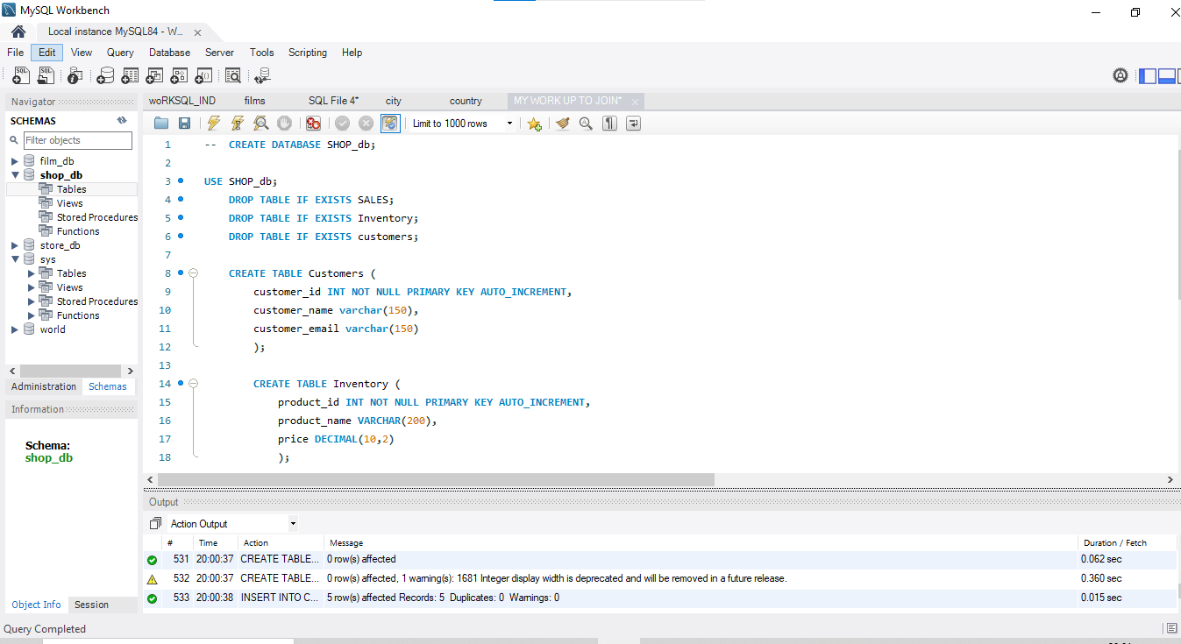  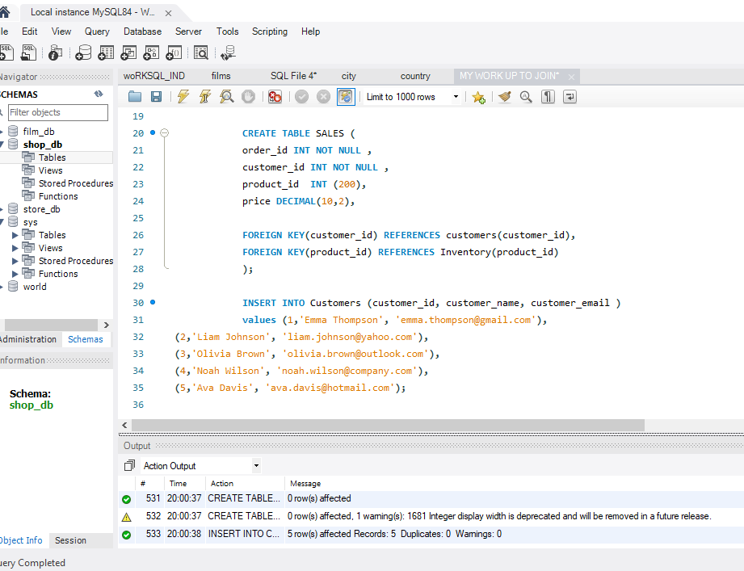
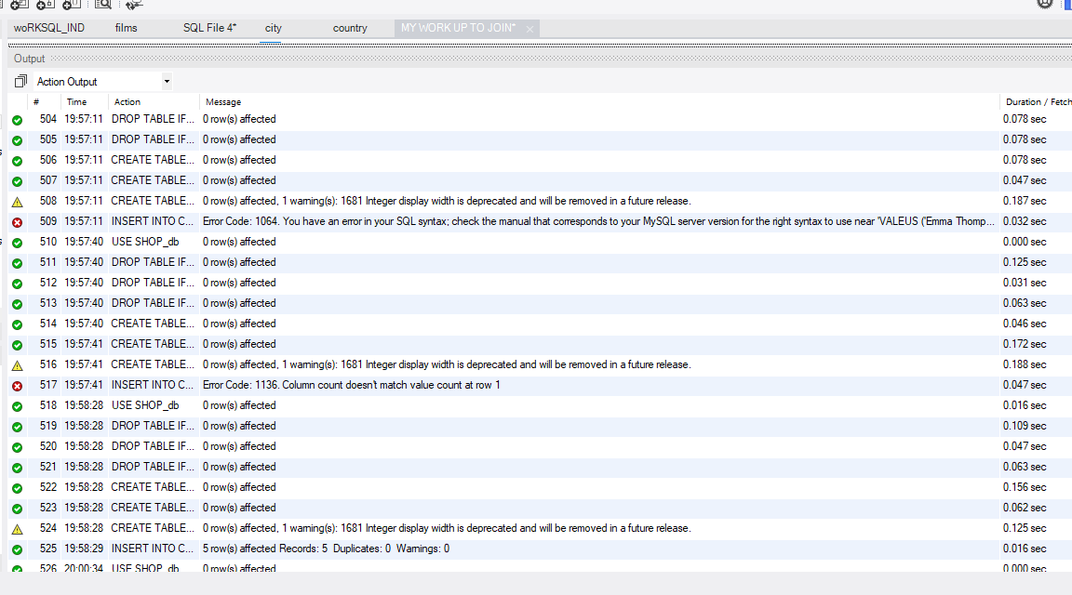

Day 4: Task 2: SQL Practical

In your groups, work together to answer the below questions. It may be of benefit if one of you shares your screen with the group and as a team answer / take screen shots from there.

Setting up the database:

- Download world_db(1) here
- Follow each step to create your database here

For each question I would like to see both the syntax used and the output.

- Count Cities in USA: Scenario: You've been tasked with conducting a demographic analysis of cities in the United States. Your first step is to determine the total number of cities within the country to provide a baseline for further analysis.

- Country with Highest Life Expectancy: Scenario: As part of a global health initiative, you've been assigned to identify the country with the highest life expectancy. This information will be crucial for prioritising healthcare resources and interventions.

- "New Year Promotion: Featuring Cities with 'New : Scenario: In anticipation of the upcoming New Year, your travel agency is gearing up for a special promotion featuring cities with names including the word 'New'. You're tasked with swiftly compiling a list of all cities from around the world. This curated selection will be essential in creating promotional materials and enticing travellers with exciting destinations to kick off the New Year in style.

- Display Columns with Limit (First 10 Rows): Scenario: You're tasked with providing a brief overview of the most populous cities in the world. To keep the report concise, you're instructed to list only the first 10 cities by population from the database.

- Cities with Population Larger than 2,000,000: Scenario: A real estate developer is interested in cities with substantial population sizes for potential investment opportunities. You're tasked with identifying cities from the database with populations exceeding 2 million to focus their research efforts.

- Cities Beginning with 'Be' Prefix: Scenario: A travel blogger is planning a series of articles featuring cities with unique names. You're tasked with compiling a list of cities from the database that start with the prefix 'Be' to assist in the blogger's content creation process.

- Cities with Population Between 500,000-1,000,000: Scenario: An urban planning committee needs to identify mid-sized cities suitable for infrastructure development projects. You're tasked with identifying cities with populations ranging between 500,000 and 1 million to inform their decision-making process.

- Display Cities Sorted by Name in Ascending Order: Scenario: A geography teacher is preparing a lesson on alphabetical order using city names. You're tasked with providing a sorted list of cities from the database in ascending order by name to support the lesson plan.

- Most Populated City: Scenario: A real estate investment firm is interested in cities with significant population densities for potential development projects. You're tasked with identifying the most populated city from the database to guide their investment decisions and strategic planning.

- City Name Frequency Analysis: Supporting Geography Education Scenario: In a geography class, students are learning about the distribution of city names around the world. The teacher, in preparation for a lesson on city name frequencies, wants to provide students with a list of unique city names sorted alphabetically, along with their respective counts of occurrences in the database. You're tasked with this sorted list to support the geography teacher.

- City with the Lowest Population: Scenario: A census bureau is conducting an analysis of urban population distribution. You're tasked with identifying the city with the lowest population from the database to provide a comprehensive overview of demographic trends.

- Country with Largest Population: Scenario: A global economic research institute requires data on countries with the largest populations for a comprehensive analysis. You're tasked with identifying the country with the highest population from the database to provide valuable insights into demographic trends.

- Capital of Spain: Scenario: A travel agency is organising tours across Europe and needs accurate information on capital cities. You're tasked with identifying the capital of Spain from the database to ensure itinerary accuracy and provide travellers with essential destination information.

- Cities in Europe: Scenario: A European cultural exchange program is seeking to connect students with cities across the continent. You're tasked with compiling a list of cities located in Europe from the database to facilitate program planning and student engagement.

- Average Population by Country: Scenario: A demographic research team is conducting a comparative analysis of population distributions across countries. You're tasked with calculating the average population for each country from the database to provide valuable insights into global population trends.

- Capital Cities Population Comparison: Scenario: A statistical analysis firm is examining population distributions between capital cities worldwide. You're tasked with comparing the populations of capital cities from different countries to identify trends and patterns in urban demographics.

- Countries with Low Population Density: Scenario: An agricultural research institute is studying countries with low population densities for potential agricultural development projects. You're tasked with identifying countries with sparse populations from the database to support the institute's research efforts.

- Cities with High GDP per Capita: Scenario: An economic consulting firm is analysing cities with high GDP per capita for investment opportunities. You're tasked with identifying cities with above-average GDP per capita from the database to assist the firm in identifying potential investment destinations.

- Display Columns with Limit (Rows 31-40): Scenario: A market research firm requires detailed information on cities beyond the top rankings for a comprehensive analysis. You're tasked with providing data on cities ranked between 31st and 40th by population to ensure a thorough understanding of urban demographics.

Course Notes

It is recommended to take notes from the course, use the space below to do so, or use the revision guide shared with the class:

Additional Information

We have included a range of additional links to further resources and information that you may find useful, these can be found within your revision guide.

END OF WORKBOOK

Please check through your work thoroughly before submitting and update the table of contents if required.

Please send your completed work booklet to your trainer.

