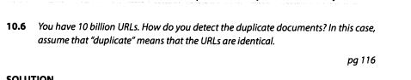
![

Documents are hashed. Hash function is non-invertable, we can only find original document using brute force method. Hash function has chaotic character, this mean that for single unit of change
we will get extremely different signatures. There should not exist two original documents which have same hash function.

hashes:
* md5
* sha2
* sha3

Assumptions:
* chaotic
* no colission
* not invertable

Use case:
* password management
* comparison of documents
* versioning

