European Startup Innovation Potential Bulletin

Dominik Stipić, December 2024
dominikstipic@gmail.com

Introduction
Startups are regarded as the power engine of innovation and progress in the common business language. If we assume this is true, I have prepared a few charts which try to measure the level of the innovation potential across Europe from the set of publicly known startups. We cannot automatically deduce that a higher index automatically means that the system is innovative but it is a good proxy for it. This is why word potential is used. An analysis gradually improves itself and it belongs to the sample-population ratio analysis type where we try to establish the ratio between targeted sample and total population.
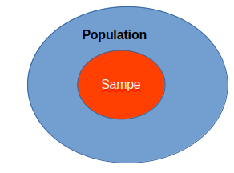

One main missed consideration is the variable size of startup employees. In the ideal case, we would, for each startup, retrieve the number of it’s employees and divide it by the number of working capable people in the country. This is the gap between the ideal case and the current analysis.

Analysis
First chart. We can see the number of startups for each country in Europe. Top 3 countries by the number of startups are in the UK, Germany and France. We can find the smallest number of startups in Malta, Slovakia and Croatia. Of course, this analysis doesn’t take into consideration the population number of the country.
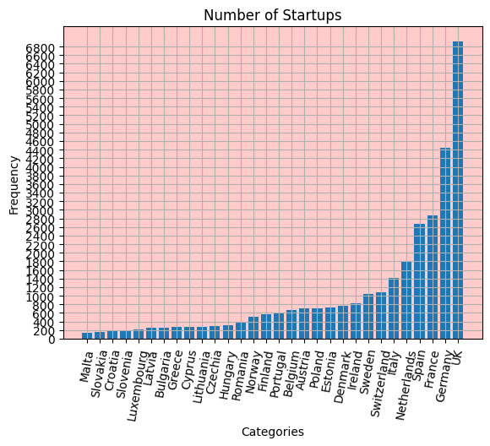

Second chart. We partially fixed the first analysis by dividing the number of startups by the total number of people in the country. But, the whole population takes into account children and retired people who are incapable of working or are legally prevented from entering into labour market. We can see the considerable change of an ordering.
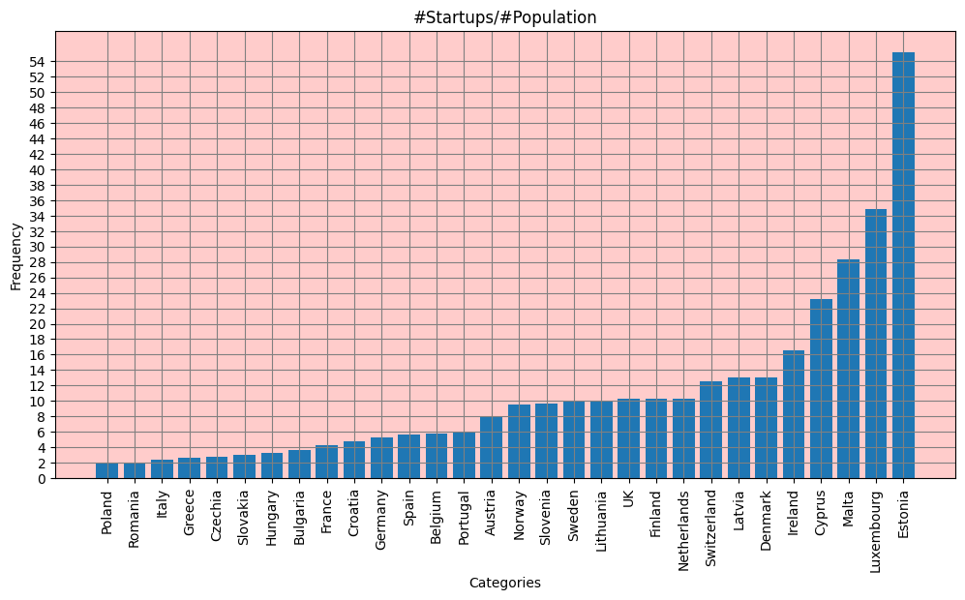

Third chart. removes the subsample of the humans with ages smaller than 18 and bigger than 60 so that we can get the number of the working capable people. On the right, we can see the number of working capable humans for each country and on the left, we can see the startup potential index or the division between the number of startups and working capable humans. Compared with the previous chart we get different ordering and the measures are of increased.

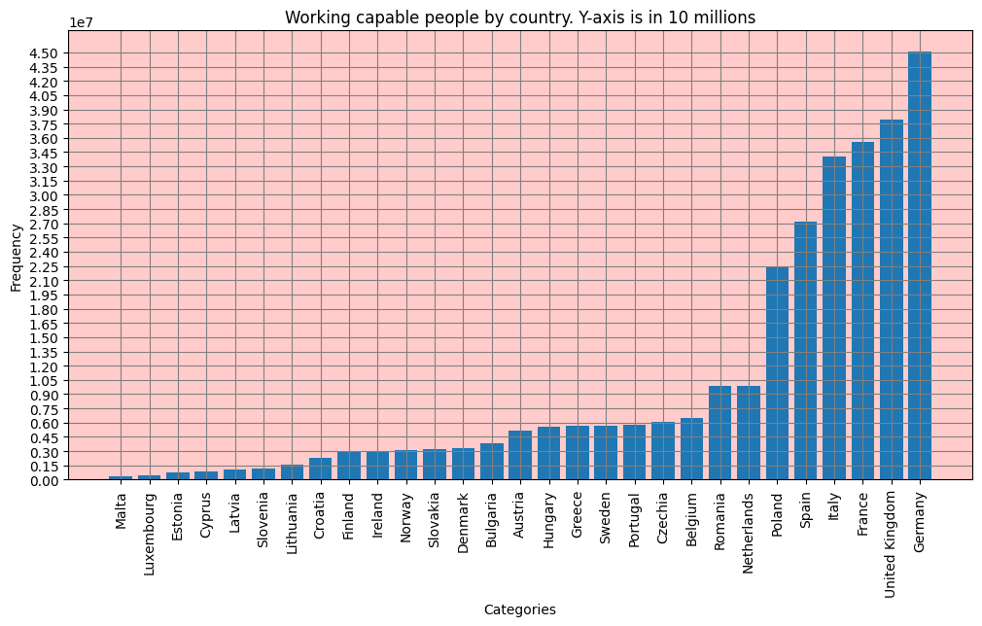
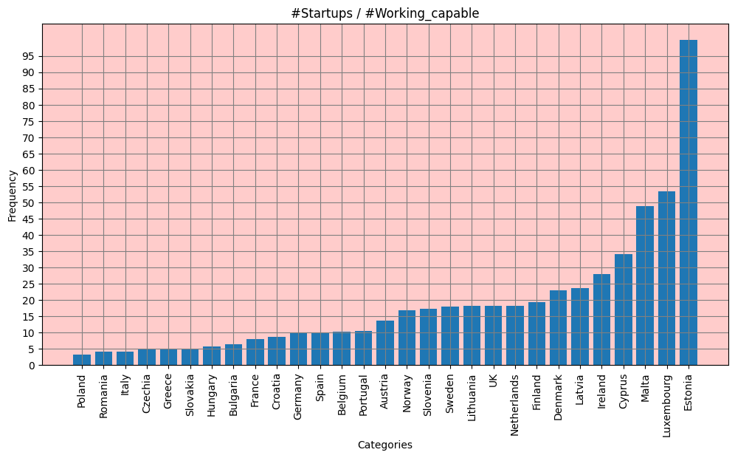

Commentary
In the end, our simple measures approximates that innovation potential is biggest in Malta, Luxembourg and Estonia. It is smallest in the Poland, Romania and Italy. To repeat again, in the ideal scenario the innovation potential would be calculated as the number of startup employees and the total working capable population but this involves larger data collection efforts which are out of the scope of this bullet article. Also, by doing data mining of the startup descriptions one could considerably improve the current measures and get the better picture of the ecosystem.

https://www.eu-startups.com/

