Untitled
Dominikus Atmaka
2026-05-04
library(tidyverse)
## Warning: package 'ggplot2' was built under R version 4.5.2
## Warning: package 'tibble' was built under R version 4.5.2
## Warning: package 'tidyr' was built under R version 4.5.2
## Warning: package 'readr' was built under R version 4.5.2
## Warning: package 'purrr' was built under R version 4.5.2
## Warning: package 'dplyr' was built under R version 4.5.2
## Warning: package 'lubridate' was built under R version 4.5.2
## ── Attaching core tidyverse packages ──────────────────────── tidyverse 2.0.0 ──
## ✔ dplyr 1.2.1 ✔ readr 2.2.0
## ✔ forcats 1.0.1 ✔ stringr 1.6.0
## ✔ ggplot2 4.0.3 ✔ tibble 3.3.1
## ✔ lubridate 1.9.5 ✔ tidyr 1.3.2
## ✔ purrr 1.2.2
## ── Conflicts ────────────────────────────────────────── tidyverse_conflicts() ──
## ✖ dplyr::filter() masks stats::filter()
## ✖ dplyr::lag() masks stats::lag()
## ℹ Use the conflicted package (<http://conflicted.r-lib.org/>) to force all conflicts to become errors
library(ggplot2)
library(readr)
library(ggpubr)
## Warning: package 'ggpubr' was built under R version 4.5.2
library(vegan)
## Warning: package 'vegan' was built under R version 4.5.2
## Loading required package: permute
## Warning: package 'permute' was built under R version 4.5.2
library(scales)
##
## Attaching package: 'scales'
##
## The following object is masked from 'package:purrr':
##
## discard
##
## The following object is masked from 'package:readr':
##
## col_factor
library(lme4)
## Warning: package 'lme4' was built under R version 4.5.2
## Loading required package: Matrix
## Warning: package 'Matrix' was built under R version 4.5.2
##
## Attaching package: 'Matrix'
##
## The following objects are masked from 'package:tidyr':
##
## expand, pack, unpack
##
## Registered S3 method overwritten by 'lme4':
## method from
## na.action.merMod car
library(lmerTest)
## Warning: package 'lmerTest' was built under R version 4.5.2
##
## Attaching package: 'lmerTest'
##
## The following object is masked from 'package:lme4':
##
## lmer
##
## The following object is masked from 'package:stats':
##
## step
library(pbkrtest)
library(emmeans)
## Warning: package 'emmeans' was built under R version 4.5.2
## Welcome to emmeans.
## Caution: You lose important information if you filter this package's results.
## See '? untidy'
library(rstatix)
##
## Attaching package: 'rstatix'
##
## The following object is masked from 'package:stats':
##
## filter
library(forcats)
library(scales)
metadata <- read_tsv("/Users/dominikusraditya/Documents/ANEQ505_HW/pempek/03_metadata/metadata.txt")
## Rows: 105 Columns: 20
## ── Column specification ────────────────────────────────────────────────────────
## Delimiter: "\t"
## chr (13): sample, sample_type, date, age_d, age_w, sex, treatment, gel_resul...
## dbl (7): sample_name, calf_number, calf_id, day, week, weekly_fecal_counts,...
##
## ℹ Use `spec()` to retrieve the full column specification for this data.
## ℹ Specify the column types or set `show_col_types = FALSE` to quiet this message.
as.character(metadata$sample_name)
## [1] "108136" "108137" "108148" "108149" "108150" "108151" "108154" "108155"
## [9] "108156" "108157" "108160" "108161" "108162" "108163" "108166" "108167"
## [17] "108168" "108169" "108173" "108174" "108175" "108180" "108181" "108184"
## [25] "108185" "108186" "108187" "108190" "108191" "108192" "108193" "108196"
## [33] "108197" "108198" "108199" "108203" "108204" "108205" "108209" "108210"
## [41] "108211" "108215" "108216" "108217" "108220" "108221" "108222" "108223"
## [49] "108233" "108234" "108235" "108238" "108239" "108240" "108241" "108244"
## [57] "108245" "108246" "108247" "108250" "108251" "108252" "108253" "108256"
## [65] "108257" "108258" "108259" "108263" "108264" "108265" "108274" "108275"
## [73] "108276" "108277" "108280" "108281" "108282" "108283" "108286" "108287"
## [81] "108288" "108289" "108292" "108293" "108294" "108295" "108298" "108299"
## [89] "108300" "108301" "108304" "108305" "108306" "108307" "108310" "108312"
## [97] "108313" "108592" "108594" "108597" "108598" "108600" "108604" "108605"
## [105] "108606"
metadata$sample_name <- as.character(metadata$sample_name)

Beta diversity

Load in beta diversity metrics and tidy to add to metadata
(remember this is already our PCOA results so this is already our ordinations). I make separate metadata’s for each beta diversity metric, another option would be to rename each PC ex. PC1J for jaccard and add PC1-PC3 for each metric to the metadata. I find it easier to keep everything separate when the metrics have different metadata. The variances extracted from the unzipped PCoA files will not match what you see in the Emperor plot, because Emperor adjusts the variance for plotting. To obtain variances that match the Emperor plot, you need to use qiime2R.
# Read in beta div metrics
bray_curtis <- read_tsv("/Users/dominikusraditya/Documents/ANEQ505_HW/pempek/04_code/beta_div/bray_curtis.txt")
## Warning: One or more parsing issues, call `problems()` on your data frame for details,
## e.g.:
## dat <- vroom(...)
## problems(dat)
## Rows: 112 Columns: 2
## ── Column specification ────────────────────────────────────────────────────────
## Delimiter: "\t"
## chr (2): Eigvals, 105
##
## ℹ Use `spec()` to retrieve the full column specification for this data.
## ℹ Specify the column types or set `show_col_types = FALSE` to quiet this message.
jaccard <- read_tsv("/Users/dominikusraditya/Documents/ANEQ505_HW/pempek/04_code/beta_div/jaccard.txt")
## Warning: One or more parsing issues, call `problems()` on your data frame for details,
## e.g.:
## dat <- vroom(...)
## problems(dat)
## Rows: 112 Columns: 2
## ── Column specification ────────────────────────────────────────────────────────
## Delimiter: "\t"
## chr (2): Eigvals, 105
##
## ℹ Use `spec()` to retrieve the full column specification for this data.
## ℹ Specify the column types or set `show_col_types = FALSE` to quiet this message.
uw_unifrac <- read_tsv("/Users/dominikusraditya/Documents/ANEQ505_HW/pempek/04_code/beta_div/unweighted_unifrac.txt")
## Warning: One or more parsing issues, call `problems()` on your data frame for details,
## e.g.:
## dat <- vroom(...)
## problems(dat)
## Rows: 112 Columns: 2
## ── Column specification ────────────────────────────────────────────────────────
## Delimiter: "\t"
## chr (2): Eigvals, 105
##
## ℹ Use `spec()` to retrieve the full column specification for this data.
## ℹ Specify the column types or set `show_col_types = FALSE` to quiet this message.
w_unifrac <- read_tsv("/Users/dominikusraditya/Documents/ANEQ505_HW/pempek/04_code/beta_div/weighted_unifrac.txt")
## Warning: One or more parsing issues, call `problems()` on your data frame for details,
## e.g.:
## dat <- vroom(...)
## problems(dat)
## Rows: 112 Columns: 2
## ── Column specification ────────────────────────────────────────────────────────
## Delimiter: "\t"
## chr (2): Eigvals, 105
##
## ℹ Use `spec()` to retrieve the full column specification for this data.
## ℹ Specify the column types or set `show_col_types = FALSE` to quiet this message.
# Clean metrics
# bray curtis
# get variance
bray_curtis_var <- bray_curtis %>%
slice(3) %>% # row 3 contains the numeric proportion explained values
separate(2, into = paste0("PC", 1:10), sep = "\t") %>% # split tab-separated values
mutate(across(starts_with("PC"), ~ as.numeric(.x) * 100)) %>% # convert to percent
select(PC1, PC2, PC3)
## Warning: Expected 10 pieces. Additional pieces discarded in 1 rows [1].
# clean ordination
bray_curtis <- bray_curtis %>%
slice(6:n()) %>%
filter(!Eigvals %in% c("Biplot", "Site constraints")) %>%
separate(2, into = paste0("PC", 1:10), sep = "\t") %>%
rename(sample_name = Eigvals) #change eigenvals to match the sampleid, sample_name etc in your metadata
## Warning: Expected 10 pieces. Additional pieces discarded in 105 rows [1, 2, 3, 4, 5, 6,
## 7, 8, 9, 10, 11, 12, 13, 14, 15, 16, 17, 18, 19, 20, ...].
metadata_bc <- bray_curtis %>%
select(sample_name,PC1, PC2, PC3) %>%
left_join(metadata) %>%
mutate(across(c(PC1, PC2, PC3), as.numeric))
## Joining with `by = join_by(sample_name)`
# Jaccard
# get variance
jaccard_var <- jaccard %>%
slice(3) %>% # row 3 contains the numeric proportion explained values
separate(2, into = paste0("PC", 1:10), sep = "\t") %>% # split tab-separated values
mutate(across(starts_with("PC"), ~ as.numeric(.x) * 100)) %>% # convert to percent
select(PC1, PC2, PC3)
## Warning: Expected 10 pieces. Additional pieces discarded in 1 rows [1].
# Clean ordinace
jaccard <- jaccard %>%
slice(6:n()) %>%
filter(!Eigvals %in% c("Biplot", "Site constraints")) %>%
separate(2, into = paste0("PC", 1:10), sep = "\t") %>%
rename(sample_name = Eigvals) #change eigenvals to match the sampleid, sample_name etc in your metadata
## Warning: Expected 10 pieces. Additional pieces discarded in 105 rows [1, 2, 3, 4, 5, 6,
## 7, 8, 9, 10, 11, 12, 13, 14, 15, 16, 17, 18, 19, 20, ...].
metadata_jaccard <- jaccard %>%
select(sample_name, PC1, PC2, PC3) %>%
left_join(metadata) %>%
mutate(across(c(PC1, PC2, PC3), as.numeric))
## Joining with `by = join_by(sample_name)`
# Unweighted Unifrac
# Get variance
uw_var <- uw_unifrac %>%
slice(3) %>% # row 3 contains the numeric proportion explained values
separate(2, into = paste0("PC", 1:10), sep = "\t") %>% # split tab-separated values
mutate(across(starts_with("PC"), ~ as.numeric(.x) * 100)) %>% # convert to percent
select(PC1, PC2, PC3)
## Warning: Expected 10 pieces. Additional pieces discarded in 1 rows [1].
# Clean ordinance
uw_unifrac <- uw_unifrac %>%
slice(6:n()) %>%
filter(!Eigvals %in% c("Biplot", "Site constraints")) %>%
separate(2, into = paste0("PC", 1:10), sep = "\t") %>%
rename(sample_name = Eigvals) #change eigenvals to match the sampleid, sample_name etc in your metadata
## Warning: Expected 10 pieces. Additional pieces discarded in 105 rows [1, 2, 3, 4, 5, 6,
## 7, 8, 9, 10, 11, 12, 13, 14, 15, 16, 17, 18, 19, 20, ...].
metadata_uwunifrac <- uw_unifrac %>%
select(sample_name, PC1, PC2, PC3) %>%
left_join(metadata) %>%
mutate(across(c(PC1, PC2, PC3), as.numeric))
## Joining with `by = join_by(sample_name)`
# Weighted Unifrac
# get variance
wunifrac_var <- w_unifrac %>%
slice(3) %>% # row 3 contains the numeric proportion explained values
separate(2, into = paste0("PC", 1:10), sep = "\t") %>% # split tab-separated values
mutate(across(starts_with("PC"), ~ as.numeric(.x) * 100)) %>% # convert to percent
select(PC1, PC2, PC3)
## Warning: Expected 10 pieces. Additional pieces discarded in 1 rows [1].
# Tidy ordinace
w_unifrac <- w_unifrac %>%
slice(6:n()) %>%
filter(!Eigvals %in% c("Biplot", "Site constraints")) %>%
separate(2, into = paste0("PC", 1:10), sep = "\t") %>%
rename(sample_name = Eigvals) #change eigenvals to match the sampleid, sample_name etc in your metadata
## Warning: Expected 10 pieces. Additional pieces discarded in 105 rows [1, 2, 3, 4, 5, 6,
## 7, 8, 9, 10, 11, 12, 13, 14, 15, 16, 17, 18, 19, 20, ...].
metadata_wunifrac <- w_unifrac %>%
select(sample_name, PC1, PC2, PC3) %>%
left_join(metadata) %>%
mutate(across(c(PC1, PC2, PC3), as.numeric))
## Joining with `by = join_by(sample_name)`

Bray Curtis
#PC1
# Build model
model_day_treatment_bc1 <- lmer(PC1 ~ treatment*day + treatment + (1|calf_id), data = metadata_bc)
## boundary (singular) fit: see help('isSingular')
# I always add which PC I am testing into the model name
# Residual diagnostic plot, check assumptions
plot(model_day_treatment_bc1)
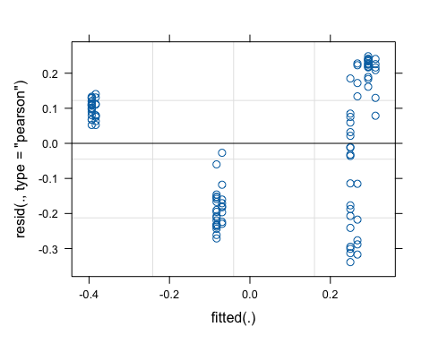
# look at estimated variance components
summary(model_day_treatment_bc1)
## Linear mixed model fit by REML. t-tests use Satterthwaite's method [
## lmerModLmerTest]
## Formula: PC1 ~ treatment * day + treatment + (1 | calf_id)
## Data: metadata_bc
##
## REML criterion at convergence: -27.6
##
## Scaled residuals:
## Min 1Q Median 3Q Max
## -1.8469 -0.9935 0.3714 0.7135 1.3547
##
## Random effects:
## Groups Name Variance Std.Dev.
## calf_id (Intercept) 0.00000 0.0000
## Residual 0.03362 0.1834
## Number of obs: 105, groups: calf_id, 30
##
## Fixed effects:
## Estimate Std. Error df t value Pr(>|t|)
## (Intercept) 3.234e-01 4.820e-02 1.010e+02 6.710 1.15e-09 ***
## treatmentpair -1.826e-02 5.788e-02 1.010e+02 -0.316 0.753
## day -1.122e-02 1.277e-03 1.010e+02 -8.782 4.28e-14 ***
## treatmentpair:day 1.315e-04 1.535e-03 1.010e+02 0.086 0.932
## ---
## Signif. codes: 0 '***' 0.001 '**' 0.01 '*' 0.05 '.' 0.1 ' ' 1
##
## Correlation of Fixed Effects:
## (Intr) trtmnt day
## treatmentpr -0.833
## day -0.749 0.624
## trtmntpr:dy 0.624 -0.746 -0.832
## optimizer (nloptwrap) convergence code: 0 (OK)
## boundary (singular) fit: see help('isSingular')
# residual diagnostic plot, check assumptions
anova(model_day_treatment_bc1)
## Type III Analysis of Variance Table with Satterthwaite's method
## Sum Sq Mean Sq NumDF DenDF F value Pr(>F)
## treatment 0.0033 0.0033 1 101 0.0996 0.7530
## day 7.0970 7.0970 1 101 211.1056 <2e-16 ***
## treatment:day 0.0002 0.0002 1 101 0.0073 0.9319
## ---
## Signif. codes: 0 '***' 0.001 '**' 0.01 '*' 0.05 '.' 0.1 ' ' 1
# pairwise comparisons
emmeans(model_day_treatment_bc1, pairwise ~ treatment|day)
## $emmeans
## day = 27.9:
## treatment emmean SE df lower.CL upper.CL
## individual 0.01002 0.0320 29.0 -0.0555 0.0756
## pair -0.00457 0.0217 25.8 -0.0491 0.0400
##
## Degrees-of-freedom method: kenward-roger
## Confidence level used: 0.95
##
## $contrasts
## day = 27.9:
## contrast estimate SE df t.ratio p.value
## individual - pair 0.0146 0.0387 27.9 0.377 0.7088
##
## Degrees-of-freedom method: kenward-roger
#PC2
# Build model
model_day_treatment_bc2 <- lmer(PC2 ~ treatment*day + treatment + (1|calf_id), data = metadata_bc)
## boundary (singular) fit: see help('isSingular')
# I always add which PC I am testing into the model name
# Residual diagnostic plot, check assumptions
plot(model_day_treatment_bc2)
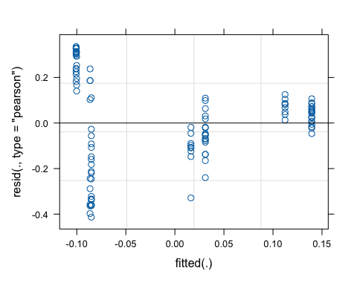
# look at estimated variance components
summary(model_day_treatment_bc2)
## Linear mixed model fit by REML. t-tests use Satterthwaite's method [
## lmerModLmerTest]
## Formula: PC2 ~ treatment * day + treatment + (1 | calf_id)
## Data: metadata_bc
##
## REML criterion at convergence: -9.9
##
## Scaled residuals:
## Min 1Q Median 3Q Max
## -2.06626 -0.54746 0.09043 0.54637 1.67708
##
## Random effects:
## Groups Name Variance Std.Dev.
## calf_id (Intercept) 0.00000 0.0000
## Residual 0.04003 0.2001
## Number of obs: 105, groups: calf_id, 30
##
## Fixed effects:
## Estimate Std. Error df t value Pr(>|t|)
## (Intercept) -1.036e-01 5.260e-02 1.010e+02 -1.969 0.0517 .
## treatmentpair -9.607e-04 6.316e-02 1.010e+02 -0.015 0.9879
## day 3.427e-03 1.394e-03 1.010e+02 2.458 0.0157 *
## treatmentpair:day 4.472e-04 1.675e-03 1.010e+02 0.267 0.7901
## ---
## Signif. codes: 0 '***' 0.001 '**' 0.01 '*' 0.05 '.' 0.1 ' ' 1
##
## Correlation of Fixed Effects:
## (Intr) trtmnt day
## treatmentpr -0.833
## day -0.749 0.624
## trtmntpr:dy 0.624 -0.746 -0.832
## optimizer (nloptwrap) convergence code: 0 (OK)
## boundary (singular) fit: see help('isSingular')
# residual diagnostic plot, check assumptions
anova(model_day_treatment_bc2)
## Type III Analysis of Variance Table with Satterthwaite's method
## Sum Sq Mean Sq NumDF DenDF F value Pr(>F)
## treatment 0.00001 0.00001 1 101 0.0002 0.9879
## day 0.76017 0.76017 1 101 18.9886 3.166e-05 ***
## treatment:day 0.00285 0.00285 1 101 0.0713 0.7901
## ---
## Signif. codes: 0 '***' 0.001 '**' 0.01 '*' 0.05 '.' 0.1 ' ' 1
# pairwise comparisons
emmeans(model_day_treatment_bc2, pairwise ~ treatment|day)
## $emmeans
## day = 27.9:
## treatment emmean SE df lower.CL upper.CL
## individual -0.00786 0.0350 29.0 -0.0794 0.0637
## pair 0.00367 0.0236 25.8 -0.0449 0.0523
##
## Degrees-of-freedom method: kenward-roger
## Confidence level used: 0.95
##
## $contrasts
## day = 27.9:
## contrast estimate SE df t.ratio p.value
## individual - pair -0.0115 0.0422 27.9 -0.273 0.7867
##
## Degrees-of-freedom method: kenward-roger
#PC3
# Build model
model_day_treatment_bc3 <- lmer(PC3 ~ treatment*day + treatment + (1|calf_id), data = metadata_bc)
## boundary (singular) fit: see help('isSingular')
# I always add which PC I am testing into the model name
# Residual diagnostic plot, check assumptions
plot(model_day_treatment_bc3)
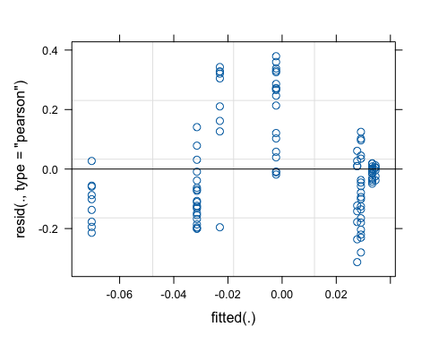
# look at estimated variance components
summary(model_day_treatment_bc3)
## Linear mixed model fit by REML. t-tests use Satterthwaite's method [
## lmerModLmerTest]
## Formula: PC3 ~ treatment * day + treatment + (1 | calf_id)
## Data: metadata_bc
##
## REML criterion at convergence: -46.5
##
## Scaled residuals:
## Min 1Q Median 3Q Max
## -1.87387 -0.74019 -0.08281 0.36680 2.27115
##
## Random effects:
## Groups Name Variance Std.Dev.
## calf_id (Intercept) 0.00000 0.000
## Residual 0.02788 0.167
## Number of obs: 105, groups: calf_id, 30
##
## Fixed effects:
## Estimate Std. Error df t value Pr(>|t|)
## (Intercept) 3.618e-02 4.389e-02 1.010e+02 0.824 0.412
## treatmentpair -1.847e-03 5.271e-02 1.010e+02 -0.035 0.972
## day -1.690e-03 1.163e-03 1.010e+02 -1.453 0.149
## treatmentpair:day 6.462e-04 1.398e-03 1.010e+02 0.462 0.645
##
## Correlation of Fixed Effects:
## (Intr) trtmnt day
## treatmentpr -0.833
## day -0.749 0.624
## trtmntpr:dy 0.624 -0.746 -0.832
## optimizer (nloptwrap) convergence code: 0 (OK)
## boundary (singular) fit: see help('isSingular')
# residual diagnostic plot, check assumptions
anova(model_day_treatment_bc3)
## Type III Analysis of Variance Table with Satterthwaite's method
## Sum Sq Mean Sq NumDF DenDF F value Pr(>F)
## treatment 0.000034 0.000034 1 101 0.0012 0.97211
## day 0.106667 0.106667 1 101 3.8260 0.05323 .
## treatment:day 0.005955 0.005955 1 101 0.2136 0.64495
## ---
## Signif. codes: 0 '***' 0.001 '**' 0.01 '*' 0.05 '.' 0.1 ' ' 1
# pairwise comparisons
emmeans(model_day_treatment_bc3, pairwise ~ treatment|day)
## $emmeans
## day = 27.9:
## treatment emmean SE df lower.CL upper.CL
## individual -0.01104 0.0292 29.0 -0.0707 0.0486
## pair 0.00516 0.0197 25.8 -0.0354 0.0457
##
## Degrees-of-freedom method: kenward-roger
## Confidence level used: 0.95
##
## $contrasts
## day = 27.9:
## contrast estimate SE df t.ratio p.value
## individual - pair -0.0162 0.0352 27.9 -0.460 0.6490
##
## Degrees-of-freedom method: kenward-roger

Jaccard
PC1
# Build model
model_day_treatment_j1 <- lmer(PC1 ~ treatment*day + treatment + (1|calf_id), data = metadata_jaccard)
## boundary (singular) fit: see help('isSingular')
# I always add which PC I am testing into the model name
# Residual diagnostic plot, check assumptions
plot(model_day_treatment_j1)
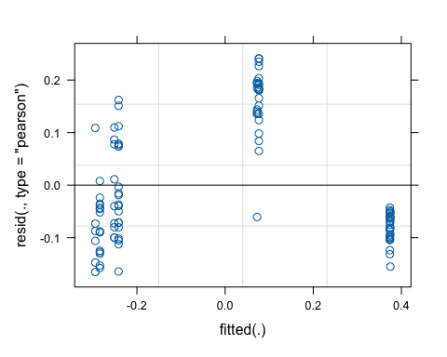
# look at estimated variance components
summary(model_day_treatment_j1)
## Linear mixed model fit by REML. t-tests use Satterthwaite's method [
## lmerModLmerTest]
## Formula: PC1 ~ treatment * day + treatment + (1 | calf_id)
## Data: metadata_jaccard
##
## REML criterion at convergence: -113
##
## Scaled residuals:
## Min 1Q Median 3Q Max
## -1.3770 -0.7426 -0.4156 0.9124 2.0093
##
## Random effects:
## Groups Name Variance Std.Dev.
## calf_id (Intercept) 0.00000 0.0000
## Residual 0.01443 0.1201
## Number of obs: 105, groups: calf_id, 30
##
## Fixed effects:
## Estimate Std. Error df t value Pr(>|t|)
## (Intercept) -3.053e-01 3.158e-02 1.010e+02 -9.668 4.82e-16 ***
## treatmentpair 1.053e-02 3.792e-02 1.010e+02 0.278 0.782
## day 1.080e-02 8.369e-04 1.010e+02 12.901 < 2e-16 ***
## treatmentpair:day -1.844e-04 1.006e-03 1.010e+02 -0.183 0.855
## ---
## Signif. codes: 0 '***' 0.001 '**' 0.01 '*' 0.05 '.' 0.1 ' ' 1
##
## Correlation of Fixed Effects:
## (Intr) trtmnt day
## treatmentpr -0.833
## day -0.749 0.624
## trtmntpr:dy 0.624 -0.746 -0.832
## optimizer (nloptwrap) convergence code: 0 (OK)
## boundary (singular) fit: see help('isSingular')
# residual diagnostic plot, check assumptions
anova(model_day_treatment_j1)
## Type III Analysis of Variance Table with Satterthwaite's method
## Sum Sq Mean Sq NumDF DenDF F value Pr(>F)
## treatment 0.0011 0.0011 1 101 0.0772 0.7817
## day 6.5372 6.5372 1 101 453.0860 <2e-16 ***
## treatment:day 0.0005 0.0005 1 101 0.0336 0.8549
## ---
## Signif. codes: 0 '***' 0.001 '**' 0.01 '*' 0.05 '.' 0.1 ' ' 1
# pairwise comparisons
emmeans(model_day_treatment_j1, pairwise ~ treatment|day)
## $emmeans
## day = 27.9:
## treatment emmean SE df lower.CL upper.CL
## individual -0.00371 0.0210 29.0 -0.0466 0.0392
## pair 0.00167 0.0142 25.8 -0.0275 0.0308
##
## Degrees-of-freedom method: kenward-roger
## Confidence level used: 0.95
##
## $contrasts
## day = 27.9:
## contrast estimate SE df t.ratio p.value
## individual - pair -0.00538 0.0253 27.9 -0.212 0.8333
##
## Degrees-of-freedom method: kenward-roger
PC2
# Build model
model_day_treatment_j2 <- lmer(PC2 ~ treatment*day + treatment + (1|calf_id), data = metadata_jaccard)
## boundary (singular) fit: see help('isSingular')
# I always add which PC I am testing into the model name
# Residual diagnostic plot, check assumptions
plot(model_day_treatment_j2)
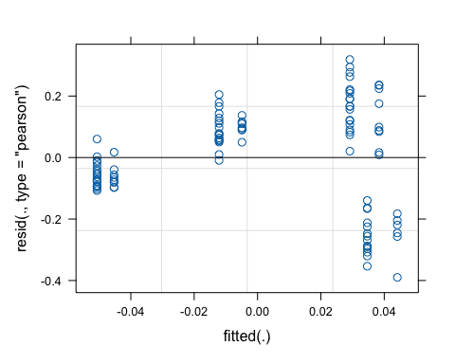
# look at estimated variance components
summary(model_day_treatment_j2)
## Linear mixed model fit by REML. t-tests use Satterthwaite's method [
## lmerModLmerTest]
## Formula: PC2 ~ treatment * day + treatment + (1 | calf_id)
## Data: metadata_jaccard
##
## REML criterion at convergence: -47.7
##
## Scaled residuals:
## Min 1Q Median 3Q Max
## -2.3481 -0.5707 0.1049 0.6907 1.9211
##
## Random effects:
## Groups Name Variance Std.Dev.
## calf_id (Intercept) 0.00000 0.000
## Residual 0.02756 0.166
## Number of obs: 105, groups: calf_id, 30
##
## Fixed effects:
## Estimate Std. Error df t value Pr(>|t|)
## (Intercept) 4.557e-02 4.364e-02 1.010e+02 1.044 0.299
## treatmentpair -9.545e-03 5.240e-02 1.010e+02 -0.182 0.856
## day -1.442e-03 1.157e-03 1.010e+02 -1.247 0.215
## treatmentpair:day 6.608e-05 1.390e-03 1.010e+02 0.048 0.962
##
## Correlation of Fixed Effects:
## (Intr) trtmnt day
## treatmentpr -0.833
## day -0.749 0.624
## trtmntpr:dy 0.624 -0.746 -0.832
## optimizer (nloptwrap) convergence code: 0 (OK)
## boundary (singular) fit: see help('isSingular')
# residual diagnostic plot, check assumptions
anova(model_day_treatment_j2)
## Type III Analysis of Variance Table with Satterthwaite's method
## Sum Sq Mean Sq NumDF DenDF F value Pr(>F)
## treatment 0.000914 0.000914 1 101 0.0332 0.85583
## day 0.113264 0.113264 1 101 4.1104 0.04525 *
## treatment:day 0.000062 0.000062 1 101 0.0023 0.96218
## ---
## Signif. codes: 0 '***' 0.001 '**' 0.01 '*' 0.05 '.' 0.1 ' ' 1
# pairwise comparisons
emmeans(model_day_treatment_j2, pairwise ~ treatment|day)
## $emmeans
## day = 27.9:
## treatment emmean SE df lower.CL upper.CL
## individual 0.00529 0.0290 29.0 -0.0540 0.0646
## pair -0.00241 0.0196 25.8 -0.0427 0.0379
##
## Degrees-of-freedom method: kenward-roger
## Confidence level used: 0.95
##
## $contrasts
## day = 27.9:
## contrast estimate SE df t.ratio p.value
## individual - pair 0.0077 0.035 27.9 0.220 0.8276
##
## Degrees-of-freedom method: kenward-roger
PC3
# Build model
model_day_treatment_j3 <- lmer(PC3 ~ treatment*day + treatment + (1|calf_id), data = metadata_jaccard)
## boundary (singular) fit: see help('isSingular')
# I always add which PC I am testing into the model name
# Residual diagnostic plot, check assumptions
plot(model_day_treatment_j3)
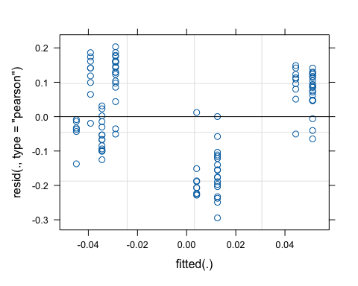
# look at estimated variance components
summary(model_day_treatment_j3)
## Linear mixed model fit by REML. t-tests use Satterthwaite's method [
## lmerModLmerTest]
## Formula: PC3 ~ treatment * day + treatment + (1 | calf_id)
## Data: metadata_jaccard
##
## REML criterion at convergence: -92.5
##
## Scaled residuals:
## Min 1Q Median 3Q Max
## -2.21605 -0.75806 0.09078 0.88178 1.52910
##
## Random effects:
## Groups Name Variance Std.Dev.
## calf_id (Intercept) 0.00000 0.000
## Residual 0.01768 0.133
## Number of obs: 105, groups: calf_id, 30
##
## Fixed effects:
## Estimate Std. Error df t value Pr(>|t|)
## (Intercept) -4.631e-02 3.495e-02 1.010e+02 -1.325 0.188
## treatmentpair 1.049e-02 4.197e-02 1.010e+02 0.250 0.803
## day 1.440e-03 9.264e-04 1.010e+02 1.554 0.123
## treatmentpair:day -5.757e-05 1.113e-03 1.010e+02 -0.052 0.959
##
## Correlation of Fixed Effects:
## (Intr) trtmnt day
## treatmentpr -0.833
## day -0.749 0.624
## trtmntpr:dy 0.624 -0.746 -0.832
## optimizer (nloptwrap) convergence code: 0 (OK)
## boundary (singular) fit: see help('isSingular')
# residual diagnostic plot, check assumptions
anova(model_day_treatment_j3)
## Type III Analysis of Variance Table with Satterthwaite's method
## Sum Sq Mean Sq NumDF DenDF F value Pr(>F)
## treatment 0.001104 0.001104 1 101 0.0624 0.80319
## day 0.113584 0.113584 1 101 6.4245 0.01279 *
## treatment:day 0.000047 0.000047 1 101 0.0027 0.95886
## ---
## Signif. codes: 0 '***' 0.001 '**' 0.01 '*' 0.05 '.' 0.1 ' ' 1
# pairwise comparisons
emmeans(model_day_treatment_j3, pairwise ~ treatment|day)
## $emmeans
## day = 27.9:
## treatment emmean SE df lower.CL upper.CL
## individual -0.00609 0.0232 29.0 -0.0536 0.0414
## pair 0.00278 0.0157 25.8 -0.0295 0.0351
##
## Degrees-of-freedom method: kenward-roger
## Confidence level used: 0.95
##
## $contrasts
## day = 27.9:
## contrast estimate SE df t.ratio p.value
## individual - pair -0.00888 0.028 27.9 -0.317 0.7539
##
## Degrees-of-freedom method: kenward-roger

Unweighted Unifrac
PC1
# Build model
model_day_treatment_uwunifrac1 <- lmer(PC1 ~ treatment*day + treatment + (1|calf_id), data = metadata_uwunifrac)
## boundary (singular) fit: see help('isSingular')
# I always add which PC I am testing into the model name
# Residual diagnostic plot, check assumptions
plot(model_day_treatment_uwunifrac1)
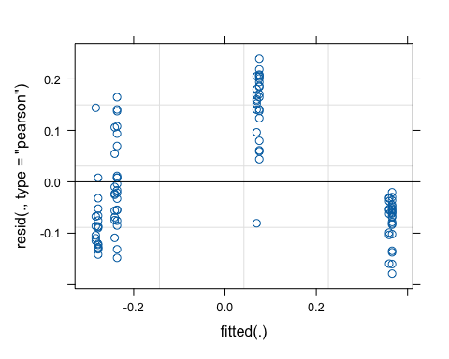
# look at estimated variance components
summary(model_day_treatment_uwunifrac1)
## Linear mixed model fit by REML. t-tests use Satterthwaite's method [
## lmerModLmerTest]
## Formula: PC1 ~ treatment * day + treatment + (1 | calf_id)
## Data: metadata_uwunifrac
##
## REML criterion at convergence: -120.9
##
## Scaled residuals:
## Min 1Q Median 3Q Max
## -1.5462 -0.7216 -0.3262 0.9165 2.0733
##
## Random effects:
## Groups Name Variance Std.Dev.
## calf_id (Intercept) 0.00000 0.0000
## Residual 0.01334 0.1155
## Number of obs: 105, groups: calf_id, 30
##
## Fixed effects:
## Estimate Std. Error df t value Pr(>|t|)
## (Intercept) -2.935e-01 3.036e-02 1.010e+02 -9.667 4.87e-16 ***
## treatmentpair 5.117e-03 3.646e-02 1.010e+02 0.140 0.889
## day 1.037e-02 8.047e-04 1.010e+02 12.883 < 2e-16 ***
## treatmentpair:day 2.110e-05 9.671e-04 1.010e+02 0.022 0.983
## ---
## Signif. codes: 0 '***' 0.001 '**' 0.01 '*' 0.05 '.' 0.1 ' ' 1
##
## Correlation of Fixed Effects:
## (Intr) trtmnt day
## treatmentpr -0.833
## day -0.749 0.624
## trtmntpr:dy 0.624 -0.746 -0.832
## optimizer (nloptwrap) convergence code: 0 (OK)
## boundary (singular) fit: see help('isSingular')
# residual diagnostic plot, check assumptions
anova(model_day_treatment_uwunifrac1)
## Type III Analysis of Variance Table with Satterthwaite's method
## Sum Sq Mean Sq NumDF DenDF F value Pr(>F)
## treatment 0.0003 0.0003 1 101 0.0197 0.8887
## day 6.1443 6.1443 1 101 460.5966 <2e-16 ***
## treatment:day 0.0000 0.0000 1 101 0.0005 0.9826
## ---
## Signif. codes: 0 '***' 0.001 '**' 0.01 '*' 0.05 '.' 0.1 ' ' 1
# pairwise comparisons
emmeans(model_day_treatment_uwunifrac1, pairwise ~ treatment|day)
## $emmeans
## day = 27.9:
## treatment emmean SE df lower.CL upper.CL
## individual -0.00391 0.0202 29.0 -0.0452 0.0374
## pair 0.00180 0.0136 25.8 -0.0263 0.0298
##
## Degrees-of-freedom method: kenward-roger
## Confidence level used: 0.95
##
## $contrasts
## day = 27.9:
## contrast estimate SE df t.ratio p.value
## individual - pair -0.00571 0.0244 27.9 -0.234 0.8165
##
## Degrees-of-freedom method: kenward-roger
PC2
# Build model
model_day_treatment_uwunifrac2 <- lmer(PC2 ~ treatment*day + treatment + (1|calf_id), data = metadata_uwunifrac)
## boundary (singular) fit: see help('isSingular')
# I always add which PC I am testing into the model name
# Residual diagnostic plot, check assumptions
plot(model_day_treatment_uwunifrac2)
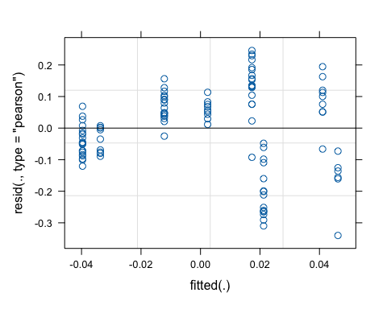
# look at estimated variance components
summary(model_day_treatment_uwunifrac2)
## Linear mixed model fit by REML. t-tests use Satterthwaite's method [
## lmerModLmerTest]
## Formula: PC2 ~ treatment * day + treatment + (1 | calf_id)
## Data: metadata_uwunifrac
##
## REML criterion at convergence: -93.3
##
## Scaled residuals:
## Min 1Q Median 3Q Max
## -2.5681 -0.5781 0.1716 0.6889 1.8559
##
## Random effects:
## Groups Name Variance Std.Dev.
## calf_id (Intercept) 0.00000 0.0000
## Residual 0.01754 0.1324
## Number of obs: 105, groups: calf_id, 30
##
## Fixed effects:
## Estimate Std. Error df t value Pr(>|t|)
## (Intercept) 4.750e-02 3.481e-02 1.010e+02 1.364 0.175
## treatmentpair -2.530e-02 4.180e-02 1.010e+02 -0.605 0.546
## day -1.288e-03 9.227e-04 1.010e+02 -1.396 0.166
## treatmentpair:day 3.064e-04 1.109e-03 1.010e+02 0.276 0.783
##
## Correlation of Fixed Effects:
## (Intr) trtmnt day
## treatmentpr -0.833
## day -0.749 0.624
## trtmntpr:dy 0.624 -0.746 -0.832
## optimizer (nloptwrap) convergence code: 0 (OK)
## boundary (singular) fit: see help('isSingular')
# residual diagnostic plot, check assumptions
anova(model_day_treatment_uwunifrac2)
## Type III Analysis of Variance Table with Satterthwaite's method
## Sum Sq Mean Sq NumDF DenDF F value Pr(>F)
## treatment 0.006422 0.006422 1 101 0.3662 0.5464
## day 0.073524 0.073524 1 101 4.1925 0.0432 *
## treatment:day 0.001339 0.001339 1 101 0.0764 0.7829
## ---
## Signif. codes: 0 '***' 0.001 '**' 0.01 '*' 0.05 '.' 0.1 ' ' 1
# pairwise comparisons
emmeans(model_day_treatment_uwunifrac2, pairwise ~ treatment|day)
## $emmeans
## day = 27.9:
## treatment emmean SE df lower.CL upper.CL
## individual 0.01151 0.0231 29.0 -0.0358 0.0588
## pair -0.00523 0.0156 25.8 -0.0374 0.0269
##
## Degrees-of-freedom method: kenward-roger
## Confidence level used: 0.95
##
## $contrasts
## day = 27.9:
## contrast estimate SE df t.ratio p.value
## individual - pair 0.0167 0.0279 27.9 0.599 0.5538
##
## Degrees-of-freedom method: kenward-roger
PC3
# Build model
model_day_treatment_uwunifrac3 <- lmer(PC3 ~ treatment*day + treatment + (1|calf_id), data = metadata_uwunifrac)
## boundary (singular) fit: see help('isSingular')
# I always add which PC I am testing into the model name
# Residual diagnostic plot, check assumptions
plot(model_day_treatment_uwunifrac3)
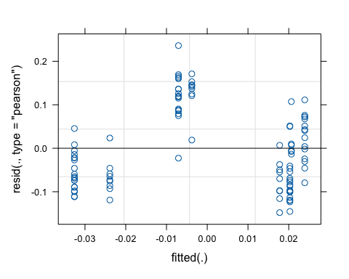
# look at estimated variance components
summary(model_day_treatment_uwunifrac3)
## Linear mixed model fit by REML. t-tests use Satterthwaite's method [
## lmerModLmerTest]
## Formula: PC3 ~ treatment * day + treatment + (1 | calf_id)
## Data: metadata_uwunifrac
##
## REML criterion at convergence: -161
##
## Scaled residuals:
## Min 1Q Median 3Q Max
## -1.5620 -0.7976 -0.2364 0.8022 2.4923
##
## Random effects:
## Groups Name Variance Std.Dev.
## calf_id (Intercept) 0.000000 0.00000
## Residual 0.008973 0.09472
## Number of obs: 105, groups: calf_id, 30
##
## Fixed effects:
## Estimate Std. Error df t value Pr(>|t|)
## (Intercept) 2.137e-02 2.490e-02 1.010e+02 0.858 0.393
## treatmentpair 3.476e-03 2.990e-02 1.010e+02 0.116 0.908
## day -7.186e-04 6.600e-04 1.010e+02 -1.089 0.279
## treatmentpair:day -1.931e-04 7.932e-04 1.010e+02 -0.243 0.808
##
## Correlation of Fixed Effects:
## (Intr) trtmnt day
## treatmentpr -0.833
## day -0.749 0.624
## trtmntpr:dy 0.624 -0.746 -0.832
## optimizer (nloptwrap) convergence code: 0 (OK)
## boundary (singular) fit: see help('isSingular')
# residual diagnostic plot, check assumptions
anova(model_day_treatment_uwunifrac3)
## Type III Analysis of Variance Table with Satterthwaite's method
## Sum Sq Mean Sq NumDF DenDF F value Pr(>F)
## treatment 0.000121 0.000121 1 101 0.0135 0.90767
## day 0.037904 0.037904 1 101 4.2244 0.04243 *
## treatment:day 0.000532 0.000532 1 101 0.0593 0.80813
## ---
## Signif. codes: 0 '***' 0.001 '**' 0.01 '*' 0.05 '.' 0.1 ' ' 1
# pairwise comparisons
emmeans(model_day_treatment_uwunifrac3, pairwise ~ treatment|day)
## $emmeans
## day = 27.9:
## treatment emmean SE df lower.CL upper.CL
## individual 0.001295 0.0166 29.0 -0.0326 0.0352
## pair -0.000623 0.0112 25.8 -0.0236 0.0224
##
## Degrees-of-freedom method: kenward-roger
## Confidence level used: 0.95
##
## $contrasts
## day = 27.9:
## contrast estimate SE df t.ratio p.value
## individual - pair 0.00192 0.02 27.9 0.096 0.9242
##
## Degrees-of-freedom method: kenward-roger

Weighted Unifrac
PC1
# Build model
model_day_treatment_wunifrac1 <- lmer(PC1 ~ treatment*day + treatment + (1|calf_id), data = metadata_wunifrac)
## boundary (singular) fit: see help('isSingular')
# I always add which PC I am testing into the model name
# Residual diagnostic plot, check assumptions
plot(model_day_treatment_wunifrac1)
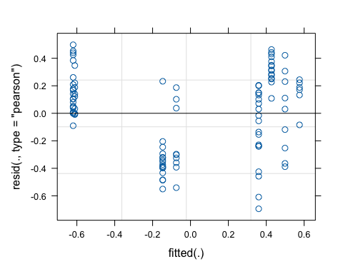
# look at estimated variance components
summary(model_day_treatment_wunifrac1)
## Linear mixed model fit by REML. t-tests use Satterthwaite's method [
## lmerModLmerTest]
## Formula: PC1 ~ treatment * day + treatment + (1 | calf_id)
## Data: metadata_wunifrac
##
## REML criterion at convergence: 72.2
##
## Scaled residuals:
## Min 1Q Median 3Q Max
## -2.3109 -0.9771 0.1704 0.7383 1.6577
##
## Random effects:
## Groups Name Variance Std.Dev.
## calf_id (Intercept) 0.00000 0.0000
## Residual 0.09028 0.3005
## Number of obs: 105, groups: calf_id, 30
##
## Fixed effects:
## Estimate Std. Error df t value Pr(>|t|)
## (Intercept) 0.594812 0.078988 101.000000 7.530 2.19e-11 ***
## treatmentpair -0.150250 0.094844 101.000000 -1.584 0.116
## day -0.019136 0.002094 101.000000 -9.141 6.99e-15 ***
## treatmentpair:day 0.002245 0.002516 101.000000 0.892 0.374
## ---
## Signif. codes: 0 '***' 0.001 '**' 0.01 '*' 0.05 '.' 0.1 ' ' 1
##
## Correlation of Fixed Effects:
## (Intr) trtmnt day
## treatmentpr -0.833
## day -0.749 0.624
## trtmntpr:dy 0.624 -0.746 -0.832
## optimizer (nloptwrap) convergence code: 0 (OK)
## boundary (singular) fit: see help('isSingular')
# residual diagnostic plot, check assumptions
anova(model_day_treatment_wunifrac1)
## Type III Analysis of Variance Table with Satterthwaite's method
## Sum Sq Mean Sq NumDF DenDF F value Pr(>F)
## treatment 0.2266 0.2266 1 101 2.5096 0.1163
## day 18.5125 18.5125 1 101 205.0595 <2e-16 ***
## treatment:day 0.0719 0.0719 1 101 0.7962 0.3744
## ---
## Signif. codes: 0 '***' 0.001 '**' 0.01 '*' 0.05 '.' 0.1 ' ' 1
# pairwise comparisons
emmeans(model_day_treatment_wunifrac1, pairwise ~ treatment|day)
## $emmeans
## day = 27.9:
## treatment emmean SE df lower.CL upper.CL
## individual 0.0603 0.0525 29.0 -0.0471 0.1677
## pair -0.0273 0.0355 25.8 -0.1002 0.0457
##
## Degrees-of-freedom method: kenward-roger
## Confidence level used: 0.95
##
## $contrasts
## day = 27.9:
## contrast estimate SE df t.ratio p.value
## individual - pair 0.0875 0.0634 27.9 1.381 0.1781
##
## Degrees-of-freedom method: kenward-roger
PC2
# Build model
model_day_treatment_wunifrac2 <- lmer(PC2 ~ treatment*day + treatment + (1|calf_id), data = metadata_wunifrac)
## boundary (singular) fit: see help('isSingular')
# I always add which PC I am testing into the model name
# Residual diagnostic plot, check assumptions
plot(model_day_treatment_wunifrac2)
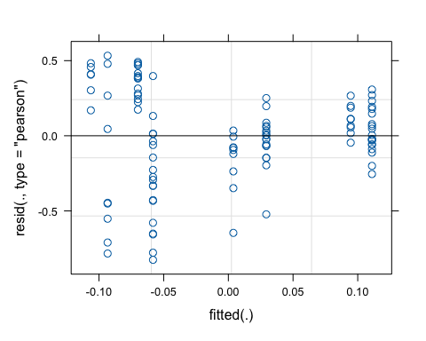
# look at estimated variance components
summary(model_day_treatment_wunifrac2)
## Linear mixed model fit by REML. t-tests use Satterthwaite's method [
## lmerModLmerTest]
## Formula: PC2 ~ treatment * day + treatment + (1 | calf_id)
## Data: metadata_wunifrac
##
## REML criterion at convergence: 87.8
##
## Scaled residuals:
## Min 1Q Median 3Q Max
## -2.54536 -0.44655 0.04373 0.71428 1.64129
##
## Random effects:
## Groups Name Variance Std.Dev.
## calf_id (Intercept) 0.0000 0.0000
## Residual 0.1053 0.3245
## Number of obs: 105, groups: calf_id, 30
##
## Fixed effects:
## Estimate Std. Error df t value Pr(>|t|)
## (Intercept) -1.095e-01 8.532e-02 1.010e+02 -1.284 0.202
## treatmentpair 3.669e-02 1.024e-01 1.010e+02 0.358 0.721
## day 3.240e-03 2.261e-03 1.010e+02 1.433 0.155
## treatmentpair:day -3.211e-04 2.718e-03 1.010e+02 -0.118 0.906
##
## Correlation of Fixed Effects:
## (Intr) trtmnt day
## treatmentpr -0.833
## day -0.749 0.624
## trtmntpr:dy 0.624 -0.746 -0.832
## optimizer (nloptwrap) convergence code: 0 (OK)
## boundary (singular) fit: see help('isSingular')
# residual diagnostic plot, check assumptions
anova(model_day_treatment_wunifrac2)
## Type III Analysis of Variance Table with Satterthwaite's method
## Sum Sq Mean Sq NumDF DenDF F value Pr(>F)
## treatment 0.01351 0.01351 1 101 0.1283 0.72097
## day 0.54086 0.54086 1 101 5.1350 0.02558 *
## treatment:day 0.00147 0.00147 1 101 0.0140 0.90616
## ---
## Signif. codes: 0 '***' 0.001 '**' 0.01 '*' 0.05 '.' 0.1 ' ' 1
# pairwise comparisons
emmeans(model_day_treatment_wunifrac2, pairwise ~ treatment|day)
## $emmeans
## day = 27.9:
## treatment emmean SE df lower.CL upper.CL
## individual -0.01904 0.0567 29.0 -0.1350 0.0970
## pair 0.00868 0.0383 25.8 -0.0701 0.0875
##
## Degrees-of-freedom method: kenward-roger
## Confidence level used: 0.95
##
## $contrasts
## day = 27.9:
## contrast estimate SE df t.ratio p.value
## individual - pair -0.0277 0.0685 27.9 -0.405 0.6886
##
## Degrees-of-freedom method: kenward-roger
PC3
# Build model
model_day_treatment_wunifrac3 <- lmer(PC3 ~ treatment*day + treatment + (1|calf_id), data = metadata_wunifrac)
## boundary (singular) fit: see help('isSingular')
# I always add which PC I am testing into the model name
# Residual diagnostic plot, check assumptions
plot(model_day_treatment_wunifrac3)
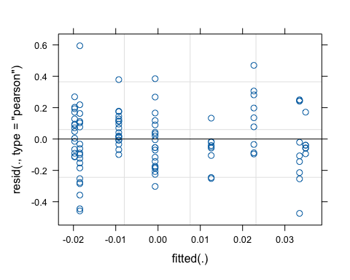
# look at estimated variance components
summary(model_day_treatment_wunifrac3)
## Linear mixed model fit by REML. t-tests use Satterthwaite's method [
## lmerModLmerTest]
## Formula: PC3 ~ treatment * day + treatment + (1 | calf_id)
## Data: metadata_wunifrac
##
## REML criterion at convergence: -18.9
##
## Scaled residuals:
## Min 1Q Median 3Q Max
## -2.47654 -0.54879 -0.08648 0.61498 3.10604
##
## Random effects:
## Groups Name Variance Std.Dev.
## calf_id (Intercept) 0.00000 0.0000
## Residual 0.03664 0.1914
## Number of obs: 105, groups: calf_id, 30
##
## Fixed effects:
## Estimate Std. Error df t value Pr(>|t|)
## (Intercept) 3.527e-02 5.032e-02 1.010e+02 0.701 0.485
## treatmentpair -5.529e-02 6.042e-02 1.010e+02 -0.915 0.362
## day -3.601e-04 1.334e-03 1.010e+02 -0.270 0.788
## treatmentpair:day 6.671e-04 1.603e-03 1.010e+02 0.416 0.678
##
## Correlation of Fixed Effects:
## (Intr) trtmnt day
## treatmentpr -0.833
## day -0.749 0.624
## trtmntpr:dy 0.624 -0.746 -0.832
## optimizer (nloptwrap) convergence code: 0 (OK)
## boundary (singular) fit: see help('isSingular')
# residual diagnostic plot, check assumptions
anova(model_day_treatment_wunifrac3)
## Type III Analysis of Variance Table with Satterthwaite's method
## Sum Sq Mean Sq NumDF DenDF F value Pr(>F)
## treatment 0.0306845 0.0306845 1 101 0.8374 0.3623
## day 0.0000402 0.0000402 1 101 0.0011 0.9736
## treatment:day 0.0063468 0.0063468 1 101 0.1732 0.6782
# pairwise comparisons
emmeans(model_day_treatment_wunifrac3, pairwise ~ treatment|day)
## $emmeans
## day = 27.9:
## treatment emmean SE df lower.CL upper.CL
## individual 0.0252 0.0335 29.0 -0.0432 0.0936
## pair -0.0115 0.0226 25.8 -0.0579 0.0350
##
## Degrees-of-freedom method: kenward-roger
## Confidence level used: 0.95
##
## $contrasts
## day = 27.9:
## contrast estimate SE df t.ratio p.value
## individual - pair 0.0367 0.0404 27.9 0.908 0.3717
##
## Degrees-of-freedom method: kenward-roger

