pempek_stats_figures
2026-03-10

This script is a general guide for making publication-quality visualizations using QIIME2-generated outputs

Research Questions
- Does microbial community composition change over accumulated degree days?
- Does facility influence microbial diversity or community composition?
- Do soil and skin samples differ in their microbial diversity and community composition?
- Your research question doesn’t need to be included in your R Markdown, but you should have a data analysis plan. It’s easy to go down rabbit holes if you don’t stick to analyses that directly address your questions. ################################################################################

loading packages

Load packages
library(tidyverse)
## Warning: package 'ggplot2' was built under R version 4.5.2
## Warning: package 'tibble' was built under R version 4.5.2
## Warning: package 'tidyr' was built under R version 4.5.2
## Warning: package 'readr' was built under R version 4.5.2
## Warning: package 'purrr' was built under R version 4.5.2
## Warning: package 'dplyr' was built under R version 4.5.2
## Warning: package 'lubridate' was built under R version 4.5.2
## ── Attaching core tidyverse packages ──────────────────────── tidyverse 2.0.0 ──
## ✔ dplyr 1.2.1 ✔ readr 2.2.0
## ✔ forcats 1.0.1 ✔ stringr 1.6.0
## ✔ ggplot2 4.0.3 ✔ tibble 3.3.1
## ✔ lubridate 1.9.5 ✔ tidyr 1.3.2
## ✔ purrr 1.2.2
## ── Conflicts ────────────────────────────────────────── tidyverse_conflicts() ──
## ✖ dplyr::filter() masks stats::filter()
## ✖ dplyr::lag() masks stats::lag()
## ℹ Use the conflicted package (<http://conflicted.r-lib.org/>) to force all conflicts to become errors
library(ggplot2)
library(readr)
library(ggpubr)
## Warning: package 'ggpubr' was built under R version 4.5.2
library(vegan)
## Warning: package 'vegan' was built under R version 4.5.2
## Loading required package: permute
## Warning: package 'permute' was built under R version 4.5.2
library(scales)
##
## Attaching package: 'scales'
##
## The following object is masked from 'package:purrr':
##
## discard
##
## The following object is masked from 'package:readr':
##
## col_factor
library(lme4)
## Warning: package 'lme4' was built under R version 4.5.2
## Loading required package: Matrix
## Warning: package 'Matrix' was built under R version 4.5.2
##
## Attaching package: 'Matrix'
##
## The following objects are masked from 'package:tidyr':
##
## expand, pack, unpack
##
## Registered S3 method overwritten by 'lme4':
## method from
## na.action.merMod car
library(lmerTest)
## Warning: package 'lmerTest' was built under R version 4.5.2
##
## Attaching package: 'lmerTest'
##
## The following object is masked from 'package:lme4':
##
## lmer
##
## The following object is masked from 'package:stats':
##
## step
library(pbkrtest)
library(emmeans)
## Warning: package 'emmeans' was built under R version 4.5.2
## Welcome to emmeans.
## Caution: You lose important information if you filter this package's results.
## See '? untidy'
library(rstatix)
##
## Attaching package: 'rstatix'
##
## The following object is masked from 'package:stats':
##
## filter
library(forcats)
library(scales)

Metadata

Import and clean metadata if needed
metadata <- read_tsv("/Users/dominikusraditya/Documents/ANEQ505_HW/pempek/03_metadata/metadata.txt")
## Rows: 105 Columns: 20
## ── Column specification ────────────────────────────────────────────────────────
## Delimiter: "\t"
## chr (13): sample, sample_type, date, age_d, age_w, sex, treatment, gel_resul...
## dbl (7): sampleid, calf_number, calf_id, day, week, weekly_fecal_counts, pen
##
## ℹ Use `spec()` to retrieve the full column specification for this data.
## ℹ Specify the column types or set `show_col_types = FALSE` to quiet this message.

Alpha diversity

Import alpha diversity data from QIIME2 output
# Alpha diversity metrics
shannon <- read_tsv("/Users/dominikusraditya/Documents/ANEQ505_HW/pempek/04_code/alpha_div/shannon.tsv")
## New names:
## Rows: 105 Columns: 2
## ── Column specification
## ──────────────────────────────────────────────────────── Delimiter: "\t" dbl
## (2): ...1, shannon_entropy
## ℹ Use `spec()` to retrieve the full column specification for this data. ℹ
## Specify the column types or set `show_col_types = FALSE` to quiet this message.
## • `` -> `...1`
evenness <- read_tsv("/Users/dominikusraditya/Documents/ANEQ505_HW/pempek/04_code/alpha_div/evenness.tsv")
## New names:
## Rows: 105 Columns: 2
## ── Column specification
## ──────────────────────────────────────────────────────── Delimiter: "\t" dbl
## (2): ...1, pielou_evenness
## ℹ Use `spec()` to retrieve the full column specification for this data. ℹ
## Specify the column types or set `show_col_types = FALSE` to quiet this message.
## • `` -> `...1`
observed_features <- read_tsv("/Users/dominikusraditya/Documents/ANEQ505_HW/pempek/04_code/alpha_div/observed_features.tsv")
## New names:
## Rows: 105 Columns: 2
## ── Column specification
## ──────────────────────────────────────────────────────── Delimiter: "\t" dbl
## (2): ...1, observed_features
## ℹ Use `spec()` to retrieve the full column specification for this data. ℹ
## Specify the column types or set `show_col_types = FALSE` to quiet this message.
## • `` -> `...1`
faiths_pd <- read_tsv("/Users/dominikusraditya/Documents/ANEQ505_HW/pempek/04_code/alpha_div/faith_pd.tsv")
## New names:
## Rows: 105 Columns: 2
## ── Column specification
## ──────────────────────────────────────────────────────── Delimiter: "\t" dbl
## (2): ...1, faith_pd
## ℹ Use `spec()` to retrieve the full column specification for this data. ℹ
## Specify the column types or set `show_col_types = FALSE` to quiet this message.
## • `` -> `...1`

Tidy metrics and add to metadata
# Shannon
shannon <- shannon %>%
rename(sampleid = 1) #rename 1st column to to match metadata
# Evenness
evenness <- evenness %>%
rename(sampleid = 1) #rename 1st column to to match metadata
# Observed Features
observed_features <- observed_features %>%
rename(sampleid = 1) #rename 1st column to to match metadata
# Faiths PD
faiths_pd <- faiths_pd %>%
rename(sampleid = 1) #rename 1st column to to match metadata
# Add to metadata
metadata <- metadata %>%
left_join(shannon, by = "sampleid") %>%
left_join(evenness, by = "sampleid") %>%
left_join(observed_features, by = "sampleid") %>%
left_join(faiths_pd, by = "sampleid")

Tidy metadata with metrics
metadata <- metadata %>%
drop_na(shannon_entropy, pielou_evenness, observed_features, faith_pd)

Linear Mixed Effects Models

Time (question 1)
Shannon
# Build model
model_age_d_shannon <- lmer(shannon_entropy ~ age_d + (1|calf_id), data = metadata) # I name all my models with the variable I am testing and the metric I am testing.
## boundary (singular) fit: see help('isSingular')
# Residual diagnostic plot, check assumptions
plot(model_age_d_shannon)
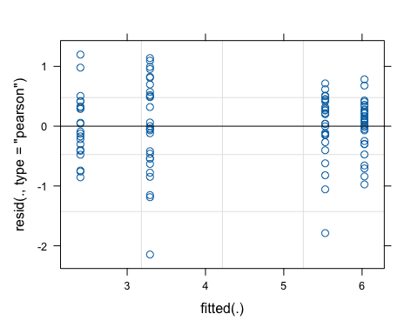
# look at estimated variance components
summary(model_age_d_shannon)
## Linear mixed model fit by REML. t-tests use Satterthwaite's method [
## lmerModLmerTest]
## Formula: shannon_entropy ~ age_d + (1 | calf_id)
## Data: metadata
##
## REML criterion at convergence: 196.9
##
## Scaled residuals:
## Min 1Q Median 3Q Max
## -3.5696 -0.5025 0.0732 0.6763 1.9916
##
## Random effects:
## Groups Name Variance Std.Dev.
## calf_id (Intercept) 3.164e-18 1.779e-09
## Residual 3.614e-01 6.012e-01
## Number of obs: 105, groups: calf_id, 30
##
## Fixed effects:
## Estimate Std. Error df t value Pr(>|t|)
## (Intercept) 2.4027 0.1312 101.0000 18.316 < 2e-16 ***
## age_dday 35 3.1263 0.1749 101.0000 17.873 < 2e-16 ***
## age_dday 5 0.8887 0.1735 101.0000 5.121 1.46e-06 ***
## age_dday 63 3.6273 0.1723 101.0000 21.058 < 2e-16 ***
## ---
## Signif. codes: 0 '***' 0.001 '**' 0.01 '*' 0.05 '.' 0.1 ' ' 1
##
## Correlation of Fixed Effects:
## (Intr) ag_d35 ag_dd5
## age_dday 35 -0.750
## age_dday 5 -0.756 0.567
## age_dday 63 -0.762 0.571 0.576
## optimizer (nloptwrap) convergence code: 0 (OK)
## boundary (singular) fit: see help('isSingular')
# residual diagnostic plot, check assumptions
anova(model_age_d_shannon)
## Type III Analysis of Variance Table with Satterthwaite's method
## Sum Sq Mean Sq NumDF DenDF F value Pr(>F)
## age_d 229.43 76.478 3 101 211.62 < 2.2e-16 ***
## ---
## Signif. codes: 0 '***' 0.001 '**' 0.01 '*' 0.05 '.' 0.1 ' ' 1
Evenness
# Build model
model_day_evenness <- lmer(pielou_evenness ~ day + (1|calf_id), data = metadata) # I name all my models with the variable I am testing and the metric I am testing.
## boundary (singular) fit: see help('isSingular')
# Residual diagnostic plot, check assumptions
plot(model_day_evenness)
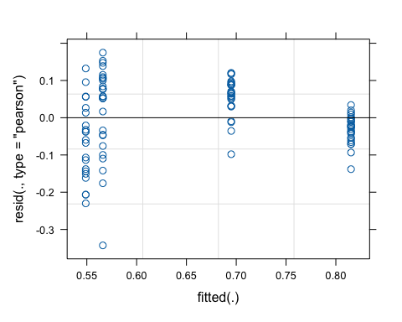
# look at estimated variance components
summary(model_day_evenness)
## Linear mixed model fit by REML. t-tests use Satterthwaite's method [
## lmerModLmerTest]
## Formula: pielou_evenness ~ day + (1 | calf_id)
## Data: metadata
##
## REML criterion at convergence: -179.3
##
## Scaled residuals:
## Min 1Q Median 3Q Max
## -3.6504 -0.5041 0.0157 0.7282 1.8617
##
## Random effects:
## Groups Name Variance Std.Dev.
## calf_id (Intercept) 0.000000 0.00000
## Residual 0.008815 0.09389
## Number of obs: 105, groups: calf_id, 30
##
## Fixed effects:
## Estimate Std. Error df t value Pr(>|t|)
## (Intercept) 5.446e-01 1.366e-02 1.030e+02 39.86 <2e-16 ***
## day 4.296e-03 3.628e-04 1.030e+02 11.84 <2e-16 ***
## ---
## Signif. codes: 0 '***' 0.001 '**' 0.01 '*' 0.05 '.' 0.1 ' ' 1
##
## Correlation of Fixed Effects:
## (Intr)
## day -0.742
## optimizer (nloptwrap) convergence code: 0 (OK)
## boundary (singular) fit: see help('isSingular')
# residual diagnostic plot, check assumptions
anova(model_day_evenness)
## Type III Analysis of Variance Table with Satterthwaite's method
## Sum Sq Mean Sq NumDF DenDF F value Pr(>F)
## day 1.236 1.236 1 103 140.21 < 2.2e-16 ***
## ---
## Signif. codes: 0 '***' 0.001 '**' 0.01 '*' 0.05 '.' 0.1 ' ' 1
Observed Features
# Build model
model_day_obfeatures <- lmer(observed_features ~ day + (1|calf_id), data = metadata) # I name all my models with the variable I am testing and the metric I am testing.
## boundary (singular) fit: see help('isSingular')
# Residual diagnostic plot, check assumptions
plot(model_day_obfeatures)
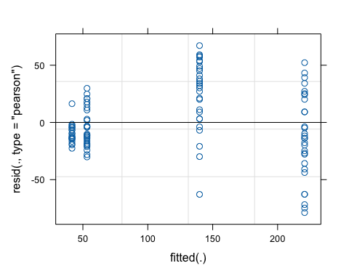
# look at estimated variance components
summary(model_day_obfeatures)
## Linear mixed model fit by REML. t-tests use Satterthwaite's method [
## lmerModLmerTest]
## Formula: observed_features ~ day + (1 | calf_id)
## Data: metadata
##
## REML criterion at convergence: 1012.8
##
## Scaled residuals:
## Min 1Q Median 3Q Max
## -2.5747 -0.5427 -0.1506 0.6807 2.1936
##
## Random effects:
## Groups Name Variance Std.Dev.
## calf_id (Intercept) 1.021e-16 1.011e-08
## Residual 9.365e+02 3.060e+01
## Number of obs: 105, groups: calf_id, 30
##
## Fixed effects:
## Estimate Std. Error df t value Pr(>|t|)
## (Intercept) 38.7190 4.4532 103.0000 8.695 5.82e-14 ***
## day 2.8900 0.1183 103.0000 24.439 < 2e-16 ***
## ---
## Signif. codes: 0 '***' 0.001 '**' 0.01 '*' 0.05 '.' 0.1 ' ' 1
##
## Correlation of Fixed Effects:
## (Intr)
## day -0.742
## optimizer (nloptwrap) convergence code: 0 (OK)
## boundary (singular) fit: see help('isSingular')
# residual diagnostic plot, check assumptions
anova(model_day_obfeatures)
## Type III Analysis of Variance Table with Satterthwaite's method
## Sum Sq Mean Sq NumDF DenDF F value Pr(>F)
## day 559346 559346 1 103 597.27 < 2.2e-16 ***
## ---
## Signif. codes: 0 '***' 0.001 '**' 0.01 '*' 0.05 '.' 0.1 ' ' 1
Faiths PD
# Build model
model_day_faithpd <- lmer(faith_pd ~ day + (1|calf_id), data = metadata) # I name all my models with the variable I am testing and the metric I am testing.
## boundary (singular) fit: see help('isSingular')
# Residual diagnostic plot, check assumptions
plot(model_day_faithpd)
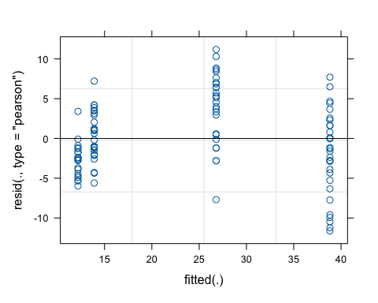
# look at estimated variance components
summary(model_day_faithpd)
## Linear mixed model fit by REML. t-tests use Satterthwaite's method [
## lmerModLmerTest]
## Formula: faith_pd ~ day + (1 | calf_id)
## Data: metadata
##
## REML criterion at convergence: 631.9
##
## Scaled residuals:
## Min 1Q Median 3Q Max
## -2.4130 -0.5770 -0.2035 0.7344 2.3213
##
## Random effects:
## Groups Name Variance Std.Dev.
## calf_id (Intercept) 0.00 0.000
## Residual 23.19 4.815
## Number of obs: 105, groups: calf_id, 30
##
## Fixed effects:
## Estimate Std. Error df t value Pr(>|t|)
## (Intercept) 11.76155 0.70073 103.00000 16.79 <2e-16 ***
## day 0.42955 0.01861 103.00000 23.08 <2e-16 ***
## ---
## Signif. codes: 0 '***' 0.001 '**' 0.01 '*' 0.05 '.' 0.1 ' ' 1
##
## Correlation of Fixed Effects:
## (Intr)
## day -0.742
## optimizer (nloptwrap) convergence code: 0 (OK)
## boundary (singular) fit: see help('isSingular')
# residual diagnostic plot, check assumptions
anova(model_day_faithpd)
## Type III Analysis of Variance Table with Satterthwaite's method
## Sum Sq Mean Sq NumDF DenDF F value Pr(>F)
## day 12356 12356 1 103 532.86 < 2.2e-16 ***
## ---
## Signif. codes: 0 '***' 0.001 '**' 0.01 '*' 0.05 '.' 0.1 ' ' 1

day split into 3
Shannon
# Add metadata column
metadata <- metadata %>%
mutate(day_split = cut(
day,
breaks = 3,
labels = c("1-5", "5-35", "35-63"),
include.lowest = TRUE
))
# Stats
# Build model
model_daysplit_shannon <- lmer(shannon_entropy ~ day_split + (1|calf_id), data = metadata)
## boundary (singular) fit: see help('isSingular')
# Residual diagnostic plot, check assumptions
plot(model_daysplit_shannon)
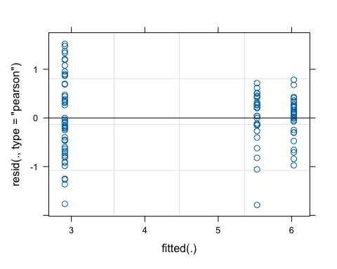
# look at estimated variance components
summary(model_daysplit_shannon)
## Linear mixed model fit by REML. t-tests use Satterthwaite's method [
## lmerModLmerTest]
## Formula: shannon_entropy ~ day_split + (1 | calf_id)
## Data: metadata
##
## REML criterion at convergence: 218.7
##
## Scaled residuals:
## Min 1Q Median 3Q Max
## -2.66289 -0.59924 0.03602 0.56797 2.26326
##
## Random effects:
## Groups Name Variance Std.Dev.
## calf_id (Intercept) 0.0000 0.0000
## Residual 0.4508 0.6714
## Number of obs: 105, groups: calf_id, 30
##
## Fixed effects:
## Estimate Std. Error df t value Pr(>|t|)
## (Intercept) 2.91056 0.09591 102.00000 30.35 <2e-16 ***
## day_split5-35 2.61845 0.16092 102.00000 16.27 <2e-16 ***
## day_split35-63 3.11947 0.15730 102.00000 19.83 <2e-16 ***
## ---
## Signif. codes: 0 '***' 0.001 '**' 0.01 '*' 0.05 '.' 0.1 ' ' 1
##
## Correlation of Fixed Effects:
## (Intr) d_5-35
## dy_splt5-35 -0.596
## dy_spl35-63 -0.610 0.363
## optimizer (nloptwrap) convergence code: 0 (OK)
## boundary (singular) fit: see help('isSingular')
# residual diagnostic plot, check assumptions
anova(model_daysplit_shannon)
## Type III Analysis of Variance Table with Satterthwaite's method
## Sum Sq Mean Sq NumDF DenDF F value Pr(>F)
## day_split 219.96 109.98 2 102 243.98 < 2.2e-16 ***
## ---
## Signif. codes: 0 '***' 0.001 '**' 0.01 '*' 0.05 '.' 0.1 ' ' 1
# pairwise comparisons
emmeans(model_daysplit_shannon, pairwise ~ day_split)
## $emmeans
## day_split emmean SE df lower.CL upper.CL
## 1-5 2.91 0.0963 80.9 2.72 3.10
## 5-35 5.53 0.1290 102.0 5.27 5.79
## 35-63 6.03 0.1250 102.0 5.78 6.28
##
## Degrees-of-freedom method: kenward-roger
## Confidence level used: 0.95
##
## $contrasts
## contrast estimate SE df t.ratio p.value
## (1-5) - (5-35) -2.618 0.161 79.5 -16.233 <0.0001
## (1-5) - (35-63) -3.119 0.158 78.1 -19.796 <0.0001
## (5-35) - (35-63) -0.501 0.180 75.5 -2.789 0.0182
##
## Degrees-of-freedom method: kenward-roger
## P value adjustment: tukey method for comparing a family of 3 estimates

day figure (voltility plot)
# Shannon
day_shannon <- ggplot(metadata, aes(x = day, y = shannon_entropy, linetype = treatment)) +
geom_line(linewidth = 0.7, alpha = 0.8) +
theme_bw(base_size = 14) +
labs(
x = "Age (Days)",
y = "Shannon Entropy",
linetype = "Sample Type",
title = "Shannon"
) +
theme(
axis.title = element_text(face = "bold"),
axis.text = element_text(color = "black"),
legend.title = element_text(face = "bold"),
legend.position = "bottom",
legend.background = element_rect(fill = "transparent"),
plot.title = element_text(face = "bold")
)
day_shannon
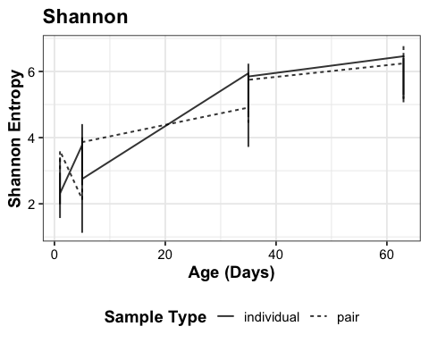
# Evennes
day_evenness <- ggplot(metadata, aes(x = day, y = pielou_evenness, linetype = treatment)) +
geom_line(size = 0.7, alpha = 0.8) +
theme_bw(base_size = 14) +
labs(
x = "Age (Days)",
y = "Pielou's Evenness",
linetype = "Sample Type",
title = "Evenness"
) +
theme(
axis.title = element_text(face = "bold"),
axis.text = element_text(color = "black"),
legend.title = element_text(face = "bold"),
legend.position = "bottom",
legend.background = element_rect(fill = "transparent"),
plot.title = element_text(face = "bold")
)
## Warning: Using `size` aesthetic for lines was deprecated in ggplot2 3.4.0.
## ℹ Please use `linewidth` instead.
## This warning is displayed once per session.
## Call `lifecycle::last_lifecycle_warnings()` to see where this warning was
## generated.
day_evenness
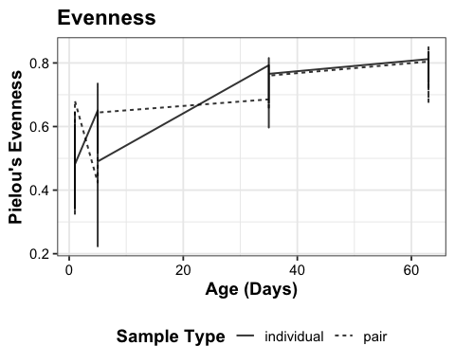
# Observed Features
day_obfeatures <- ggplot(metadata, aes(x = day, y = observed_features, linetype = treatment)) +
geom_line(size = 0.7, alpha = 0.8) +
theme_bw(base_size = 14) +
labs(
x = "Age (Days)",
y = "Observed Features",
linetype = "Sample Type",
title = "Observed Features"
) +
theme(
axis.title = element_text(face = "bold"),
axis.text = element_text(color = "black"),
legend.title = element_text(face = "bold"),
legend.position = "bottom",
legend.background = element_rect(fill = "transparent"),
plot.title = element_text(face = "bold")
)
day_obfeatures
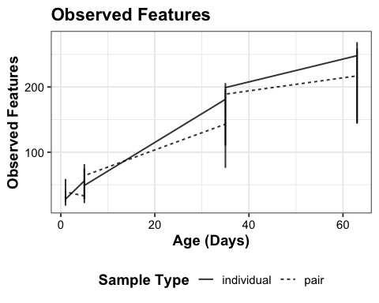
# Faith's PD
day_faithpd <- ggplot(metadata, aes(x = day, y = faith_pd, linetype = treatment)) +
geom_line(size = 0.7, alpha = 0.8) +
theme_bw(base_size = 14) +
labs(
x = "Age (Days)",
y = "Faith's PD",
linetype = "Sample Type",
title = "Faith's PD"
) +
theme(
axis.title = element_text(face = "bold"),
axis.text = element_text(color = "black"),
legend.title = element_text(face = "bold"),
legend.position = "bottom",
legend.background = element_rect(fill = "transparent"),
plot.title = element_text(face = "bold")
)
day_faithpd
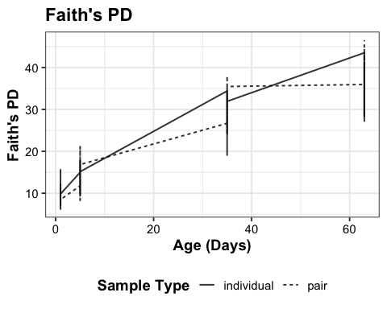
# Combine the plots
alpha_div_day <- ggarrange(day_shannon, day_evenness,
day_obfeatures, day_faithpd,
ncol = 2, nrow = 2,
labels = c("A","B","C","D"),
common.legend = TRUE,
legend = "bottom")
alpha_div_day
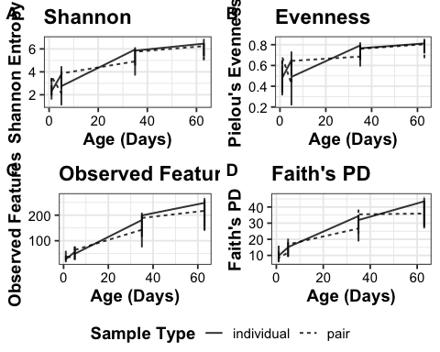
# Save the figure
ggsave(alpha_div_day, filename = "../05_figures/alpha_div_addOc.jpeg", device = "jpeg", dpi = 300, width = 12, height = 9)
model_daysplit_shannon <- lmer(shannon_entropy ~ day_split + (1|treatment), data = metadata)
pvals <- pairs(emmeans(model_daysplit_shannon, ~ day_split)) |> as.data.frame()
# make table for stat_pvalue_manual with rounded p-values
pvals_table <- data.frame(
group1 = c("1-5","5-35","35-63"),
group2 = c("5-35","35-63","1-5"),
p = round(pvals$p.value, 3), # round to 3 decimals
y.position = max(metadata$shannon_entropy) + c(0.1,0.3,0.5)
)
# plot
day_split_shannon <- ggplot(metadata, aes(x = day_split, y = shannon_entropy)) +
geom_boxplot() +
stat_pvalue_manual(pvals_table, label = "p") +
theme_bw() +
theme(
axis.title = element_text(face = "bold"),
plot.title = element_text(face = "bold"))+
labs(x = "Age (Days)",
y = "Shannon Entropy",
title = "Shannon Diversity for Age (Days) Split into 3 Groups")
day_split_shannon
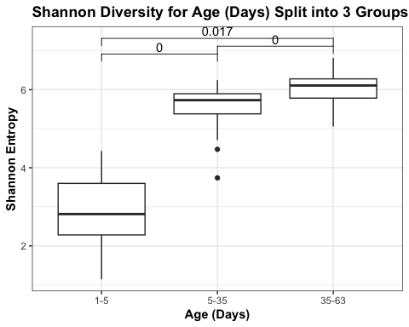
# Save the figure
ggsave(day_split_shannon, filename = "../05_figures/day_split_shannon.jpeg", device = "jpeg", dpi = 300, width = 8, height = 9)

Day + Treatment (question 2)
Shannon
# Build model
model_age_treatment_shannon <- lmer(shannon_entropy ~ treatment*day_split + (1|calf_id), data = metadata)
## boundary (singular) fit: see help('isSingular')
# Residual diagnostic plot, check assumptions
plot(model_age_treatment_shannon)
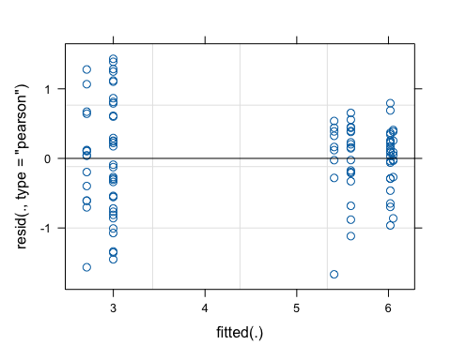
# look at estimated variance components
summary(model_age_treatment_shannon)
## Linear mixed model fit by REML. t-tests use Satterthwaite's method [
## lmerModLmerTest]
## Formula: shannon_entropy ~ treatment * day_split + (1 | calf_id)
## Data: metadata
##
## REML criterion at convergence: 219.2
##
## Scaled residuals:
## Min 1Q Median 3Q Max
## -2.4743 -0.5024 0.1337 0.5716 2.1250
##
## Random effects:
## Groups Name Variance Std.Dev.
## calf_id (Intercept) 0.0000 0.0000
## Residual 0.4536 0.6735
## Number of obs: 105, groups: calf_id, 30
##
## Fixed effects:
## Estimate Std. Error df t value Pr(>|t|)
## (Intercept) 2.7103 0.1739 99.0000 15.586 < 2e-16 ***
## treatmentpair 0.2886 0.2088 99.0000 1.382 0.170
## day_split5-35 2.6973 0.2840 99.0000 9.498 1.36e-15 ***
## day_split35-63 3.3413 0.2840 99.0000 11.766 < 2e-16 ***
## treatmentpair:day_split5-35 -0.1065 0.3452 99.0000 -0.309 0.758
## treatmentpair:day_split35-63 -0.3199 0.3416 99.0000 -0.937 0.351
## ---
## Signif. codes: 0 '***' 0.001 '**' 0.01 '*' 0.05 '.' 0.1 ' ' 1
##
## Correlation of Fixed Effects:
## (Intr) trtmnt d_5-35 d_35-6 t:_5-3
## treatmentpr -0.833
## dy_splt5-35 -0.612 0.510
## dy_spl35-63 -0.612 0.510 0.375
## trtmn:_5-35 0.504 -0.605 -0.823 -0.308
## trtm:_35-63 0.509 -0.611 -0.312 -0.831 0.370
## optimizer (nloptwrap) convergence code: 0 (OK)
## boundary (singular) fit: see help('isSingular')
# residual diagnostic plot, check assumptions
anova(model_age_treatment_shannon)
## Type III Analysis of Variance Table with Satterthwaite's method
## Sum Sq Mean Sq NumDF DenDF F value Pr(>F)
## treatment 0.455 0.455 1 99 1.0038 0.3188
## day_split 194.769 97.385 2 99 214.6904 <2e-16 ***
## treatment:day_split 0.399 0.199 2 99 0.4394 0.6457
## ---
## Signif. codes: 0 '***' 0.001 '**' 0.01 '*' 0.05 '.' 0.1 ' ' 1
# pairwise comparisons
emmeans(model_age_treatment_shannon, pairwise ~ treatment|day_split)
## $emmeans
## day_split = 1-5:
## treatment emmean SE df lower.CL upper.CL
## individual 2.71 0.175 78.7 2.36 3.06
## pair 3.00 0.116 77.8 2.77 3.23
##
## day_split = 5-35:
## treatment emmean SE df lower.CL upper.CL
## individual 5.41 0.225 99.0 4.96 5.85
## pair 5.59 0.159 99.0 5.27 5.91
##
## day_split = 35-63:
## treatment emmean SE df lower.CL upper.CL
## individual 6.05 0.225 99.0 5.61 6.50
## pair 6.02 0.151 99.0 5.72 6.32
##
## Degrees-of-freedom method: kenward-roger
## Confidence level used: 0.95
##
## $contrasts
## day_split = 1-5:
## contrast estimate SE df t.ratio p.value
## individual - pair -0.2886 0.210 78.4 -1.376 0.1728
##
## day_split = 5-35:
## contrast estimate SE df t.ratio p.value
## individual - pair -0.1821 0.275 99.0 -0.661 0.5101
##
## day_split = 35-63:
## contrast estimate SE df t.ratio p.value
## individual - pair 0.0313 0.271 99.0 0.116 0.9081
##
## Degrees-of-freedom method: kenward-roger
Really quick lets just look when we don’t split day
# Build model
model_day_treatment_shannon2 <- lmer(shannon_entropy ~ treatment*day + (1|calf_id), data = metadata)
## boundary (singular) fit: see help('isSingular')
# Residual diagnostic plot, check assumptions
plot(model_day_treatment_shannon2)
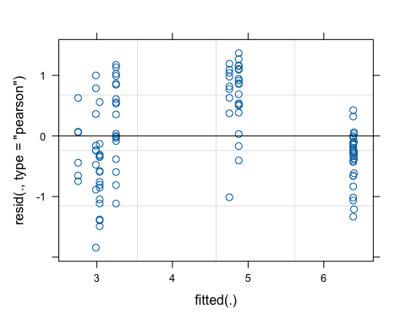
# look at estimated variance components
summary(model_day_treatment_shannon2)
## Linear mixed model fit by REML. t-tests use Satterthwaite's method [
## lmerModLmerTest]
## Formula: shannon_entropy ~ treatment * day + (1 | calf_id)
## Data: metadata
##
## REML criterion at convergence: 260.8
##
## Scaled residuals:
## Min 1Q Median 3Q Max
## -2.4116 -0.6217 -0.1213 0.8215 1.7895
##
## Random effects:
## Groups Name Variance Std.Dev.
## calf_id (Intercept) 0.0000 0.0000
## Residual 0.5844 0.7645
## Number of obs: 105, groups: calf_id, 30
##
## Fixed effects:
## Estimate Std. Error df t value Pr(>|t|)
## (Intercept) 2.695185 0.200965 101.000000 13.411 <2e-16 ***
## treatmentpair 0.289854 0.241307 101.000000 1.201 0.232
## day 0.058786 0.005326 101.000000 11.037 <2e-16 ***
## treatmentpair:day -0.004756 0.006401 101.000000 -0.743 0.459
## ---
## Signif. codes: 0 '***' 0.001 '**' 0.01 '*' 0.05 '.' 0.1 ' ' 1
##
## Correlation of Fixed Effects:
## (Intr) trtmnt day
## treatmentpr -0.833
## day -0.749 0.624
## trtmntpr:dy 0.624 -0.746 -0.832
## optimizer (nloptwrap) convergence code: 0 (OK)
## boundary (singular) fit: see help('isSingular')
# residual diagnostic plot, check assumptions
anova(model_day_treatment_shannon2)
## Type III Analysis of Variance Table with Satterthwaite's method
## Sum Sq Mean Sq NumDF DenDF F value Pr(>F)
## treatment 0.843 0.843 1 101 1.4428 0.2325
## day 181.523 181.523 1 101 310.6165 <2e-16 ***
## treatment:day 0.323 0.323 1 101 0.5519 0.4593
## ---
## Signif. codes: 0 '***' 0.001 '**' 0.01 '*' 0.05 '.' 0.1 ' ' 1
# pairwise comparisons
emmeans(model_day_treatment_shannon2, pairwise ~ treatment)
## NOTE: Results may be misleading due to involvement in interactions
## $emmeans
## treatment emmean SE df lower.CL upper.CL
## individual 4.34 0.1340 29.0 4.06 4.61
## pair 4.49 0.0903 25.8 4.31 4.68
##
## Degrees-of-freedom method: kenward-roger
## Confidence level used: 0.95
##
## $contrasts
## contrast estimate SE df t.ratio p.value
## individual - pair -0.157 0.161 27.9 -0.974 0.3385
##
## Degrees-of-freedom method: kenward-roger
Evenness
# Build model
model_day_treatment_evenness <- lmer(pielou_evenness ~ treatment*day_split + (1|calf_id), data = metadata)
## boundary (singular) fit: see help('isSingular')
# Residual diagnostic plot, check assumptions
plot(model_day_treatment_evenness)
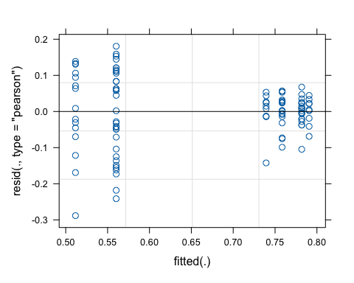
# look at estimated variance components
summary(model_day_treatment_evenness)
## Linear mixed model fit by REML. t-tests use Satterthwaite's method [
## lmerModLmerTest]
## Formula: pielou_evenness ~ treatment * day_split + (1 | calf_id)
## Data: metadata
##
## REML criterion at convergence: -180
##
## Scaled residuals:
## Min 1Q Median 3Q Max
## -3.2147 -0.4188 0.0847 0.5957 2.0135
##
## Random effects:
## Groups Name Variance Std.Dev.
## calf_id (Intercept) 0.000000 0.00000
## Residual 0.008044 0.08969
## Number of obs: 105, groups: calf_id, 30
##
## Fixed effects:
## Estimate Std. Error df t value Pr(>|t|)
## (Intercept) 0.51166 0.02316 99.00000 22.094 < 2e-16 ***
## treatmentpair 0.04862 0.02780 99.00000 1.749 0.0834 .
## day_split5-35 0.22765 0.03782 99.00000 6.020 2.97e-08 ***
## day_split35-63 0.27901 0.03782 99.00000 7.378 5.03e-11 ***
## treatmentpair:day_split5-35 -0.02949 0.04597 99.00000 -0.641 0.5228
## treatmentpair:day_split35-63 -0.05744 0.04549 99.00000 -1.263 0.2096
## ---
## Signif. codes: 0 '***' 0.001 '**' 0.01 '*' 0.05 '.' 0.1 ' ' 1
##
## Correlation of Fixed Effects:
## (Intr) trtmnt d_5-35 d_35-6 t:_5-3
## treatmentpr -0.833
## dy_splt5-35 -0.612 0.510
## dy_spl35-63 -0.612 0.510 0.375
## trtmn:_5-35 0.504 -0.605 -0.823 -0.308
## trtm:_35-63 0.509 -0.611 -0.312 -0.831 0.370
## optimizer (nloptwrap) convergence code: 0 (OK)
## boundary (singular) fit: see help('isSingular')
# residual diagnostic plot, check assumptions
anova(model_day_treatment_evenness)
## Type III Analysis of Variance Table with Satterthwaite's method
## Sum Sq Mean Sq NumDF DenDF F value Pr(>F)
## treatment 0.00819 0.00819 1 99 1.0182 0.3154
## day_split 1.22569 0.61284 2 99 76.1822 <2e-16 ***
## treatment:day_split 0.01311 0.00656 2 99 0.8151 0.4455
## ---
## Signif. codes: 0 '***' 0.001 '**' 0.01 '*' 0.05 '.' 0.1 ' ' 1
# pairwise comparisons
emmeans(model_day_treatment_evenness, pairwise ~ treatment|day_split)
## $emmeans
## day_split = 1-5:
## treatment emmean SE df lower.CL upper.CL
## individual 0.512 0.0233 78.7 0.465 0.558
## pair 0.560 0.0154 77.8 0.530 0.591
##
## day_split = 5-35:
## treatment emmean SE df lower.CL upper.CL
## individual 0.739 0.0299 99.0 0.680 0.799
## pair 0.758 0.0212 99.0 0.716 0.800
##
## day_split = 35-63:
## treatment emmean SE df lower.CL upper.CL
## individual 0.791 0.0299 99.0 0.731 0.850
## pair 0.782 0.0201 99.0 0.742 0.822
##
## Degrees-of-freedom method: kenward-roger
## Confidence level used: 0.95
##
## $contrasts
## day_split = 1-5:
## contrast estimate SE df t.ratio p.value
## individual - pair -0.04862 0.0279 78.4 -1.740 0.0857
##
## day_split = 5-35:
## contrast estimate SE df t.ratio p.value
## individual - pair -0.01913 0.0367 99.0 -0.522 0.6031
##
## day_split = 35-63:
## contrast estimate SE df t.ratio p.value
## individual - pair 0.00883 0.0360 99.0 0.245 0.8070
##
## Degrees-of-freedom method: kenward-roger
Observed Features
# Build model
model_day_treatment_obfeatures <- lmer(observed_features ~ treatment*day_split + (1|calf_id), data = metadata)
# Residual diagnostic plot, check assumptions
plot(model_day_treatment_obfeatures)
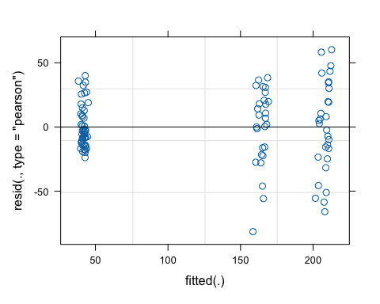
# look at estimated variance components
summary(model_day_treatment_obfeatures)
## Linear mixed model fit by REML. t-tests use Satterthwaite's method [
## lmerModLmerTest]
## Formula: observed_features ~ treatment * day_split + (1 | calf_id)
## Data: metadata
##
## REML criterion at convergence: 955.2
##
## Scaled residuals:
## Min 1Q Median 3Q Max
## -2.98114 -0.54937 -0.08146 0.65884 2.20024
##
## Random effects:
## Groups Name Variance Std.Dev.
## calf_id (Intercept) 20.4 4.516
## Residual 748.7 27.363
## Number of obs: 105, groups: calf_id, 30
##
## Fixed effects:
## Estimate Std. Error df t value Pr(>|t|)
## (Intercept) 41.022 7.235 74.132 5.670 2.59e-07 ***
## treatmentpair 1.357 8.686 73.587 0.156 0.876
## day_split5-35 120.315 11.570 78.172 10.399 < 2e-16 ***
## day_split35-63 163.315 11.570 78.172 14.116 < 2e-16 ***
## treatmentpair:day_split5-35 3.835 14.058 76.435 0.273 0.786
## treatmentpair:day_split35-63 4.407 13.906 75.921 0.317 0.752
## ---
## Signif. codes: 0 '***' 0.001 '**' 0.01 '*' 0.05 '.' 0.1 ' ' 1
##
## Correlation of Fixed Effects:
## (Intr) trtmnt d_5-35 d_35-6 t:_5-3
## treatmentpr -0.833
## dy_splt5-35 -0.602 0.501
## dy_spl35-63 -0.602 0.501 0.378
## trtmn:_5-35 0.495 -0.593 -0.823 -0.311
## trtm:_35-63 0.501 -0.600 -0.315 -0.832 0.372
# residual diagnostic plot, check assumptions
anova(model_day_treatment_obfeatures)
## Type III Analysis of Variance Table with Satterthwaite's method
## Sum Sq Mean Sq NumDF DenDF F value Pr(>F)
## treatment 328 328 1 28.459 0.4382 0.5133
## day_split 487560 243780 2 74.108 325.5827 <2e-16 ***
## treatment:day_split 96 48 2 74.108 0.0641 0.9379
## ---
## Signif. codes: 0 '***' 0.001 '**' 0.01 '*' 0.05 '.' 0.1 ' ' 1
# pairwise comparisons
emmeans(model_day_treatment_obfeatures, pairwise ~ treatment|day_split)
## $emmeans
## day_split = 1-5:
## treatment emmean SE df lower.CL upper.CL
## individual 41.0 7.27 76.7 26.5 55.5
## pair 42.4 4.82 75.0 32.8 52.0
##
## day_split = 5-35:
## treatment emmean SE df lower.CL upper.CL
## individual 161.3 9.26 98.8 143.0 179.7
## pair 166.5 6.55 98.8 153.5 179.5
##
## day_split = 35-63:
## treatment emmean SE df lower.CL upper.CL
## individual 204.3 9.26 98.8 186.0 222.7
## pair 210.1 6.20 98.7 197.8 222.4
##
## Degrees-of-freedom method: kenward-roger
## Confidence level used: 0.95
##
## $contrasts
## day_split = 1-5:
## contrast estimate SE df t.ratio p.value
## individual - pair -1.36 8.73 76.2 -0.156 0.8768
##
## day_split = 5-35:
## contrast estimate SE df t.ratio p.value
## individual - pair -5.19 11.30 98.8 -0.458 0.6480
##
## day_split = 35-63:
## contrast estimate SE df t.ratio p.value
## individual - pair -5.76 11.10 98.8 -0.517 0.6061
##
## Degrees-of-freedom method: kenward-roger
Faith’s PD
# Build model
model_day_treatment_faithpd <- lmer(faith_pd ~ treatment*day_split + (1|calf_id), data = metadata)
# Residual diagnostic plot, check assumptions
plot(model_day_treatment_faithpd)
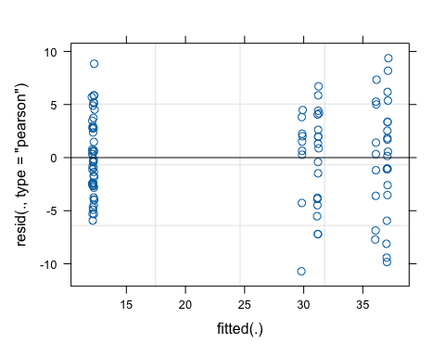
# look at estimated variance components
summary(model_day_treatment_faithpd)
## Linear mixed model fit by REML. t-tests use Satterthwaite's method [
## lmerModLmerTest]
## Formula: faith_pd ~ treatment * day_split + (1 | calf_id)
## Data: metadata
##
## REML criterion at convergence: 592
##
## Scaled residuals:
## Min 1Q Median 3Q Max
## -2.42341 -0.60752 0.07115 0.67203 2.11953
##
## Random effects:
## Groups Name Variance Std.Dev.
## calf_id (Intercept) 0.08982 0.2997
## Residual 19.51194 4.4172
## Number of obs: 105, groups: calf_id, 30
##
## Fixed effects:
## Estimate Std. Error df t value Pr(>|t|)
## (Intercept) 12.13369 1.14523 75.07412 10.595 < 2e-16 ***
## treatmentpair 0.09934 1.37486 74.71446 0.072 0.943
## day_split5-35 17.72803 1.86339 77.58650 9.514 1.15e-14 ***
## day_split35-63 23.97542 1.86339 77.58650 12.867 < 2e-16 ***
## treatmentpair:day_split5-35 1.25092 2.26513 75.82468 0.552 0.582
## treatmentpair:day_split35-63 0.87113 2.24099 75.27189 0.389 0.699
## ---
## Signif. codes: 0 '***' 0.001 '**' 0.01 '*' 0.05 '.' 0.1 ' ' 1
##
## Correlation of Fixed Effects:
## (Intr) trtmnt d_5-35 d_35-6 t:_5-3
## treatmentpr -0.833
## dy_splt5-35 -0.611 0.509
## dy_spl35-63 -0.611 0.509 0.376
## trtmn:_5-35 0.502 -0.603 -0.823 -0.309
## trtm:_35-63 0.508 -0.609 -0.312 -0.832 0.370
# residual diagnostic plot, check assumptions
anova(model_day_treatment_faithpd)
## Type III Analysis of Variance Table with Satterthwaite's method
## Sum Sq Mean Sq NumDF DenDF F value Pr(>F)
## treatment 13.6 13.6 1 27.690 0.6975 0.4108
## day_split 10760.2 5380.1 2 73.401 275.7333 <2e-16 ***
## treatment:day_split 6.7 3.4 2 73.401 0.1722 0.8422
## ---
## Signif. codes: 0 '***' 0.001 '**' 0.01 '*' 0.05 '.' 0.1 ' ' 1
# pairwise comparisons
emmeans(model_day_treatment_faithpd, pairwise ~ treatment|day_split)
## $emmeans
## day_split = 1-5:
## treatment emmean SE df lower.CL upper.CL
## individual 12.1 1.150 78.3 9.84 14.4
## pair 12.2 0.763 77.3 10.71 13.8
##
## day_split = 5-35:
## treatment emmean SE df lower.CL upper.CL
## individual 29.9 1.480 99.0 26.93 32.8
## pair 31.2 1.050 99.0 29.14 33.3
##
## day_split = 35-63:
## treatment emmean SE df lower.CL upper.CL
## individual 36.1 1.480 99.0 33.18 39.0
## pair 37.1 0.990 99.0 35.12 39.0
##
## Degrees-of-freedom method: kenward-roger
## Confidence level used: 0.95
##
## $contrasts
## day_split = 1-5:
## contrast estimate SE df t.ratio p.value
## individual - pair -0.0993 1.38 78 -0.072 0.9429
##
## day_split = 5-35:
## contrast estimate SE df t.ratio p.value
## individual - pair -1.3503 1.81 99 -0.746 0.4575
##
## day_split = 35-63:
## contrast estimate SE df t.ratio p.value
## individual - pair -0.9705 1.78 99 -0.546 0.5866
##
## Degrees-of-freedom method: kenward-roger

treatment figure ajusted for time (box plot) (3 timepoint box plot)
model_day_treatment_faithpd <- lmer(faith_pd ~ treatment*day_split + (1|calf_id), data = metadata)
pvals <- pairs(
emmeans(model_day_treatment_faithpd, ~ treatment | day_split)
) |> as.data.frame()
pvals_table <- pvals %>%
separate(contrast, into = c("group1","group2"), sep = " - ") %>%
dplyr::mutate(
p = round(p.value, 4),
y.position = max(metadata$faith_pd) + 0.1
)
pvals_table
## group1 group2 day_split estimate SE df t.ratio
## 1 individual pair 1-5 -0.09934469 1.381399 78.02914 -0.07191598
## 2 individual pair 5-35 -1.35026840 1.810465 98.97325 -0.74581293
## 3 individual pair 35-63 -0.97047201 1.778940 98.97176 -0.54553377
## p.value p y.position
## 1 0.9428528 0.9429 46.62512
## 2 0.4575481 0.4575 46.62512
## 3 0.5866139 0.5866 46.62512

day + facility + sex (question 3)
Shannon
# Build model
model_treatment_day_shannon <- lmer(shannon_entropy ~ treatment*day + sex + (1|calf_id), data = metadata)
## boundary (singular) fit: see help('isSingular')
# Residual diagnostic plot, check assumptions
plot(model_treatment_day_shannon)
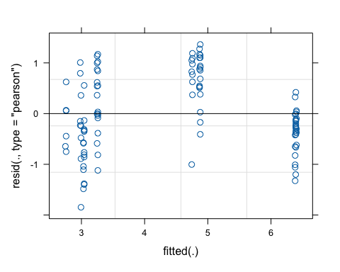
# look at estimated variance components
summary(model_treatment_day_shannon)
## Linear mixed model fit by REML. t-tests use Satterthwaite's method [
## lmerModLmerTest]
## Formula: shannon_entropy ~ treatment * day + sex + (1 | calf_id)
## Data: metadata
##
## REML criterion at convergence: 262.7
##
## Scaled residuals:
## Min 1Q Median 3Q Max
## -2.4045 -0.6235 -0.1257 0.8126 1.7749
##
## Random effects:
## Groups Name Variance Std.Dev.
## calf_id (Intercept) 0.0000 0.0000
## Residual 0.5902 0.7683
## Number of obs: 105, groups: calf_id, 30
##
## Fixed effects:
## Estimate Std. Error df t value Pr(>|t|)
## (Intercept) 2.698879 0.208290 100.000000 12.957 <2e-16 ***
## treatmentpair 0.290432 0.242636 100.000000 1.197 0.234
## day 0.058788 0.005353 100.000000 10.982 <2e-16 ***
## sexmale -0.011269 0.155407 100.000000 -0.073 0.942
## treatmentpair:day -0.004754 0.006433 100.000000 -0.739 0.462
## ---
## Signif. codes: 0 '***' 0.001 '**' 0.01 '*' 0.05 '.' 0.1 ' ' 1
##
## Correlation of Fixed Effects:
## (Intr) trtmnt day sexmal
## treatmentpr -0.799
## day -0.725 0.624
## sexmale -0.245 -0.033 -0.006
## trtmntpr:dy 0.606 -0.745 -0.832 -0.004
## optimizer (nloptwrap) convergence code: 0 (OK)
## boundary (singular) fit: see help('isSingular')
# residual diagnostic plot, check assumptions
anova(model_treatment_day_shannon)
## Type III Analysis of Variance Table with Satterthwaite's method
## Sum Sq Mean Sq NumDF DenDF F value Pr(>F)
## treatment 0.846 0.846 1 100 1.4328 0.2341
## day 181.511 181.511 1 100 307.5375 <2e-16 ***
## sex 0.003 0.003 1 100 0.0053 0.9423
## treatment:day 0.322 0.322 1 100 0.5461 0.4617
## ---
## Signif. codes: 0 '***' 0.001 '**' 0.01 '*' 0.05 '.' 0.1 ' ' 1
# pairwise comparisons
emmeans(model_treatment_day_shannon, pairwise ~ treatment|day)
## $emmeans
## day = 27.9:
## treatment emmean SE df lower.CL upper.CL
## individual 4.34 0.1370 29.5 4.06 4.61
## pair 4.49 0.0924 25.1 4.30 4.68
##
## Results are averaged over the levels of: sex
## Degrees-of-freedom method: kenward-roger
## Confidence level used: 0.95
##
## $contrasts
## day = 27.9:
## contrast estimate SE df t.ratio p.value
## individual - pair -0.158 0.162 27.2 -0.972 0.3398
##
## Results are averaged over the levels of: sex
## Degrees-of-freedom method: kenward-roger
Evenness
# Build model
model_treatment_day_evenness <- lmer(pielou_evenness ~ treatment*day + sex + (1|calf_id), data = metadata)
## boundary (singular) fit: see help('isSingular')
# Residual diagnostic plot, check assumptions
plot(model_treatment_day_evenness)
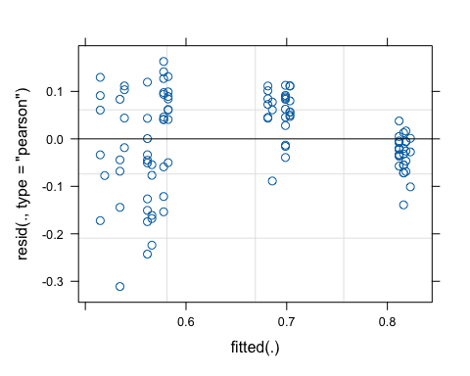
# look at estimated variance components
summary(model_treatment_day_evenness)
## Linear mixed model fit by REML. t-tests use Satterthwaite's method [
## lmerModLmerTest]
## Formula: pielou_evenness ~ treatment * day + sex + (1 | calf_id)
## Data: metadata
##
## REML criterion at convergence: -157.4
##
## Scaled residuals:
## Min 1Q Median 3Q Max
## -3.3079 -0.5380 0.0068 0.8250 1.7344
##
## Random effects:
## Groups Name Variance Std.Dev.
## calf_id (Intercept) 0.000000 0.00000
## Residual 0.008842 0.09403
## Number of obs: 105, groups: calf_id, 30
##
## Fixed effects:
## Estimate Std. Error df t value Pr(>|t|)
## (Intercept) 5.099e-01 2.549e-02 1.000e+02 20.000 <2e-16 ***
## treatmentpair 4.772e-02 2.970e-02 1.000e+02 1.607 0.111
## day 4.897e-03 6.552e-04 1.000e+02 7.475 3e-11 ***
## sexmale 4.449e-03 1.902e-02 1.000e+02 0.234 0.816
## treatmentpair:day -8.648e-04 7.874e-04 1.000e+02 -1.098 0.275
## ---
## Signif. codes: 0 '***' 0.001 '**' 0.01 '*' 0.05 '.' 0.1 ' ' 1
##
## Correlation of Fixed Effects:
## (Intr) trtmnt day sexmal
## treatmentpr -0.799
## day -0.725 0.624
## sexmale -0.245 -0.033 -0.006
## trtmntpr:dy 0.606 -0.745 -0.832 -0.004
## optimizer (nloptwrap) convergence code: 0 (OK)
## boundary (singular) fit: see help('isSingular')
# residual diagnostic plot, check assumptions
anova(model_treatment_day_evenness)
## Type III Analysis of Variance Table with Satterthwaite's method
## Sum Sq Mean Sq NumDF DenDF F value Pr(>F)
## treatment 0.02283 0.02283 1 100 2.5824 0.1112
## day 1.13719 1.13719 1 100 128.6119 <2e-16 ***
## sex 0.00048 0.00048 1 100 0.0547 0.8156
## treatment:day 0.01067 0.01067 1 100 1.2064 0.2747
## ---
## Signif. codes: 0 '***' 0.001 '**' 0.01 '*' 0.05 '.' 0.1 ' ' 1
# pairwise comparisons
emmeans(model_treatment_day_evenness, pairwise ~ treatment|day)
## $emmeans
## day = 27.9:
## treatment emmean SE df lower.CL upper.CL
## individual 0.649 0.0167 29.5 0.615 0.683
## pair 0.672 0.0113 25.1 0.649 0.696
##
## Results are averaged over the levels of: sex
## Degrees-of-freedom method: kenward-roger
## Confidence level used: 0.95
##
## $contrasts
## day = 27.9:
## contrast estimate SE df t.ratio p.value
## individual - pair -0.0236 0.0199 27.2 -1.187 0.2456
##
## Results are averaged over the levels of: sex
## Degrees-of-freedom method: kenward-roger
Observed features
# Build model
model_treatment_day_obfeatures <- lmer(observed_features ~ treatment*day + sex + (1|calf_id), data = metadata)
## boundary (singular) fit: see help('isSingular')
# Residual diagnostic plot, check assumptions
plot(model_treatment_day_obfeatures)
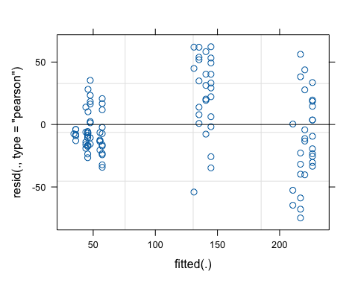
# look at estimated variance components
summary(model_treatment_day_obfeatures)
## Linear mixed model fit by REML. t-tests use Satterthwaite's method [
## lmerModLmerTest]
## Formula: observed_features ~ treatment * day + sex + (1 | calf_id)
## Data: metadata
##
## REML criterion at convergence: 999.9
##
## Scaled residuals:
## Min 1Q Median 3Q Max
## -2.4405 -0.5630 -0.2101 0.6392 2.0313
##
## Random effects:
## Groups Name Variance Std.Dev.
## calf_id (Intercept) 0.0 0.00
## Residual 939.2 30.65
## Number of obs: 105, groups: calf_id, 30
##
## Fixed effects:
## Estimate Std. Error df t value Pr(>|t|)
## (Intercept) 41.22956 8.30879 100.00000 4.962 2.87e-06 ***
## treatmentpair 1.44204 9.67887 100.00000 0.149 0.882
## day 2.84162 0.21353 100.00000 13.308 < 2e-16 ***
## sexmale -9.61866 6.19927 100.00000 -1.552 0.124
## treatmentpair:day 0.07487 0.25662 100.00000 0.292 0.771
## ---
## Signif. codes: 0 '***' 0.001 '**' 0.01 '*' 0.05 '.' 0.1 ' ' 1
##
## Correlation of Fixed Effects:
## (Intr) trtmnt day sexmal
## treatmentpr -0.799
## day -0.725 0.624
## sexmale -0.245 -0.033 -0.006
## trtmntpr:dy 0.606 -0.745 -0.832 -0.004
## optimizer (nloptwrap) convergence code: 0 (OK)
## boundary (singular) fit: see help('isSingular')
# residual diagnostic plot, check assumptions
anova(model_treatment_day_obfeatures)
## Type III Analysis of Variance Table with Satterthwaite's method
## Sum Sq Mean Sq NumDF DenDF F value Pr(>F)
## treatment 21 21 1 100 0.0222 0.8819
## day 472792 472792 1 100 503.4131 <2e-16 ***
## sex 2261 2261 1 100 2.4074 0.1239
## treatment:day 80 80 1 100 0.0851 0.7711
## ---
## Signif. codes: 0 '***' 0.001 '**' 0.01 '*' 0.05 '.' 0.1 ' ' 1
# pairwise comparisons
emmeans(model_treatment_day_obfeatures, pairwise ~ treatment|day)
## $emmeans
## day = 27.9:
## treatment emmean SE df lower.CL upper.CL
## individual 116 5.45 29.5 105 127
## pair 119 3.69 25.1 112 127
##
## Results are averaged over the levels of: sex
## Degrees-of-freedom method: kenward-roger
## Confidence level used: 0.95
##
## $contrasts
## day = 27.9:
## contrast estimate SE df t.ratio p.value
## individual - pair -3.53 6.47 27.2 -0.546 0.5895
##
## Results are averaged over the levels of: sex
## Degrees-of-freedom method: kenward-roger
Faith’s PD
# Build model
model_treatment_day_faithpd <- lmer(faith_pd ~ treatment*day + sex + (1|calf_id), data = metadata)
## boundary (singular) fit: see help('isSingular')
# Residual diagnostic plot, check assumptions
plot(model_treatment_day_faithpd)
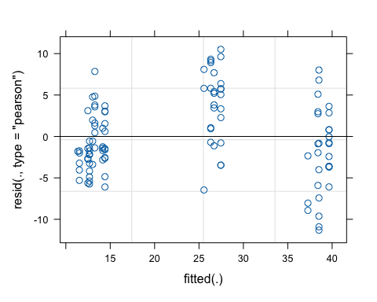
# look at estimated variance components
summary(model_treatment_day_faithpd)
## Linear mixed model fit by REML. t-tests use Satterthwaite's method [
## lmerModLmerTest]
## Formula: faith_pd ~ treatment * day + sex + (1 | calf_id)
## Data: metadata
##
## REML criterion at convergence: 630.9
##
## Scaled residuals:
## Min 1Q Median 3Q Max
## -2.3353 -0.6656 -0.1722 0.7107 2.1706
##
## Random effects:
## Groups Name Variance Std.Dev.
## calf_id (Intercept) 0.00 0.000
## Residual 23.45 4.843
## Number of obs: 105, groups: calf_id, 30
##
## Fixed effects:
## Estimate Std. Error df t value Pr(>|t|)
## (Intercept) 12.06397 1.31293 100.00000 9.189 5.94e-15 ***
## treatmentpair 0.16444 1.52942 100.00000 0.108 0.915
## day 0.41813 0.03374 100.00000 12.392 < 2e-16 ***
## sexmale -1.13743 0.97959 100.00000 -1.161 0.248
## treatmentpair:day 0.01713 0.04055 100.00000 0.422 0.674
## ---
## Signif. codes: 0 '***' 0.001 '**' 0.01 '*' 0.05 '.' 0.1 ' ' 1
##
## Correlation of Fixed Effects:
## (Intr) trtmnt day sexmal
## treatmentpr -0.799
## day -0.725 0.624
## sexmale -0.245 -0.033 -0.006
## trtmntpr:dy 0.606 -0.745 -0.832 -0.004
## optimizer (nloptwrap) convergence code: 0 (OK)
## boundary (singular) fit: see help('isSingular')
# residual diagnostic plot, check assumptions
anova(model_treatment_day_faithpd)
## Type III Analysis of Variance Table with Satterthwaite's method
## Sum Sq Mean Sq NumDF DenDF F value Pr(>F)
## treatment 0.3 0.3 1 100 0.0116 0.9146
## day 10384.9 10384.9 1 100 442.8429 <2e-16 ***
## sex 31.6 31.6 1 100 1.3482 0.2484
## treatment:day 4.2 4.2 1 100 0.1784 0.6736
## ---
## Signif. codes: 0 '***' 0.001 '**' 0.01 '*' 0.05 '.' 0.1 ' ' 1
# pairwise comparisons
emmeans(model_treatment_day_faithpd, pairwise ~ treatment|day)
## $emmeans
## day = 27.9:
## treatment emmean SE df lower.CL upper.CL
## individual 23.2 0.862 29.5 21.4 24.9
## pair 23.8 0.582 25.1 22.6 25.0
##
## Results are averaged over the levels of: sex
## Degrees-of-freedom method: kenward-roger
## Confidence level used: 0.95
##
## $contrasts
## day = 27.9:
## contrast estimate SE df t.ratio p.value
## individual - pair -0.643 1.02 27.2 -0.629 0.5348
##
## Results are averaged over the levels of: sex
## Degrees-of-freedom method: kenward-roger

Sample type figure
model_treatment_day_obfeatures <- lmer(observed_features ~ treatment*day + sex + (1|calf_id), data = metadata)
## boundary (singular) fit: see help('isSingular')
pvals <- pairs(
emmeans(model_treatment_day_obfeatures, ~ treatment | day)
) |> as.data.frame()
pvals_table <- pvals %>%
separate(contrast, into = c("group1","group2"), sep = " - ") %>%
dplyr::mutate(
p = round(p.value, 4),
y.position = max(metadata$observed_features) + 0.1
)
pvals_table
## group1 group2 day estimate SE df t.ratio p.value
## 1 individual pair 27.93333 -3.533281 6.471739 27.21044 -0.5459555 0.5895451
## p y.position
## 1 0.5895 273.1

