Instructions for Drivers

Remove this section in your proposal document

- Familiarize yourself with the Review Process
- Save your document in the TSDs folder with a descriptive title and the "TSD" prefix in the title
e.g.
TSD: Service to Service
TSD: Governance: Conditional approval and remediation plan
TSD: NetApp ONTAP Storage Integration with Data
- Share the document for Comment with all relevant parties (all of Domino is usually OK)
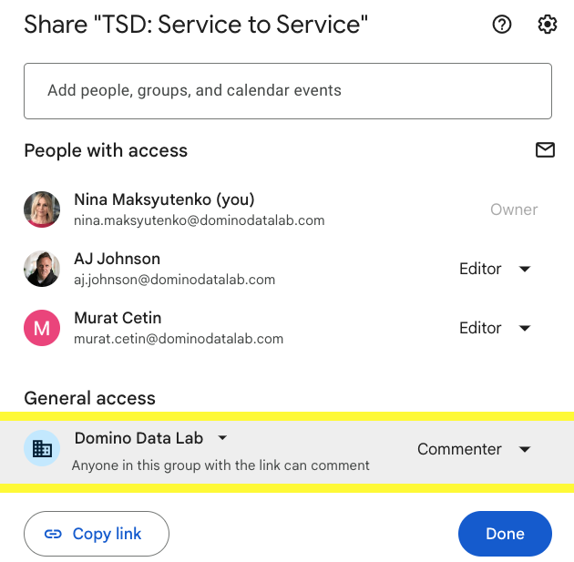

- Create a Jira issue on the REVIEW board and link it to this document. Also add the Jira URL to the Background section below.
- Fill out the document
  - Each of the sections below contains descriptive text intended to guide you and suggest areas to focus on. Remove it and replace it with actual content relevant to that section.
  - Not all sections are relevant and applicable to all proposals. Remove the ones that are not applicable to your design or project.
- Delete this grey box.
- Profit!

Technical Specifications Document
Author(s)/Driver(s)

See the Software Design Review Process for a description of the roles and responsibilities
Roles | Name(s) | Comments
Driver
Approver (AJ)
Contributors
Informed

1. Feature Overview

Proposal Summary (TL;DR)
This section is required - unless there is a PRD
In this section, include a numbered list of specific changes or building blocks you are proposing. The goal is to give reviewers anchoring points for discussion and a concrete set of items to either approve or reject. It's possible for only some of these items to be approved and for the rest to become the subject of a future proposal. Below is an example of such a list just to illustrate the concept. Your proposal and item list may be very different in nature.

- Refactoring Nucleus to move Compute Grid code and functionality to a separate microservice
- Using a message bus as the exclusive, asynchronous communication mechanism between Nucleus and Compute Grid
- Message protocol specification
- Using Redis Streams as the message bus
- Using Avro as the serialization protocol for all messages

Objectives
This section is required - unless there is a PRD
Describe the scope of what you are trying to achieve by implementing this proposal. Why should we invest in this work, and what are the risks if we don’t. Also important; what are not trying to achieve? I.e., define the scope of the work.

Motivating Requirements
This section is optional
Link to a PRD or One pager/initiative proposal. Also if this proposal is aligned to a longer architectural vision.

Terminology
This section is optional
Define any terms that might be ambiguous, even those that are commonly used in Domino, but may have the same definition universally. Here is a very typical example:

- Milestone - A minimal unit of work that delivers customer value.

Proposal
This section is required

This is the meaty part of the document and the largest top-level section!

Describe in detail what you are proposing to do. Use diagrams if they help illustrate the implementation. (Consider http://diagrams.net, https://lucid.app/documents#/dashboard, which are great, free options.) Use subsections to partition this part of the document further in a way that makes it easier for reviewers to navigate and understand.

2. Requirements and Assumptions
- Functional Requirements:
  - Detail what the feature must do (e.g., user actions, system responses).
  - Provide numbered list for clarity, if applicable.
- Non-Functional Requirements / Architecture Characteristics:
  - Availability, disaster recovery, performance, recoverability, robustness, scalability, configurability, extensibility, installability, maintainability, archiveability, observability, security, usability, etc.
  - Backup / restore should be implemented with domino-data-importer
- Assumptions:
  - Outline any assumptions that guide this specification (e.g., dependencies on other teams or systems).

3. Architecture and System Design
- System Components Affected:
  - List components or services that will be modified or created.
- High-Level Architecture Diagram:
  - Include a diagram showing the major components and data flow.
  - Specify any net new cloud infrastructure or changes to existing infrastructure and whether this introduces support burden / cost
  - Document support for environments - all cloud + on-prem
- Data and Domain Model / Entities:
  - Detail any new database schemas, tables, or changes to existing ones.
  - Detail any microservice specific data stores
  - Describe changes to the information architecture including any new entities
- APIs and Integrations:
  - Describe any new APIs being created, modified or broken - both public and internal.
  - Include method names, request/response examples, data formats, etc.
- Authorization Model
  - Note the use of existing authz controls or net new authorization systems
- Third-Party Services / Tools Used:
  - Mention any dependencies on external libraries, APIs, or services.
- Control / Data Plane
  - Note special considerations where control and data plane are separated. Are services deployed to both? Some guidance here:
    - Support and upgradeability are generally considered simpler in the control plane
    - Customer IP (i.e. code, data) generally cannot live at rest in the control plane
    - A network bridge separates the two planes - do you have a compelling performance reason for your component to live in one plane or the other?
    - Do data planes require unique configuration?
  - If deploying in to the Data Plane what are your baseline support requirements for
    - Observability
    - Access
    - Upgrade
    - Compatibility (it may be out of sync with the control plane)
    - Operability (for example, will it ever run out of disk space?)

4. Technical Approach
- Proposed Solution:
  - Describe how you plan to build the feature, including key design decisions.
  - Explain why certain technologies or approaches were chosen over alternatives.
- Components and Modules:
  - Detail individual modules, classes, or microservices and their responsibilities.

5. Data Flow and Sequence Diagrams
- Include any relevant sequence diagrams or flowcharts that illustrate interactions, processes, or workflows.

6. Error Handling and Edge Cases
- Describe how errors will be managed and any specific edge cases that must be handled.

7. Dependencies
- Internal Dependencies:
  - Services, teams, or components within the organization that this feature depends on.
- External Dependencies:
  - Third-party APIs, libraries, or tools this feature relies upon.

8. Security Considerations

Security questionnaire:
The goal is to get an initial evaluation of the feature in terms of security - will it match the standard that Domino aims for? Do we need to ensure a specific focus on the feature for the release PenTest?

Notes:
- Some answers may trigger a follow-up from the security team or the platform team were details can be discussed
- Some questions refer to some processes that do not exist yet (ex: docker image approval), please answer the best you can.

Theme | Question | Answer
Sensitive data | Q1a: is the feature accessing/writing or creating new sensitive data like user secrets or passwords? Is Vault being used to store the data?
 | Q1b (if Q1a = yes): have you ensured you are not introducing a way to access the sensitive data without proper AuthN & AuthZ?
Service/POD | Q2a will the feature include a new service/POD in the cluster?
 | Q2b (if Q2a = yes), does your service require non-root permissions or specific Linux kernel capabilities?
NetPol  (Network Policy) | Q3: will the feature require the modification of an existing NetworkPolicy?
Docker images | Q4a: will the feature require adding a new image to Domino docker images catalog or leverage new packages?
 | Q4b: (if Q4a = yes), are you using a Chainguard base image or Domino approved packages?
 | Q4c: (if (Q4b = no), do you have the approval to bypass company policy?
Software libraries | Q5a: Will this feature add a new open-source library to the code base?
 | Q5b (If Q5a = yes): Has this library been approved by legal for licensing purposes?
 | Q5c (If Q5b = yes): Has this library been documented internally for customer contractual purposes?
Cryptography | Q6: Will this feature require cryptography of any kind (encryption, decryption, hashing functions)?
Auth | Q7a: Has this feature been designed so that it can  - Validate the service requesting it  - Respond only with data authorized by the requestor  Q7b: Does the service accept Keycloak JWT tokens? Domino API keys (use of API keys is generally deprecated)?  Q7c: How are sessions managed? Are there any specific considerations that must be made to revoke active sessions?
UI/API | Q8a: Does this feature have both UI and API functions?
 | Q8b (if Q8a = yes): Does this feature have parity across its UI and API functionality, such that an update to one will naturally update the other?
 | Q9a: Has this added any new inputs, such as form fields?
 | Q9b: Has input validation and sanitization been performed on both the client and server sides, verifying only accepted characters are accepted and blocking attacks such as XSS?
 | Q10a: Are there any new routes in the application?
Q10b: Have all route controls been validated (CSRF token protection,
AuthN/AuthZ controls, etc)
 | Q10c: Are APIs accessible only internally, externally as private APIs only to be used by Domino or as public, versioned APIs that must be documented? Are the public APIs accessible through both the public Domino ingress and to user code like jobs, workspaces and apps via the Internal API Gateway?

9. Testing Plan
To be covered in the Test Plan document

10. Migration Strategy (if applicable)
- Plan for data migration or handling legacy systems during feature implementation.

11. Deployment Plan
- Environments: Describe staging, QA, production, etc., for deployment.
- Deployment Steps: Provide steps for deploying the feature.
- Rollback Plan: Outline the process for reverting changes if necessary.

12. Monitoring and Logging
- Describe how the feature will be monitored post-release.
- Specify any logging requirements.

13. Risks and Mitigations
- List potential risks to successful implementation and ways to mitigate these risks.

14. Open Questions
- List any unresolved issues or questions that need to be addressed.

