The Gatekeeping Function
Distributions of Information in Media and the Real World
Stuart Soroka, McGill University
The Journal of Politics

Online Appendix

This online appendix includes three sections. The first provides an additional analysis: it demonstrates the connection between media content and public opinion by replicating recent time series models of the relationship between them, but relying on the data used this article. The second includes additional methodological information on media data used in the main text. The third provides the full figures for all three components of the gatekeeping models for results shown in Figures 3 through 5 in the main text.

A. Media Content and Public Opinion
We have seen that there is a tendency for media to produce an economic picture that is systematically more negative than reality. Does this matter? Do media have an independent effect on public attitudes, about the economy and about governments? There is certainly a body of work suggesting that they do. It follows that media content, and variations between media content and the “real world,” matter. We need not rely on existing work to make this point, however—effects on public opinion are readily evident using the media data used above and a relatively simple extension of the regression models presented in Table 1, where both unemployment and media tone are used to predict public opinion.
Opinion is captured here using monthly results from the Thomson Reuters/University of Michigan Survey of Consumers. Specifically, we rely on the survey question, “Would you say that at the present time business conditions are better or worse than they were a year ago?”, where the proportion of respondents saying “worse” is subtracted from the proportion of respondents saying “better” to produce a measure capturing the general trend in perspectives over time.

Table A1. Unemployment, Media Content, and Public Opinion
 | DV: Public Opinion _{t}
∆ Unemployment _{t-1} | -14.008**
 | (3.424)
∆ Unemployment: Increase _{t-1} |  | -18.142**
 |  | (6.095)
∆ Unemployment: Decrease _{t-1} |  | -10.076
 |  | (5.725)
∆ Media Tone _{t-1} | 3.663**
 | (.905)
∆ Media Tone: Increase _{t-1} |  | 1.796
 |  | (1.796)
∆ Media Tone: Decrease _{t-1} |  | 5.346**
 |  | (1.682)
Public Opinion _{t-1} | .946** | .946**
 | (.015) | (.015)
Constant | -.191 | 1.071
 | (.515) | (1.038)
N | 330 | 330
R² | .935 | .935
Cells contain OLS regression coefficients with standard errors in parentheses. ª p < .10; * p < .05; ** p < .01.

Table A1 shows the results of regressing this measure of opinion on changes in unemployment and in media content. The first column shows a simple symmetric model, which confirms that media content (on unemployment) has an independent effect on public opinion. Ceteris paribus, a 1-point increase (decrease) in the unemployment rate at t-1 leads to an average 14-point in decrease (increase) in the opinion measure at t; above and beyond that, a 1-point decrease (increase) in the net tone of media coverage at t-1 leads to an average 3.7-point increase (decrease) in opinion at t.
The second column of Table A1 reveals asymmetry in both “real-world” and media effects. Increases in unemployment matter more than decreases; and decreases in tone matter more than increases. Accounting for this asymmetry does not change the most important fact, however: media tone affects public opinion, above and beyond the effects of unemployment itself. Given what we now know about media content, it follows that the public will have a somewhat distorted view of the economy. This matters for consumer behavior, for voting behavior, and for policy preferences. It follows that the shape of the gatekeeping function may be critical to our understanding of the sources of public attitudes on a wide range of political phenomena.

B. Media Data: Additional Methodological Information
New York Times data are gathered starting in June 1980, since this is the first month for which full-text data were available in Lexis-Nexis Academic. Economic articles were identified using a subject search including all stories for which any of the following terms were listing as “Relevancy: Major Terms only”: under (a) “Economic Conditions”: Deflation, Economic Decline, Economic Depression, Economic Growth, and Economic Recovery, Inflation and Recession; under (b) “Economic Indicators”: Average Earnings, Consumer Credit, Consumer Prices, Consumer Spending, Employment Rates, Existing Home Sales, Money Supply, New Home Sales, Productivity, Retail Trade Figures, Unemployment Rates, Wholesale Prices. The search also includes geographic terms that ensure that all New York Times news stories collected focus on the US national (and not foreign) economy. Once downloaded, the following are excluded: (a) any story less than 80 words, as these are typically short notes rather than actual newspaper articles and (b) any story that is in fact just a long list of reported economic figures.
Identification of articles dealing with employment issues was based on a full-text search of articles for employment-related keywords. This is just one method of capturing unemployment-related information in these data. It is also possible to extract just the sentences mentioning unemployment, for instance, as a means of excluding information on other economic topics. The two techniques produce measures that are highly correlated, however, likely reflecting the fact that an article that is negative (positive) about unemployment tends to be negative (positive) overall.
Where the human coding of media data is concerned, note that the decision rule was a follows: two coders have to assign a non-neutral value—in the same direction—in order for an article to be categorized as something other than Neutral. If only one coder assigns a non-neutral value, the article remains in the Neutral category, then; and in the very few cases in which there were codes of both negative and positive, articles are assigned to the Neutral category. Though note that, overall, differences between coders were small. All three coders picked the same tone category 65% of the time; codes were only one code apart in 34% of the cases; the remaining 1% of cases reflected a wider division.
To test the strength of the dictionary for the kind of economic news content used here, results from the automated coding are first compared with results from human coders. Three coders were asked to assign one of three codes—positive, negative, or neutral—to a sample of 450 NYT stories on the economy. The sample was selected so as to produce human codes, to a certain extent at least, distributed across the range of automated tone. The selection process was thus as follows. Based on the automated tone measure, the entire body of data was divided into three: one body of articles with tone one standard deviation below the mean, one body of articles with tone one standard deviation above the mean, and the remaining articles, all within one standard deviation of the mean. Then, for each newspaper, 150 stories were drawn entirely at random from each of these three subsamples.
The use of human coders in this case was closer to what is typical in computational linguistics than to what is found in political science and communications. In the latter, researchers typically train coders to assign identical codes. This is clearly important when one is assigning topics, or frames, but may not be effective where tone is concerned. For some computational linguists, differences across human coders are regarded as capturing real variation, or ambiguity, given the natural and structural ambiguity in categories of sentiment. Following this approach, codes from the three human coders are arranged here into a 5-point scale: Negative, where all three coders selected negative; Mildly Negative, where two coders selected negative; Neutral, where two or more coders selected neutral; Mildly Positive, where two coders selected positive; and Positive, where all three coders selected positive.
The resulting categories are clearer in Figure A1, which plots the average automated tone value for each of the five categories of manually-coded tone. Note that the structure and use of the English language, the style in which newspaper stories are written, and the effectiveness with which the dictionary captures positive or negative tone will mean that the automated score for what to readers are “neutral” articles is not necessarily zero. In these data the average value of automated tone for all stories is actually quite close to 0, however. The mean of all stories is -.16, and the mean for stories human-coded as neutral is .04.

Figure A1. Average Automated Tone, by Manual Categories
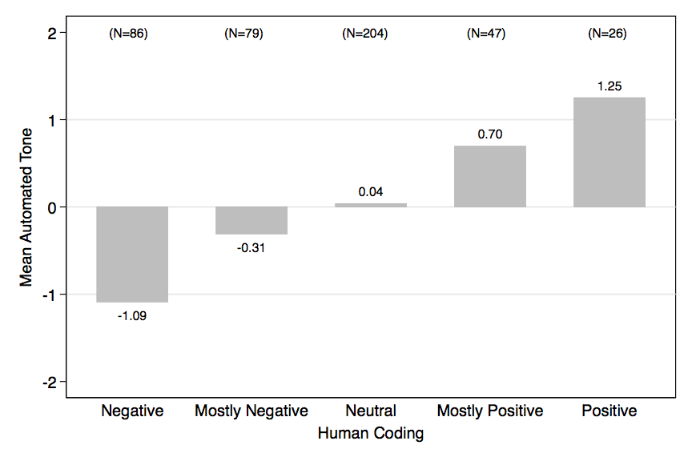
Most importantly, automated results across the range of human-coded values clearly suggests that the automated measure captures something having to do with tone. The mean value is lowest for clearly negative stories, and increases systematically as one moves up the scale. T-tests also suggest that the automated means are different, relying on pairwise comparisons as one moves up human-coded scale from Negative to Positive.

C. Additional Analyses
Figures 3 through 5 in the text show the estimated gatekeeping function (G) for a number of analyses; for the sake of brevity, they exclude the real-world (RW) and media (M) distributions from which G is derived. The full results are included in the figures that follow.
Figure A2. The Gatekeeping Function, Inflation
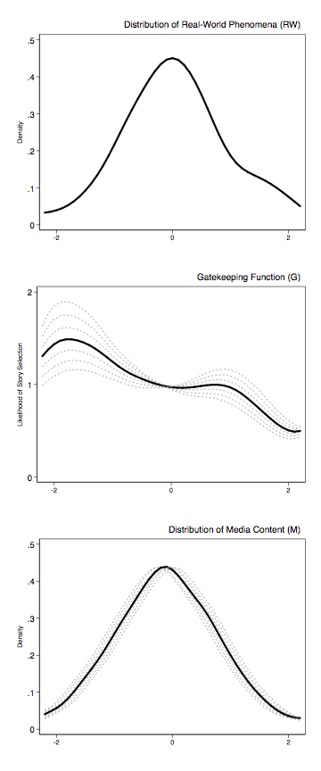
Figure A3. The Gatekeeping Function, Interest Rates
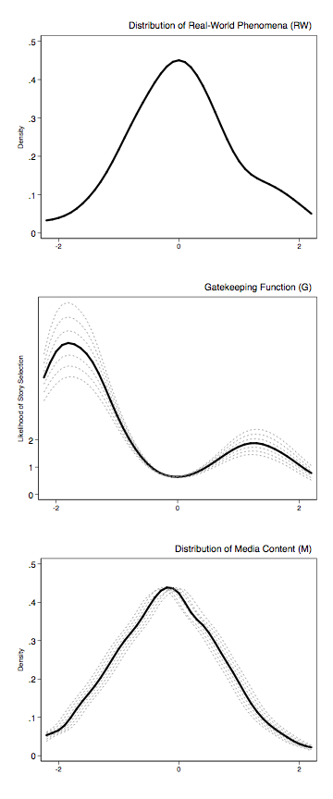
Figure A4. The Gatekeeping Function, Unemployment, Democratic President, New York Times
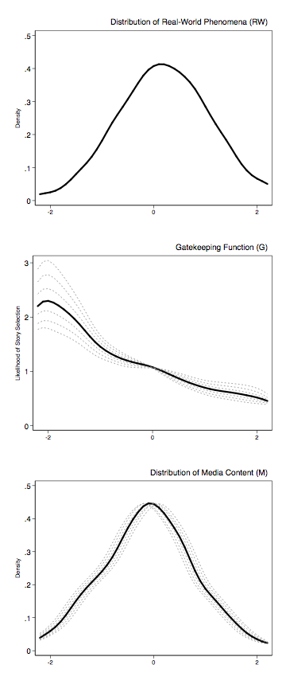
Figure A5. The Gatekeeping Function, Unemployment, Republican Presides, New York Times
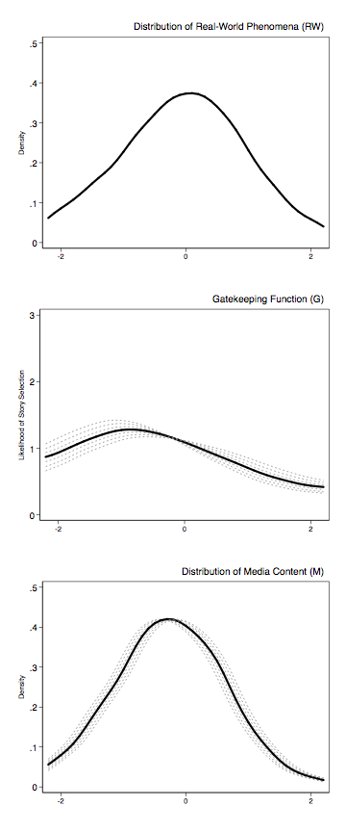
Figure A6. The Gatekeeping Function, Inflation, Democratic President, New York Times
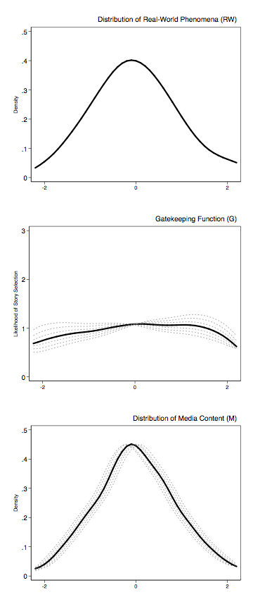
Figure A7. The Gatekeeping Function, Inflation, Republican President, New York Times
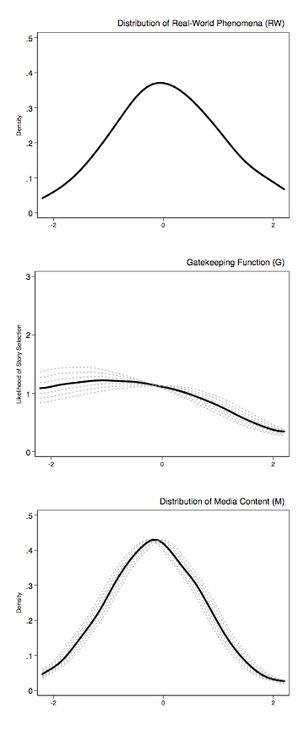
Figure A8. The Gatekeeping Function, Unemployment, Democratic President, Washington Post
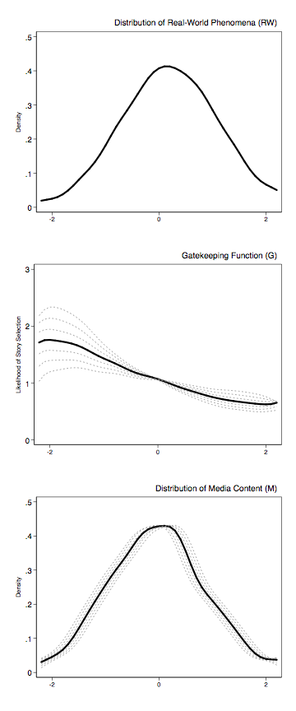
Figure A9. The Gatekeeping Function, Unemployment, Republican President, Washington Post
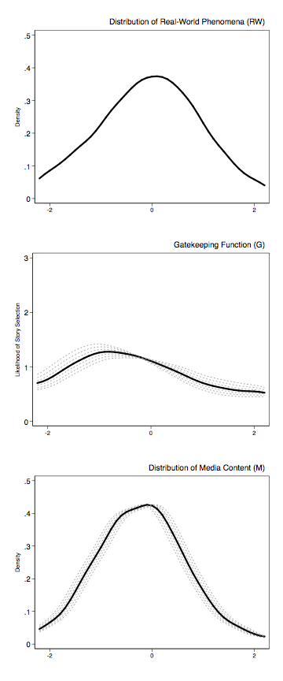
Figure A10. The Gatekeeping Function, Inflation, Democratic President, Washington Post
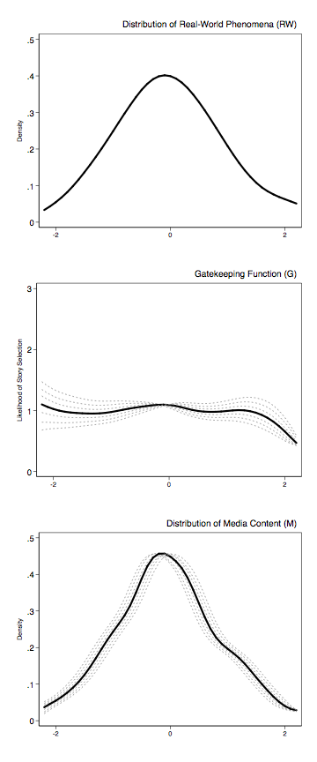
Figure A11. The Gatekeeping Function, Inflation, Republican President, Washington Post
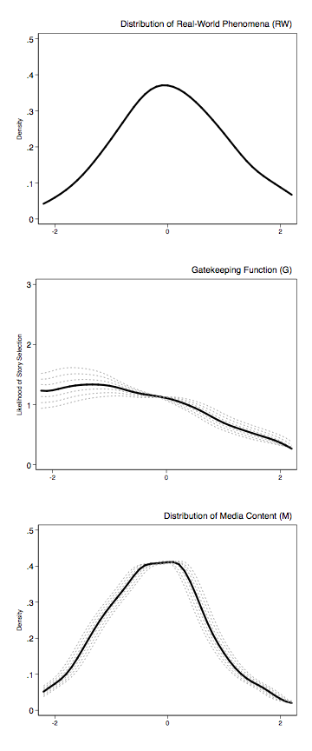

See, e.g., Behr, Roy, and Shanto Iyengar 1985. “Television News, Real-World Cues, and Changes in the Public Agenda.” Public Opinion Quarterly 49: 38–57. Nadeau, Richard, Richard G. Niemi, David P. Fan, and Timothy Amato. 1999. “Elite Economic Forecasts, Economic News, Mass Economic Judgments, and Presidential Approval.” Journal of Politics 61: 109–35; Sanders, D., D. Marsh, and H. Ward. (1993). “The Electoral Impact of Press Coverage of the British Economy, 1979–87.” British Journal of Political Science 23: 175–210.
The same can be done using other macroeconomic indicators, of course, but unemployment is the one most systematically related to the general economic attitudes used here.
Data are publicly available at www.sca.isr.umich.edu/main.php. And note that this is just one question in the survey for which this kind of analysis can be performed. Similar results obtain, for instance, using the standard egotropic question, “We are interested in how people are getting along financially these days. Would you say that you (and your family living there) are better off or worse off financially than you were a year ago?” Results using other questions are available upon request.
As for models in Table 1, unemployment and media content are included at t-1 to account for the fact that the Michigan Survey of Consumers is in the field not just at the beginning, but over the course of any given month. See also note #20.
Note that the coefficients for opinion at t-1 are very close to 1, suggesting a very strong autoregressive process, and indeed the likelihood of a unit root. Estimating the model as an error-correction model, more reliable in the face of integrated time series data, produces very similar results, however. For the sake of simplicity, and comparability with the preceding models of media content, we rely on a basic ADL model here.
In each case, the coefficient for a negative shift is statistically different from zero, while the coefficient for positive shifts is not. That said, as before, based on a two-tailed test the coefficients are not quite statistically different from each other. For unemployment, F=.70, p=.40; for media, F=1.43, p=.23.
E.g, Subasic, Pero, and Alison Huettner. 2001. “Affect Analysis of Text Using Fuzzy Typing.” IEEE Transactions on Fuzzy Systems 9 (4): 483–96. Subasic, Pero, and Alison Huettner. 2001. “Affect Analysis of Text Using Fuzzy Typing.” IEEE Transactions on Fuzzy Systems 9 (4): 483–96.
Automated codes are also shown to be systematically related to the human codes in a simple OLS regression setup. In a model regressing automated tone on human tone, results are: automated tone = .092 (.082) + .565 (.072) * human tone. (Standard errors in parentheses, N=442).
Using one-tailed tests, the t-test and p values are as follows: Negative to Mildly Negative, t=–3.086, p=.001; Mildly Negative to Neutral, t=–1.574, p=.058; Neutral to Mildly Positive, t=–2.384, p=.009 ; Mildly Positive to Positive, t=–1.695, p=.056.

