NAME_CONTRACT_STATUS
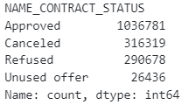
10,753 cases where status is ‘cancelled’ yet AMT_CREDIT > 0.
305,566 cases where status is ‘cancelled’ and AMT_CREDIT == 0.
261,519 cases where status is ‘refused’ yet AMT_CREDIT > 0.
1,552 cases where status is ‘approved’ yet AMT_CREDIT = 0 or NA
NAME_CONTRACT_TYPE
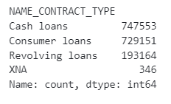
NFLAG_INSURED_ON_APPROVAL
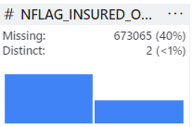
DAYS_FIRST_DRAWING
Nearly 40% missing in all days attribute
