Dominic Lanza

Professor Kyvernitis

CIS 3344

10/30/2020

### 1. Missing Database Driver

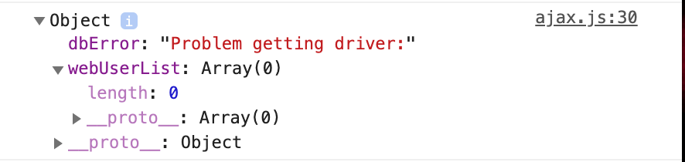

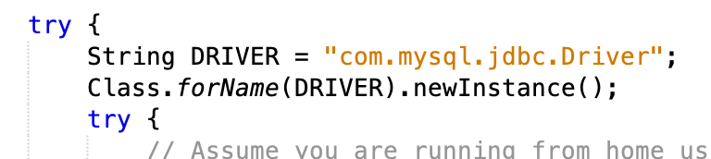

With this statement “String DRIVER = “com.mysql.jdbc.Driver”; defines the database driver. When removed the user will get the error message above.

### 2. Database Unreachable

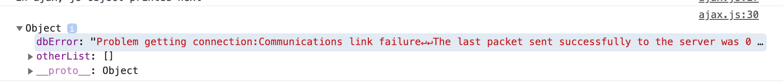

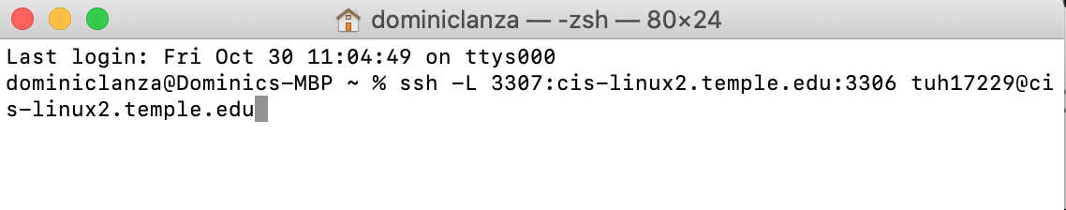

Without the user connecting to their SQL school database, they will encounter a database connection error. The way to combat this error is by connecting through a terminal or putty.

### 3. Database Not Authorized



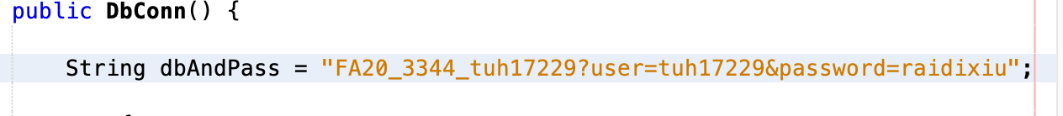

When you remove your username and password in the String dbAndPass input. You will not be authorized to access the database.

### 4. Syntax error in SQL Statement

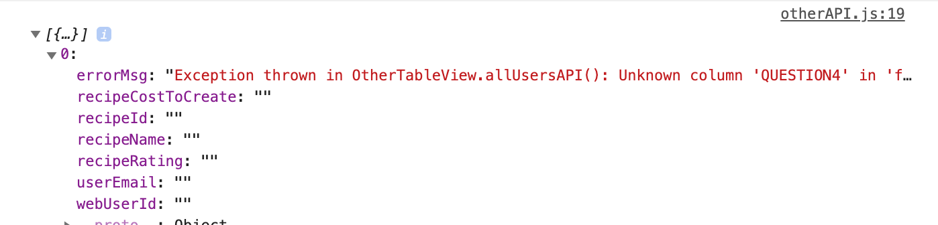



This will be thrown when there is an error in your SQL statement. As you can see above, “QUESTION4” in my SELECT statement is not a defined column. Thus checking your column names in your statement to make sure they are correct are not incorrect will ensure the user not receiving this error.

### 5. Error Extracting Data from Result Set (bad column name)

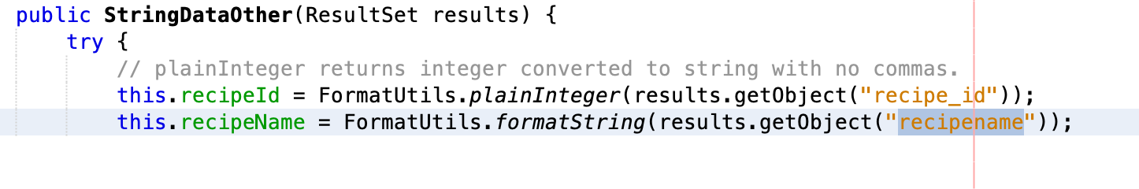

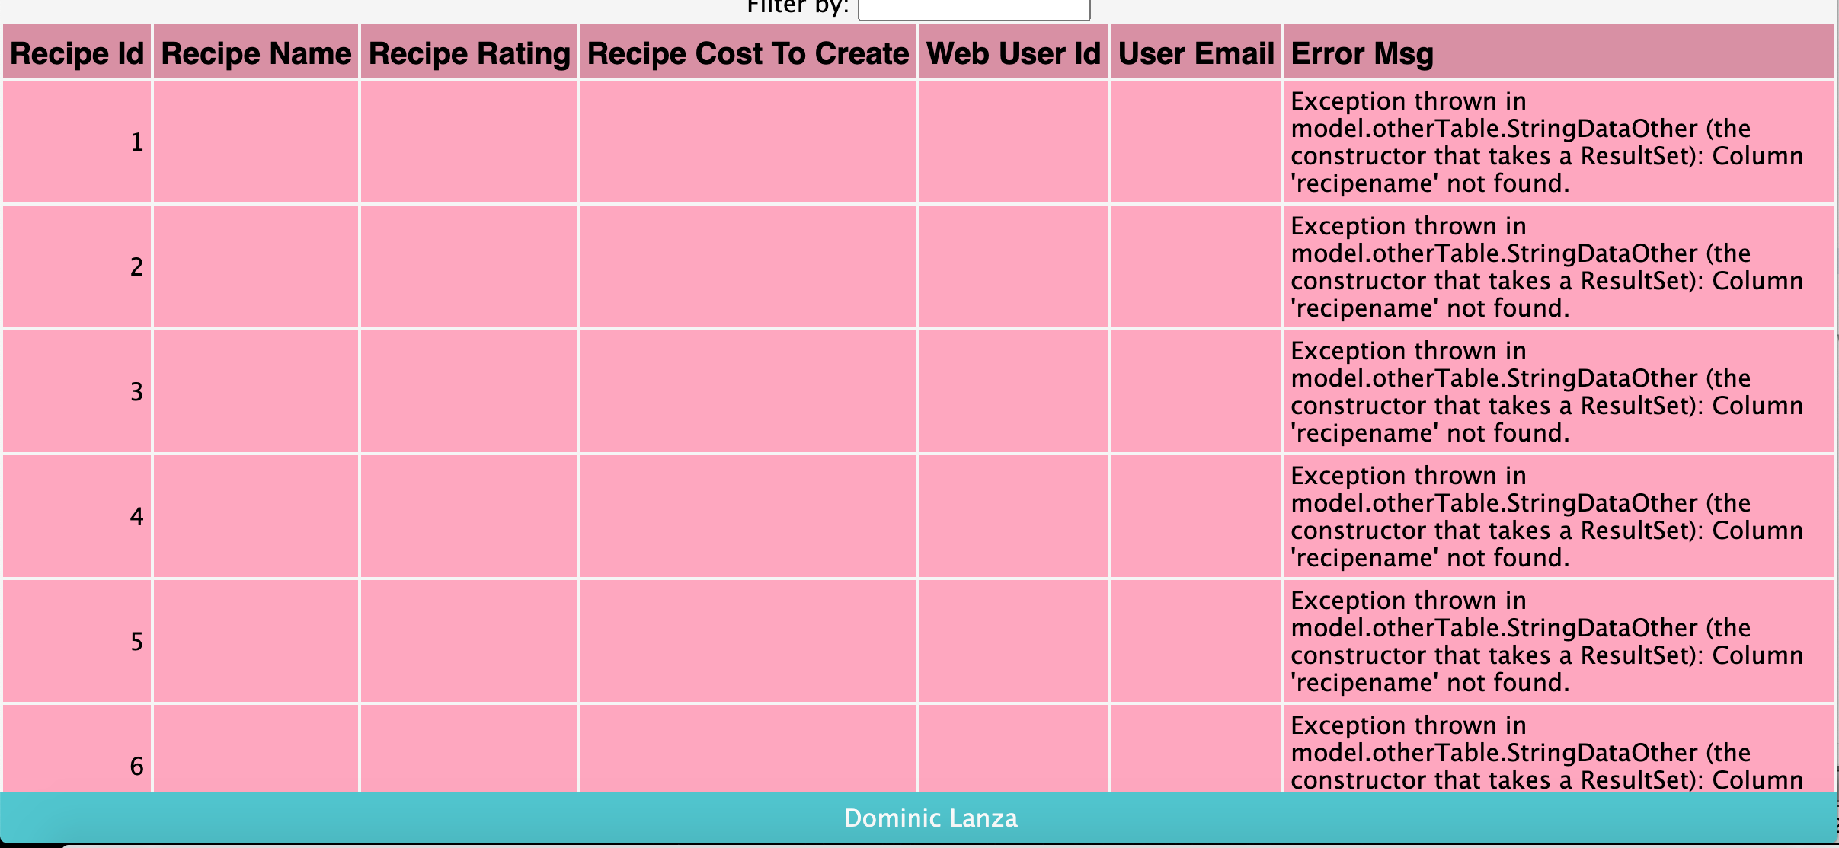

This shows the wrong naming convention in the “this.recipeName” statement. As you can see above the getObject call to recipe name is invalid because there is no column named recipename. The way to fix this error is to correctly write the proper column.

### 6. Error Extracting Data from Result Set (wrong data type)

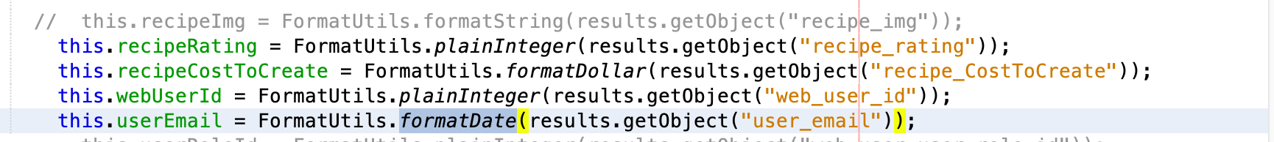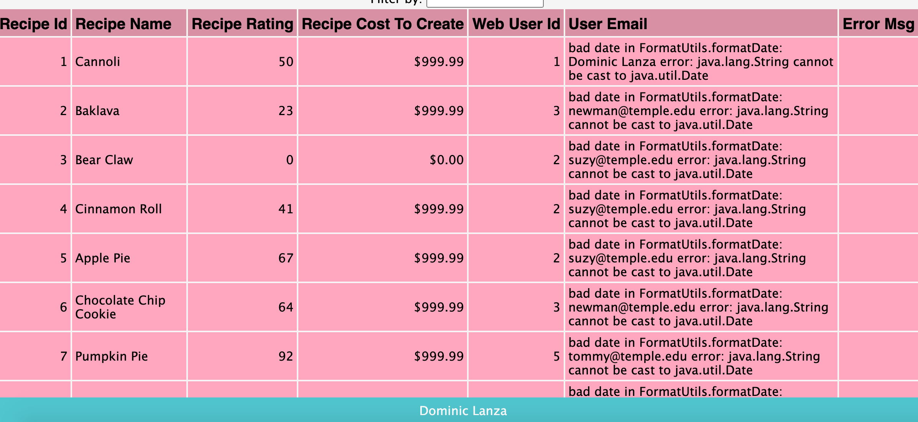

The issue listed above is the wrong data type attempting to extract the email. With that being said the email input cannot be formatted correctly therefore it returns this error message.