**Project Specification Document**

Ericsson - iPerf3

Dominic Marks

Qianwen Yan

Scott Weninger

Weikang Yang

**Table of Contents**

Section Page

Table of Contents

1. Project Vision and Objectives

1.1 Project Scope and Vision

1.2 Project Goals and Objectives

2. Project Planning

2.1 Project Lifecycle

2.2 Project Setup

2.3 Stakeholders

2.4 Project Resources

2.5 Assumptions

2.6 Estimates

3. Project Tracking

3.1 Tracking

3.2 Communication Plan

Regularly Scheduled Meetings

Information To Be Shared Within Our Group

Information To Be Provided To Other Groups

Information Needed From Other Groups

3.3 Deliverables

3.4 Project Metrics

4. Requirements

4.1 Overall Description

4.2 Users and Roles

4.3 Use Case Diagrams

4.4 User Stories (Requirements)

4.5 User Story Acceptance Criteria

4.6 Constraints and Limitations

5. Design

5.1 Introduction

5.2 Scope

5.3 High-Level Component Design

5.4 Activity Diagrams

5.5 Class Diagram

5.6 Sequence Diagram

5.6 Data Architecture

5.7 Alternative Designs and Design Rationale

6. User Interface

6.1 UI Description

6.2 UI Mockup

7. Test Plan

7.1 Test Plan Description

7.2 Testing Tools

7.3 Test Data

7.4 Test Types and Frequency

7.5 Test Coverage

7.6 Test Location

8. Project Closure

8.1 Goals / Vision

8.2 Delivered Solution

8.3 Remaining Work

9. Deliverables

9.1 Study Results

9.2 Requirements and Design Documents

9.3 Code

9.4 Tests and Test Results

9.5 Build Process Documents

9.6 Install Process Documents

9.7 Administrator’s and/or User’s Manual

9.8 Postmortem Document

9.9 Final Report

10. Definitions and Acronyms

**1. Project Vision and Objectives**

**1.1 Project Scope and Vision**

Ericsson is one of the biggest providers of radio infrastructure on all technologies; GSM, WCDMA and LTE. When you are making a call, watching a YouTube clip or accessing the internet from your mobile phone, chances are you are being served by at least some component of Ericsson’s product portfolio. Today, Ericsson provides Radio Access Networks of all kinds to billions of people. iPerf is a tool that sends traffic to another iPerf entity and evaluates network characteristics such as throughput and latency. It is available as open source as well as executable binaries on several platforms. The purpose of this project is to develop an Android app that performs network evaluation with the open source tool iPerf3, and put iPerf3 in a framework that stores results from iPerf measurements together with information fetched from Android environment.

**1.2 Project Goals and Objectives**

|  |  |
| --- | --- |
| **#** | **Goal or Objective** |
| 1 | Develop the application for Android platform. |
| 2 | Make the application available in small increments based on user stories provided by the sponsor. |
| 3 | Make the system easy to support – provide good documentation, configuration/build files, administrator’s manual |
| 4 | Make the system very easy to use – little to no training required |
| 5 | Build and deliver a functional prototype by mid-semester |
| 6 | Have fun working on the project |

**2. Project Planning**

**2.1 Project Lifecycle**

The team will use an agile approach with a focus on getting a working prototype of Android Application which based on the network measurement tools - iPerf3 with a simple UI. The prototype should be finished and demonstrate to our sponsors and classmate by midterm. After the first demonstration, our team will focus on functions have less priority such as Ping and FTP connection functions.

**2.2 Project Setup**

|  |  |
| --- | --- |
| **#** | **Decision Description** |
| 1 | Android Studio will be the IDE |
| 2 | Access to the Swedish server through coneye.myqnapcloud.com. |
| 3 | Access to the Iperf3 server through port 5201 which is the standard port for iperf3. |
| 4 | Code will be stored and maintained at <https://github.com/dommarks/Iperf3ericsson> |
|  |  |

**2.3 Stakeholders**

|  |  |
| --- | --- |
| **Stakeholder** | **Role** |
| Ericsson | Company that will use the final product for bandwidth testing |
| Oskar Myrberg | Mentor |
| Anders Olsson D | Mentor |
| Dean Knudson | Instructor |
| Dominic Marks | Team member |
| Qianwen Yan | Team member |
| Scott Weninger | Team member |
| Weikang Yang | Team member |

**2.4 Project Resources**

|  |  |
| --- | --- |
| **Resource** | **Resource Description** |
| iPerf Server | Server used to capture data to measure bandwidth |
| Capstone Team | Our team of students who will be the primary developers of the project. |
| Oskar Myrberg/Anders Olsson | Our mentors |
| Android Studio | The IDE we will use to develop the app |
| MS Project | Used for the project planning document |
|  |  |
|  |  |
|  |  |

**2.5 Assumptions**

|  |  |
| --- | --- |
| **#** | **Assumption** |
| A1 | Team will have sufficient time to complete tasks each week |
| A2 | The team will have heavy support from our mentors to guide us as the project progresses |
| A3 | Java will be the programming language used |
|  |  |

**3. Project Tracking**

**3.1 Tracking**

|  |  |  |
| --- | --- | --- |
| **Information** | **Description** | **Link** |
| Bug Tracking | Bug tracking will be done with Trac. | https://csprojects.cs.ndsu.nodak.edu/csci445/2015/spring/csci445s15ericsson/trac |
| Weekly Report | The report produced weekly | https://github.com/dommarks/Iperf3ericsson |

**3.2 Communication Plan**

**Regularly Scheduled Meetings**

|  |  |  |
| --- | --- | --- |
| **Meeting Type** | **Frequency/Schedule** | **Who Attends** |
| Meeting With Mentor | Weekly, Monday 8:00am | Project team and mentor |
| Team Meeting | Weekly | Project team |
| Short Meeting | Weekly in class | Project team |
| Sprint Planning Meeting | Start of each sprint | Project team and mentor |
| Sprint Retrospective Meeting | End of each sprint | Project team |

**Information To Be Shared Within Our Group**

|  |  |  |  |
| --- | --- | --- | --- |
| **Who?** | **What Information?** | **When?** | **How?** |
| Project team | Task assignments | Weekly | Team meetings, listing in MS Project file. |
| Project team | idea collaboration | Multiple times per week | meetings/ email/ phone |
| Project team | Any decision that is made regarding the project | Whenever they occur | meetings/email/phone |

**Information Needed From Other Groups**

|  |  |  |  |
| --- | --- | --- | --- |
| **Who?** | **What Information?** | **When?** | **How?** |
| Mentor | Requirement changes | Whenever change is made | Conference call or meeting with mentor. |
| Mentor | Feedback on progress | End of each week | Meeting/email |

**3.3 Deliverables**

|  |  |  |  |
| --- | --- | --- | --- |
|  | **Deliverable** | **Delivery Time** | |
| **Interim** | **Final** |
| 1 | Prototype Code/demo and Design | X | X |
| 2 | Build/Configuration Files | X | X |
| 3 | Regression Tests | ▢ | X |
| 4 | Project Documentation | ▢ | X |
| 5 | Requirements Document | X | X |

**3.4 Project Metrics**

|  |  |  |
| --- | --- | --- |
| **Metric** | **Frequency** | **Location** |
| Estimated User Story Points | Per User Story at the start of each sprint | MS Project Plan |
| Estimated User Story Points | Per Sprint at the start of each sprint | MS Project Plan |
| Actual User Story Points | Per Sprint at the end of each sprint | MS Project Plan |
| Estimated Effort | Per task | MS Project Plan |
| Actual Effort | At end of each task | MS Project Plan |
| Maintenance Effort | As occurring | MS Project Plan |
| Estimated Size | Per task requiring code | MS Project Plan |
| Actual Size | At completion of task requiring code | MS Project Plan |

**4.  Requirements**

**4.1   Overall Description**

Ericsson is one of the biggest providers of radio infrastructure on all technologies; GSM, WCDMA and LTE. When you are making a call, watching a YouTube clip or accessing the internet from your mobile phone, chances are you are being served by at least some component of Ericsson’s product portfolio. Today, Ericsson provides Radio Access Networks of all kinds to billions of people. iPerf is a tool that sends traffic to another iPerf entity and evaluates network characteristics such as throughput and latency. It is available as open source as well as executable binaries on several platforms.

The purpose of this project is to develop an Android app that performs network evaluation with the open source tool iPerf3, and put iPerf3 in a framework that stores results from iPerf measurements together with information fetched from Android environment. Meanwhile, the team will provide a clear UI design which user can understand easily and access to it to test the network

characteristics.

**4.2   Users and Roles**

|  |  |
| --- | --- |
| **User** | **Description** |
| User | A regular user who is the primary operator of the system. |
| Admin | A user who also has the ability to make any changes of the system. |
|  |  |

**4.3   Use Case Diagrams**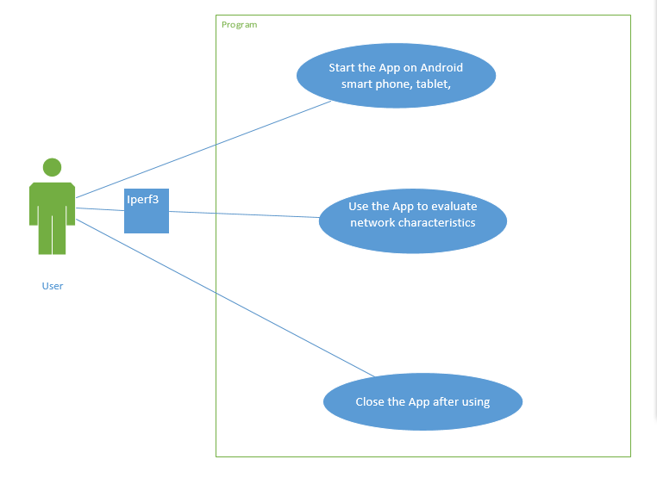

**4.4   User Stories (Requirements)**

**User Story Points Benchmark --** All team members agree that creating a clear UI for use in this system would be worth 5 points. All team members have had previous experience designing UI for their other class.

|  |  |  |  |  |
| --- | --- | --- | --- | --- |
| **ID** | **Added** | **Description** | **Status** | **Story**  **Points** |
| 100 | Sprint2 | As a user, I want the IPerf3 conversation should be able to gather bandwidth strength. | **C** | **8** |
| 200 | Sprint2 | As a user, I want the App to be able to run on an Android phone. | **C** | **3** |
| 300 | Sprint2 | As a user, I want a clear UI to use while running the App. | **C** | **5** |
| 400 | Sprint3 | As a user I want to be able to view data in real time | **T** | **45** |
| 500 | Sprint3 | As a user I want to be able to have my information reported to a database each time I use the app. | **C** | **45** |
| 600 | Sprint 3 | As a user, I want the App to display a graph of the information being gathered and calculated. | **C** | **13** |
| 700 | Sprint 4 | As a user, I want to be able to send the project through FTP to other users. | **C** | **21** |

**4.5 User Story Acceptance Criteria**

|  |  |  |
| --- | --- | --- |
| **ID** | **Description** | **Verification** |
| 201 | We shall write code in Java in order to be compatible with Android environment. | The App should be able to run on an Android device successfully. |
| 202 | A user can not run multiply iperf tests in the same time | The App will test to see if there are multiple iperf commands running in the same time |

|  |  |  |
| --- | --- | --- |
| 310 | A user can easily understand the UI design. | The UI should be designed as simple as possible. |
| 510 | All the information should be stored in database. | The information stored in database can be used for future retrieval. |
|  |  |  |

**4.6 Constraints and Limitations**

|  |  |
| --- | --- |
| **Constraint** | **ID** |
| Team shall not provide alternative language pack files. | n/a |
| The running system is not required to be compatible with Windows or Mac OSs. | 200 |
| The mentors can’t be contacted in person because of the company location. | n/a |

**5. Design**

**5.1 Introduction**

This section of the design document will show what our plans are for the diagrams we may include as well as some high-level design components. We are looking to have informative desgin diagrams.

**5.2 Scope**

This design document will serve to outline a very high level design. This document will not include a thorough description of all of the lower level modules

**5.3 High-Level Component Design**

|  |  |
| --- | --- |
| **Component** | **Description** |
| Start Button | This will be a button that allows the user to start a test. |
| GUI | This will allow the user to have a nice, clean display of available options or features. |
| Test Function | Run the neessary tests to check the codes. |
|  |  |

|  |  |
| --- | --- |
| **Component** | **Related Requirements** |
| Start Button | 200 |
| GUI | 300 |
| Test Function | 100 200 500 600 |
|  |  |
|  |  |

**5.4 Activity Diagrams**

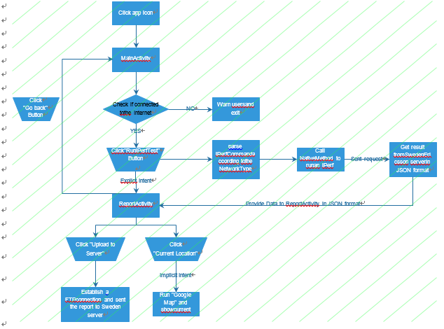

|  |  |
| --- | --- |
|  |  |
|  |  |

**5.5 Class Diagram**

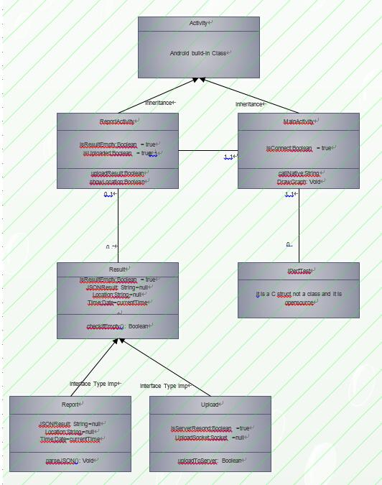

**5.6 Sequence Diagram**

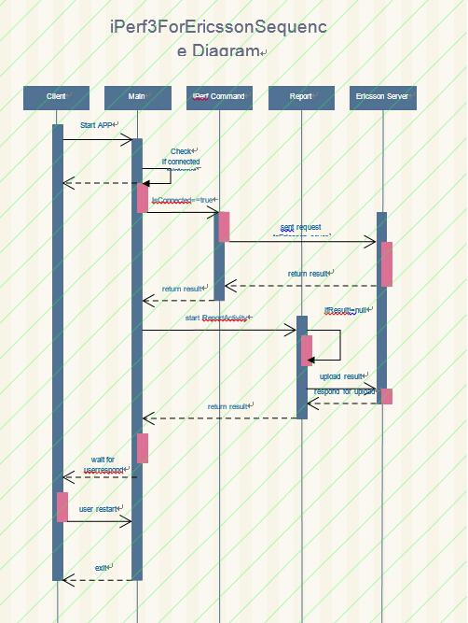

**5.6 Data Architecture**

Data that needs to be stored in database for future retrieval.

**5.7 Alternative Designs and Design Rationale**

N/A