A Mini project on

Women Safe Routes Guidance System
submitted in partial fulfillment for award of the degree of Bachelor of Technology in
Information Technology By

Poreddy Laxmi Sree 23321A1240
Dommeti Laxmi Prasanna 23321A1241
M Pooja 23321A1261

Under the Esteemed Guidance of Internal Guide
T Sudha Rani
Associate Professor, Information Technology



Bhoj Reddy Engineering College for Women
Department of Information Technology
(Sponsored by Sangam Laxmibai Vidyapeet, Accredited by NAAC with A Grade, Approved by AICTE and Affiliated to JNTUH) Vinaynagar, IS Sadan Crossroads, Saidabad, Hyderabad – 500 059, Telangana. www.brecw.ac.in
Ph: +91 -40-2453 7282; Email: principal@brecw.ac.in

AY 2025–26


Bhoj Reddy Engineering College for Women
Department of Information Technology
(Sponsored by Sangam Laxmibai Vidyapeet, Accredited by NAAC with A Grade, Approved by AICTE and Affiliated to JNTUH)
Recognized by UGC under section 2(f) of the UGC Act,1956
Vinaynagar, IS Sadan Crossroads, Saidabad, Hyderabad – 500 059, Telangana. www.brecw.ac.in

Ref No: BRECW/IT Dept/Project 2025-26/MP-B-03 Date: 09-06-2025

CERTIFICATE

This is to certify that the Mini Project entitled “Women Safe Routes Guidance System” is a bonafide work carried out by

Poreddy Laxmi Sree 23321A1240
Dommeti Laxmi Prasanna 23321A1241
M Pooja 23321A1261

In partial fulfillment for award of the degree of Bachelor of Technology in Department of Information Technology from Bhoj Reddy Engineering College for Women, Hyderabad affiliated to Jawaharlal Nehru Technological University Hyderabad (JNTUH).

T Sudha Rani Dr M Sandhya Rani External Examiner Internal Guide Head of the Department

Sangam Laxmibai Vidyapeet is an educational society for promotion of education among girls and women.
It is established in 1952 and registered under the Telangana Societies Registration Act.

ACKNOWLEDGEMENT
It is our pleasure to express our whole hearted thanks to our internal guide T Sudha Rani , Associate Professor, Department of Information Technology , for her extreme guidance and support in completing this project successfully.
We are thankful to our project coordinator Minhaj Begum, Associate Professor, Department of Information Technology, for her dynamic valuable guidance and constant management.
We express thanks and gratitude to Dr M Sandhya Rani, Professor & Head of the Department, Information Technology, for his encouragement and guidance in carrying out the major project presentation.
We would also like to thank Dr G Shyama Chandra Prasad, Professor & Principal of Bhoj Reddy Engineering College for Women for encouragement in carrying out our mini project successfully. We are also thankful to the staff members of Information Technology department, my friends and to our parents who helped us in completing this project successfully.

By
Poreddy Laxmi Sree (23321A1241)
Dommeti Laxmi Prasanna (23321A1240)
M pooja (23321A1261)

Index

Contents | Page No
List of Figures/Screenshots | i
Abstract | ii
1. Introduction | 1-4
1.1 Purpose of the Project | 2
1.2 Existing System | 3
1.3 Proposed System | 3
1.4 Advantages of Proposed System | 4
2. Related Work | 5-6
2.1 Survey | 6
3. Requirement Analysis | 7-10
3.1 Functional Requirements | 8
3.2 Non Functional Requirements | 8-9
3.3 Computational Requirements | 10
3.3.1 Software Requirements | 10
3.3.2 Hardware Requirements | 10
4. Design | 11-20
4.1 Architecture | 12-14
4.1.1 System Architecture | 12-13
4.1.2 Technical Architecture | 13-14
4.2 UML Diagrams | 15-18
4.2.1 Use Case Diagram | 15
4.2.2 Class Diagram | 16
4.2.3 Sequence Diagram | 17
4.2.4 Activity Diagram | 18
4.3 Modules | 19
5. Implementation | 20-24
5.1 Pseudo Code | 21-24

6. Screenshots | 25-29
7. Test Cases | 30-31
8. Conclusion | 32-33
- Future Scope | 34-35
- References | 36-37

List of Figures

S. No | Figure Name | Fig. No | Page No
1 | System Architecture | 4.1.1.1 | 13
2 | Technical Architecture | 4.1.2.1 | 14
3 | Use case | 4.2.1.1 | 15
4 | Class diagram | 4.2.2.1 | 16
5 | Sequence diagram | 4.2.3.1 | 17
6 | Activity diagram | 4.2.4.1 | 18
7 | Screenshots | 6.1-6.8 | 25-29

Abstract
In modern navigation systems, most applications focus on providing the shortest or fastest route without considering user safety. This can expose users to unsafe areas such as poorly lit roads or high-crime zones. The Women Safe Routes Guidance System Application is designed to overcome this limitation by providing the safest route between a source and destination. The system uses location-based services, real-time data, and artificial intelligence to analyze multiple routes. It considers factors such as crime rate, traffic conditions, and road safety to assign a safety score to each route. Based on this analysis, the application recommends the safest path along with alternative routes. Additionally, it includes an audio recording feature during travel to collect potential evidence in case of emergencies The application provides a user-friendly interface where users can enter their travel details and receive safe navigation guidance. It is especially useful for women, students, and travelers during night journeys or in unfamiliar locations. The Women Safe Routes Guidance System aims to enhance women’s safety, provide confidence during travel, and minimize exposure to high-risk areas through intelligent route planning and real-time assistance.
Keywords: Women Safety, Safe Routes, Smart Navigation, Crime Data, GPS, Safety Score, Real-Time Tracking, Route Planning, Audio Recording.

ii

1.Introduction

1.Introduction
Women Safe Routes Guidance System Introduction

In today’s world, transportation and navigation have become an essential part of daily life. People rely heavily on navigation applications to travel from one place to another. However, most existing navigation systems focus mainly on providing the shortest or fastest route, without considering the safety of the user. This creates a major issue, especially for women, students, and individuals traveling at night or in unfamiliar areas.
The Safe Route Application is designed to address this problem by providing routes that are not only efficient but also safe. The main aim of this system is to help users choose routes that minimize risks by avoiding unsafe locations such as high-crime areas, poorly lit roads, and isolated paths. The application uses modern technologies such as GPS, real-time data analysis, and artificial intelligence to evaluate and recommend the safest routes.
This application plays a vital role in improving personal safety and building confidence among users while traveling. By focusing on safety rather than just speed or distance, the Women Safe Route Guidance System Application contributes to creating a more secure and reliable navigation experience.

1.1 Purpose of the Project:
The main purpose of the Women Safe Route Guidance System is to improve personal safety during travel by providing users with the safest route instead of just the shortest or fastest one. The project aims to reduce the risk of encountering unsafe areas such as high-crime zones, poorly lit streets, or isolated locations. It is designed to use advanced technologies like machine learning, real-time data analysis, and location-based services to evaluate and compare different routes based on safety factors. By assigning safety scores and suggesting secure paths, the system helps users make informed travel decisions. Additionally, the project aims to enhance confidence and independence, especially for women, students, and travellers, by offering features like real-time navigation and emergency audio recording for evidence collection. Overall, the goal is to create a smart, reliable, and user-friendly navigation system that prioritizes safety and minimizes exposure to potential risks during travel.
Department of IT, BRECW Page 2

Women Safe Route Guidance System Introduction
1.2 Existing System:
The existing navigation systems such as Google Maps are widely used for daily travel and route planning. These applications primarily focus on providing the shortest or fastest path between a source and destination by using GPS technology and real-time traffic updates. While they are highly efficient in reducing travel time and fuel consumption, they do not take user safety into account when suggesting routes. Important safety factors such as crime-prone areas, poorly lit streets, deserted roads, and unsafe neighborhoods are not considered in their route calculation. As a result, users, especially women, students, and travellers, may unknowingly pass through high-risk zones, particularly during night travel or in unfamiliar locations. Moreover, existing systems lack advanced safety features such as route safety scoring, risk assessment based on historical crime data, and intelligent decision-making using machine learning. They also do not provide emergency support functionalities like automatic audio recording, alert systems, or evidence collection during travel. The absence of these features makes current navigation systems less reliable in terms of personal security. Therefore, despite their efficiency in navigation, existing systems fail to address the critical aspect of user safety, creating a need for a smarter and safer route guidance system that prioritizes security along with convenience.

1.3 Proposed System:
The proposed system is a Women Safe Route Guidance System that helps users travel safely by suggesting the safest route instead of just the shortest one. Unlike apps like Google Maps, this system considers safety factors such as crime rate, traffic, street lighting, and crowded areas.
It analyzes different routes using machine learning and gives each route a safety score. Based on this, it recommends the safest path and also shows alternative routes. The system uses GPS to guide users in real time while traveling.
Additionally, it includes an audio recording feature during travel for safety and evidence in case of emergencies. The application is easy to use and is especially helpful for women, students, and travellers, particularly during night time or in unknown places.

Department of IT, BRECW Page 3

Women Safe Route Guidance System Introduction
1.4 Advantages of Proposed System:
- Enhances user safety by avoiding unsafe areas
- Offers real-time GPS navigation
- Easy to use and user-friendly interface
- Helpful for women, students, and travelers
- Increases confidence during travel
- Reduces risk of entering high-crime zones

Department of IT,BRECW Page 4

Department of IT, BRECW Page

2. Related Work

Women Safe Route Guidance System Related Work
Department of IT, BRECW Page 6

2. Related Work

2.1 Survey:

The survey focuses on analyzing existing research and technologies related to route navigation systems and safety-based routing. Traditional navigation systems are mainly designed to provide the shortest or fastest route using algorithms such as Dijkstra. However, these systems do not consider safety as a primary factor, which can lead users through unsafe or high-risk areas.
Recent research highlights the importance of integrating safety into route planning systems. Studies show that the fastest route is not always the safest, as it may increase the risk of accidents or exposure to unsafe environments.
Several research works have explored safe route-finding techniques by incorporating factors such as traffic accidents, crime data, and environmental conditions. These systems use data-driven approaches to evaluate routes based on safety metrics rather than just distance or time. However, measuring safety accurately remains a major challenge due to variations in data sources and lack of real-time information.
Advanced approaches such as Artificial Intelligence and Machine Learning have been introduced to improve safe navigation. For example, some models use reinforcement learning to identify routes that avoid crime-prone areas while maintaining efficiency. These methods show that combining safety and route optimization is possible but requires large amounts of real-time data and continuous learning. Additionally, research in smart transportation systems emphasizes the use of IoT, mobile crowd sensing, and real-time data collection to enhance route safety. These technologies allow systems to analyze dynamic conditions such as traffic congestion, weather, and accidents to provide safer route recommendations. Despite these advancements, existing systems still face limitations such as lack of accurate safety data, difficulty in balancing safety and travel time, and limited real-world implementation. Therefore, there is a need for a system that effectively integrates safety parameters into navigation to provide reliable and user-friendly safe routing solutions.

Stylish U
Department of IT, BRECW Page 6

3. Requirement Analysis

- Requirement Analysis
Women Safe Route Guidance System Requirement Analysis
Department of IT, BRECW Page 8

3.1 Functional Requirements:
The Women Safe Route Guidance System is a smart navigation platform designed to provide safer travel routes by analyzing safety-related data such as crime rates, traffic conditions, and environmental factors. The system is intended for users such as women, students, and travelers who require secure navigation, especially during night-time or in unfamiliar locations. It also includes real-time GPS tracking and emergency support features to enhance user safety. The system ensures a simple and user-friendly interface where users can easily enter their travel details and receive guidance.
• User Registration and Login
• Source and Destination Input
• Route Analysis and Safety Score Calculation
• Alternative Route Suggestions
• Real-Time GPS Navigation
• Emergency Support Features
• Display of Route and Safety Information

  - Non-Functional Requirements:
The Women Safe Route Guidance System is designed to be reliable, secure, and efficient, ensuring a smooth and safe user experience. The application must provide a simple and easy-to-use interface so that users can quickly access navigation features without confusion. It should process data efficiently to deliver real-time route suggestions and updates without delays. The system must ensure data privacy and security, especially for user location and recorded information.
• Performance
• Security
• Scalability
• Usability
• Reliability
• Availability

3.2.1.Performance: The system must provide fast and responsive performance, ensuring that route analysis, safety score calculation, and navigation updates are processed in real time without delays. GPS tracking and route recommendations should update instantly based on changing conditions such as traffic or safety alerts. Map loading, route visualization, and transitions between screens must be smooth to ensure a seamless user experience during travel.
Women Safe Route Guidance System Requirement Analysis
Department of IT, BRECW Page 9

3.2.2.Security: The system must ensure strong protection of user data, including location details, travel history, and recorded audio files. Secure authentication mechanisms should be implemented to prevent unauthorized access. All data must be transmitted using secure protocols (such as HTTPS), and sensitive features like audio recording and location tracking must be protected with proper permissions and encryption to maintain user privacy.
3.2.3.Scalability:The system must be capable of handling an increasing number of users, routes, and data sources such as crime records and real-time traffic information. As usage grows, the system should maintain consistent performance without requiring major redesign. The architecture should support expansion to multiple cities or regions and allow integration of additional safety factors in the future.
3.2.4.Usability: The application must be simple, intuitive, and easy to use for all users, including those with minimal technical knowledge. Features such as entering source and destination, viewing safe routes, and starting navigation should be clear and require minimal steps. The interface should be consistent, visually clear, and accessible across different devices like smartphones and tablets.
3.2.5.Reliability: The system must operate consistently under normal and heavy usage conditions, ensuring accurate route suggestions and uninterrupted navigation. It should minimize errors, crashes, or data loss, especially during critical operations like route guidance and emergency recording. In case of any failure, the system should handle it gracefully and provide clear notifications to the user.
3.2.6. Availability: The application must be available 24/7 to provide continuous support for users during travel at any time of the day. Essential features such as route guidance, GPS tracking, and safety alerts must always remain functional. System maintenance should be minimal and scheduled during low-usage periods to avoid disruption of services.
Women Safe Route Guidance System Requirement Analysis
3.3 Computational Resource
3.3.1 Software Requirements:
- Front-end : React.js , Flutter
• Back-end : Node.js
• Database : Supabase
• Development Tool : Visual Studio Code

3.3.2 Hardware Requirements:
- Processor : i5 or above
- RAM : 8 GB or more
- Hard Disk : 20 GB or more
Department of IT, BRECW Page 10

Title
Department of IT, BRECW Page 10

4. Design

Women Safe Route Guidance System Design
4. Design

4.1 Architecture:
4.1.1 System Architecture:
System Architecture describes the overall structure and functioning of the Women Safe Route Guidance System, defining how different components of the system interact to provide safe and efficient navigation services. It represents the flow of the application in a structured and pictorial form, showing how user inputs are processed and transformed into safe route recommendations. The main purpose of system architecture is to provide a complete solution that is logically organized and aligned with the system requirements, ensuring safety, reliability, and real-time performance. The system architecture of this application is designed based on a layered approach, which includes components such as the mobile application, location services, map APIs, database, and emergency support system. The mobile application acts as the primary interface where users perform actions such as registration, login, entering source and destination, and receiving navigation guidance. These inputs are processed through the system to generate meaningful outputs in the form of safe routes.
The architecture is conceptual and focuses on high-level system behavior, including how data flows between components and how different modules interact with each other. It includes functional elements such as route safety analysis, real-time location tracking, and emergency alert services. The system evaluates multiple routes using safety parameters like crime data, traffic conditions, and environmental factors, ensuring that users are guided through safer paths rather than just the shortest ones.
System architecture also emphasizes relationships between system elements such as the interaction between the mobile device, external services like map APIs, and backend databases. It incorporates behavioral aspects like real-time updates, continuous tracking, and emergency notifications. The integration of these components ensures that the system responds dynamically to changing conditions during travel. The architecture supports key lifecycle concepts such as scalability, maintainability, and adaptability. It can be extended to support additional safety features, new data sources, or deployment in different geographical locations. It also ensures that the system remains reliable and available under different usage conditions. Overall, the system architecture provides a clear and organized framework for developing and implementing the application, ensuring that all components function together effectively to deliver intelligent, real-time, and safe navigation services.
Department of IT, BRECW Page 12

Women Safe Route Guidance System Design

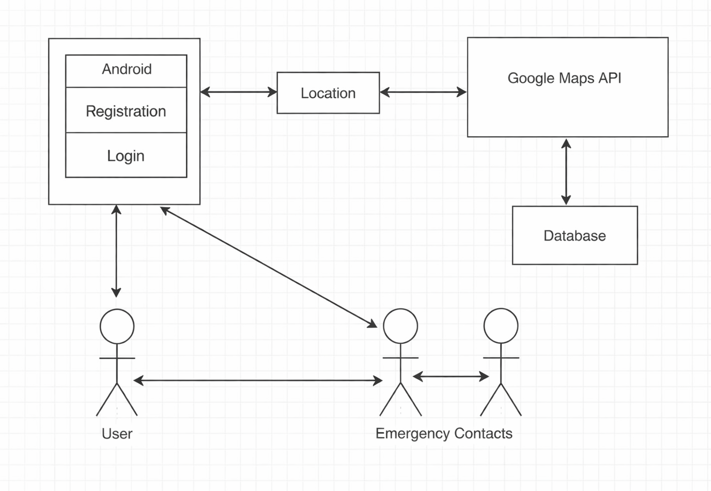
Fig. 4.1.1.1 System Architecture
4.1.2 Technical Architecture:
Technical Architecture refers to the structured design and organization of the system components required to develop and operate the Women Safe Route Guidance System. It focuses on how different software and hardware components interact with each other to provide safe, reliable, and real-time navigation services to users. The technical architecture integrates application components such as route analysis, safety scoring, and emergency services with technological components like GPS sensors, mobile devices, and external APIs.
The architecture of this system follows a layered approach, which includes the mobile layer, API gateway, application layer, data layer, and integration layer. Each layer has a specific role in ensuring smooth communication, efficient processing, and secure data handling. The mobile layer provides the user interface where users input their travel details and receive navigation guidance. The API gateway acts as a bridge between the frontend and backend, managing requests and ensuring secure data transfer.
The application layer contains the core functionalities of the system, including authentication
Department of IT,BRECW Page 13
services, route safety engine, movement tracking, and SOS alert services. These components work together to analyze multiple routes using machine learning algorithms and assign safety scores based on factors such as crime data, traffic conditions, and environmental safety. The data layer stores essential information such as user data, crime records, and route history, which are used for analysis and decision-making.
Women Safe Route Guidance System Design
The integration layer connects the system with external services such as map APIs and GPS sensors, enabling real-time location tracking and accurate route mapping. These components are usually acquired from external providers and integrated into the system to enhance its functionality. A technical architecture diagram provides a high-level overview of how all these components interact within the system. It illustrates the flow of data from user input to route analysis and finally to safe route recommendation. The architecture ensures that the system meets important requirements such as performance, scalability, security, and reliability.

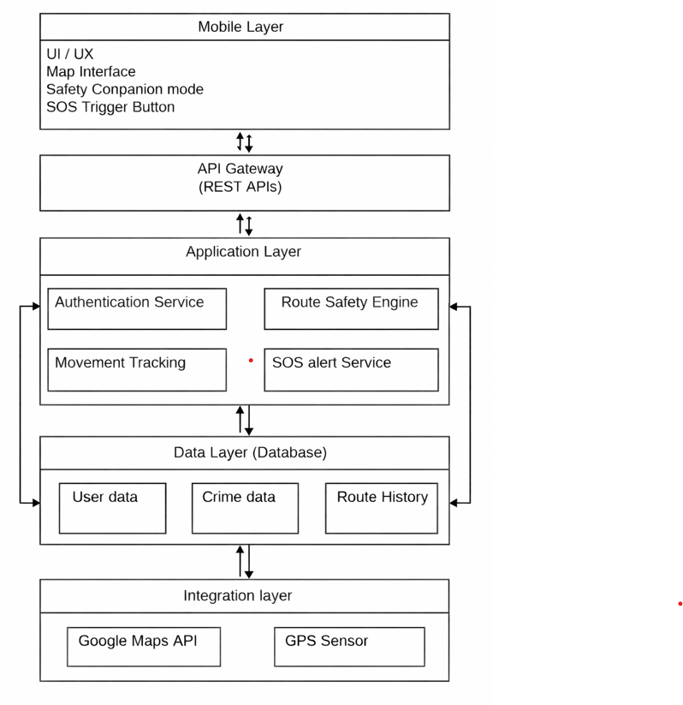
Fig. 4.1.2.1 Technical Architecture
Department of IT, BRECW Page 14

Women Safe Route Guidance System Design
Department of IT, BRECW Page 15

4.2 UML Diagrams

4.2.1 Use Case diagram
A use case diagram is a diagram that shows a set of use cases and actors and their relationships.
4.2.1.1 Common Properties
A use case diagram is just a special kind of diagram and shares the same common properties as do all other diagrams - a name and graphical contents that are a projection into a model. What distinguishes a use case diagram from all other kinds of diagrams is its content.
4.2.1.2 Contents
Use case diagrams commonly contain
• Use cases
• Actors
• Dependency, generalization, and association relationships
4.2.1.3 Common Uses
The use case diagrams are used to model the static use case view of a system. This view primarily
supports the behavior of a system - the outwardly visible services that the system provides in the context of its environment.
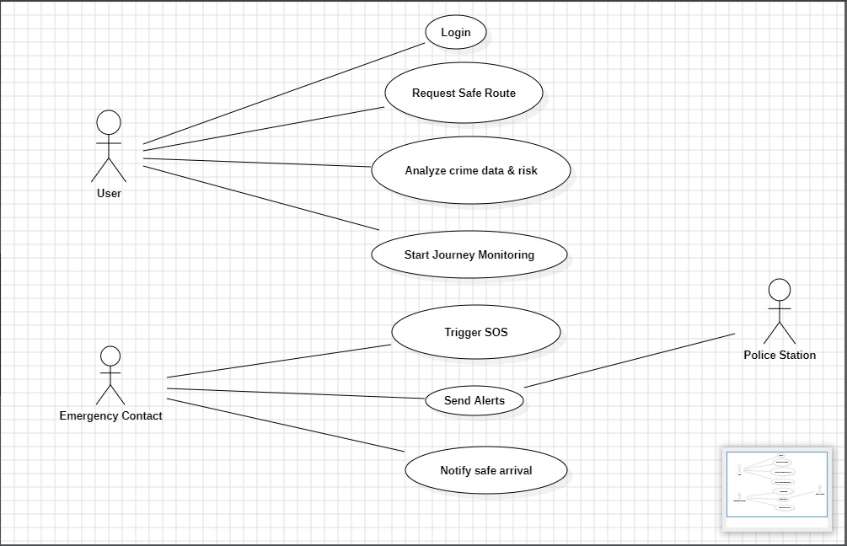
Fig. 4.2.1.1 Use case diagram

Women Safe Route Guidance System Design
Department of IT, BRECW Page 16

4.2.2 Class Diagram:
A class diagram is a diagram that shows a set of classes, interfaces, and collaborations and their
relationships.
Class diagram commonly contain the following things:
- Classes
- Interfaces
- Collaborations
- Dependency, generalization and association relationships
4.2.2.1 Common Uses:
Class diagrams are used to model the static design view of a system.
While modelling the static design view of a system, class diagrams are used in one of the three
ways:
- To model the vocabulary of a system
- To model simple collaborations
- To model a logical database schema
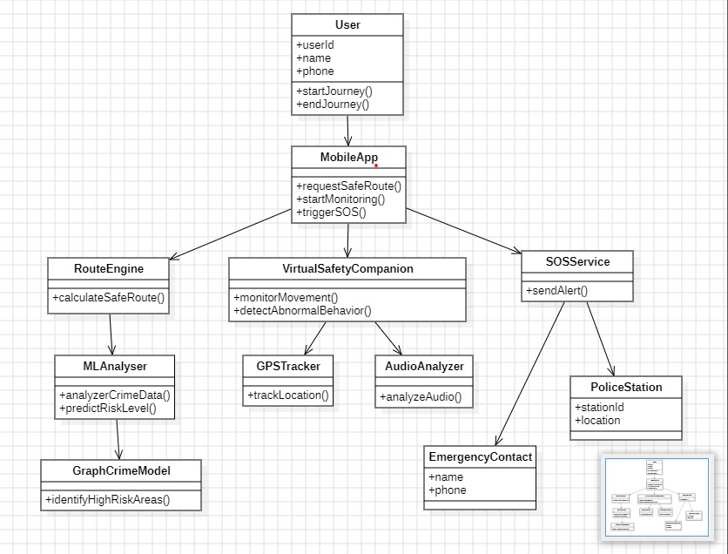
Fig. 4.2.2.1 Class Diagram

4.2.3 Sequence Diagram:
Women Safe Route Guidance System Design
Department of IT, BRECW Page 17

A sequence diagram emphasizes the time ordering of messages. Sequence diagram is formed by first placing the objects that participate in the interaction at the top of your diagram, across the X axis. Next, you place the messages that these objects send and receive along the Y axis, in order of increasing time from top to bottom. This gives the reader a clear visual cue to the flow of control over time. First, there is the object lifeline. An object lifeline is the vertical dashed line that represents the existence of an object over a period of time. Second, there is the focus of control. The focus of control is a tall, thin rectangle that shows the period of time during which an object is performing an action, either directly or through a subordinate procedure.
4.2.4.1 Content:
Sequence diagrams commonly contain
- Objects
- Links
- Messages
      - Common Use:
Modeling Flows of Control by Time Ordering.
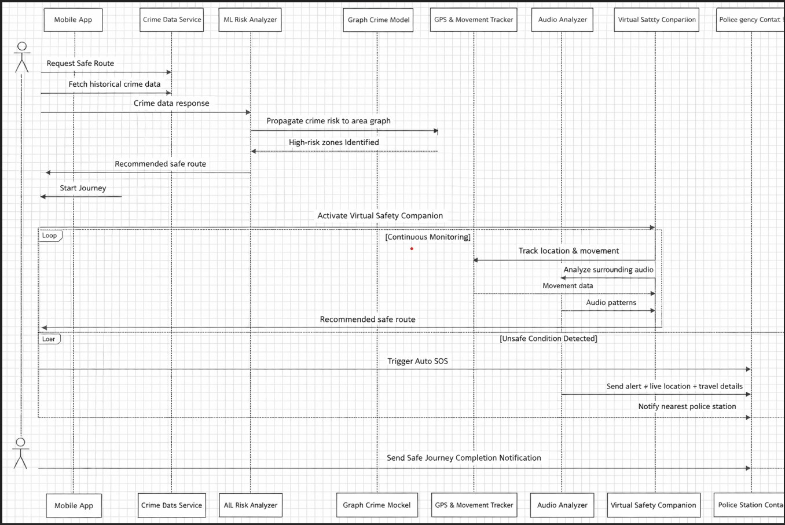
Fig. 4.2.3.1 Sequence Diagram

Women Safe Route Guidance System Design
4.2.4 Activity Diagram:
is made up of executable atomic computations that result in a change in state of the system or the return of a value. Actions encompass calling another operation, sending a signal, creating, or destroying an object, some pure computation, such as evaluating an expression. An activity diagram is a collection of vertices and arcs.
4.2.4.1 Common Properties
An activity diagram is just a special kind of diagram shares the same common properties as do all other diagrams - a name and graphical contents that are a projection into a model. What distinguishes an interaction diagram from all other kinds of diagrams is its content.
4.2.4.2 Content:
An activity diagram shows the flow from activity to activity. An activity is an ongoing non atomic execution within a state machine. Activities ultimately result in some action, which Activity diagrams commonly contain
- Activity states and action states
- Transitions
- Objects
4.2.4.3 Common Uses:
Activity diagrams are used to model the dynamic aspects of a system. When you model the
dynamic aspects of a system, you will typically use activity diagrams in two ways
- To model a workflow
- To model an operation
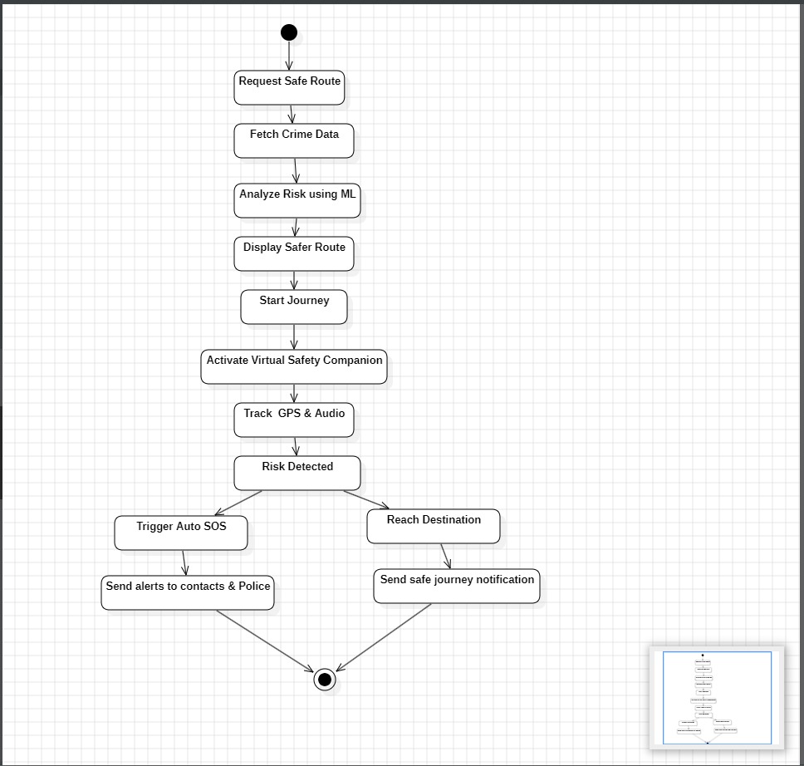
Department of IT, BRECW Page 18

Fig. 4.2.4.1 Activity diagram

Women Safe Route Guidance System Design
Department of IT, BRECW Page 19

4.3 Modules
Module is a part of a program. Programs are composed of one or more independently developed modules. A module description provides detailed information about a module and its supported components. The included description is available directly by making environment check for supported components. The modules are
- User Registration and Profile Module:
This module allows users to securely register and log in to the application. Users can create, update, and manage their personal profiles.
- Data Collection and Incident Reporting Module:
This module collects safety-related data such as crime reports, unsafe locations, and user feedback. Users can report incidents they encounter and provide safety ratings for specific areas. This data is used to improve route safety analysis and system accuracy.
- Safe Route Analysis Module:
Assigns safety scores to each route. Considers crime data, traffic, lighting, and crowd density. Identifies safest and risky routes
- Navigation and Location Tracking Module:
This module provides real-time GPS navigation to guide users along the selected safe route. It continuously tracks the user’s location and allows live location sharing with trusted contacts for added safety during travel.
- Emergency Alert and Audio Recording Module:
This module enables users to send SOS alerts during emergency situations. When activated, it shares the user’s real-time location with emergency contacts and automatically starts audio recording (with permission) to collect evidence.
- Admin Monitoring and Management Module:
This module allows administrators to monitor system activities, verify reported incidents, and update safety-related data. Admins can manage crime data, unsafe locations, and ensure the system provides accurate and reliable safety information.

5. Implementation

5.1 Pseudo Code
Women Safe Route Guidance System Implementation
Department of IT, BRECW Page 21

Index.html:
<!doctype html>
<html lang="en">
<head>
<!-- Basic Meta -->
<meta charset="UTF-8" />
<meta name="viewport" content="width=device-width, initial-scale=1.0" />
<title>SafeRoute - Women Safe Route Guidance System</title>
<!-- SEO Meta -->
<meta
name="description"
content="SafeRoute helps women find the safest routes using AI-powered crime prediction,
live GPS tracking, panic alerts, and real-time navigation."/>
<meta name="author" content="SafeRoute" />
<meta
name="keywords"
content="women safety, safe route finder, AI crime prediction, live GPS tracking, panic button,
emergency alert, women commute safety" />
<!-- Open Graph (WhatsApp, Facebook, LinkedIn) -->
<meta property="og:title" content="SafeRoute - AI-Powered Women Safety Route Finder" />
<meta
property="og:description"
content="Find the safest route with real-time GPS navigation and AI-based crime prediction
for women’s safety."/>
<meta property="og:type" content="website" />
<meta property="og:image" content="https://lovable.dev/opengraph-image-p98pqg.png" />
<meta property="og:url" content="https://saferoute.app" />
<!-- Twitter Card -->
<meta name="twitter:card" content="summary_large_image" />
<meta name="twitter:title" content="SafeRoute - Women Safety Route Finder" />
<meta
name="twitter:description"
content="AI-powered safe route recommendations with live GPS tracking and emergency alerts." />
<meta name="twitter:image" content="https://lovable.dev/opengraph-image-p98pqg.png" />
<!-- Favicon -->
<link rel="icon" type="image/png" sizes="32x32" href="/favicon.png" />
<link rel="icon" type="image/png" sizes="16x16" href="/favicon-16x16.png" />
<link rel="icon" type="image/svg+xml" href="/favicon.svg" />
<link rel="apple-touch-icon" sizes="180x180" href="/apple-touch-icon.png" />
<link rel="manifest" href="/site.webmanifest" />
<!-- Canonical -->
<link rel="canonical" href="https://saferoute.app" />
<!-- Robots -->
<meta name="robots" content="index, follow" />
<!-- Theme Color -->
<meta name="theme-color" content="#e11d48" />
</head>
<body>
<!-- React Root -->
<!-- Main React Entry -->
<script type="module" src="/src/main.tsx"></script>
</body>
</html>

Index.css:
@import url('https://fonts.googleapis.com/css2?family=DM+Sans:ital,opsz,wght@0,9..40,100..1000;1,9..40,100..1000&display=swap');
@tailwind base;
@tailwind components;
@tailwind utilities
@layer base {
* {
@apply border-border;
}
body {
@apply bg-background text-foreground font-sans antialiased;
font-family: 'DM Sans', system-ui, sans-serif;
}
h1, h2, h3, h4, h5, h6 {
@apply font-semibold tracking-tight;
}
}
@layer utilities {
.text-balance {
text-wrap: balance;
}
.gradient-hero {
background: var(--gradient-hero);
}
.gradient-safe {
background: var(--gradient-safe);
}
.gradient-card {
background: var(--gradient-card);
}
.gradient-panic {
background: var(--gradient-panic);
}
.shadow-card {
box-shadow: var(--shadow-md);
}
.shadow-card-hover {
box-shadow: var(--shadow-lg);
}

.shadow-panic {
box-shadow: var(--shadow-panic);
}
.shadow-safe {
box-shadow: var(--shadow-safe);}

.animate-pulse-panic {
animation: pulse-panic 1.5s ease-in-out infinite;
}
.animate-float {
animation: float 6s ease-in-out infinite;
}
.animate-slide-up {
animation: slide-up 0.5s ease-out;
}
.animate-fade-in {
animation: fade-in 0.4s ease-out;
}
.animate-scale-in {
animation: scale-in 0.3s ease-out;
}
}
@keyframes pulse-panic {
0%, 100% {
box-shadow: 0 0 20px 4px hsl(var(--panic-glow) / 0.4);
transform: scale(1);
}
50% {
box-shadow: 0 0 40px 12px hsl(var(--panic-glow) / 0.6);
transform: scale(1.02);
}
}
@keyframes float {
0%, 100% {
transform: translateY(0px);
}
50% {
transform: translateY(-10px);
}
}
@keyframes slide-up {
from {
opacity: 0;
transform: translateY(20px);
}
to {
opacity: 1;
transform: translateY(0);
}
}
@keyframes fade-in {
from {
opacity: 0;
}
to {
opacity: 1;
}
}

@keyframes scale-in {
from {
opacity: 0;
transform: scale(0.95);
}
to {
opacity: 1;
transform: scale(1);
}
}

/* Safety score progress bar */
.safety-score-bar {
background: linear-gradient(90deg,
hsl(var(--danger)) 0%,
hsl(var(--moderate)) 50%,
hsl(var(--safe)) 100%
);
}

/* Map placeholder styles */
.map-container {
background: linear-gradient(180deg,
hsl(var(--muted)) 0%,
hsl(var(--accent)) 100%
);
}

6. Screenshots

Women Safe Route Guidance System Screen shots

Department of IT, BRECW Page 26
6. Screenshots

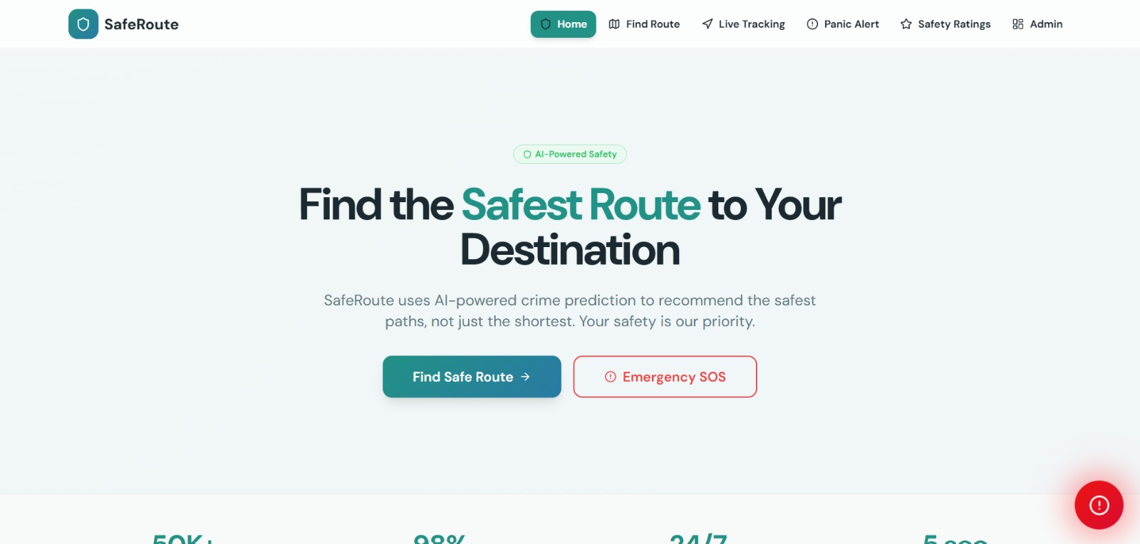

Screenshot 6.1 Safe Route Home page

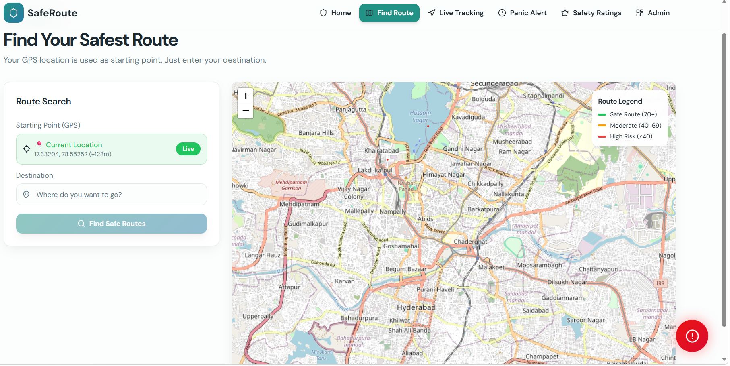

Screenshot 6.2 Find Route Page

Women Safe Route Guidance System Screen shots

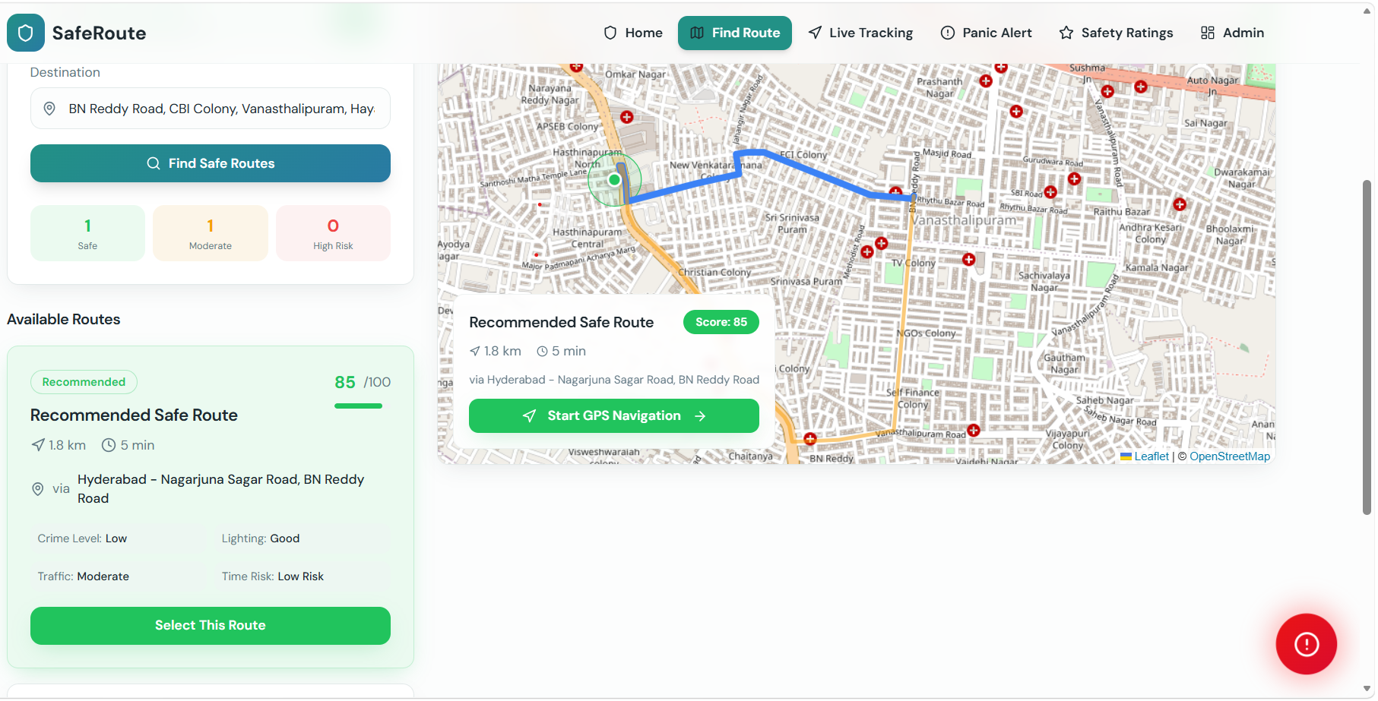

Screenshot 6.3 Select Route Page

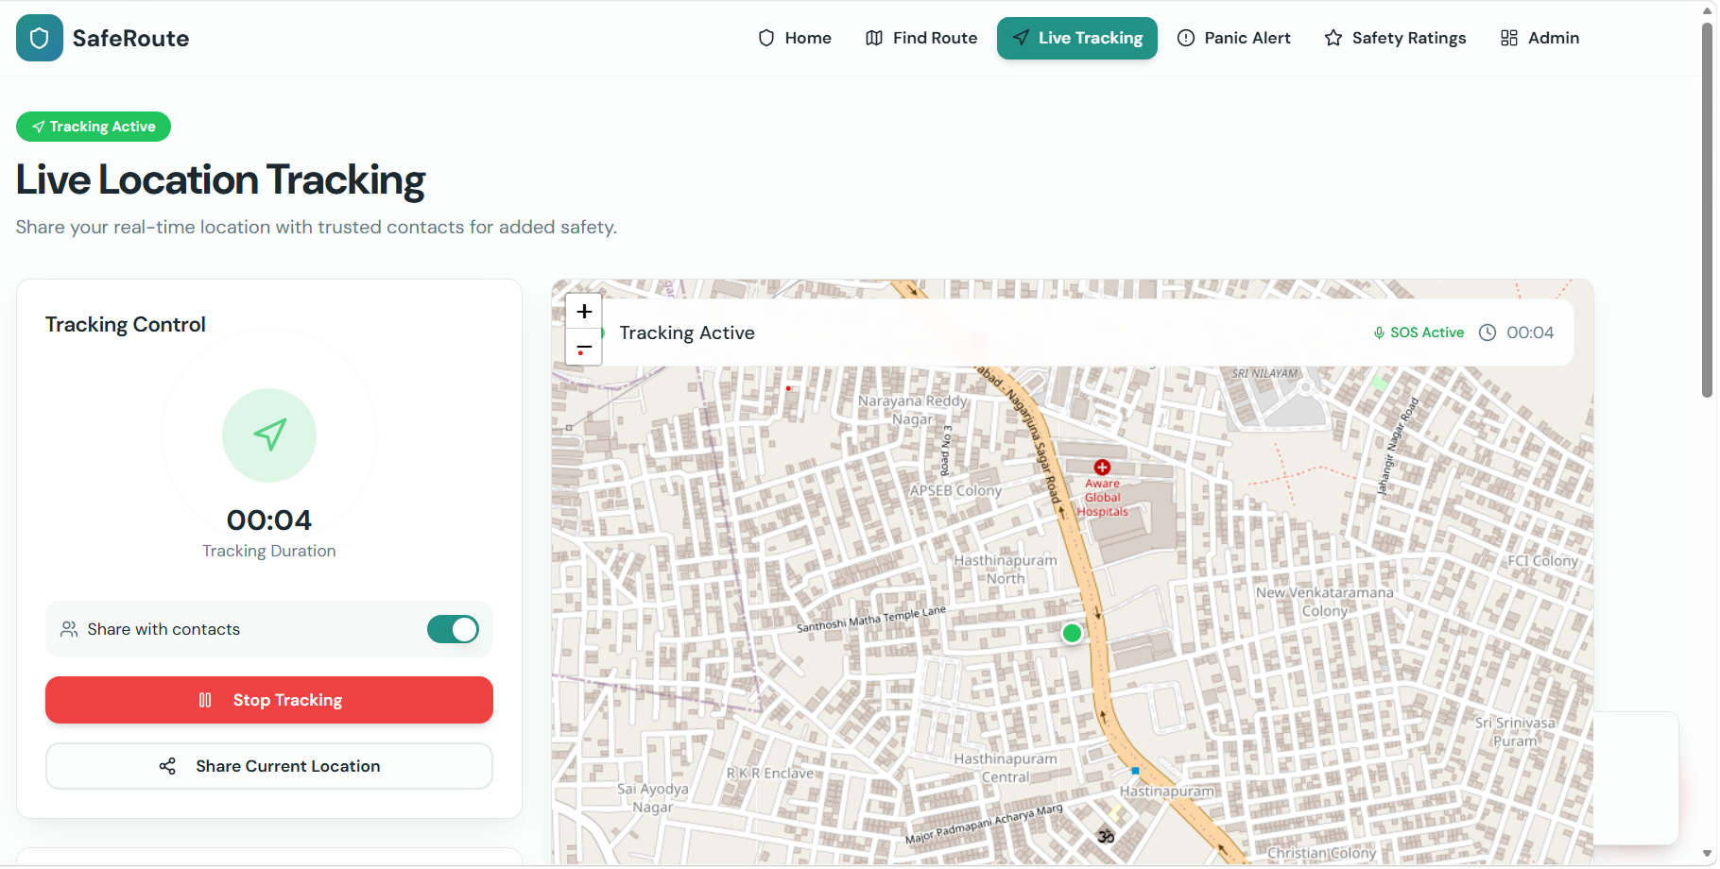

Screenshot 6.4 Live Tracking Page
Department of IT, BRECW Page 27
Women Safe Route Guidance System Screen shots

Department of IT, BRECW Page 28

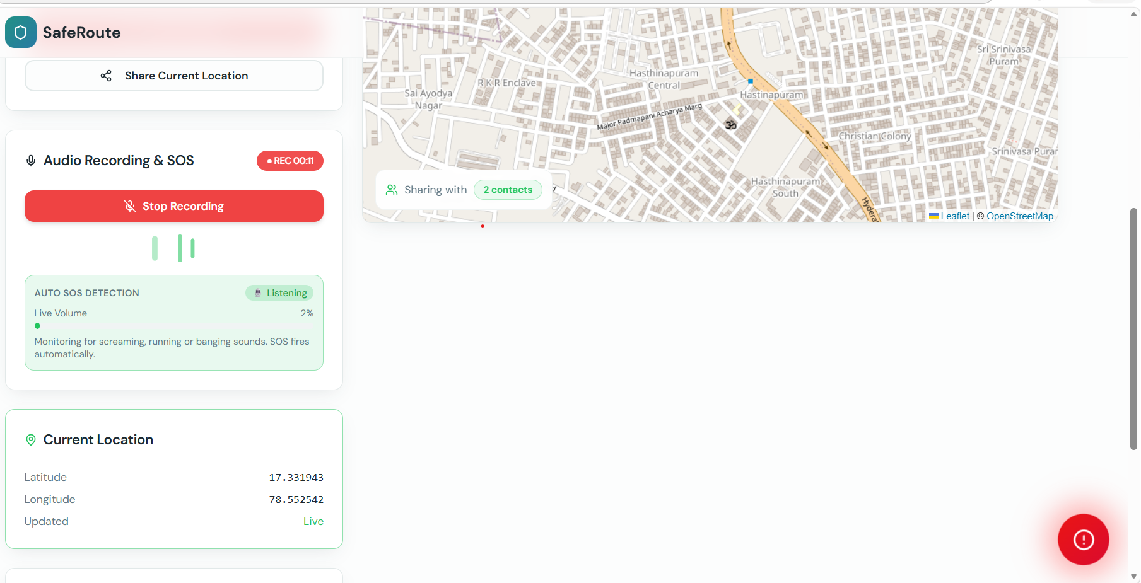

Screenshot 6.5 Audio Recording Page

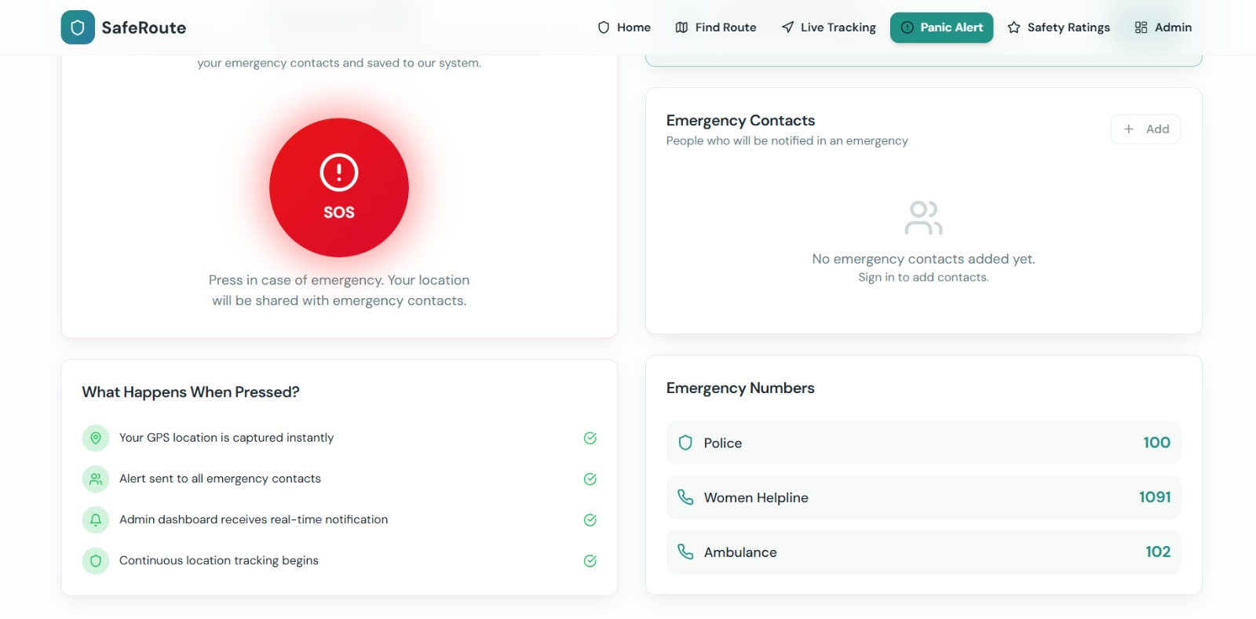

Screenshot 6.6 Panic Alert Page

Women Safe Route Guidance System Screen shots

Department of IT, BRECW Page 29

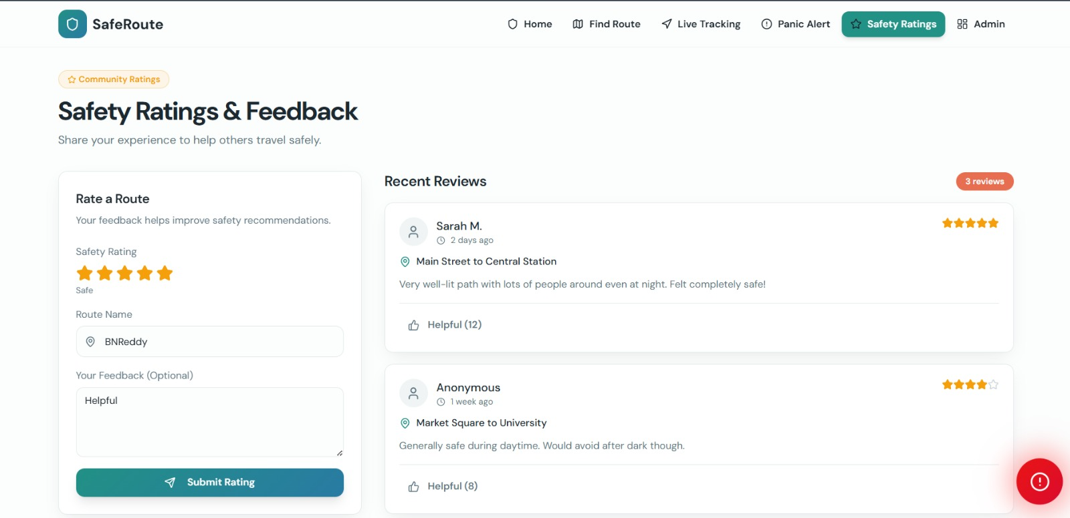

Screenshot 6.6 Safety Ratings page

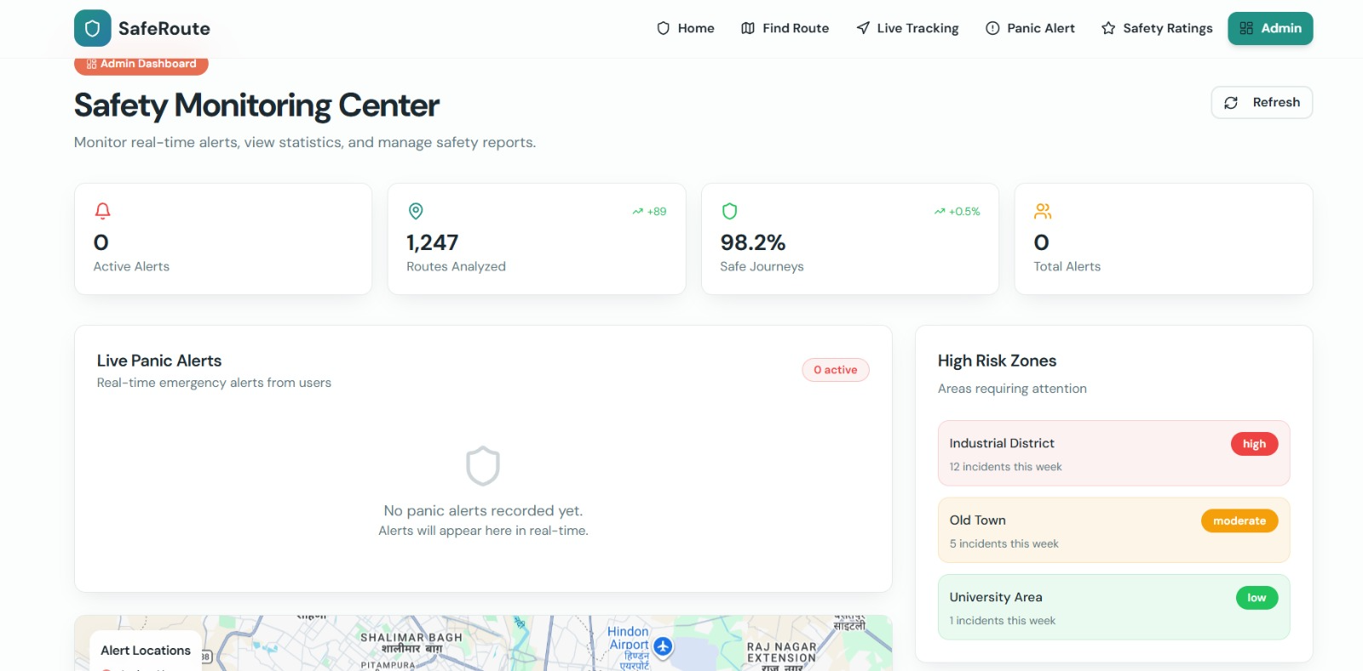

Screenshot 6.7 Admin Page

7. Test Cases
7.Test Cases
Department of IT, BRECW Page 31

Women Safe Route Guidance System Test Cases

Test ID | Module | Test Scenario | Input | Expected Output | Actual output | Status
TC-01 | Registration | Register with valid details | Valid user details | Registration successful | Registration successful | Pass
TC-02 | Registration | Missing registration fields | Empty required fields | Fill all required Fields | Fill all required fields | Pass
TC-03 | User Login | Login with correct credientals | Correct username and password | Login successful | Login successful | Pass
TC-04 | User login | Login with incorrect credentials | Invalid username/ password | Enter correct username or password | Enter correct username or password | Pass
TC-05 | Location Input | Enter locations | Source & destination | Route displayed | Route displayed | Pass
TC-06 | Route | Safe route check | Valid input | Safest route shown | Safest route shown | Pass
TC-07 | Navigation | Start navigation | Click start | Navigation starts | Navigation starts | Pass
TC-08 | Alert and SOS | Unsafe area alert | Enter risky zone, Press SOS button | Warning message | Warning message | Pass
TC-09 | Recording | Audio recording | Start recording | Recording starts | Recording starts | Pass
TC-10 | Tracking | Share location | Enable sharing | Location shared | Location shared | Pass

8. Conclusion
Stylish Union- style meets elegance Conclusion

Title
Department of IT, BRECW Page 33
3
8. Conclusion
Women Safe Route Guidance System Conclusion
Department of IT, BRECW Page 33

The Women Safe Route Guidance System is designed to enhance personal safety by providing intelligent and secure navigation for users. Unlike traditional navigation systems that focus only on the shortest or fastest routes, this system prioritizes safety by analyzing various factors such as crime data, traffic conditions, lighting, and crowd density. By using advanced technologies like machine learning and real-time location tracking, the system is able to recommend the safest routes and help users avoid risky areas.
The system also includes important safety features such as SOS alerts, live location sharing, and automatic audio recording during emergencies, which provide additional protection and support to users. These features ensure that users can quickly respond to dangerous situations and seek help when needed. The user-friendly interface makes the application easy to use for people of all backgrounds, including women, students, and travellers.
Furthermore, the system is designed to be scalable, reliable, and secure, ensuring smooth performance even with increasing users and data. The integration of real-time data and external services enhances the accuracy and effectiveness of route recommendations. The modular and layered architecture also allows future improvements and addition of new features.
Overall, the Women Safe Route Guidance System successfully addresses the limitations of existing navigation systems by focusing on user safety. It not only helps users travel more securely but also builds confidence and independence during travel, especially in unfamiliar or high-risk areas. This project demonstrates how technology can be effectively used to solve real-world safety challenges and contribute to a safer society.

Title
Department of IT, BRECW Page 35

9.Future Scope

- Future Scope
Women Safe Route Guidance System Future Scope
Department of IT, BRECW Page 35

The future scope of the Women Safe Route Guidance System includes enhancing the application with advanced technologies such as artificial intelligence and real-time data integration to improve safety predictions and route accuracy. The system can be expanded by integrating with police and emergency services for faster response, as well as adding features like voice assistance, wearable device support, and multi-language options for better accessibility. It can also include community-based alerts, live incident reporting, and support for public transport navigation. Overall, the system can be developed into a more intelligent, automated, and widely accessible solution to ensure higher safety and user confidence during travel.

Title
Department of IT, BRECW Page 37

10. References
10.References
Women Safe Route Guidance System References
Department of IT, BRECW Page 37

    - Vigneshwaran.K 1, Sumithra.S2, Janani.R3, "An Intelligent Tracking System Based on GSM and GPS Using Smartphones ",, Vol. 4, Issue 5, May 2015 .
    - E. Borgia, D. G. Gomes, B. Lagesse, R. Lea, and D. Puccinelli, “Special issue on" Internet of Things: Research challenges and Solutions".,” Computer Communications, vol. 89, no. 90, pp. 1–4, 2016.
    - Anand Jatti, Madhvi Kannan, Alisha RM, Vijayalakshmi P, Shrestha Sinha,“Design and Development of an IoT based wearable device for the Safety and Security of women and girl children”, IEEE International Conference On Electronics Information Communication Technology, India, May 2016.
    - Gowri Predeba.B, Shyamala.N, Tamilselvi.E, Ramalakshmi.S, Selsi aulvina. C, “Women Security System Using GSM and GPS”, International Journal of Advanced Research Trends in Engineering and Technology (IJARTET)Vol. 3, Special Issue 19, April 2016.
    - Ms. G. Rathi, Ms. T. Prathipa, Ms. R. Ramya, Ms. B. Vidhya, “Smart Security Solution forWomen Using Wearables”, IJAICT Volume 3, Issue 11, Doi:01.0401/ijaict.2017.03.03, March 2017.
    - Prof. R.A. Jain, Aditya Patil, Prasenjeet Nikam, Shubham More, Saurabh Totewar,” Women’s safety using IOT “. Vol: 04 Issue: 05| May-2017
    - Jismi Thomas, Maneesha K J and Nambissan “TOUCH ME NOT-A Women Safety Device” Safe cities free of Violence against Women and Girls Initiative, 2018.

