**INTRODUCTION:**

With this **Telecom Billing System**, we can perform and manage billing operations like they do in Telecom companies. Here, we can add records with name, phone number and the amount of payment and we can view, modify, search and delete existing records. we can also make payment by providing our phone number instead of name. All data added or modified are recorded in a file.

**Features:**

* Add new records: add new data into file with name, phone number and amount to be paid
* View list of records – lists all telephone billing records
* Modify records – edit the added records; name, phone number and amount of payment can be edited
* View payment – shows amount to be paid
* Search records – search for added/updated records in file
* Delete records – removes data permanently from file

**Defining our System:**

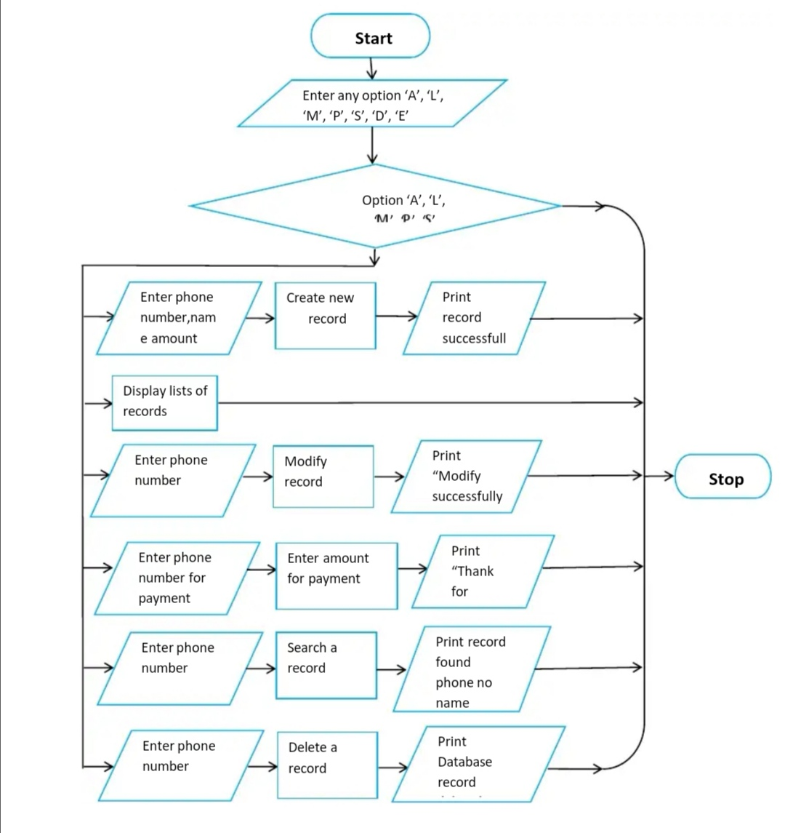

**4W’s and 1’H:**

**Who:**

1.computer science engineering

2.communication developer

**What:**

Telecom billing is the group of processes of communications service providers that are responsible to collect consumption data, calculate charging and billing information, produce bills to customers, process their payments .

**When:**

When the plan of our validity expires.

**Where:**

This project can be used for various plans of phone billing.

**How:**

This project can perform various monthly plans of recharging the phone.

**Detail Requirement:**

**High Level Requirements:**

|  |  |  |
| --- | --- | --- |
| **ID** | **Description** | **Status(Implemented/Future)** |
| HLR-1 | User shall be able to recharge | Implemented |
| HLR-2 | Keep on updating the validity of present plan | Implemented |
| HLR-3 | Convert the networking generations without changing the user contact number | Future |

**Low Level Requirements:**

|  |  |  |
| --- | --- | --- |
| **ID** | **Description** | **Status(Implemented/Future)** |
| LLR-1 | Everyone can access | Implemented |