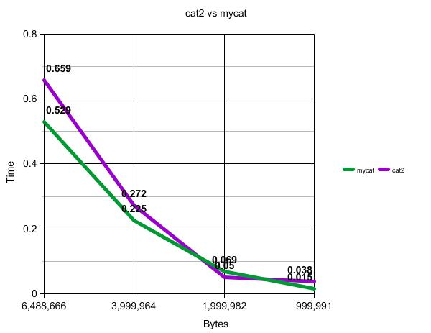

As seen on the graph above, my cat was slightly faster on all but the 2,000,000 byte document. I can’t tell how reliable this numbers are, since every time I ran the same document I got different times, so this is an average of 10 runs on both cats for each file size. I think that there are 2 main reasons for the advantage my cat has. The first and obvious one is the system calls. I think that these are faster than using the file library, since I expect at some point the file library uses these sys calls, so I am removing all the extra things that I don’t need for cat. Another reason is that my cat does not use a second file, I use the buffer that the read function fills up.