**Automated door access based on RFID using Arduino**

Domnic Sam J(20BCS097)

Jeyajith Roshan(20BCS101)

Mepco Schlenk Engineering College,Sivakasi.

**Problem Statement:**

The arduino based RFID door lock system is secure and responsive as compared to other systems. With the use of arduino, it becomes much easy to design. Program a code and upload it to arduino just like a plug and play device. It is simple and cost efficientproject and can be used as a basic access control mechanism. Their main advantageis contactless communication and RFID tags can work in any environmentalconditions. This is the reason RFID systems are more efficient.

1. **RFID Technology**

Radio Frequency Identification abbreviated as RFID , is a progressive development that can be used to advance the passageway control framework . It gives a robotization in different procedures extending from mechanical parts to home control. RFID innovation will assist us with developing a door access control framework which can permit the passage of approved faculty in the confined zones. Additionally this innovation is utilized prominently in charge get to frameworks which has wide scope of uses in regions, for example, staff distinguishing proof, customer products following, etc. RFID frameworks are essentially a blend of RFID innovation and figuring innovation. They principally comprises of three segments in particular examiner (reader), transponder (tag) and PC containing database. The reader goes through the content of different labels and transmit content to the server for confirmation. When the data is prepared and checked, get to is conceded. This RFID framework gives a wide scope of frequencies from low recurrence range to microwave recurrence range. With the expansion in the quantity of illicit sections over the previous decade, different organizations and workplaces empower creation and establishment of robotized door security frameworks. These frameworks are planned to give wellbeing to confined room in companies, shops and workplaces. This mechanized frameworks gives upheld section and diminishes the odds of robbery. RFID based security framework utilizing Arduino **Figure.1** has a RFID reader joined to it. RFID reader reads the one of a kind alphanumeric code of RFID labels and sends it to Arduino. At that point Arduino distinguishes whether RFID card is substantial or invalid. On the off chance that the card is invalid, at that point framework turns on the ringer. Be that as it may, on the off chance that the RFID card appeared by the client is legitimate, at that point the servo engine is turned on and door open.

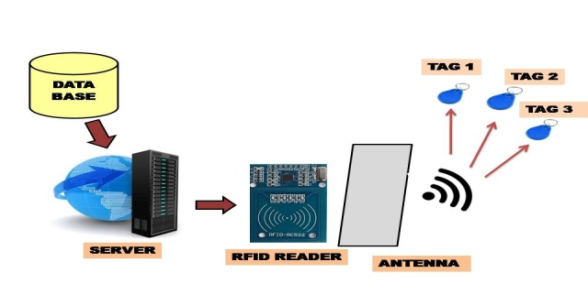

**Fig. 1.** RFID Control access system

1. **Simplified block diagram**

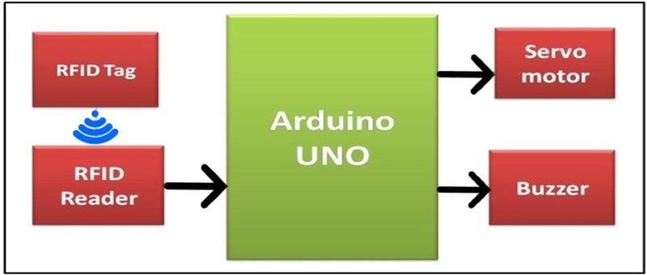

**Fig. 2.** Block diagram of system model

The block diagram in **Figure 2.** shows the connection between the various blocks. These blocks together define the functionality of Arduino UNO. We used RFID ID tag and RFID reader , which is used to match the data on tag with the data in the database program which leads to movement of door by confirming whether the data is correct and/or incorrect. Opening of the door uses servo motor that gets its feed from Arduino board. The opening and closing is based on the flag set by the Arduino response. When the flag is set to 1, the door opens and if it is set to 0, the door remains closed. The and buzzer based on the feed also comes from the Arduino board.

1. **Hardware components**

The framework dependent on this model is introduced at the passage of the restricted room. In this created work, we require the RFID Module, RFID tag, and servo engine to see the controlling framework. It could utilize a minimized hardware worked around the Arduino UNO board. The project could be created in embedded C. The segments required in the model are as follows:

* 1. **Arduino UNO board**

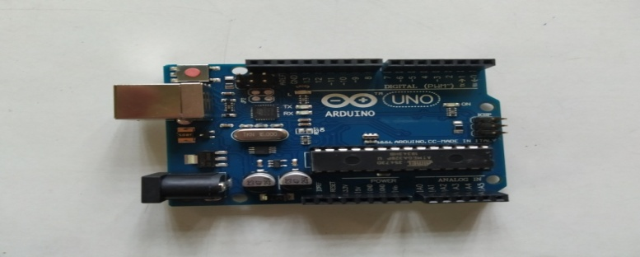

**Fig. 3.** Arduino UNO board

Arduino UNO is an open-source microcontroller board dependent on the Microchip ATmega328P microcontroller. It utilizes a type B USB port for power. It is programmable with a product called ARDUINO IDE . In our work, we have utilized an Arduino board as appeared in **Figure 3.**

* 1. **RFID Module**

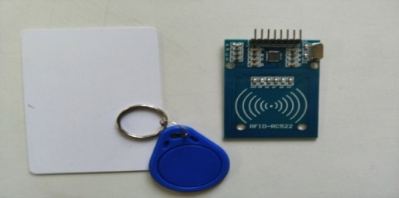

**Fig. 4.** RFID Tag and RFID Reader

RFID is contracted as Radio Frequency Identification. It makes a remote correspondence and empowers information move between RFID tag and RFID reader. This module can read and compose information without direct contact. The RFID label comprises of kilobytes of rich data in it. The RFID reader is a functioning segment .The RFID tag, then again, is a detached segment that is situated on the item we need to distinguish. It has an antenna attached to a microchip. So as we place the tag is near the scope of RFID reader than some voltage is created in reception apparatus curl and voltage act as power. In our work, we have utilized RC522 MODULE to get to door control framework **Figure 4**.

* 1. **Servo motor**

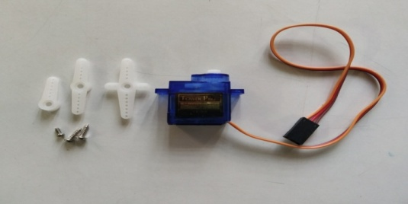

**Fig. 5.** Servo motor

A servomotor control the angular position, speed, and acceleration. It comprises of a reasonable engine coupled to a sensor for position feedback. Servomotors have various applications in the field of mechanical autonomy, computerized producing and so on. Engine in our work is to open and close the door consequently when the RFID per user recognizes the RFID tag of the client **Figure 5**.

* 1. **Buzzer**

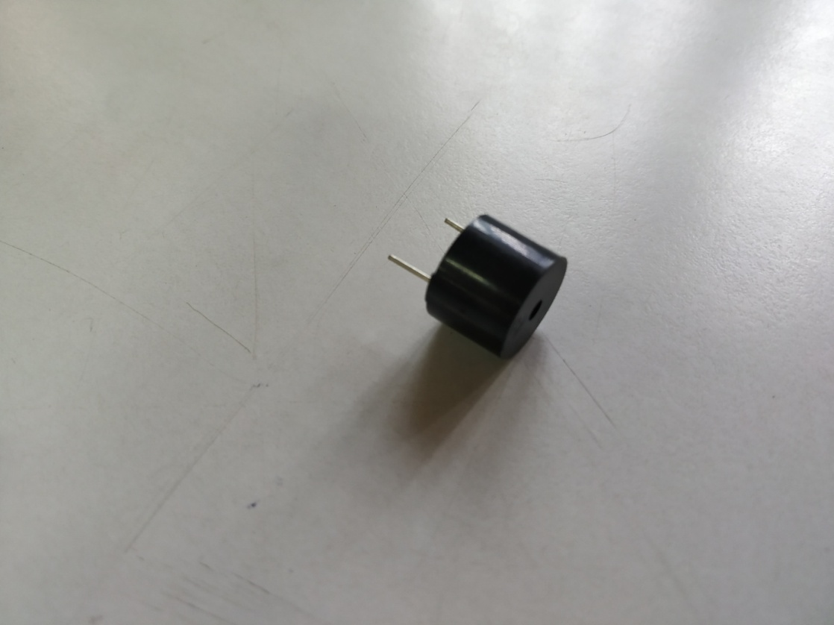

**Fig.6.** Buzzer

It is a two pin device which gives sound component to our work **Figure.6**. The piezo signal produces sound dependent on the switch of the piezoelectric impact . In our work, we have utilized a buzzer.

1. **Software technology : Arduino(IDE)**

The program can be written in a programming language for a compiler to produces binary code. This code editor has salient features like syntax highlighting. It provides one-click mechanisms to compile and upload programs to an Arduino board. Our undertaking gives the Arduino incorporated advancement condition (IDE), which is a cross-stage application written in the programming language PYTHON. It has begun from the IDE for the dialects Handling and Wiring.

1. **System diagram**

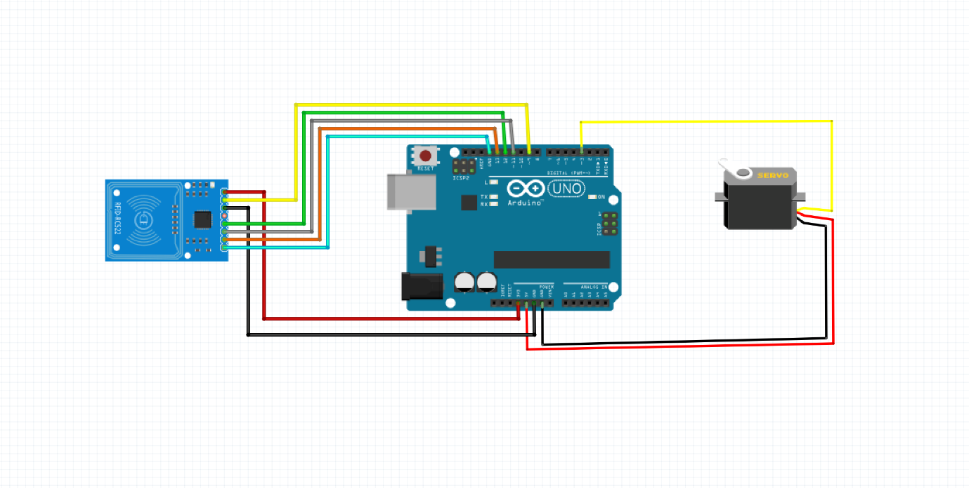

**Fig. 7.** Sysytem diagram

1. **System flow chart**

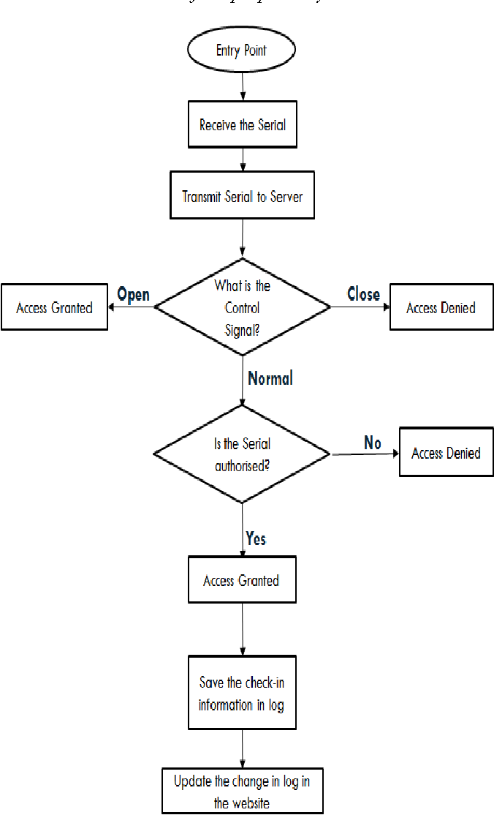

**Fig. 8.** Flow chart

1. **Results and Conclusion**

RFID based security and access control framework is a quick and profoundly tied down framework when contrasted with some other biometric frameworks. It gives contact less correspondence and works without the observable pathway. With the assistance of Arduino, the framework are effectively open and works inconclusively. Clients can change the capacities in the Arduino code .RFID control framework decreases human exertion and mistake. Also, with the assistance of this numerous RFID labels can be read at once which prompts high proficiency of RFID framework. Radio Frequency Identification (RFID) is a remote advancement that can be used to develop the passageway control framework. This innovation gives a progressive robotization in different procedures running from modern divisions to home control .

1. **Implementation (CODE)**

***#include <SPI.h>***

***#include <MFRC522.h>***

***#include <Servo.h>***

***#define SS_PIN 10***

***#define RST_PIN 9***

***#define SERVO_PIN 3***

***Servo myservo;***

***#define ACCESS_DELAY 2000***

***#define DENIED_DELAY 1000***

***MFRC522 mfrc522(SS_PIN, RST_PIN);   // Create MFRC522 instance.***

***void setup()***

***{***

***Serial.begin(9600);   // Initiate a serial communication***

***SPI.begin();          // Initiate  SPI bus***

***mfrc522.PCD_Init();   // Initiate MFRC522***

***myservo.attach(SERVO_PIN);***

***myservo.write( 70 );***

***delay(7500);***

***myservo.write( 0 );***

***Serial.println("Put your card to the reader...");***

***Serial.println();***

***}***

***void loop()***

***{***

***// Look for new cards***

***if ( ! mfrc522.PICC_IsNewCardPresent())***

***{***

***return;***

***}***

***// Select one of the cards***

***if ( ! mfrc522.PICC_ReadCardSerial())***

***{***

***return;***

***}***

***//Show UID on serial monitor***

***Serial.print("UID tag :");***

***String content= "";***

***byte letter;***

***for (byte i = 0; i < mfrc522.uid.size; i++)***

***{***

***Serial.print(mfrc522.uid.uidByte[i] < 0x10 ? " 0" : " ");***

***Serial.print(mfrc522.uid.uidByte[i], HEX);***

***content.concat(String(mfrc522.uid.uidByte[i] < 0x10 ? " 0" : " "));***

***content.concat(String(mfrc522.uid.uidByte[i], HEX));***

***}***

***Serial.println();***

***Serial.print("Message : ");***

***content.toUpperCase();***

***if (content.substring(1) == "69 C8 E2 2A") //change here the UID of the card***

***{***

***Serial.println("Authorized access");***

***Serial.println();***

***myservo.write( 70 );***

***delay(7500);***

***myservo.write( 0 );***

***}***

***else   {***

***Serial.println(" Access denied");***

***delay(DENIED_DELAY);***

***}***

***}***

1. **References**
2. www.elprocus.com/understanding-about-types-of-access-control-systems/
3. www.security.honeywell.com
4. https://searchsecurity.techtarget.com
5. www.vectorsecurity.com
6. https://www.elprocus.com/automatic-door-lock-system-using-RFID-and-arduino/
7. https://www.slideshare.net/naveeniift/RFID-and-its-applications
8. www.fibre2fashion.com/industry-article/3271/RFID-applications