Tasks

- What is the difference between http://www.wifonicnetworks.com and http://www.wifonicnetworks.com:80 ?

- What is the difference between HTTP and HTTPS? Which port does HTTPS use? Which RFC should be checked to get more information about HTTPS?

- HTTPS uses TLS (SSL) to encrypt normal HTTP requests and responses. As a result, HTTPS is far more secure than HTTP

- HTTPs uses port 443

- RFC for HTTPs is 2818

- Sniff traffic to https://www.wifonicnetworks.com in a tcpdump-session and open the website in a browser on the same machine. What are you seeing now? Why?

- What is the difference between HTTP/1.0 and HTTP/1.1 and HTTP/2.0? Why is it easier to use HTTP/1.0 when using tools like nc?

HTTP/1.0 requests header, HTTP/1.1 Host header and HTTP/2.0 request multiplexing.

- What is the purpose of the following HTTP status codes: 200, 302, 304, 400, 401, 404, 429, 500, 502? What does the leading number indicate?
- standard response codes given by web servers on the internet. The codes help identify the cause of the problem when a web page or other resource doesn't load properly

- HTTP 200 OK success status response code indicates that the request has succeeded

- Find out how to change the User-Agent in Firefox and change it to Mozilla/4.0 (compatible; MSIE 2.0; Windows NT 5.0; Trident/4.0; SLCC2; .NET CLR 2.0.50727; .NET CLR 3.5.30729; .NET CLR 3.0.30729; Media Center PC 6.0) (Internet Explorer 2). Does the web-experience differ?
Open a new tab
Browse to "about:config"
Dismiss the warning
Create a new preference item
Close the Preferences window
Resetting your user agent in Firefox

No it does not

- What could be the purpose of switching User-Agents for a web-developer and for an IT Security expert?

It allows them to allows you to mimic, spoof or fake other browsers, devices or search engine spiders

- Why could it be dangerous not to change the server banner for a webserver?

The default value exposes the amount of information that would be revealed to an attacker.

- How do you change the server banner for an Apache server?
- Install the Apache server and the required packages.(
- apt-get install apache2 curl)
- Verify the configured Apache token.
- Verify the Apache header.
- Edit the Apache configuration file.
- Restart the Apache service.

- Get the server banner in a tcpdump-session from www.wifonicnetworks.com. What is the problem when sniffing traffic via a proxy?

The person or group controller of a proxy can see your traffic, especially if it is a free proxy

- Shortly explain the purpose of DNS. Is it possible to work with the Internet without DNS?
- converts domain names, which can be read by humans, into IP addresses, which in turn can be read by machines
- Yes the internet can work without DNS If we have an IP-based system of identifying nodes

- What is a domain, a subdomain and Punycode?

A domain name is the address people type into a browser in order to reach a site.

Subdomains are the part of a domain that comes before the main domain name and domain extension

Punycode is a standardized encoding method that allows Unicode characters to be mapped using a limited ASCII character set that consists of only the following elements:
- Lower case letters: a to z
- Digits: 0 to 9
- Special characters: hyphen (-)

- Make an example diagram, which shows recursive and iterative queries. Use www.wifonicnetworks.com as domain, assume you are doing a request from home.

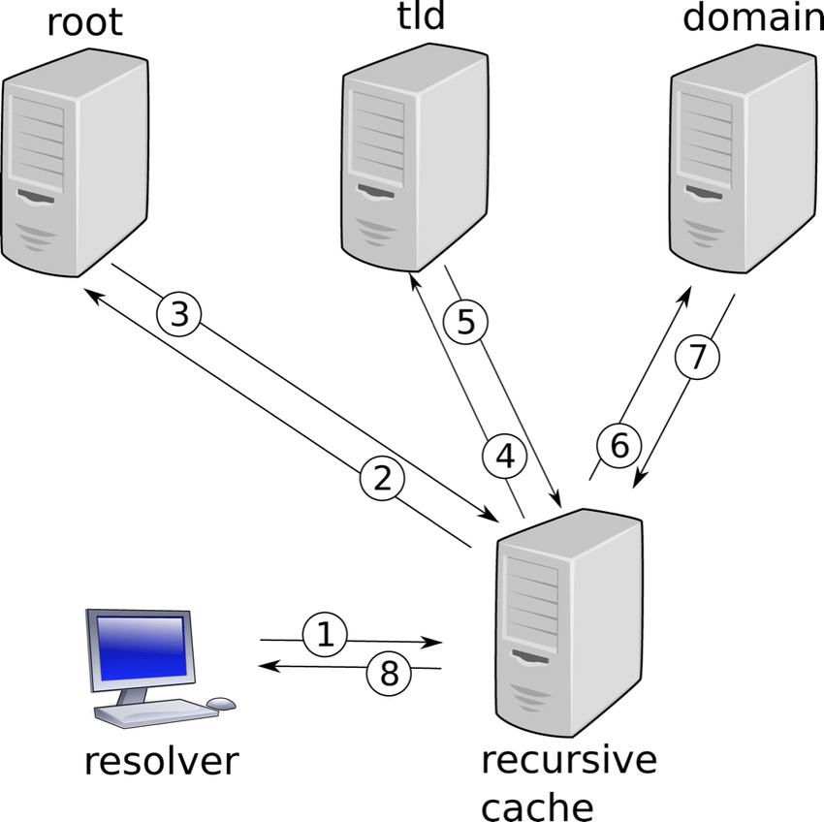

- How can you list and flush the DNS cache under Windows?

Open the command line interface(CMD)

enter the following line: ipconfig /flushdns
The command should return confirmation that the cache has successfully flushed

- What is reverse mapping and what is its purpose? Why don't we use the "normal" domain again for reverse mapping?

- It is the process in which DNS database includes zone files that use the IP address to find machine host names, enabling IP address to host name resolution

- Reverse mapping is used primarily to verify the identity of the machine that sent a message or to authorize remote operations on a local host

- normal domain only assign names to IP addresses.

- What is a resource record?

- Resource code is the unit of entry in DNS zones flies
- It is the basic building blocks of host-name and IP information and are used to resolve all DNS queries

- The following entry is from the zone file from the DNS server bind: foobar.example.com. 3600 IN A 172.30.0.7 What is its purpose?
It helps in online certificate authority for secure, automated certificate management

- Add an example reverse mapping entry to this zone file for the reverse domain 7.0.30.172.in-addr.arpa.

reverse zone domain 0.168.192.in-addr.arpa.
- Add an example IPv6 entry for the domain foobar.examle.copm to this zone file with the example IPv6 IP 2001:db8::affe:89ab

fec0::9256:a00:20ff:fe12:528

- What would happen if all root servers for DNS would shut down? What would happen if all authoritative servers for the com domain would shut down?

DNS lookups would gradually start failing

(What would happen if all authoritative servers for the com domain would shut down?)
There will be no answers to recursive DNS nameservers about where specific websites can be found.

- Investigate, how many root servers for DNS exist and where their location is. Why is it not a good idea to keep them at one place?

there are over 600 different DNS root servers distributed across every populated continent on earth

It is not a good idea to keep them in one place because

- Investigate, if there were any attacks on the DNS root servers in the past. What would be a good short-term solution for a company like Wifonicnetworks, if all root server should fail.
October 23, 2002 a massive massive distributed denial-of-service (DDoS) attack (define) of unknown origin briefly interrupted Web traffic on nine of the 13 DNS "root" servers that control the Internet but experts on Wednesday dismissed the overall threat as "minimal."

What would be a good short-term solution for a company like Wifonicnetworks, if all root server should fail.
Try refreshing and reloading the webpage, some times the temporary problem can be solved by trying the page again

- There is a similar tool to dig on Windows machines (also sometimes installed on Linux ones). What is its name? Investigate, why dig should be used instead of this tool.

Nslookup command

dig should be used instead of nslookup command because nslookup has arcane interface and frequently inconsistent behavior

- How can you use dig to find out a DNS server version (banner grabbing)?
example
dig google.com

- Find out the responsible mail server for wifonicnetworks.com with dig. Do a parallel tcpdump-session and verify the output of dig.

- Find out the authoritative name servers for wifonicnetworks.com with dig. Do a parallel tcpdump-session and verify the output of dig.
- Ask one of those authoritative Wifonicnetworks name servers for the IP of google.com with dig. Does this reply differ from a normal query with dig ? If yes, why? Verify both queries with tcpdump.
- Investigate what DNS-tunneling is. How can you detect it? (Detecting DNS Tunneling (giac.org)
- What is the program whois and what is its relationship to DNS? What valuable information does it has?
is a query and response protocol that is widely used for querying databases that store the registered users or assignees of an Internet resource, such as a domain name, an IP address block or an autonomous system, but is also used for a wider range of other information

The NS Servers on Whois are only used during queries

- Find out the owner, the abuse-mailbox and the corresponding IP-address-range for the IP for wifonicnetworks.com. Use online variants or (better) an external root server.

- Give examples for protocols, which can be encapsulated in TCP.
Link-layer
Netwrok layer

- Make a diagram which shows the connection termination (similar diagram to the establishment).
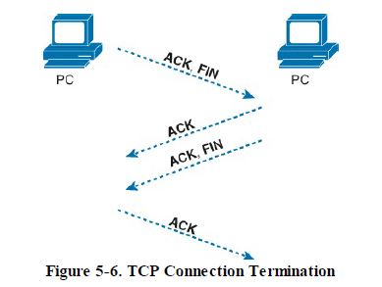

- If a connection gets terminated by RST and you was expecting a FIN, ACK, what kind of operating system do you expect on the other side of the connection?

- What is the IANA-recommended port range to choose an ephemeral port from?
1024–65535

- Which port range choose the following operating systems from for ephemeral ports: Common Linux distributions, Windows 2000, Windows XP, FreeBSD, Windows 7, Windows Server 2003, Windows Server 2008, Windows 8 /10?

- Many Linux kernels use the port range 32768–60999

- Microsoft Windows operating systems through Windows XP use the range 1025–5000

- From a security perspective: Why should all operating systems use the IANA-recommended port range?
It is responsible for maintaining the official assignments of port numbers for specific uses

- On which ports are the following applications running usually: DNS, HTTPS, POP3, SMTP, NetBIOS, Kazaa, Unreal Tournament, BitTorrent, Back Orifice, Oracle DB?

DNS port 53
HTTPs port 443
pop3 port 110
SMTP port 25, 587, 465
NetBIOS port 137,138
kazaa port 1214
Unreal tournament port 7777-7779, 7780 and 8777
BitTorrent port 6881-6889
Back Orifice port 31337
Oracle DB port 1521

- Which applications are running on those ports: 123, 8080, 20, 21, 23, 1080, 3306?

123 Network Time Protocol (NTP),
8080 apache tomcat, alassian JIRA application
20 File transfer protocol data transfer
21 File transfer protocol command
23 Telnet protocol
1080 SOCKY proxy
3306 MSQL database system
- Why could it make sense to run an SSH server on port 10022 instead of 22?
Because port 10022 is used to create the SSH connection between the Gateway and the Transfer server

- Give an example how to verify an application, which is running on a different port. Do this from a client perspective.
Open the command prompt - start >> run >> cmd or start >> All Programs >> Accessories >> Command Prompt.
- Type netstat -aon | findstr '[port_number]'. Replace the [port_number] with the actual port number that you want to check and hit enter.
- If the port is being used by any application, then that application's detail will be shown. The number, which is shown at the last column of the list, is the PID (process ID) of that application. Make note of this.
- Type tasklist | findstr '[PID]'. Replace the [PID] with the number from the above step and hit enter.
- You'll be shown the application name that is using your port number.

- What is the purpose of the file /etc/services?
used by applications to translate human readable service names into port numbers when connecting to a machine across a network

- What is the minimum value for the Data Offset within the TCP header? Why?
minimum size header is 5 words because because it gives a minumu size of 20bits

- True or false: The TCP header has a fixed size.
True
- True or false: Every TCP segment should have the ACK-flag being set.
True

- How is the TCP checksum calculated for IPv6 (No calculation needed, only basic idea)? 1 Give an overview about the TCP header fields Window Size , Window Scale and MSS and their relationship to each other

.To calculate the TCP segment header's Checksum field, the TCP pseudo header is first constructed and placed, logically, before the TCP segment. The checksum is then calculated over both the pseudo header and the TCP segment. The pseudo header is then discarded.

The TCP receive window size is the amount of receive data (in bytes) that can be buffered during a connection. The sending host can send only that amount of data before it must wait for an acknowledgment and window update from the receiving host.
The TCP window size field controls the flow of data and is limited to 2 bytes, or a window size of 65,535 bytes.

The default TCP mss is 536 bytes. It's value can be optionally set as a TCP option, but cannot be changed once the connection is established

- Give an example for the usage of the PSH-flag.
packet capture of an HTTP GET request.

- What is the purpose of the TCP timestamps?
It enables the endpoints to keep a current measurement of the roundtrip time (RTT) of the network between them.

- Which information can an attacker gain, when timestamps are available and why is this information a security risk?
Provides a means to guess the operating system of the target.
The information gives them a bypass mechanism to use

- Can you use the above mentioned header fields to identify an operating system? Give examples.
Yes it can be used:
The adversary sends a probe packet to the remote host to identify if timestamps are present.

- What is the TCP Slow-start algorithm?
It is an algorithm which balances the speed of a network connection.

- Assume that all devices from your client to the server ignore TCP segments, which are not RFC-compliant, and forward them to the server without objection. What parts of the header can you use for tunneling data?

- Which snaplen (tcpdump –s option) should be sufficient after answering the above question for getting the whole packet data? What is the default value? What does -s0 do?

Default value 68 bytes for IPv4 packets and 96 bytes for IPv6 packets.

-s0 see the full snaplen capture

- Sniff a session to the consecur.de with tcpdump and wget. Make sure that the result of tcpdump is written to a file. What are the values for every TCP header field of the first TCP segment sent by the client.
Explain, why tcpdump 'tcp[13] & 2 != 0' gets all packets with at least the SYN flag enabled. Give example calculations and explain it with the logical AND.
- What does the following command do? tcpdump 'tcp[12] & 80 != 0' verbose output suppressed
What does the following command do? tcpdump 'tcp[13] & 18 != 0' This points us to the tcpdump filter expression
- What does the following command do? tcpdump 'tcp[13] & 0x02 != 0' Find all SYN packets

- What does the following command do? tcpdump 'tcp[13] & 0x02 = 0 and tcp[13] & 0x10 != 0'
Show all URG packets

- What is the source port and destination port in the following tcpdump output?

- Which flags are set and which size in bytes does the TCP header have?
0x0000: 4500 003c a13b 4000 4006 3138 0a00 020f E..<.;@.@.18....
0x0010: 105e 4bdc beef 0050 e6d3 593a 0000 0000 .^K....P..Y:....
0x0020: a002 3908 c07b 0000 0204 05b4 0402 080a ..9..{..........
0x0030: 0003 f801 0000 0000 0103 0306 ............

31. If you find a binary value of 0010 0000 in the 13th offset of the TCP header, what does it mean? How does the 13th offset of the TCP header look like, when SYN and RST are both set? Is this a valid flag combination? How would a tcpdump-filter look like to get those packets?
32. There is an alternate syntax for getting the tcp-flags with tcpdump. Investigate, how this syntax does look like and give an example tcpdump-command, which is getting packets with SYN and ACK flags enabled.
tcpdump -i utun1 tcp[tcpflags] == ‘tcp-syn’

- Give examples for applications, which should use either TCP or UDP.
E-Mail- TCP
Streaming media applications such as movie - UDP

- Which transport protocol does DNS use? Why?
UDP

- What is the maximum size of an UDP datagram?
65,535 bytes

- How do you capture only UDP packets with tcpdump?
We use a netcat (nc) tool

- Start a tcpdump-session and sniff only for UDP traffic. What is the most common traffic?

- What is the main purpose of the IP?
The purpose of an IP address is to handle the connection between devices that send and receive information across a network

- How can you check your public IP address?
By typing Ipconfig in the CMD or ifconfig in the terminal

- Is 172.32.16.12 a public or a private IP address? Explain your answer.
It is a public IP because it is assigned to be used in the world internet

- Is 10.20.10.0 a public or a private IP address? Explain your answer.
It is a private IP address because it can only be used within the routers home page

- Is 192.100.168.1 a public or private IP-address? Explain your answer.
It is a private IP because you can use it in your local network and assign it to your devices such as a personal computer, laptop, tablet and/or smartphone

- What private address range do you recommend for a company with 68 765 assets? Assume that the company wants to have them all in the same subnet.

- True or false: NAT should be always used because of security reasons. Give also a short reason.
False,
because it breaks the end-to-end communication model which is essential for proper IP connection

- What is IP-Masquerading? Is there a difference to NAT?
It is a process where one computer acts as an IP gateway for a network.
There is no difference with a NAT

- Explain the following routing schemes: unicast, multicast, anycast, broadcast, geocast. Give examples for every scheme and explain it with a short diagram.
Unicasting, the data traffic flows from a single source node to a single destination node on the network. It is a 'one-to-one' type of data transmission between the sender and receiver. Eg
One-to-one type communication maintains the privacy of the information between two devices

Anycast is a one-to-nearest kind of transmission in which a single source sends a message to the nearest destination(among multiple possible destinations) eg
if we search something on the internet, the request is fulfilled by the nearest source using anycasting

Multicast is a kind of transmission type in which a single source communicates a message to a group of devices example If a sender multicasts some data on a destination address, all the devices that are connected to that destination IP Multicast group will receive that data

Broadcasting is a transmission type in which the data traffic flows from a single source to all the devices on the network. Eg whenever we connect to the internet through HTTP, we broadcast requests to all devices asking about the DHCP server

Geocasting is a technique for routing data on the Internet. Eg if a website operates identical servers in the United States and Germany, a user in Great Britain gets the information faster from Germany

- What is a gateway and what is its purpose?
It is a hardware device that goes about as a “gate” between two networks
It’s purpose is to communicates with your Internet service provider (ISP), receives data, sends it to the router to translate and distribute to your wireless devices

- Assume there is a gateway between the networks 10.0.0.0/23 and 10.0.2.0/24. Packets are routed between both networks. Your client is in the first network. The gateway's address for the first network is 10.0.1.0. Which command do you use under linux to make the second network accessible from your client?
Ifconfig command

- What is the header size of both TCP and IPv4, if both protocols have no options included?
20bytes long

- What is the maximum size of an IP packet including payload?
maximum size is 65,535 bytes

- What happens to the IPv4 checksum, when the TTL changes, when a router is passed?
At every router hop, the TTL field is decremented by one until it reaches zero, causing the datagram to be discarded.

- Investigate, how the IPv4 checksum is being calculated. Calculate the IPv4 checksum for
4500 003c 0001 4000 4006 XXXX 0a00 0001 0a00 0010

16. Investigate the term MTU and explain its purpose, especially regarding fragmentation. Give examples for typical MTU values.
The maximum transfer unit (MTU) specifies the maximum transmission size of an interface. I used by TCP to determine the maximum size of each packet in any transmission. Values are 1500bytes, 9000bytes.

17. Give an example for fragmentation with the following values: IP packet with data size of 3860 bytes, an IP header without options and a MTU with 1500 bytes. Write down the size of the header and data in bytes, the current MF-bit and the fragment offset for each fragment.

18. What happens, if those packets reach another router, the new route has a MTU of 1000. What fragmentation strategy will be used now? (No example needed, only general idea)

19. There are two indications for a receiver that a packet is a fragment. Which ones?
If the Fragment Offset field > 0 then it is a packet fragment.
if the Fragment Offset field = 0 and the MF flag is set then it is a fragment packet

20. Which tcpdump command is highly verbose, gets all payload data, shows the packet in hex and ASCII and triggers on traffic from the IPs 192.168.2.1 and 192.168.2.5 on port 8080?
tcpdump -vvv
21. What would be a good tcpdump-command to trigger on all packets with a small (smaller than 5) TTL? If you see a lot of packets with such small values, what have you probably discovered? (Hint: You already used the corresponding program).
tcpdump -v

22. Which transport protocol was used in the following trace:
0x0000: 4500 0044 7cb9 4000 4011 1a3f 0a00 020f
0x0010: 106e 8734 8dcd 0035 0030 a3f2 072f 0100
0x0020: 0001 0000 0000 0000 0231 3501 3201 3002
0x0030: 3130 0769 6e2d 6164 6472 0461 7270 6100
0x0040: 000c 0001

23. What does the following command do?
tcpdump -vvv 'ip[6] = 64'

controls the detail, or verbosity, of the output

