
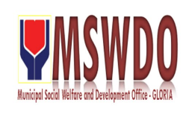
Municipal Social Welfare and Development Office
C E R T I F I C A T E O F E L I G I B I L I T Y

This is to certify that John Reymar , Filipino/s, of legal age/s from Everlasting, Agsalin, Gloria, Oriental Mindoro is eligible to avail outright financial assistance for his sister's hospital bill.

Based on just assessment of this office, the above mention is classified as individual in crisis situation and qualified to receive aid from the government.
Signed by:

Doms Agoncillo, Pres
Municipal Social Welfare & Dev’t Officer

