
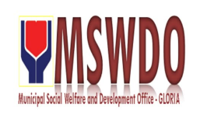
Municipal Social Welfare and Development Office
C E R T I F I C A T E

This is to certify that ${client_name} ${client_civil_status} of legal age/s resident/s of ${client_address} is financially incapable to support ${brot_sis} burial expenses.

This further certifies that their income is below family threshold. The Family doesn't have any real property for taxation purposes according to Assessor and Treasury office of this Municipality.

Issued this ${request_date} for the purpose seeking of financial assistance.
Prepared by:

${prep_by}
Municipal Social Welfare & Dev’t Officer

