
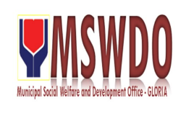
Municipal Social Welfare and Development Office
C E R T I F I C A T E O F E L I G I B I L I T Y

This is to certify that ${client_name} , Filipino/s, of legal age/s from ${client_address} is eligible to avail outright financial assistance for ${brot_sis} medical expenses.

Based on just assessment of this office, the above mention is classified as individual in crisis situation and qualified to receive aid from the government.
Signed by:

${prep_by}
Municipal Social Welfare & Dev’t Officer

