
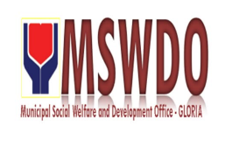
Municipal Social Welfare and Development Office
Q U A R T E R L Y R E P O R T

This report provides a comprehensive overview of Municipal Social Welfare and Development Office's activities and performance during the First Quarter of 2025. It highlights key achievements, financial data, and demographic information related to the individuals we served. The report aims to provide a clear and concise summary of our quarterly progress towards fulfilling our mission.
Total Expenses Total Expenses for First Quarter
Amount: ₱28,000.00
Demographic Breakdown Gender
- Male: 17
- Female: 15
Age Group
- Child:
- Youth: 3
- Adult: 1
- Senior: 4
Total Individuals Served 32

