**Pirate Gallery Submissions for New Website**

Just leave the bold and fill in the other info and delete my examples.

Thanks!!

**Send the following info in a word doc!**

**Name as you would like to appear**

Debra Rae Sanders

**Media in which you specialize**

Mixed Media / Sculpture/ Installation / Kiln Formed Glass

**Member or Associate, How many years/shows at Pirate?**

Debra Rae Sanders has been a full Pirate member since 2000

**Bio**

Viewing the world through the lens of her unique vision, Debra Sanders creates imaginative mixed media sculptures and installations.  Her inspiration often comes in the form of familiar surroundings and objects which are then transformed into amazing displays using a variety of mediums such as kiln formed glass, silicone, photography and projections. For Sanders, the medium with which she chooses to create is more of a means toward the desired effect rather than about the medium itself.  Possessing a wide range of knowledge and skills allows her to fabricate, mold and create with whatever medium best suits the concept she is attempting to convey. Sanders works often evoke myriad feelings tapping into something both ethereal and dreamlike. Merging a sense of otherworldliness with translucent materials, Sanders art often address questions of secrecy, mortality and abjection. Cycles of work are sometimes devoted to, nature, anatomical references and aging,

Sanders lives and creates in Colorado and is a member of the artist cooperative; Pirate: Contemporary Art Gallery. Being a member of an alternative cooperative such as Pirate allows Sanders the freedom to explore her creative process in a way that is uninhibited and free from the constraints of more commercial environments.

**Website/ all social media links**

www.debrasanders.gallery

**Captions for all images**

**Name**

*Debra Sanders*

*Swell 2012*

Digital Photograph

15’ x 12’

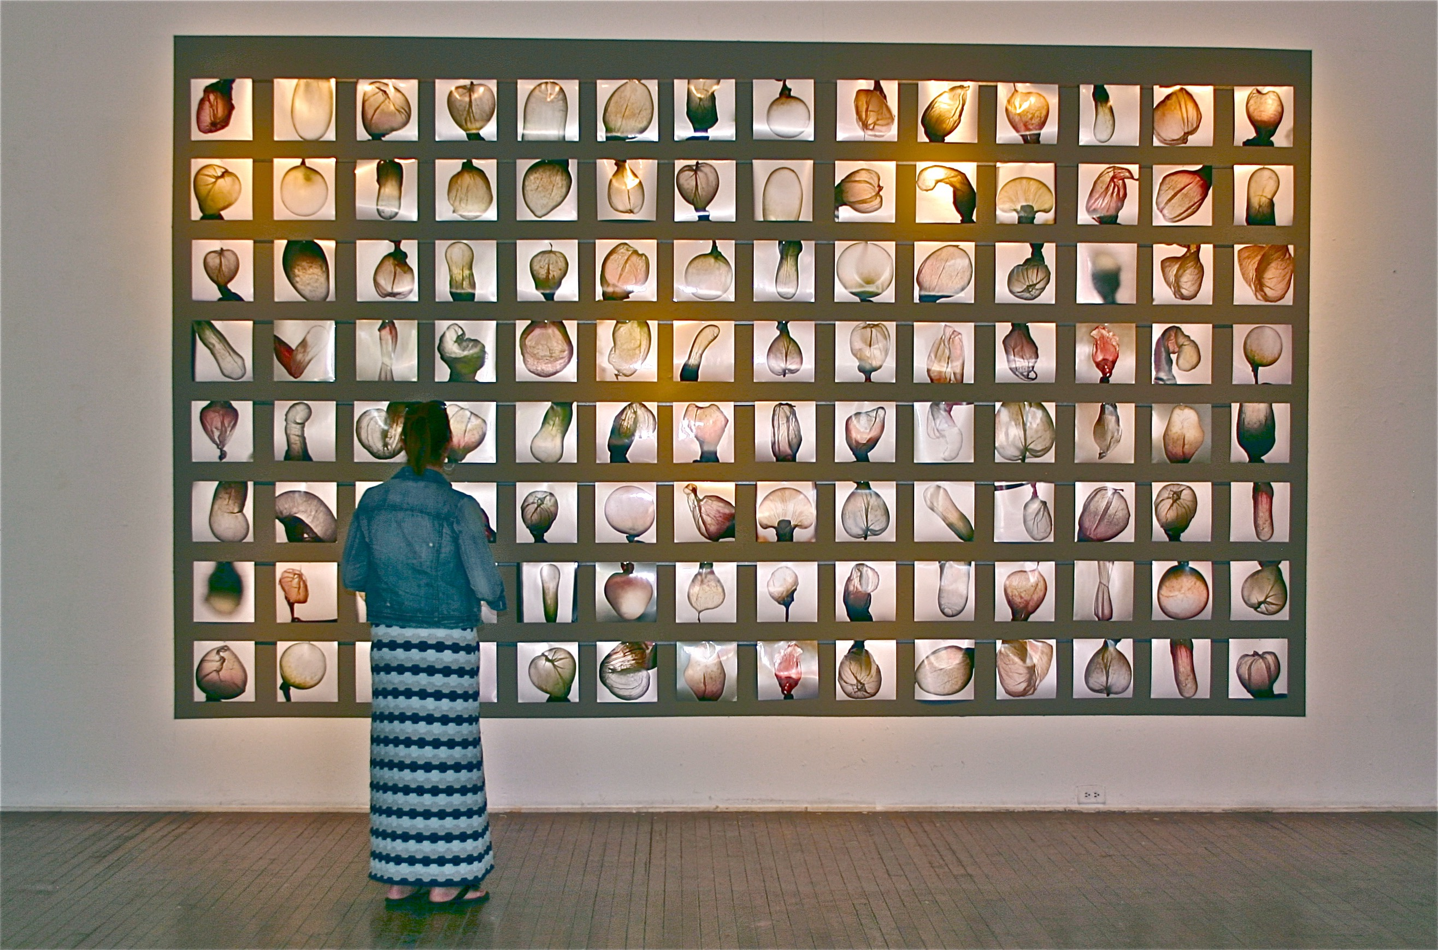

*Debra Sanders*

*Wired*

*2010 – Present*

*Kiln Formed Glass / Steel*

*6” X 10’*

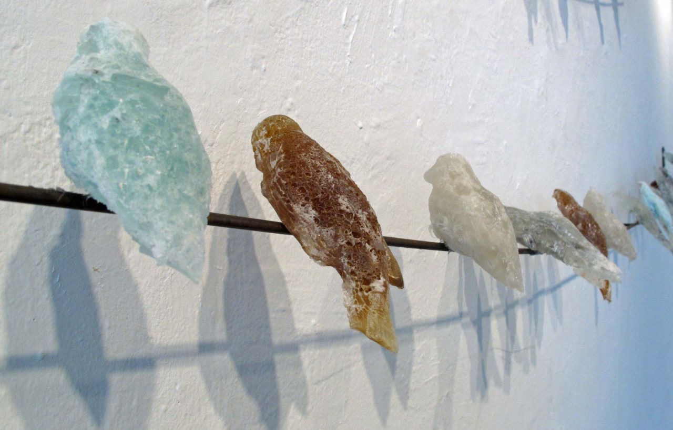

**Is there anything else you would like to highlight thats not in your bio?**

-Awards

-Publications

-Residencies