Model:

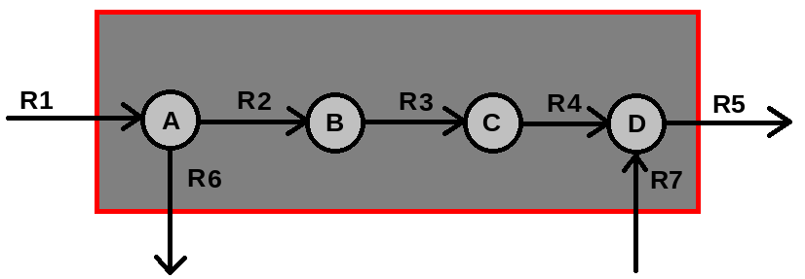

rfile:
"R1" "R2" "R3" "R4" "R5" "R6" "R7"

mfile:
"A" "B" "C" "D"

sfile:
1 -1 0 0 0 -1 0
0 1 -1 0 0 0 0
0 0 1 -1 0 0 0
0 0 0 1 -1 0 1

rvfile:
0 0 0 0 0 0 0

tfile:
1 0 0 0 1 0 0

MILP3(E^{i}): min 0
s.t. S*v = 0,
v_{r1} ≥ 1,
v_{r2} ≥ 1,
a_{l} ≤ v_{l},
v_{l} ≤ M₀*a_{l},
S^{T}*y + u^{r1}*x ≥ M₁*(a - 1 - u^{r2}),
-x ≥ 1,
Σ_{lЄsupp(eq)}a_{l} ≤ |supp(e^{q})| - 1,
v_{l} > 0,
a_{l} Є {0,1},
x,y_{m} Є R

MILP3(E^{i}) for first iteration which is characterized by an empty set E of elementary modes:
\ENCODING=ISO-8859-1
\Problem name: perlOP

Minimize
obj:
Subject To
t_lt_Mz_0: v_R1 - 100 a_R1 <= 0
t_lt_Mz_1: v_R2 - 100 a_R2 <= 0
t_lt_Mz_2: v_R3 - 100 a_R3 <= 0
t_lt_Mz_3: v_R4 - 100 a_R4 <= 0
t_lt_Mz_4: v_R5 - 100 a_R5 <= 0
t_lt_Mz_5: v_R6 - 100 a_R6 <= 0
t_lt_Mz_6: v_R7 - 100 a_R7 <= 0
z_lt_t_0: - v_R1 + a_R1 <= 0
z_lt_t_1: - v_R2 + a_R2 <= 0
z_lt_t_2: - v_R3 + a_R3 <= 0
z_lt_t_3: - v_R4 + a_R4 <= 0
z_lt_t_4: - v_R5 + a_R5 <= 0
z_lt_t_5: - v_R6 + a_R6 <= 0
z_lt_t_6: - v_R7 + a_R7 <= 0
avoid_trivial: a_R1 + a_R2 + a_R3 + a_R4 + a_R5 + a_R6 + a_R7 >= 1
A: v_R1 - v_R2 - v_R6 = 0
B: v_R2 - v_R3 = 0
C: v_R3 - v_R4 = 0
D: v_R4 - v_R5 + v_R7 = 0
vr_0: v_R1 >= 1
vr_4: v_R5 >= 1
ST_Dirc_R1_R5: - 101 a_R1 + y_0_A + x_0 >= -101
ST_Dirc_R1_R5: - 101 a_R2 - y_0_A + y_0_B >= -101
ST_Dirc_R1_R5: - 101 a_R3 - y_0_B + y_0_C >= -101
ST_Dirc_R1_R5: - 101 a_R4 - y_0_C + y_0_D >= -101
ST_Dirc_R1_R5: - 101 a_R5 - y_0_D >= -202
ST_Dirc_R1_R5: - 101 a_R6 - y_0_A >= -101
ST_Dirc_R1_R5: - 101 a_R7 + y_0_D >= -101
x_R1_R5: - x_0 >= 1
Bounds
0 <= a_R1 <= 1
0 <= a_R2 <= 1
0 <= a_R3 <= 1
0 <= a_R4 <= 1
0 <= a_R5 <= 1
0 <= a_R6 <= 1
0 <= a_R7 <= 1
y_0_A Free
y_0_B Free
y_0_C Free
y_0_D Free
x_0 Free
Binaries
a_R1 a_R2 a_R3 a_R4 a_R5 a_R6 a_R7
End

Solution computed by CPLEX:
v1 v2 v3 v4 v5 v6 v7 a1 a2 a3 a4 a5 a6 a7 yA yB yC yD z
1.0 1.0 1.0 1.0 2.0 0.0 1.0 1 1 1 1 1 0 1 1 1 1 101 -1

Stoichiometric matrix S¹ of subnetwork N¹:
1 -1 0 0 0 0 0
0 1 -1 0 0 0 0
0 0 1 -1 0 0 0
0 0 0 1 -1 0 1

LP(N^{i}): min 0
s.t. S^{i}*v = 0,
v_{r1} ≥ 1,
v_{j} ≥ 0,

LP(N¹) solved by CPLEX:
\ENCODING=ISO-8859-1
\Problem name: perlOP

Minimize
obj: 0
Subject To
A: v_R1 - v_R2 = 0
B: v_R2 - v_R3 = 0
C: v_R3 - v_R4 = 0
D: v_R4 - v_R5 + v_R7 = 0
vr_0: v_R1 >= 1
End

Solution computed by CPLEX:
v1 v2 v3 v4 v5 v6 v7
1.0 1.0 1.0 1.0 1.0 0.0 0.0

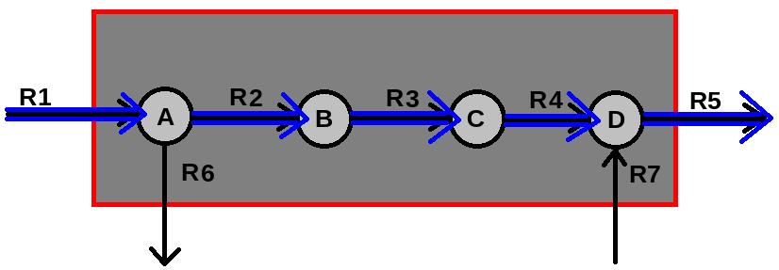

Question:
CPLEX could also find the following solution for LP(N¹), as there is no objective function given:
v1 v2 v3 v4 v5 v6 v7
1.0 1.0 1.0 1.0 2.0 0.0 1.0

Minimize
obj: 0
Subject To
A: v_R1 - v_R2 = 0 => 1 - 1 = 0
B: v_R2 - v_R3 = 0 => 1 - 1 = 0
C: v_R3 - v_R4 = 0 => 1 - 1 = 0
D: v_R4 - v_R5 + v_R7 = 0 => 1 - 2 + 1 = 0
vr_0: v_R1 >= 1 => 1 >= 1
End

