Assignment 1: Analysis Report

Matheus Vinicius Ferreira Figueiredo Teixeira

Student ID: 301236904

Course: COMP 237 – Sec. 002

# Script Execution

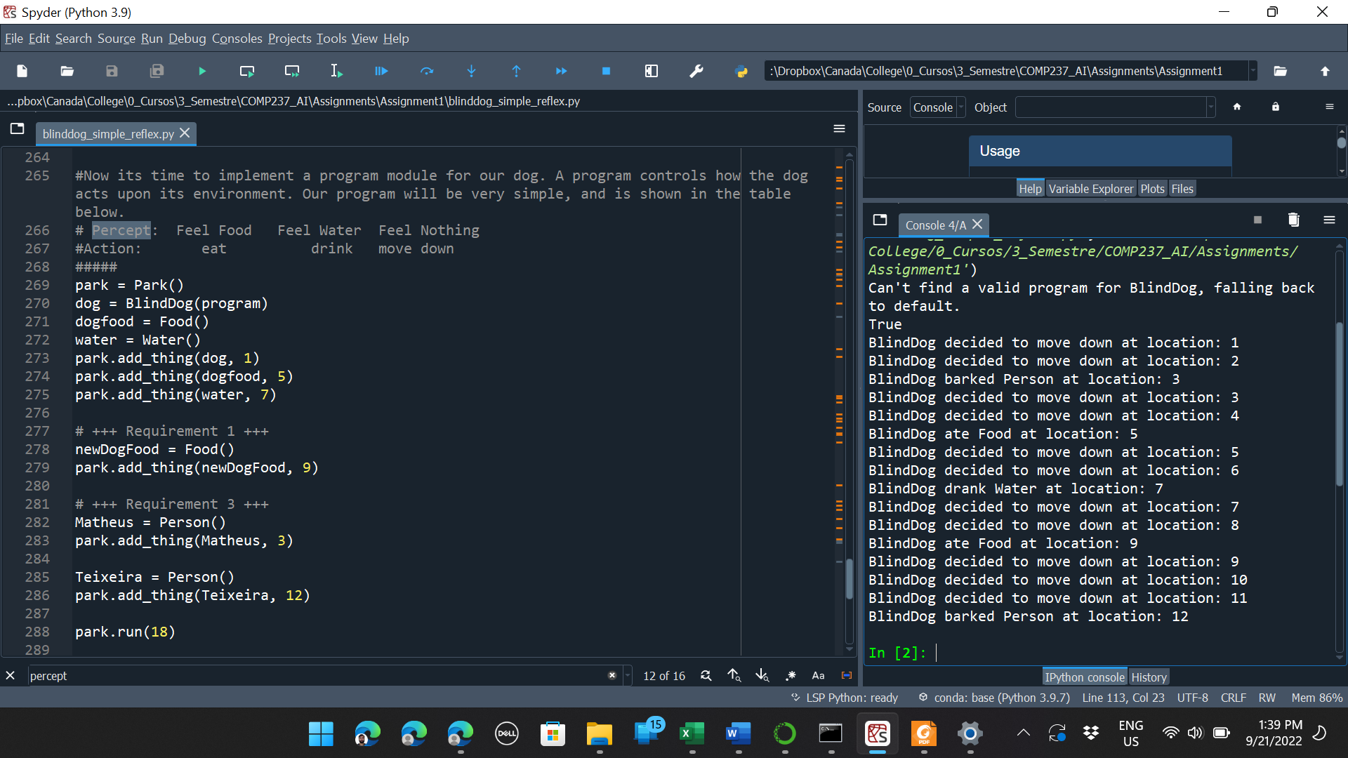

# Class diagram and Analysis

Figure 1: Partial Class Diagram for the blinddog_simple_reflex.py code. To denote that a method is being overwritten, the method name is repeated in the child class.

For this assignment I had to use:

1. For requirement 1,
   1. I had to make a new instance of the **Food class**
   2. And I had to use the method **add_thing()** of the **park object**, which was inherited from the **Environment class**
2. For requirement 2,
   1. I had to create the **Person class,** a child for the **Thing class**
3. For requirement 3,
   1. I had to create 2 new instances of the **Person class**
   2. And I had to use, two times, the method **add_thing()** of the **park object**, which was inherited from the **Environment class**
4. For requirement 4,
   1. I had to add a new condition inside the **execute_action()** method in the **Park class.** This function is overwriting the original **execute_action()** method in the **Environment class.**
   2. I also had to include new logic in **is_done()** method from **Park class** to check if there is any person still present in the park. This function is overwriting the original **is_done()** method in the **Environment class.**
   3. Finally, I had to add a new condition inside **program()** function. This function is passed as parameter to the **Agent** constructor of the **dog** object. This program is the method that defines what the dog will do when it finds a **Thing**.
5. For requirement 5,
   1. All I did was calling the **run()** method of the park object.