

CENTENNIAL COLLEGE PROGRESS CAMPUS

COURSE COMP213 Winter 2022

ASSIGNMENT #3

**Select a product that you really like (example: a TV set, a laptop, a car, etc.)**

**Find information about your favorite product on the Internet.**

**Using the product information (picture, description, features, similar products, company that sells the product), create in MS Expression Web 4 or VSCode an HTML page with content *similar* to the following screenshot of a typical product online page:**

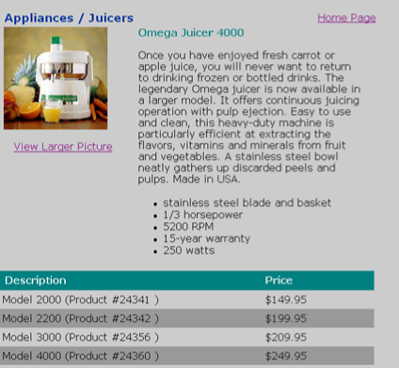

**Required Features:**

* **Design the page layout to fit a 1024px screen (width:980px) and show the content centered on the screen.**
* **Choose appropriate font families that look good on the screen (Hint: use a sans serif font for the main text on the page).**
* **Add a banner for your page (not shown in above picture) to include a product-related picture, the product company logo hyperlinked to their website, some title text.**
* **Add a hotspot map of Canada (not shown in above picture) and hyperlink 3 provinces to the website of local distributors of the product.**
* **Save the HTML page as Assignment3.html.**
* **When you click the “Home Page” hyperlink, redirect the browser to your home page (index.html) on studentweb.**
* **When you click the “View Larger Picture” hyperlink, open another document called Details.html, that displays a detailed (larger) picture of your product and a “back” hyperlink to the product info page.**

* **Create an HTML comment within your document that shows your name and student number**.
* **Upload your Assignment3.html and Details.html documents to the studentweb server, and provide an “Assignment 3” hyperlink to it from your index page. Remember to upload the picture files to the server too.**

**This assignment is due on ___________at 10pm. Late submissions are allowed only for 2 additional days and they are marked out of 80%.**