Lab 4 – Part A - Chapter 3

Matheus Vinicius Ferreira Figueiredo Teixeira

Fawad Mohammed Zaheer

Centennial College

Web Interface Design

May Haidar

February 2nd, 2022

# Visit the website you are evaluating. Write a paper that includes the following information:

## URL of the website

http://www.telework.gov/

## Name of the website

Telework Guide

## Target audience

“The information contained on telework.gov pertains only to Executive Branch agencies and employees.” (U.S. Office of Personnel Management, n.d., para. 4).

## Screenshot of the home page

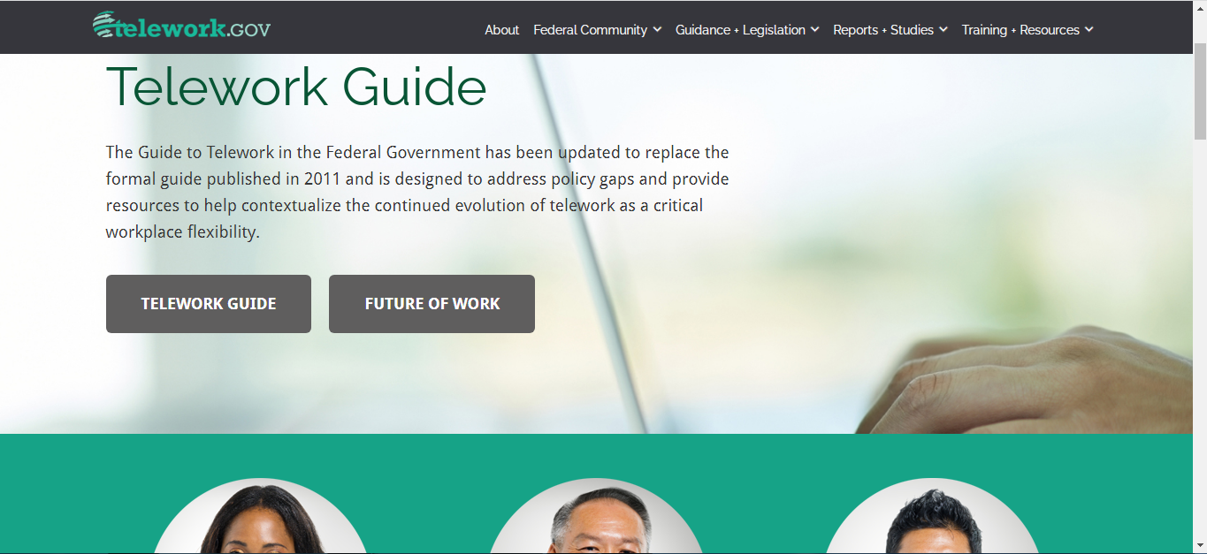

Screenshot from the home page of Telework Guide.

## Indicate the type(s) of the home page

For people working remotely

## f. Describe how the design principles of contrast, repetition, alignment, and proximity are applied. Be specific.

* Repetition: The color of the Logo (green) is repeated on the Main Heading of the page. There is an image which has some shades of light green on it. And also, it is used as background color for some pictures.
* Contrast: There is a good contrast in the navigation bar: the logo is green, the other links are in white, while the background is in dark gray. This pattern is repeated throughout the whole page, wherever the background is in a solid dark color, the letters are white, yellow, or in a shade of gray; but in white or (light color) backgrounds, the letters are black, orange or blue.
* Proximity: The is a navigation bar with all the menu options near to each on the top side of the page, aligned near to the right side. There are 2 buttons near each other: one is a link to “TELEWORK GUIDE” and the other is a link to “FUTURE OF WORK”. There are also 3 images near each other, and below each image there are text linking to: “TELEWORK MANAGING OFFICER & COORDINATOR”, “MANAGER”, and “EMPLOYEE”
* Alignment: there are 3 pictures aligned in a horizontal line, the buttons “TELEWORK GUIDE” and “FUTURE OF WORK” also aligned in the horizontal, and of course all of the links on the navigation bar are aligned to each other. There is a margin aligning the Logo, the main title, the first paragraph and “TELEWORK GUIDE” vertically.

## G. Complete the Web Design Best Practices Checklist

**Page Layout:**

* Appealing to target audience
* Consistent site header/logo
* Consistent navigation area
* Informative page title that includes the company/organization/site name
* Good use of basic design principles: repetition, contrast, proximity, and alignment
* Balance of text/graphics/white space on page
* Good contrast between text and background

**Browser Compatibility:**

* Displays on popular/current versions of Microsoft Edge
* Displays on current versions of Google Chrome

**Navigation:**

* Main navigation links are clearly and consistently labeled
* Navigation is easy to use for target audience
* Navigation is structured in an unordered list
* Navigation aids, such as site map, skip navigation link, or breadcrumbs are used
* All navigation hyperlinks "work" — are not broken

**Color and Graphics:**

* Color is used consistently
* Text color has sufficient contrast with background color
* Color is not used alone to convey meaning
* Use of color and graphics enhances rather than distracts from the site
* Graphics are optimized and do not significantly slow download
* Each graphic used serves a clear purpose

**Content Presentation:**

* Common fonts such as Arial or Times New Roman are used
* Techniques of writing for the Web are used: headings, bullet points, brief paragraphs
* Fonts, font sizes, and font colors are consistently used
* Content provides meaningful, useful information
* Content is organized in a consistent manner
* Content does not include outdated material
* Content is free of typographical and grammatical errors
* Content provides links to other useful sites
* Avoids the use of "Click here" when writing text for hyperlinks

**Functionality:**

* All internal hyperlinks work.
* All external hyperlinks work.

## Accessibility:

* Navigation is structured in an unordered list.
* Text color has sufficient contrast with background color.

## H. Recommend three improvements for the website

1. Copyright not shown. Inserting a line with copyright information.
2. Banner too small. Increase the Banner area.
3. “Three Click Rule” not applicable everywhere. Comply with the “Three Click Rule”.

# 

# References

U.S. Office of Personnel Management. (n.d.). *About*. https://www.telework.gov/about/

U.S. Office of Personnel Management. (n.d.). *Telework Guide*. https://www.telework.gov/