**Web Site Project**

**1621ICT— Web Technologies**

School of ICT

Griffith University

Trimester 1, 2020

**Project Design Documentation**

**Client Background**

A local fitness center called “Fitness Lab” is the customer who contacted me to develop a website for their business. They are in the business for around 5+ years. They run a fitness store along with the gymnasium and they have authorized coaches to provide necessary dietary plans as well as customized individual workout plans. Currently they provide their service to the customers who comes to their fitness center and the supplement fitness store is open to anyone who wishes to come by.

Now they want to make sure to provide their services to people more than their daily customers and have a huge client base around the city and to open another fitness center within 20kms radius of their current location. As well as they want to get rid of their physical fitness store due to the high rent cost and high wages of the workers.

**Goals**

Client wants to have a product which can fit in the society and spread more among people. They need to do their supplement fitness store business only through the website. And it should make sure to have all the necessary items which can be sold. As well as it should have capability to provide necessary Dietary Plans and customized workout plans to the customers who visits their website. For more details there should be a client contact section as well. Along with those primary goals easy access, simple design, high customer attraction must be involved when building the product.

**Scope**

According to the customer requirements it should be a 5-page website consisting of Home, Products, Diet Plans, Workouts and Contact Us. All the main goals that client expecting to have is quite possible to achieve but due to the lack of time and the budget having an online cart to do the shopping is not possible therefore there will be only available products display on the Products page because creating and joining other scripts is not possible as I mentioned above due to the lack of resources.

This product will have different layers for each page containing different information cards with the necessary images and target buttons to achieve the maximum customer satisfaction during their time on this website to make sure to attract them and make them to visit the site again. Users have direct access to send emails to the Client through the website itself.

**Target Audience**

Both Current and new customers must have the ability to visit the website and use it according to their needs. As this is a fitness centric product it should have the ability to cater to any age range person because everybody seeks for the fitness and healthy lifestyle. Therefore, this should be user-friendly which has a simple layout and easy usability for all the people. Any device with the internet connectivity and browsing capabilities can be logged and surf on this website to get any necessary information and online shopping.

Any user can use this site to get free motivational quotes and stories which are related to fitness. As well as supplement selection and purchasing, Nutritious dietary plans for any individual body type as well as workout plans for any given time period can be received through this website. To have more person to person interaction there is a contact form to fill out and the client will keep in touch with the user to provide more services which are needed by the user.

**Requirements**

**Functional Requirements:**

Website has 5 pages which are Home, Products, Diet Plans, Workouts and Contact Us. Website will be highly responsive. It has the ability to retrieve other webpages which provide additional information. It has the ability to show the shopping page. Diet Plans and Workout pages have the ability to redirect into different pages to provide more information regarding each item on the page. Contact Us page has a contact form and it has the capability to make an email direct to the client’s email. The website will allow website owner to update all page content from a web-based admin area

**Business Requirements:**

Provide Fitness Lab store business through the website. Assist customers who seek for more information on dietary plans and workout schedules and provide them customized plans via email or the ability to use the pre-made plans on the website.

**Quality of Service Requirements:**

Performance, availability, scalability, Look and feel, consistency and serviceability as well as those are driven by business needs specified in the business requirements.

**Site Wireframe Design**

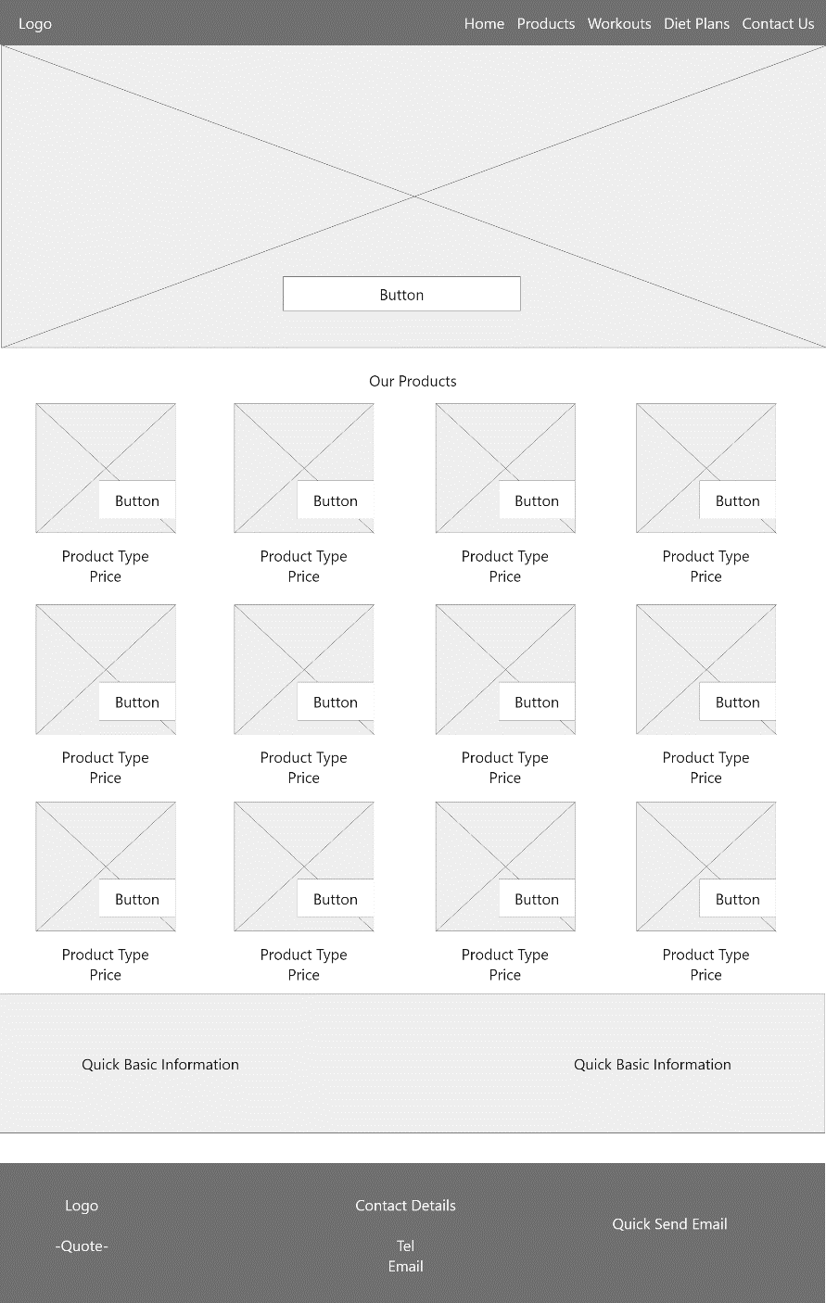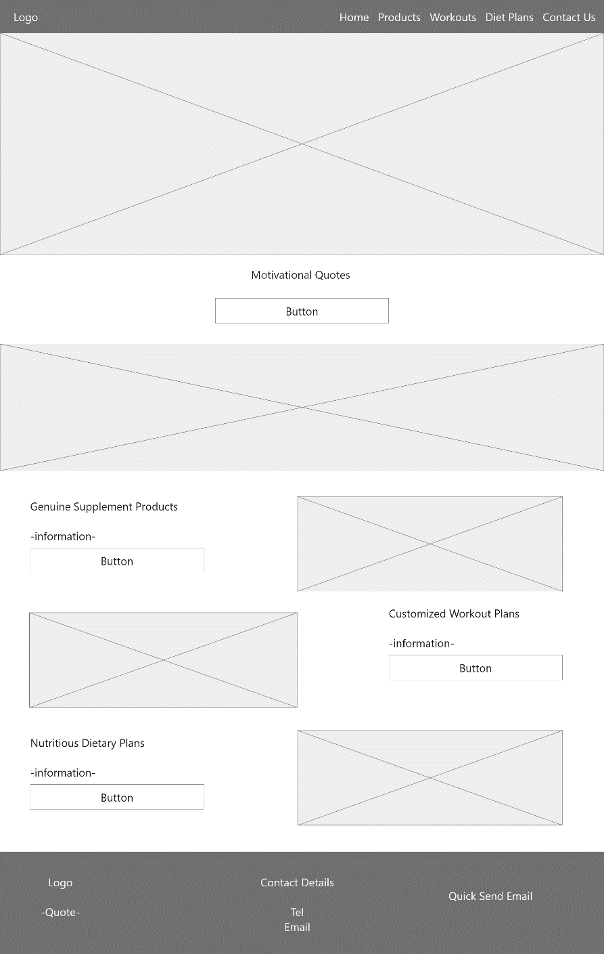

Page 2: Products Page

Page 1: Home Page

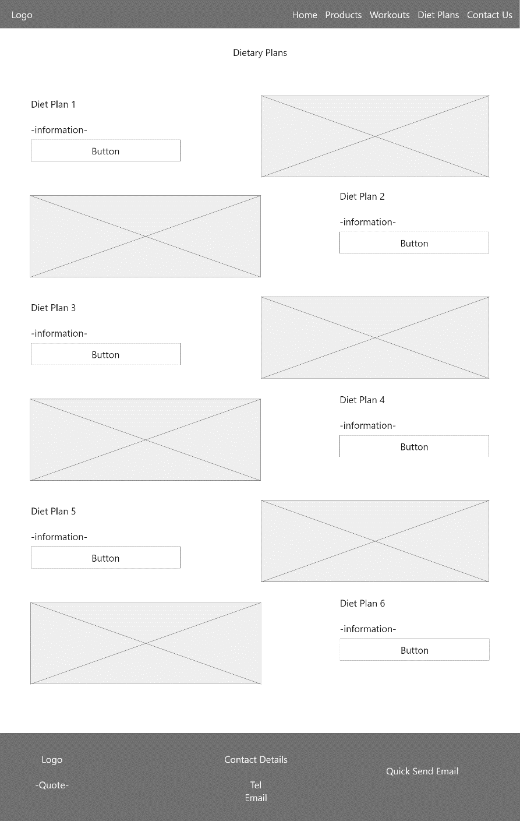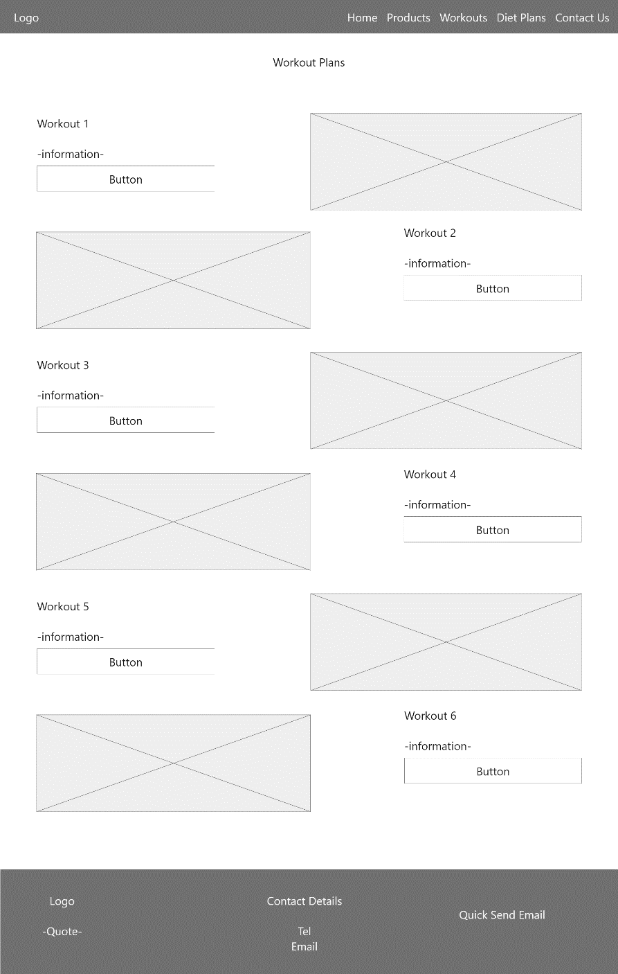

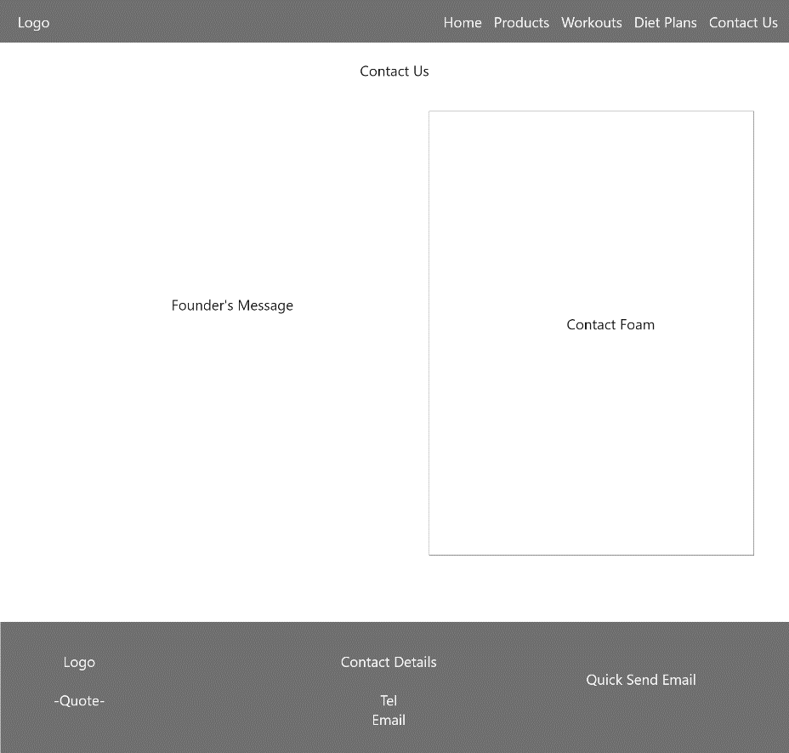

Page 5: Contact Us Page

Page 4: Diet Plans Page

Page 3: Workouts Page

**Hierarchy Chart**

