Enterprise Community Portal Audit

04/05/2020

# Enterprise Portal Users

|  |  |  |  |  |  |  |
| --- | --- | --- | --- | --- | --- | --- |
| USERNAME | EMAIL | ROLE | LAST LOGIN | CREATED | GROUPS | ITEMS |
| branch_chief1 | python@esri.com | branch_chief | -1 | 12/26/2019 | nan | 0 |
| branch_chief99 | python@esri.com | branch_chief | -1 | 12/30/2019 | nan | 0 |
| dhong | d.shaw@esri.com | org_user | 02/21/2020 | 10/31/2019 | 'group2' | 0 |
| dshaw | d.shaw@esri.com | org_admin | 02/21/2020 | 10/31/2019 | 'gahhhh group', 'group1', 'group2' | 4 |
| jjones | d.shaw@esri.com | branch_chief | -1 | 12/30/2019 | 'group1', 'group2' | 0 |
| jscarmazzi | jscarmazzi@esri.com | org_user | 11/05/2019 | 10/31/2019 | nan | 4 |
| jturco | jturco@esri.com | org_user | -1 | 10/31/2019 | 'group1', 'group2' | 0 |
| jwright | d.shaw@esri.com | org_publisher | -1 | 12/03/2019 | 'group1' | 0 |
| ksmith | d.shaw@esri.com | org_admin | 11/05/2019 | 10/31/2019 | 'group2' | 7 |
| lili | lli@esri.com | org_publisher | 10/31/2019 | 10/31/2019 | 'group2' | 0 |
| portaladmin | d.shaw@esri.com | org_admin | 04/05/2020 | 09/06/2019 | 'ds_test', 'group1', 'group2' | 18 |
| xbrown | d.shaw@esri.com | branch_chief | -1 | 12/30/2019 | nan | 0 |
| zunger | d.shaw@esri.com | org_user | -1 | 12/27/2019 | nan | 0 |

# Enterprise Groups

|  |  |  |  |  |
| --- | --- | --- | --- | --- |
| TITLE | OWNER | MANAGERS | USERS | ITEMS |
| ds_test | portaladmin | portaladmin | nan | 25 |
| gahhhh group | dshaw | dshaw | nan | 0 |
| group1 | portaladmin | portaladmin | dshaw, jjones, jturco, jwright | 23 |
| group2 | portaladmin | portaladmin | dhong, dshaw, jjones, jturco, ksmith, lili | 23 |

# Portal Items

|  |  |  |  |  |  |  |  |  |
| --- | --- | --- | --- | --- | --- | --- | --- | --- |
| TITLE | OWNER | TYPE | AUTHORITATIVE | TAGS | ACCESS | SHARED WITH GROUPS | VIEWS | CREATED |
| ds_test | portaladmin | Feature Service | nan | nan | public | 'ds_test' | 19 | 12/13/2019 |
| SampleWorldCities | portaladmin | WMS | nan | 'SampleWorldCities', 'WMSServer' | public | 'group1', 'ds_test', 'group2' | 1 | 09/06/2019 |
| Coronavirus_Cases_202003151133 | dshaw | Map Service | nan | 'Coronavirus_Cases_202003151133', 'MapServer' | public | 'group1', 'ds_test', 'group2' | 0 | 03/15/2020 |
| nc4 | ksmith | Map Service | nan | 'nc4' | public | 'group1', 'ds_test', 'group2' | 2 | 03/06/2020 |
| adfasdf | jscarmazzi | Web Map | nan | 'adasdf' | public | 'group1', 'ds_test', 'group2' | 2 | 02/15/2020 |
| dasfasf | jscarmazzi | Web Map | nan | 'afasf' | public | 'group1', 'ds_test', 'group2' | 1 | 02/15/2020 |
| location_tracking | portaladmin | Feature Service | nan | nan | org | nan | 0 | 12/13/2019 |
| Coronavirus_Cases_202003171317 | dshaw | Map Service | nan | 'Coronavirus_Cases_202003171317', 'MapServer' | public | 'group1', 'ds_test', 'group2' | 0 | 03/17/2020 |
| dsfas | ksmith | Dashboard | nan | nan | public | 'group1', 'ds_test', 'group2' | 2 | 01/10/2020 |
| shootings | portaladmin | Web Map | nan | 'shootings' | public | 'group1', 'ds_test', 'group2' | 17 | 02/21/2020 |
| my_tracks | portaladmin | Web Map | nan | 'my_trcks' | public | nan | 6 | 12/26/2019 |
| my_tracks_dashboard | portaladmin | Dashboard | nan | 'my_trcks' | private | nan | 2 | 12/26/2019 |
| dc | portaladmin | Data Store | nan | 'dc' | public | 'group1', 'ds_test', 'group2' | 2 | 12/21/2019 |
| 2020 Census Response Rates | dshaw | Map Service | nan | '2020 census' | public | 'group1', 'ds_test', 'group2' | 1 | 03/23/2020 |
| homicides | ksmith | Web Mapping Application | nan | 'homicides' | public | 'group1', 'ds_test', 'group2' | 3 | 02/25/2020 |
| scooters | portaladmin | Map Service | nan | 'scooters', 'MapServer' | public | 'group1', 'ds_test', 'group2' | 7 | 09/16/2019 |
| ArcGIS Enterprise Disaster Recovery Test | portaladmin | PDF | nan | 'disaster recovery' | private | nan | 2 | 04/03/2020 |
| postgis | portaladmin | Data Store | nan | 'postgis' | public | 'group1', 'ds_test', 'group2' | 0 | 12/20/2019 |
| homicides | ksmith | Web Map | nan | 'homicides' | public | 'group1', 'ds_test', 'group2' | 4 | 12/20/2019 |
| shooting web app | portaladmin | Web Mapping Application | nan | 'shootings' | public | 'group1', 'ds_test', 'group2' | 5 | 04/03/2020 |
| Survey123 | portaladmin | Web Mapping Application | nan | 'survey123' | public | 'group1', 'ds_test', 'group2' | 2 | 09/13/2019 |
| SampleWorldCities | portaladmin | Map Service | nan | 'SampleWorldCities', 'MapServer' | public | 'group1', 'ds_test', 'group2' | 5 | 09/06/2019 |
| Coronavirus_Cases | dshaw | Map Service | nan | 'Coronavirus_Cases', 'MapServer' | public | 'group1', 'ds_test', 'group2' | 6 | 03/13/2020 |
| shootings | jscarmazzi | Web Mapping Application | org_authoritative | 'shootings' | public | 'group1', 'ds_test', 'group2' | 9 | 02/21/2020 |

# Items With No Tags

|  |  |  |  |  |  |  |  |  |
| --- | --- | --- | --- | --- | --- | --- | --- | --- |
| TITLE | OWNER | TYPE | AUTHORITATIVE | TAGS | ACCESS | SHARED WITH GROUPS | VIEWS | CREATED |
| ds_test | portaladmin | Feature Service | nan | nan | public | 'ds_test' | 19 | 12/13/2019 |
| location_tracking | portaladmin | Feature Service | nan | nan | org | nan | 0 | 12/13/2019 |
| dsfas | ksmith | Dashboard | nan | nan | public | 'group1', 'ds_test', 'group2' | 2 | 01/10/2020 |

# Top 5 Web Maps

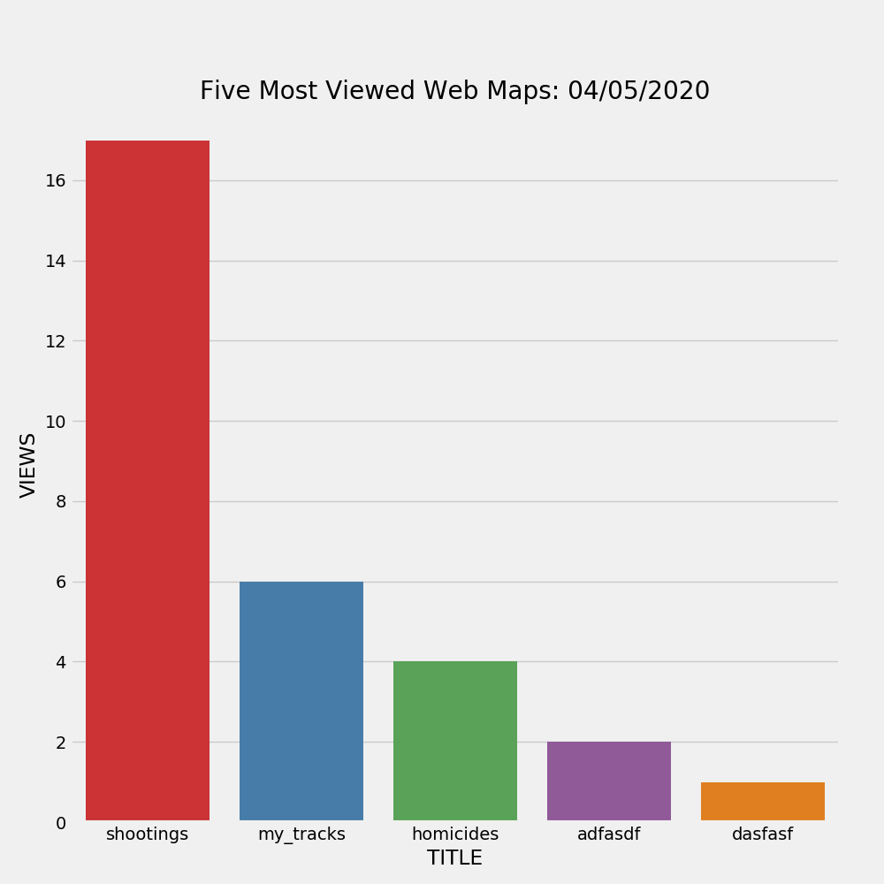

# Top 5 Web Apps

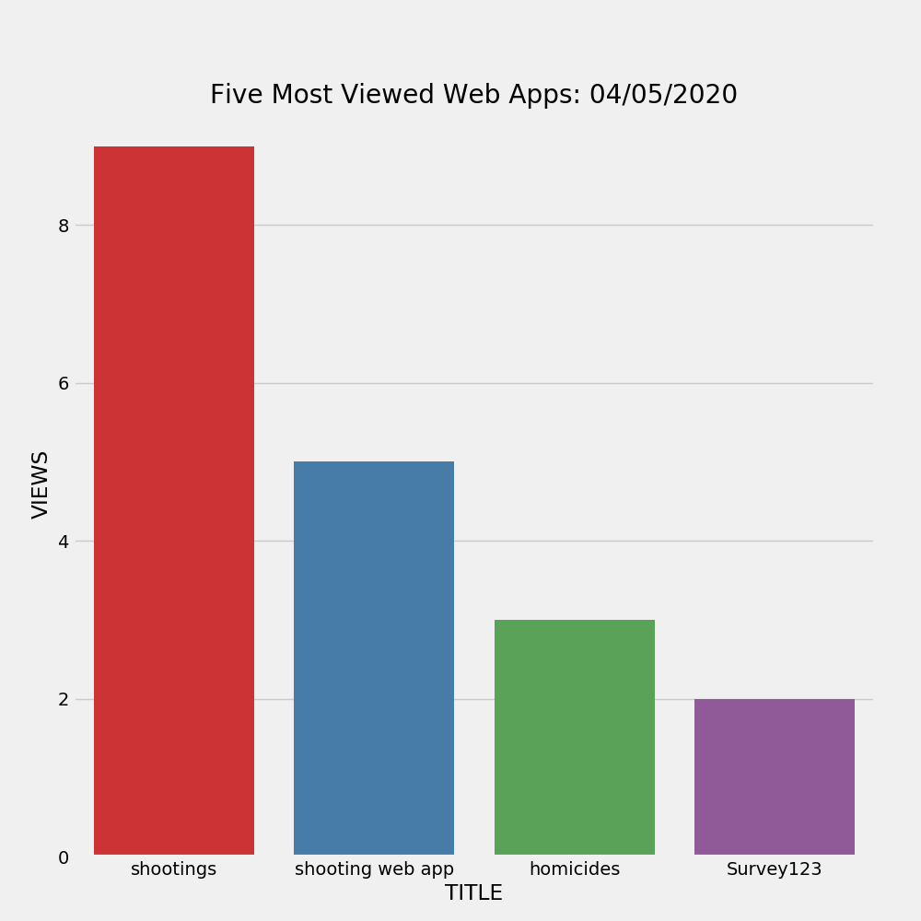

# Top Groups by Content

