Nihar Patel

1. PHP Code for the problem.



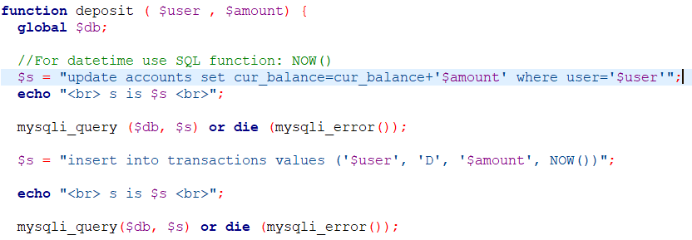



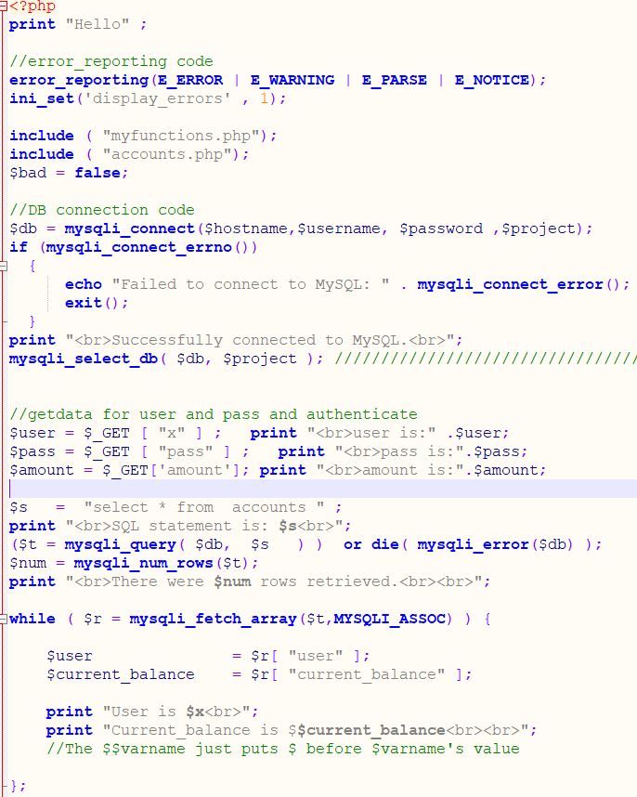



1. Snapshot the user’s A row before and after deposit, and snapshot the at table before and after.

A row before:



A row after:

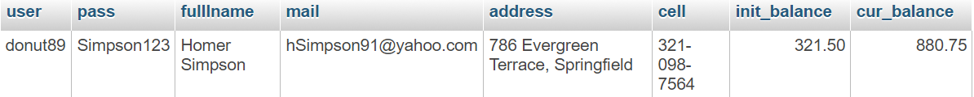

T row before:



T row after:

