**Data Exception Report**

**Data.anss (mag events 2013 to Jun 30, 2015)**



1 Row with “Unk” magtype.

**Current Action:** Omit from analysis.

**Data.small_mag (ISC from 1975 to 2012)**

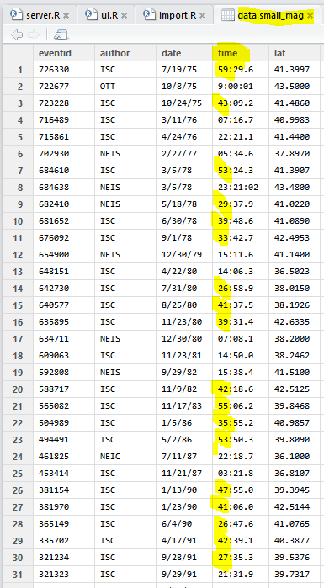

>50% of rows with invalid time.

**We do not understand what time format this could be. Any ideas?**